Supporting Information
Learning Electricity using Arduino-Android based Game to Improve STEM Literacy
Alifa Irna Yasin¹, Eka Cahya Prima¹*, Hayat Sholihin²
¹Department of Science Education, Faculty of Mathematics and Science Education, Universitas Pendidikan Indonesia, Indonesia
²Department of Chemistry Education, Faculty of Mathematics and Science Education, Universitas Pendidikan Indonesia, Indonesia
*Corresponding Author. ekacahyaprima@upi.edu

Lesson Scheme of Work
Madania Secondary School
Physics
Grade 8 - Semester 2 - 2016/2017
Week 17

Topic:  Electricity |  |  | Time frame:  3 periods (3 x 40 minutes)
Expected Outcomes
- Core Competencies:
1.  2.  3.  4. | Menghayati dan mengamalkan ajaran agama yang dianutnya.  Menghayati dan mengamalkan perilaku jujur, disiplin, tanggung jawab, peduli (gotong royong, kerjasama, toleran, damai), santun, responsif dan pro-aktif serta menunjukkan sikap sebagai bagian dari berbagai permasalahan dalam berinteraksi secara efektif dengan lingkungan sosial dan alam, dan dalam menempatkan diri sebagai cerminan bangsa dalam pergaulan dunia.  Memahami, menerapkan, menganalisa, konseptual, prosedural berdasarkan rasa ingin tahunya tentang ilmu pengetahuan, teknologi, seni, budaya, dan humaniora dengan wawasan kemanusiaan, kebangsaan, kenegaraan, dan peradaban, terkait penyebab fenomena dan kejadian, serta menerapkan pengetahuan prosedural pada bidang kajian yang spesifik sesuai dengan bakat dan minatnya untuk memecahkan masalah.  Mengolah, menalar, menyaji, dan mencipta dalam ranah kongkret dan ranah abstrak terkait dengan pengembangan dari yang dipelajarinya di sekolah secara mandiri, dan mampu menggunakan metoda sesuai kaidah keilmuan.
- Basic Competencies:
4.2 | Understand the electrical quantities and its properties
4.3 | Understand how electric circuit works
- Indicators:
4.2.2 | To state the current is related to the flow of charge and measured by ammeter
4.2.3 | To state the e.m.f of an electrical source of energy is measured in volts
4.2.4 | To state that the potential difference (p.d) across a circuit component is measured in volts
4.2.5 | To state that resistance = p.d / current and the changes in p.d or resistance will affect current
4.2.6 | To understand that electric circuits transfer energy from the battery or power source to the circuit components then into the surroundings
4.3.1 | To draw and interpret circuit diagrams containing sources, switches, resistors (fixed and variable), light-dependent resistors, lamps, ammeters, and voltmeters
4.3.2 | To understand how the current, resistor and potential difference in both series and parallel circuit
- Lessons Objectives
Students will be able to :
- State the current is related to the flow of charge
- State the e.m.f of an electrical source of energy is measured in volts
- state that the potential difference (p.d) across a circuit component is measured in volts
- State that resistance = p.d / current and the changes in p.d or resistance will affect current
- Understand that electric circuits transfer energy from the battery or power source to the circuit components then into the surroundings
- Draw and interpret circuit diagrams containing sources, switches, resistors (fixed and variable), light-dependent resistors, lamps, ammeters, and voltmeters
- Understand how the current, resistor and potential difference in both series and parallel circuit

- Materials/Subtopics:
- Current
- Electromotive force
- Potential difference
- Resistance
- Electrical circuit
- Teaching Approach/Teaching Model/ Teaching Method
- Teaching Approach  - Teaching Model  - Teaching Method |  | : STEM Learning  : Cooperative Learning  : Group Discussion, Question and Answer
G. Lesson Plan
Session 1 (3 x 40 minutes)
Duration: 3 periods ( 3 x 40 minutes)
- Opening ( 15 minutes)
(Science)
Recalling the previous materials; electrical quantities and how current is affected by resistors and potential differences
- Main Activity: (90 minutes)
  - Students are divided into 8 groups ( 1 group consist of 2 people)
  - Students are asked to open the MGames Science in their phone.
(Science and Technology Literacy )
  - To introduce the game which will be used and recalling their previous materials, students are asked to complete the questions in the worksheet by opening “Learn About Circuit” page in MGames Science .
(Science, Technology and Mathematics Literacy)
  - Students are asked to play and finish the stage of MGames Science
  - Students are asked to make drawing scheme and result from each stage in their worksheet
  - Students are introduced to YWrobot, Arduino and how to use it with protoboard, lamp and wire.
  - Students are asked to draw scheme of their circuit in their worksheet.
- Closing: (15 minutes) (Technology)
- Students are introduced about the using Arduino Uno with the video of traffic light by using Arduino Uno.
- Students are asked to submit their worksheet

Reflection

Class Materials
  - LCD Projector
  - Computer/Laptop
  - Phone
  - Worksheets and Guidance book
  - Arduino Uno
  - YWrobot
  - Lamps
  - Resistors
  - Jumper Wires
  - Protoboard
  - Markers
  - Internet connection/Library books
Resources
MGmames Science Game

Bogor, 25 of April 2017
Checked and approved by:
Subject teacher Apprentice teacher

Name: Irfan Wahyudi Name: Alifa Irna Yasin

Lesson Scheme of Work

Madania Secondary School
Physics
Grade 8 - Semester 2 - 2016/2017
Week 19

Topic:  Electricity |  |  | Time frame:  3 periods (3 x 40 minutes)
Expected Outcomes
- Core Competencies:
1.  2.  3.  4. | Menghayati dan mengamalkan ajaran agama yang dianutnya.  Menghayati dan mengamalkan perilaku jujur, disiplin, tanggung jawab, peduli (gotong royong, kerjasama, toleran, damai), santun, responsif dan pro-aktif serta menunjukkan sikap sebagai bagian dari berbagai permasalahan dalam berinteraksi secara efektif dengan lingkungan sosial dan alam, dan dalam menempatkan diri sebagai cerminan bangsa dalam pergaulan dunia.  Memahami, menerapkan, menganalisa, konseptual, prosedural berdasarkan rasa ingin tahunya tentang ilmu pengetahuan, teknologi, seni, budaya, dan humaniora dengan wawasan kemanusiaan, kebangsaan, kenegaraan, dan peradaban, terkait penyebab fenomena dan kejadian, serta menerapkan pengetahuan prosedural pada bidang kajian yang spesifik sesuai dengan bakat dan minatnya untuk memecahkan masalah.  Mengolah, menalar, menyaji, dan mencipta dalam ranah kongkret dan ranah abstrak terkait dengan pengembangan dari yang dipelajarinya di sekolah secara mandiri, dan mampu menggunakan metoda sesuai kaidah keilmuan.
- Basic Competencies:
4.2 | Understand the electrical quantities and its properties
4.3 | Understand how electric circuit works
- Indicators:
4.2.2 | To state the current is related to the flow of charge and measured by ammeter
4.2.3 | To state the e.m.f of an electrical source of energy is measured in volts
4.2.4 | To state that the potential difference (p.d) across a circuit component is measured in volts
4.2.5 | To state that resistance = p.d / current and the changes in p.d or resistance will affect current
4.2.6 | To understand that electric circuits transfer energy from the battery or power source to the circuit components then into the surroundings
4.3.1 | To draw and interpret circuit diagrams containing sources, switches, resistors (fixed and variable), light-dependent resistors, lamps, ammeters, and voltmeters
4.3.2 | To understand how the current, resistor and potential difference in both series and parallel circuit
- Lessons Objectives
Students will be able to :
- State the current is related to the flow of charge
- State the e.m.f of an electrical source of energy is measured in volts
- state that the potential difference (p.d) across a circuit component is measured in volts
- State that resistance = p.d / current and the changes in p.d or resistance will affect current
- Understand that electric circuits transfer energy from the battery or power source to the circuit components then into the surroundings
- Draw and interpret circuit diagrams containing sources, switches, resistors (fixed and variable), light-dependent resistors, lamps, ammeters, and voltmeters
- Understand how the current, resistor and potential difference in both series and parallel circuit
- Materials/Subtopics:
- Current
- Electromotive force
- Potential difference
- Resistance
- Electrical circuit
- Teaching Approach/Teaching Model/ Teaching Method
- Teaching Approach  - Teaching Model  - Teaching Method |  | : STEM Learning  : Cooperative Learning  : Group Discussion and Experiment
G. Lesson Plan
Session 1 (3 x 40 minutes)
Duration: 3 periods ( 3 x 40 minutes)
- Opening ( 15 minutes) (Technology)
  - Students are explained about electrical components.
  - Teacher explain about YWrobot
- Main Activity: (90 minutes)

- Students are divided into 5 groups, each group consist of 3-4 students.
- Students are given worksheet to guide in YWrobot experiments
(Science, Technology and Engineering)
- Students are asked to try and arrange resistor or lamp in series or parallel circuit
using YWrobot and protoboard by reading the worksheet.
- Students are asked to measure the current and voltage by using multimeter.
- Students are challenged to make series circuit with two lamps
- Students are challenged to make combination circuit ( series and parallel with
three lamps)
- Students are asked to draw scheme of their circuit in their worksheet.
- Closing: (15 minutes) (Technology)

- Students are introduced about the using Arduino Uno with the video of traffic light by using Arduino Uno.
- Students are asked to submit their worksheet
Reflection
Class Materials
  - LCD Projector
  - Computer/Laptop
  - Phone
  - Worksheets and Guidance book
  - Arduino Uno
  - YWrobot
  - Lamps
  - Resistors
  - Jumper Wires
  - Protoboard
  - Markers
  - Internet connection/Library books
Resources

Assessment
(Attached, in the form of worksheet)

Bogor, 8th of May 2017
Checked and approved by:
Subject teacher Apprentice teacher

Name: Irfan Wahyudi Name: Alifa Irna Yasin

Lesson Scheme of Work
Madania Secondary School
Physics
Grade 8 - Semester 2 - 2016/2017
Week 21

Topic:  Electricity |  |  | Time frame:  3 periods (3 x 40 minutes)
Expected Outcomes
- Core Competencies:
1.  2.  3.  4. | Menghayati dan mengamalkan ajaran agama yang dianutnya.  Menghayati dan mengamalkan perilaku jujur, disiplin, tanggung jawab, peduli (gotong royong, kerjasama, toleran, damai), santun, responsif dan pro-aktif serta menunjukkan sikap sebagai bagian dari berbagai permasalahan dalam berinteraksi secara efektif dengan lingkungan sosial dan alam, dan dalam menempatkan diri sebagai cerminan bangsa dalam pergaulan dunia.  Memahami, menerapkan, menganalisa, konseptual, prosedural berdasarkan rasa ingin tahunya tentang ilmu pengetahuan, teknologi, seni, budaya, dan humaniora dengan wawasan kemanusiaan, kebangsaan, kenegaraan, dan peradaban, terkait penyebab fenomena dan kejadian, serta menerapkan pengetahuan prosedural pada bidang kajian yang spesifik sesuai dengan bakat dan minatnya untuk memecahkan masalah.  Mengolah, menalar, menyaji, dan mencipta dalam ranah kongkret dan ranah abstrak terkait dengan pengembangan dari yang dipelajarinya di sekolah secara mandiri, dan mampu menggunakan metoda sesuai kaidah keilmuan.
- Basic Competencies:
4.2 | Understand the electrical quantities and its properties
4.3 | Understand how electric circuit works
- Indicators:
4.2.2 | To state the current is related to the flow of charge and measured by ammeter
4.2.3 | To state the e.m.f of an electrical source of energy is measured in volts
4.2.4 | To state that the potential difference (p.d) across a circuit component is measured in volts
4.2.5 | To state that resistance = p.d / current and the changes in p.d or resistance will affect current
4.2.6 | To understand that electric circuits transfer energy from the battery or power source to the circuit components then into the surroundings
4.3.1 | To draw and interpret circuit diagrams containing sources, switches, resistors (fixed and variable), light-dependent resistors, lamps, ammeters, and voltmeters
4.3.2 | To understand how the current, resistor and potential difference in both series and parallel circuit
- Lessons Objectives
Students will be able to :
- State the current is related to the flow of charge
- State the e.m.f of an electrical source of energy is measured in volts
- state that the potential difference (p.d) across a circuit component is measured in volts
- State that resistance = p.d / current and the changes in p.d or resistance will affect current
- Understand that electric circuits transfer energy from the battery or power source to the circuit components then into the surroundings
- Draw and interpret circuit diagrams containing sources, switches, resistors (fixed and variable), light-dependent resistors, lamps, ammeters, and voltmeters
- Understand how the current, resistor and potential difference in both series and parallel circuit

- Materials/Subtopics:
- Current
- Electromotive force
- Potential difference
- Resistance
- Electrical circuit
- Teaching Approach/Teaching Model/ Teaching Method
- Teaching Approach  - Teaching Model  - Teaching Method |  | : STEM Learning  : Cooperative Learning  : Group Discussion and Experiment
G. Lesson Plan
Session 1 (3 x 40 minutes)
Duration: 3 periods ( 3 x 40 minutes)
              - Opening ( 15 minutes)
            - Student are asked to gathered with their previous group.
(Engineering and Technology)
            - Students are asked make blink project by seeing the instruction on the screen.
- Main Activity: (65 minutes)(Engineering and Technology)
            - Students are asked to make traffic light project by reading their guidance book and worksheet.
            - Students are asked to make scheme of their traffic light.
            - Students are asked to modify their circuit ( changing lamp, resistor, “delayed” time, or even adding lamps).
            - Students are asked to make scheme of their modified traffic light circuit
- Closing (40 minutes)
            - Students are asked to submit their worksheet.
            - Students are asked to do post test.
Reflection
Class Materials
  - LCD Projector
  - Computer/Laptop
  - Phone
  - Worksheets and Guidance book
  - Arduino Uno
  - YWrobot
  - Lamps
  - Resistors
  - Jumper Wires
  - Protoboard
  - Markers
  - Internet connection/Library books
Resources
Assessment
(Attached, in the form of worksheet)
Bogor,24th of May 2017
Checked and approved by:
Subject teacher Apprentice teacher

Name: Irfan Wahyudi Name: Alifa Irna Yasin

MADANIA SECONDARY SCHOOL
GRADE 8 - STUDENT WORKSHEET
ELECTRICAL CIRCUIT
Name:__________________Class:8________Date:____________
Basic Competition
4.2 | Understand the electrical quantities and its properties
4.3 | Understand how electric circuit works
Indicator
4.2.2 | To state the current is related to the flow of charge and measured by ammeter
4.2.3 | To state the e.m.f of an electrical source of energy is measured in volts
4.2.4 | To state that the potential difference (p.d) across a circuit component is measured in volts
4.2.5 | To state that resistance = p.d / current and the changes in p.d or resistance will affect current
4.2.6 | To understand that electric circuits transfer energy from the battery or power source to the circuit components then into the surroundings
4.3.1 | To draw and interpret circuit diagrams containing sources, switches, resistors (fixed and variable), light-dependent resistors, lamps, ammeters, and voltmeters
4.3.2 | To understand how the current, resistor and potential difference in both series and parallel circuit
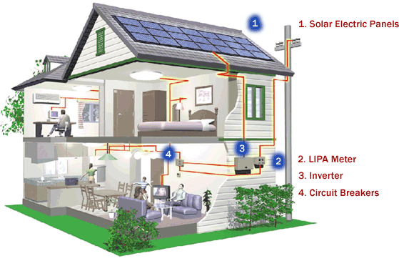
Home Electricity
Do you know homes have parallel circuitry (as opposed to series circuits) ? Its because everything does not rely on everything else. If a light bulb burns out in your kitchen, you can still use a lamp in your dining room.
Recall that a series circuit is essentially one big loop. The power source connects to the refrigerator, which connects to the water heater, which connects to the light bulb in a lamp, then back to the power source. The only way electricity can flow through all three is if all the items are working - as soon as one breaks, electrons cannot flow, therefore nothing works.
Figure 1 Home with solar electric panel
Source : rock construction.com
A parallel circuit, in contrast, connects each item directly to the power source. Essentially, the water heater has a connection to the power source, the refrigerator has a connection to the power source, and the lamp has a connection to the power source. You can picture a circuit for each that does not have any other objects (except for maybe a switch) impeding the flow of electricity.
Could you identify how electricity works in your home ? or the simplest scheme of your electrical appliances which connected in electrical circuit in your home ?
Now, we will identify the simplest scheme of electrical circuit and try to calculate electrical properties such as current, potential difference and resistance in circuit by using the game of MGames Science.
Do you still remember about ?
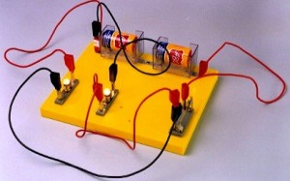
(forgot ?, please open “Learn About Circuit “ page in that game)
- How is current produced in this circuit ?
__________________________________________
__________________________________________
___________________________________________

Figure 2 Parallel Circuit
Source : http://www.kompasiana.com

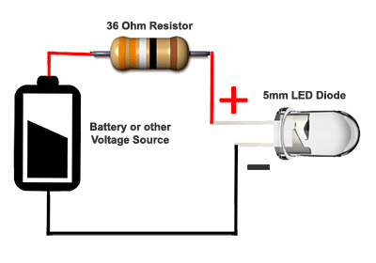
- Is there any resistor in that circuit ? what is the function of resistor ?

_________________________________________
_________________________________________
__________________________________________

Figure 3 Series Circuit with 36Ω resistor
Source : http://www.ledsupply.com/

- How does Ohm’s law mention about circuit ?
______________________________________________________________________
_______________________________________________________________________
- Look at these circuit !
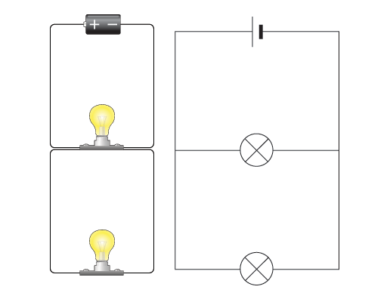
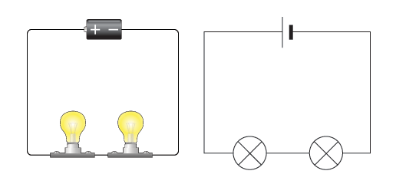

Figure 4 series and parallel circuit
Source : bbc.co.uk

What is the differences between series and parallel circuit ?
In Series : ______________________________________________________________
In Parallel :_____________________________________________________________
_______________________________________________________________________
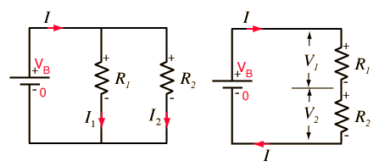
- How do you calculate the resistance of series and parallel circuit ?
Figure 5 resistance in series and parallel circuit
Source : bp.blogspot.com

In Series : ______________________________________________________________
In Parallel :_____________________________________________________________
_______________________________________________________________________
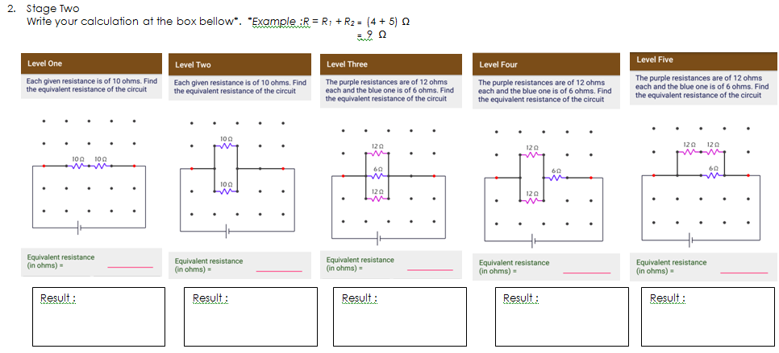
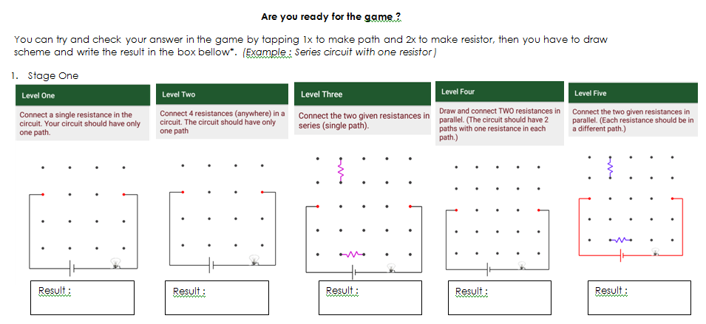

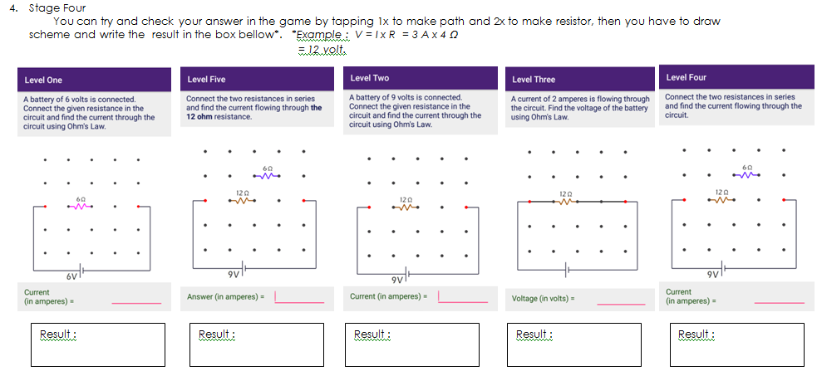
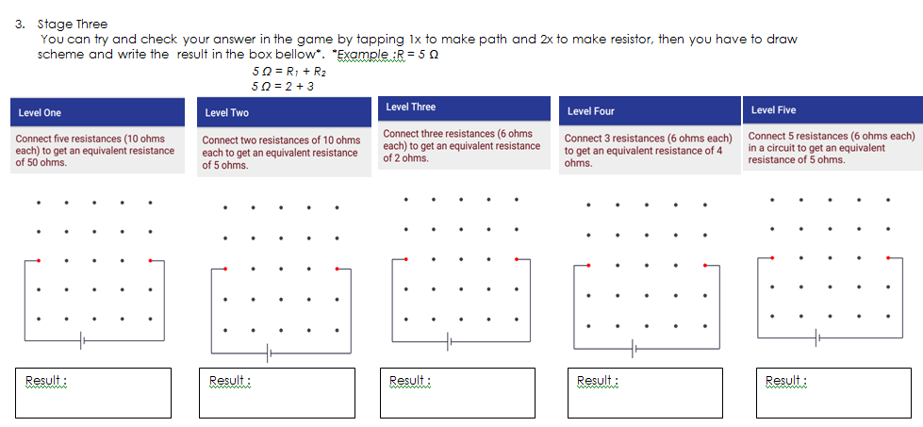
Bogor, 25 of April 2017
Checked and approved by:
Subject teacher Apprentice teacher

Name: Irfan Wahyudi Name: Alifa Irna Yasin
MADANIA SECONDARY SCHOOL
GRADE 8 - STUDENT WORKSHEET
ELECTRICAL CIRCUIT
Name:_______________________Class:8________Date:______________
Basic Competency
4.2 | Understand the electrical quantities and its properties
4.3 | Understand how electric circuit works
Indicator
4.2.2 | To state the current is related to the flow of charge and measured by ammeter
4.2.3 | To state the e.m.f of an electrical source of energy is measured in volts
4.2.4 | To state that the potential difference (p.d) across a circuit component is measured in volts
4.2.5 | To state that resistance = p.d / current and the changes in p.d or resistance will affect current
4.2.6 | To understand that electric circuits transfer energy from the battery or power source to the circuit components then into the surroundings
4.3.1 | To draw and interpret circuit diagrams containing sources, switches, resistors (fixed and variable), light-dependent resistors, lamps, ammeters, and voltmeters
4.3.2 | To understand how the current, resistor and potential difference in both series and parallel circuit

Getting Started with YWrobot Power Adaptor and Arduino Uno Microcontroller
This application of series and parallel circuit can’t be developed by using this kit. The design of each kit is very basic so it can’t be modified. Technically those kinds of tools can’t be found in the application of electric appliances. However, the tool explains the basic principle of basic series-parallel concept which in line with curriculum demands and electricity problems which commonly found at theoretical exam questions.
Figure 6 Electrical parallel circuit which commonly used in school
Source : www.kompasiana.com

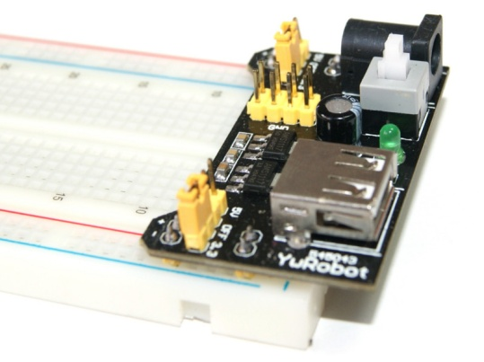
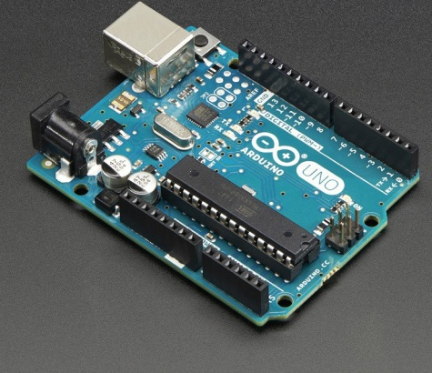

Figure 7YWrobot
Source : hetpro-store.com
Figure 8Arduino Uno
Source : adafruit.com

Nowadays, parallel and series electrical circuit using breadboard with YWrobot and Arduino Uno is become a trending topic. Yes, its true the price is relatively expensive, but it can be developed, modified and long-term used application. YWrobot provide the voltage source, which connected use a USB to Laptop, Adapter, and Battery. While Arduino Uno Microcontroller also provide voltage source, which connected use a USB to Laptop and it can control the device or appliances such as LED and LDR lamps or even thermometer which use LM35 sensor by inputting the formulae inside Arduino. Availability is very abundant in the market, but technical practitioners must know in advance the basic principles and the technical specifications.

Now, we will try basic application of YWrobot first.

- Experiment 1 (Constructing Series and Parallel Circuit use Breadboard and YWrobot)
You will need :
No. | Name | Figure
1. | Jumper Wire | 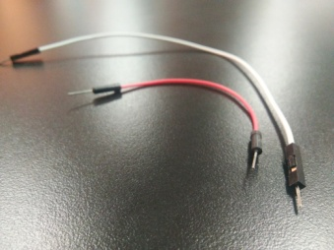
 | Ywrobot | 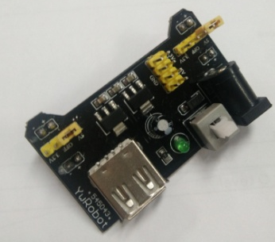
 | Breadboard | 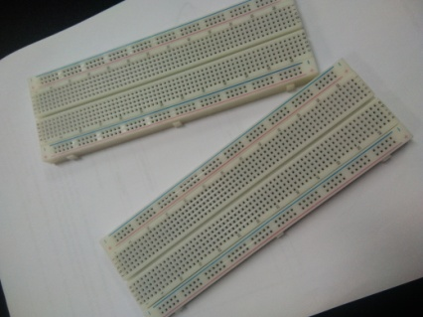
 | LED Lamp
 | Resistor (270 Ω) | 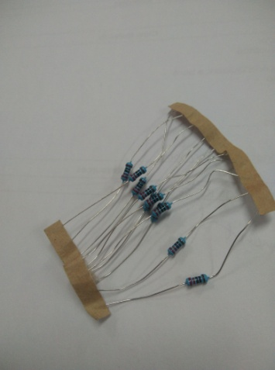
 | Battery ( 9 Volt)
 | Battery Cable Connector |  | 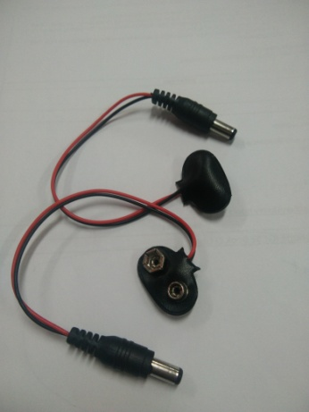

- Series and Parallel Circuit
No. | Steps | Figure
1. | Connect YwRobot on the breadboard. Four of YwRobot should fit in the hole of breadboard. | 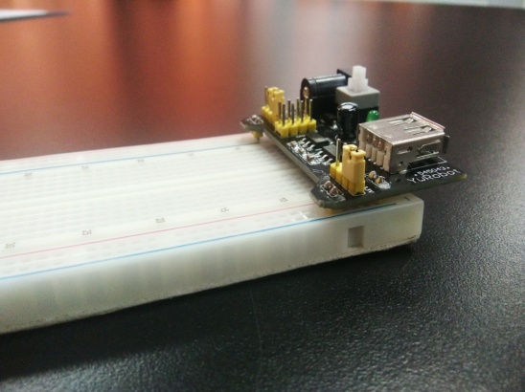
2. | Take battery cable connector, and connect it into YWrobotand two pit of battery . | 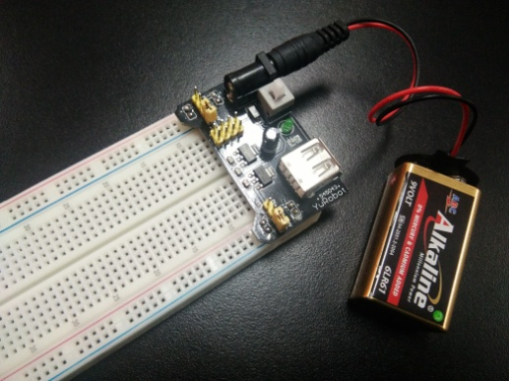
3. | - In Row 15, Connect one resistor in negative line*.  - Connect LED lamp next to resistor*.  - Connect another resistor in positive line*.  *the wire can be replaced by jumper wire  *the shorter leg of LED is attached next to resistor which placed in negative pole, the longer leg of LED is attached next to resistor which placed in one is placed in positive pole.  *the scheme of circuit should be ” - , + , - , + “ | 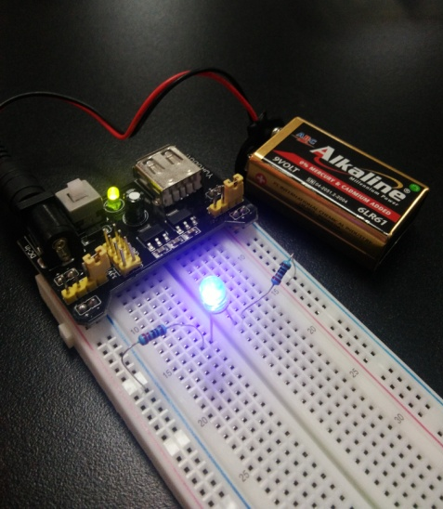
4. | In making parallel circuit, you can repeat the third step in row 18-19. | 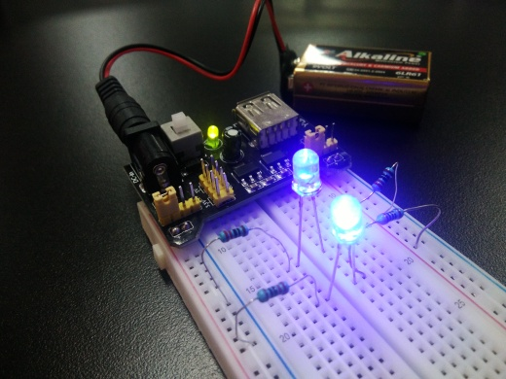

- Measuring Voltage and Current in the Working Circuit.
No. | Circuits | Diagram | PD (V) | Current (A)
1.
2.

- Build Your Own Circuit !

No. | Circuits | Schemes *
1. | 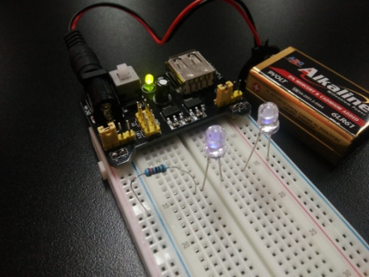
2. | 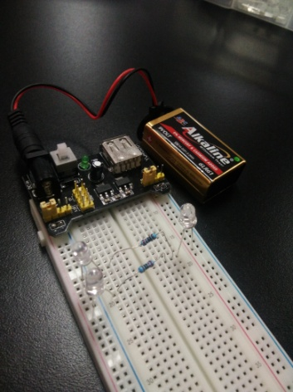
*you can draw circuit scheme after your installation is work.

Bogor, 8th of May 2017
Checked and approved by:
Subject teacher Apprentice teacher

Name: Irfan Wahyudi Name: Alifa Irna Yasin

MADANIA SECONDARY SCHOOL
GRADE 8 - STUDENT WORKSHEET
ELECTRICAL CIRCUIT

Name:_____________________Class:8_______Date:________________
Basic Competency
4.2 | Understand the electrical quantities and its properties
4.3 | Understand how electric circuit works
Indicator
4.2.2 | To state the current is related to the flow of charge and measured by ammeter
4.2.3 | To state the e.m.f of an electrical source of energy is measured in volts
4.2.4 | To state that the potential difference (p.d) across a circuit component is measured in volts
4.2.5 | To state that resistance = p.d / current and the changes in p.d or resistance will affect current
4.2.6 | To understand that electric circuits transfer energy from the battery or power source to the circuit components then into the surroundings
4.3.1 | To draw and interpret circuit diagrams containing sources, switches, resistors (fixed and variable), light-dependent resistors, lamps, ammeters, and voltmeters
4.3.2 | To understand how the current, resistor and potential difference in both series and parallel circuit

Getting Started with Arduino Uno Microcontroller

- Getting Started with Arduino
Now, you will try to make Traffic Light by using Arduino. The materials which needed is almost same with the experiment before. But, YwRobot is replaced by Arduino and the software of Arduino for inputting the formulae.
No. | Steps | Figure
1. | Connect blue connector cable to laptop as Arduinos’ power supply | 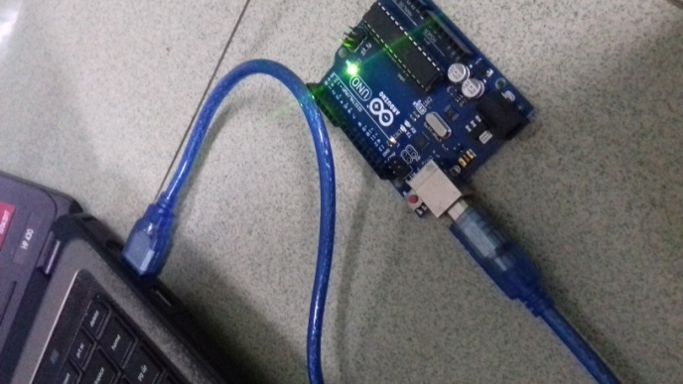
1. | - With a wire, connect ground from the Arduino (labeled GND) to the negative charge in the bottom row of the farthest right column of the bread board.  - With a wire, connect power from where it says 5V (the V stands for voltage and this is where the electric power comes from.) on the Arduino to the positive charge in the bottom row, next to right column. | 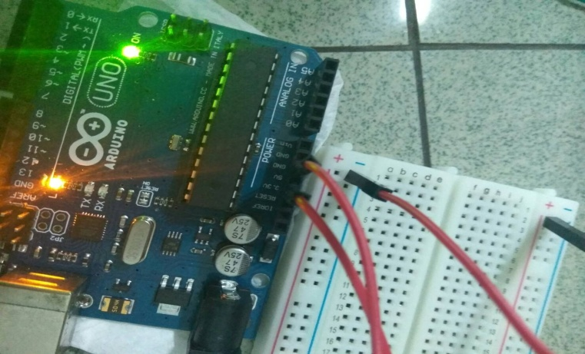
3. | - Connect the LED Lamps cathode (shorter leg) to row e7, e11 and e15 and anode (longer leg) to row f7, f11, and f15.  - With three wires which connect to digital pit of 12, 11, and 10. | 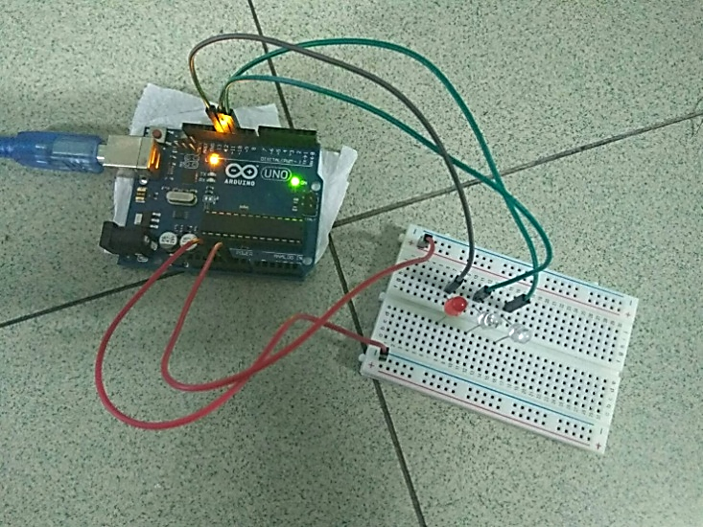
4. | Connect the resistor with one end in row d7, d11, d15 and the other end on the furthest negative column (ground). (This makes it connect to the resistor through the breadboard because they are on the same row). | 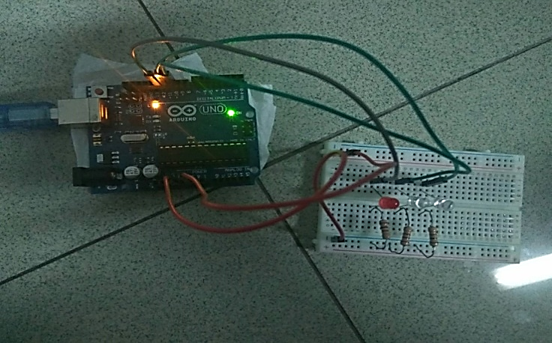
5. | The LED should light up. If it doesn’t, unplug power from the Arduino, check all of your connections and make sure you didn’t plug the LED inversely. Then try power again until it turn on. | 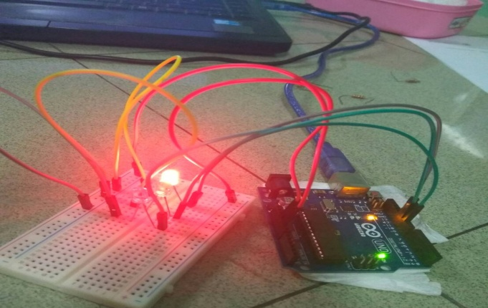
9. | Asked your Teacher to add the Script on your Arduino
10. | Draw the scheme of the circuit in the tabel.
11. | Modify your own project and write which part in the project that has been modified.

Bogor,24th of May 2017
Checked and approved by:
Subject teacher Apprentice teacher

Name: Irfan Wahyudi Name: Alifa Irna Yasin

STEM LITERACY INSTRUMENT TEST

Name : _____________ Class : ____________ Date: __________
Answer this following question carefully by crossing ( x ) the correct answer
- The iron with a 220 W heated for 120 minutes, if the electricity costs is Rp.1150 per kWh, How much we should pay for the cost?
a. Rp 210-,
b. Rp 506-,
c. Rp 2.108-,
d. Rp 5.600-,
- Why do you think when one of the lamp is turning off but another lamp is still turning on?
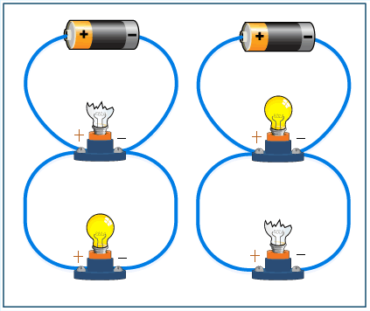
- Because the circuit is set in series, so the lamps are not connected each other.
- Because the circuit is set in series, so the wire is not connected each other.
- Because the circuit is set in parallel, so the lamps are not connected each other.
- Because the circuit is set in parallel, so the wire is not connected each other.

- Nindya uses microwave to heat the food. She plugs the microwave into the main source of electricity. The transform of energy used to heat the food is from...
- electrical energy into heat
- electrical energy into power
- electrical energy into watt
- electrical energy into main electricity

- A potential difference (p.d or V) across this resistor cause the current in this circuit Both resistor and p.d can be changed. If thcurrent is increasing, what will happen?
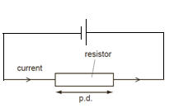
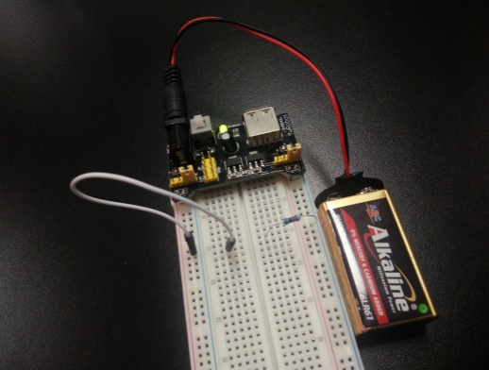

- Potential difference and resistance will decrease.
- Potential difference will decrease, while resistance will increase.
- Potential difference will increase, while resistance will decrease.
- Potential difference and resistance will increase.

- This figure shows wires which have different length and different diameters. They are made from same metal. Which wire has a greater resistance ?
a. | A longer wire with a smaller diameter
b. | A shorter wire with a smaller diameter
c. | A longer wire with a larger diameter
d. | A shorter wire with a larger diameter
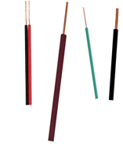

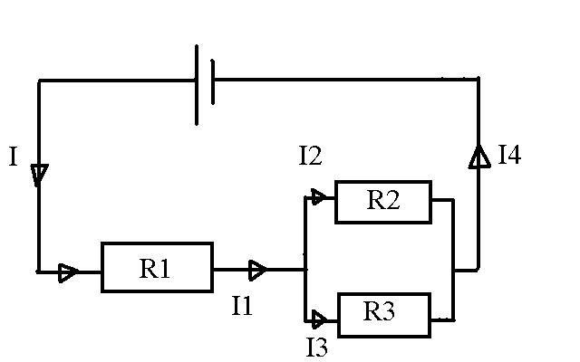
- Indra arranges a circuit above. From the experiment shows that lamp in R1 is brighter than two other lamps. Which one is the right option to explains this phenomenon?
- I= I₁ = I₂=I₃ =I₄
- I = I₄ , I₁ = I₂+I₃
- I= I₁ , I₂=I₃ +I₄
- I= I₁ + I₂+I₃ +I₄
- What is the e.m.f of this battery?
- 12 watt
- 12 A
- 9 V
- 9 e.m.f

- Look at the figure below
Why are the birds not electrified while they are standing on the high voltage cable wire?
  - There is no current flows on the cable
  - There is no potential difference between two legs of bird.
  - There are a lot of birds on the wire so each birds have equal current
  - The birds are standing in the wire

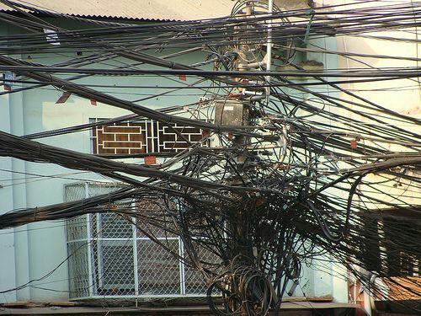
- One of the electricity problems in big cities is the installation of cable as shown in the figure. If this condition happens continuously, what will happen to this installation?
- The current flows into houses will become smaller.
- The cable will be easier to fall to the
ground.
- The potential difference among the cables will become higher and easy to
electrify birds.
- There will be short-circuit.

- Which picture that shows the wrong way to use voltmeter
A |  | Diagram
 | 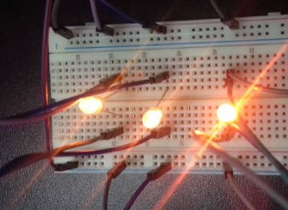 | Real Circuit
 | 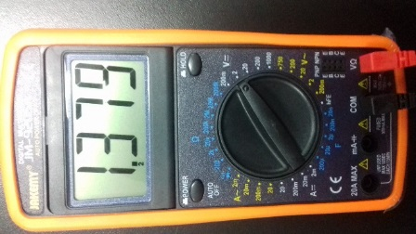 | Voltage
B |  | Diagram
 | 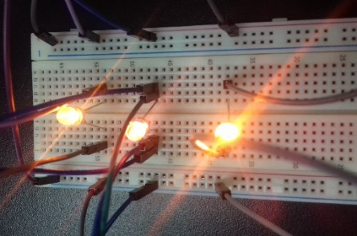 | Real Circuit
 | 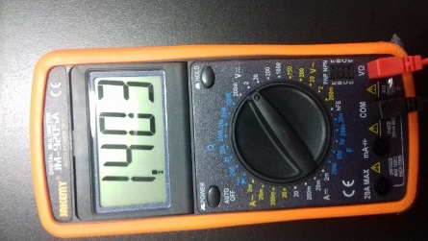 | Voltage
C |  | Diagram
 | 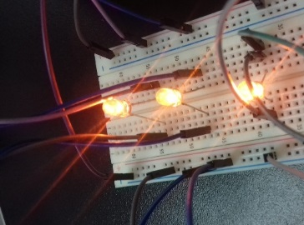 | Real Circuit
 | 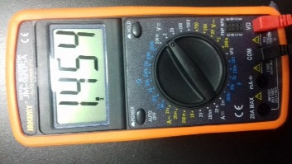 | Voltage
D |  | Diagram
 | 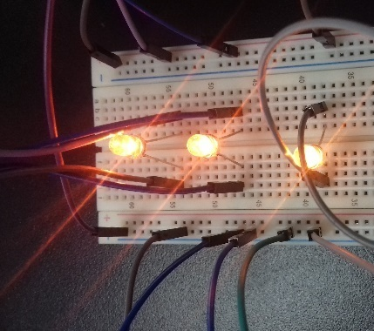 | Real Circuit
 | 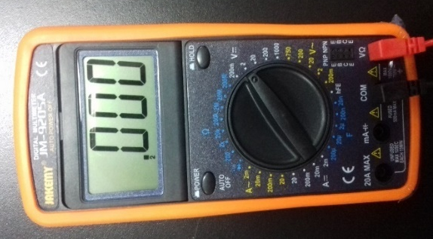 | Voltage

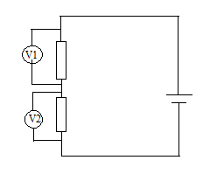
- Two potential differences are connected across a constant 12 V supply. The voltmeter readings are equal when the R₁ and R₂ has a value of 20 Ω. What happen to the readings when the value of R is reduced from 20 Ω to 10 Ω ?
R₂
R₁
 | Reading on V₁ | Reading on V₂
a | Decreases | Decreases
b | Decreases | Increases
c | Increases | Decreases
d | Increases | Increases

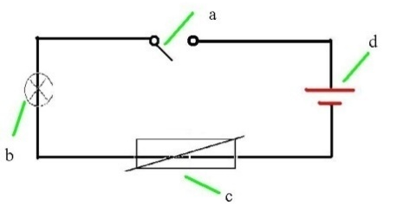
- On the circuit diagram below, name the pieces of the apparatus shown. Which pairs show the correct function between its function and electric component?

 | Function | Component
A. | To cut and connect the current flows | a
B. | To reduce the amount of current | d
C. | To supply the energy | c
D. | To direct the current flows from one components to another | b

- The multimeter sets to measure the total resistor in the circuit. The total resistor is....
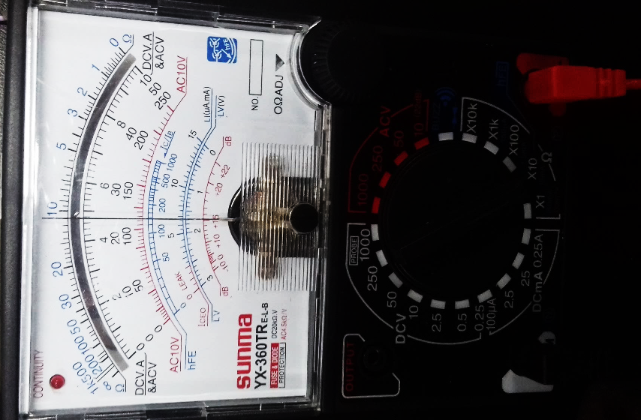
- 9 Ohm
- 11 Ohm
- 900 Ohm
- 110 Ohm

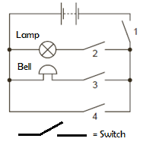
- Kresna connects the circuit as shown.
Which switches must be closed to make the bell ring without lighting the lamp ?
- 1 and 2 only
- 1 and 3 only
- 1, 3 and 4 only
- 2, 3 and 4 only

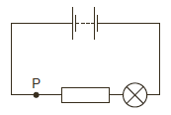
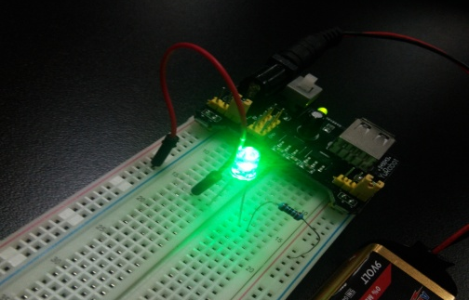
- Kamil connect a lamp in a circuit as shown as bellow.

If Kamil wants to increase the current through the lamp, what should be done by him ?
- adding another resistor in parallel with the installed resistor in the circuit
- adding another resistor in series with the installed resistor in the circuit
- decreasing the electromotive force (e.m.f.) of the battery in the circuit
- moving the lamp to point P in the circuit

- Farrell will make a circuit, which one from the following circuit that can be arranged by him to determine the resistance of resistor R ?
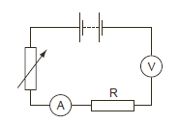

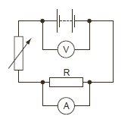

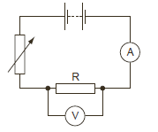

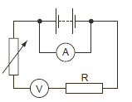

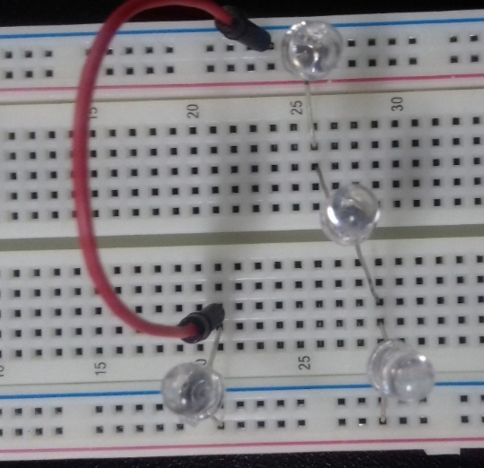
- 4 lamp is connected in circuits like the figure below. Which lamp that will glow brightest?
- A
- B
- C
- D
A
C
B

D

- When a refrigerator is plugged into the potential source of 240 V, the current that flows through it’s filament is 12.0 A. What is the resistance of it’s filament?
- 50 Ω
- 40 Ω
- 30 Ω
- 20 Ω

- Calculate the total resistance of these three resistors in the circuit!
- 3 Ω
- 3,5Ω
- 1,5 Ω
- 8 Ω

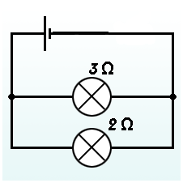
- If potential different across the circuit is 6 V what is the current across the resistor?
6 V
- 1 A
- 1.2 A
- 5 A
- 30 A

- Radifsya connects the pair of resistors in parallel. The following diagrams show the schematic circuit and the total resistance of each pair of resistors. Which one of this statement is correct ?
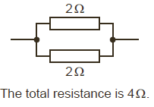

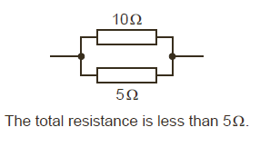

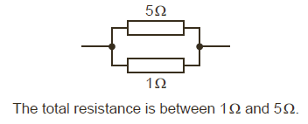

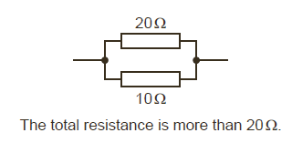

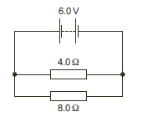
- The circuit diagram shows a 8.0 Ω and 4.0 Ω resistor connected to a 12 V battery.
12 V
What is the potential difference (p.d) across 4.0 Ω resistor ?
- 0.5 V
- 2.0 V
- 6.0 V
- 12 V

- A 12-V battery is connected to the electric circuit which shown by the figure above. All of the resistor (R1. R2, R3) have identical resistance (4 Ω). Calculate the current across the circuit!
- 2 A
- 1 A
- 4 A
- 3 A
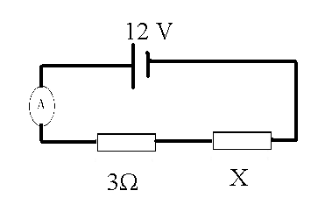
- Caren has a power supply, two resistor, and an ammeter. She arranges it in series. When the circuit is switched on, the ammeter reads 2.0 A Could you predict the value of resistor X?
- 4 Ω
- 2 Ω
- 6 Ω
- 3 Ω

- The graph shows potential difference/current characteristic of an ohmic conductor. Which graph shows the Ohm’s Law?
a. c.
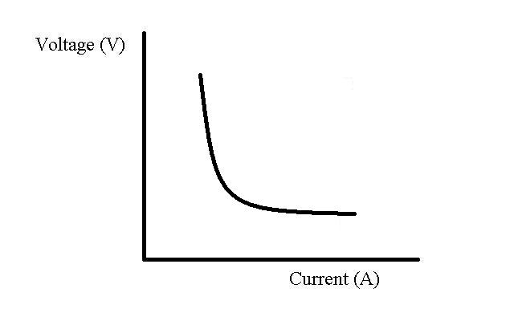
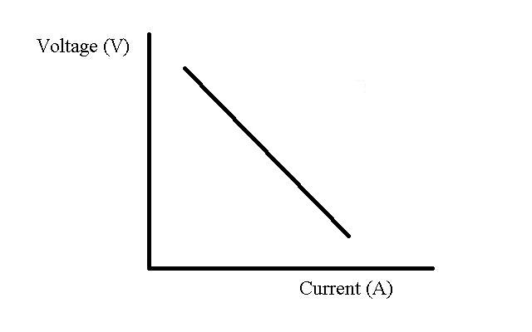

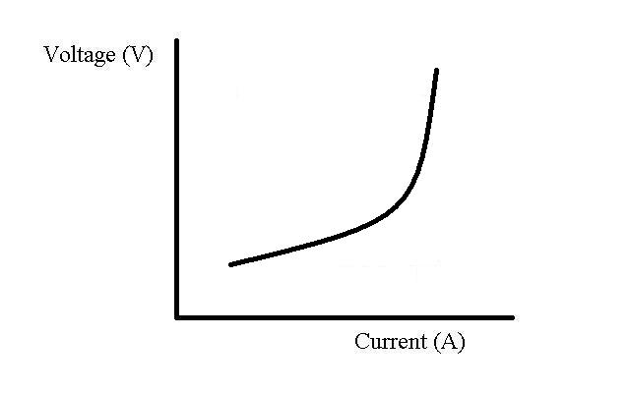
b. d.
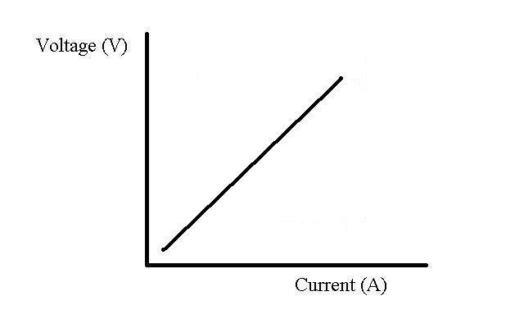

STEM Learning Implementation Observation Sheet
Observation Sheet of Teaching Activity
STEM Learning on Electricity Using Arduino-Android Game Based Experiment To Improve 8th Grade Students’ STEM Literacy
Meeting : ____________________________
Class : ____________________________
Topic : ____________________________

*Give checklist (√) sign in the yes/no column bellow.
Activity | Implementation |  | Note
 | Yes | No
Opening
Recalling the previous materials; electrical quantities and how current is affected by resistors and potential differences
Main Activity
- Students are divided into 8 groups ( 1 group consist of 2 people)
- Students are asked to open the MGames Science in their phone.

(Science and Technology Literacy )
- To introduce the game which will be used and recalling their previous materials, students are asked to complete the questions in the worksheet by opening “Learn About Circuit” page in MGames Science .

(Science, Technology and Mathematics Literacy)
- Students are asked to play and finish the stage of MGames Science
- Students are asked to make drawing scheme and result from each stage in their worksheet
Students are introduced to YWrobot, Arduino and how to use it with protoboard, lamp and wire
Closing
- Students are challenged to finish the game at least two more levels.
- Students are asked to submit their worksheet
(Technology)
- Students are introduced to YWrobot, breadboard, resistor and lamp which relate with their experiment in the next meeting.
Bogor, 25th of April 2017
Recommendation

Observer,

____________________

Observation Sheet of Teaching Activity
STEM Learning on Electricity Using Arduino-Android Game Based Experiment To Improve 8th Grade Students’ STEM Literacy
Meeting : ____________________________
Class : ____________________________
Topic : ____________________________

*Give checklist (√) sign in the yes/no column bellow.
Activity | Implementation |  | Note
 | Yes | No
Duration: 3 periods ( 3 x 40 minutes)
- Opening ( 15 minutes)
  - Students are explained about electrical components.
  - Teacher explain about Ywrobot
- Main Activity: (90 minutes)

- Students are divided into 5 groups, each group consist of 3-4 students.
- Students are given worksheet to guide in YWrobot experiments
- Students are asked to try and arrange resistor or lamp in series or parallel circuit using YWrobot and protoboard by reading the worksheet.
- Students are asked to measure the current and voltage by using multimeter.
- Students are challenged to make series circuit with two lamps
- Students are challenged to make combination circuit ( series and parallel with three lamps)
- Students are asked to draw scheme of their circuit in their worksheet.

- Closing: (15 minutes)
  - Students are introduced about the using Arduino Uno with the video of traffic light by using Arduino Uno.
  - Students are asked to submit their worksheet
Bogor, 10th May 2017
Recommendation
Observer,

______________

Observation Sheet of Teaching Activity
STEM Learning on Electricity Using Arduino-Android Game Based Experiment To Improve 8th Grade Students’ STEM Literacy
Meeting : ____________________________
Class : ____________________________
Topic : ____________________________

*Give checklist (√) sign in the yes/no column bellow.
Activity | Implementation |  | Note
 | Yes | No
Duration: 3 periods ( 3 x 40 minutes)
              - Opening ( 15 minutes)

- Student are asked to gathered with their previous group.

- Students are asked make blink project by seeing the instruction on the screen.

- Main Activity: (60 minutes)

  - Students are asked to make traffic light project by reading their guidance book and worksheet.
  - Students are asked to make scheme of their traffic light.
  - Students are asked to modify their circuit ( changing lamp, resistor, “delayed” time, or even adding lamps)
  - Students are asked to make scheme of their modified traffic light circuit
- Closing: (15 minutes)
  - Students are asked to submit their worksheet.
  - Students are asked to do post test.
Recommendation
Bogor, 24^{h} May 2017
Observer,

_____________________

