|  |  |  |
| --- | --- | --- |
| **ISSN:** | **JOURNAL Of EDUCATIONAL ADMINISTRATION RESEARCH AND REVIEW**  [https://ejournal.upi.edu/index.php/EAR/](https://www.google.com/url?sa=t&rct=j&q=&esrc=s&source=web&cd=1&ved=2ahUKEwjg_7jz--rlAhWNILcAHSfjBuQQFjAAegQIBhAB&url=https%3A%2F%2Fejournal.upi.edu%2Findex.php%2FEAR&usg=AOvVaw0aNT3UmOsp0RTueNCyjQ8i) | Vol.__ No._ **Apr. 2018** |
| **DOI：** |  |  |

PROFETICAL LEADERSHIP IN THE PERSPECTIVE OF MUHAMMDAH ABU HAM BIN MUHAMMAD AL GHAZALI (1058 - 1111 AD)

**M Asriyaha*, S Patimah b, M Mukric, M Akmansyahd**

a*Islamic State University of Raden Intan Lampung

Lampung, Indonesia, e- mail : Masfiyatulasriyah@gmail.com

b Islamic State University of Raden Intan Lampung

Lampung, Indonesia, e-mail : Sitipatimah@radenintan.ac.id

c Islamic State University of Raden Intan Lampung

Lampung, Indonesia, e-mail: M-mukri@yahoo.com

d Islamic State University of Raden Intan Lampung

Lampung, Indonesia, e- mail : akmansyah@radenintan.ac.id

**Abstract**

Ethically good leadership must be able to provide accountability to the Creator, the community, educational institutions that are led and always guided by the Holy Qur'an and the Hadith. Abu Ham Muhammdah ibn Muhammad al-Ghazali (1058-1111 AD hereinafter referred to as al-Ghazali) was one of the initiators of the ethics of leadership with the magnum opus of *Ihyâ’* *Ulûmuddîn*. One of al-Ghazali's thoughts is that leadership must refer to the values of *nubuwwat* (prophecy), namely as an effort to obtain guidance or guidance from Allah SWT. This leadership is rooted in the situational leadership exemplified by the Prophet in the organization that starts from planning, implementation, and evaluation.

This research is a library research, which is a researcher looking for data that is directly related to prophetic leadership through the works of Islamic education experts especially Al-Ghazali, both in the form of books, articles or in other forms. Data collection is done by means of documentation (documentary study). The results and findings in the study are the Prophetic leadership in the Al-Ghazali perspective that is the nature of leadership is basically innate because in fact God has chosen the child of Adam to be a prophet and leader for his people. Therefore, leadership in Islam, can not be separated from the concept of understanding the rules set by Islam based on al-Qu'ran and hadith. However, that in implementing leadership in Islam, one must have confidence that what is done and carried out is solely due to worship of Allah SWT, Characteristics of Prophetic Leadership in the Al Ghazali Perspective include: Responsibility, Hard Work, Honesty Tested and Proven, Innovative and Reformative, Have Skills and Professionals, and Bring Conducive Change.

.

**Keywords:** Al-Ghazali, Profetical of Leadership.

.

## **INTRODUCTION**

Humans are the only creatures of God who are trusted to be khalīfah (leaders) on earth. This has been explained in the Qur'an that humans were sent to this world as khalīfah as the word of Allah SWT in the QS. Al-Baqarah (2): 30.



And [mention, O Muhammad], when your Lord said to the angels, "Indeed, I will make upon the earth a successive authority." They said, "Will You place upon it one who causes corruption therein and sheds blood, while we declare Your praise and sanctify You?" Allah said, "Indeed, I know that which you do not know."

In every interpretation, the khalīfah is interpreted as a leader, then an ideal leader is those who carry out their leadership duties as well as possible. A leader must be able to implement his leadership tasks so that he makes a benefit for others, especially those they lead.

Every leader has a prophetic mandate that is crucial in various aspects, including in the field of education. The mandate outlines that good leadership must be able to provide accountability to the Creator, the community, the institutions he leads, and to himself. On the other hand, the ethical values ​​(ethics) of prophetic-based leadership must be based on guidelines for the Qur'an and the Hadith. Al-Quran and al-Hadith based leadership is what is actually called prophetic leadership. This prophetic leadership, although built on a transcendental basis, is the teachings contained in the Qur'an and al-Hadith, but actually in terms of technical leadership this prophetic contains something that is profane, adaptable, and not rigid.

Basically, the prophetic leadership practiced by the Prophet Muhammad. not stand alone, but the mission carried out is a continuation of the mission of the previous prophets even started by the Prophet Adam. This prophetic leadership makes the prophet a role of model. Therefore this leadership is universal, applies to all human beings, has the same vision and mission that is to monotheate Allah SWT and be a mercy to the universe.

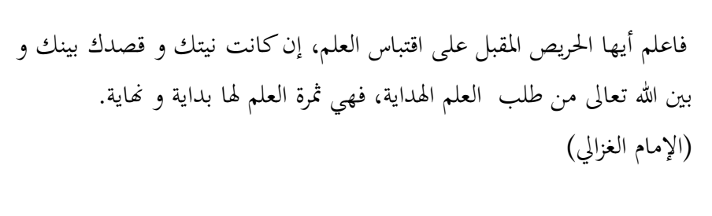Normatively, there are many Muslim scholars who have thoughts related to leadership, both leadership in general or leadership specifically. Imām al-Mawardī, for example, explained a lot about the concept of leadership in the book of al-Ahkām al-Sulthāniyah, Ibn Taymiyah explained broadly about the concept of Islamic leadership in his book al-Khilāfah wa al-Mulk, al-Fārībī explained the concept of leadership in his writings Arā ahl Madīnah al-Fadlīlah, and also the Hujjat al-Islām alImām Abū Hamīd Muhammad ibn Muhammad ibn Ahmad al-Thūsī al-Ghazālī in many of his works.

Imām al-Ghazālī (1058-1111 AD), hereinafter referred to as al-Ghazālī, was one of the initiators of the ethical issue of leadership. Through his magnum opus, Ihyā 'Ulūm al-Din, he explained a lot about the moral values ​​for human beings on this earth. He is known not only as an intellectual, thinker and shūfī, but also an education practitioner.

Al-Ghazali had served as chancellor of the Nizhamiyah Madrasah, the largest tertiary institution during the Abbasid era. During his leadership, this madrasa developed very rapidly and became a reference for the majority of Muslim intellectuals to learn. Therefore, even though at that time the Islamic intellectual world was rife with various schools of thought that emerged, his figure was still able to fly in the midst of Muslim scientific discourse at that time.

In the context of true prophetic leadership, al-Ghazali has given an explanation of the dimensions that must be possessed and attached to a leader, including the personal dimension which is stimulating and modest, motivating, intelligent, trustworthy, independent, influential and able to enforce rules.

Based on these dimensions it can be understood that prophetic-based leadership behavior will be realized if there is a change in self from a leader. Leaders must have the will to bring great changes to individuals and organizations, the process of creating innovation, reviewing the structure, and organizational values ​​to be better and more relevant.

On the other hand, as a whole Al-Ghazali believes that leadership must refer to the values of *nubuwwat* (prophecy) as an effort to obtain guidance or guidance from Allah SWT. He said:

"Know, O leaders who expect the advancement of science in the future. If the intention between you and Allah SWT to advance science is to reach hidayah (inspiration to know God), then you will get the fruits of science (true happiness) from the beginning to the end of your life ".

Al-Ghazali's view is in line with the concept of prophetic leadership which emphasizes prophetic character. Every leader must be able to inspire the people he leads to move to manifest values ​​based on the prophetic spirit. Therefore, the figure of the Prophet Muhammad. become a central figure as inspiration. The leadership behavior of the Prophet Muhammad. become the ethical basis of what is called prophetic-based leadership. The entire basis of the prophetic ethics is the main inspiration for leadership for every Muslim in representing Allah SWT to regulate and protect the lives of human beings on this earth.

In line with that, Kuntowijoyo said that prophetic-based leadership can be described by the presence of the Prophet Muhammad who has three sacred missions in order to improve the order of human life, namely the mission of humanization, liberalization, and human transcendence. The mission of humanization is leadership that promotes human values, tolerance, democracy, and serves the interests of the wider community in order to improve welfare and make people independent. The mission of liberalization is to free each individual from the shackles of the system in a social order; Prophetic-based leadership does not justify any behavior that is not in accordance with the rules and norms of religion or ordered by the Prophet in his leadership. The final mission, transcendence, is a further manifestation of the mission of humanization and the mission of liberalization, namely the growth of divine awareness that is able to move the heart and be sincere towards everything that has been done.

In the end, prophetic-based leadership should be a solution to leadership in educational institutions, communities, and even countries to realize a better life order. Various problems that arise will be resolved if each leader has the awareness and leadership patterns as exemplified by the prophets, especially the Prophet Muhammad.

Based on the background of the problem above, the writer can describe the focus of the study as follows:

1. What is the prophetic-based leadership dimension in the perspective of al-Ghazali?
2. What are the characteristics of prophetic-based leadership in the perspective of Al-Ghazali?
3. What is the prophetic-based leadership model in the perspective of al-Ghazali?

Based on the formulation of the problem above, the authors describe the scope of the study as follows:

1. The key to the success of prophetic-based leadership comes from good management and participation by all components in society. To prepare for the implementation of prophetic-based leadership requires commitment from all parties so that it can be achieved well.
2. Prophetic-based leadership in the perspective of Imam al-Ghazali who is rooted in the situational leadership of Prophet Muhammad SAW was institutionalized into the organization as the development of responsibilities and competencies from superiors to subordinates, and democratic leadership is useful for seeking advice from subordinates for superiors. This study is expected to be useful as an alternative model of leadership that can be applied by leaders.
3. The success of prophetic-based leadership in the perspective of Imam al-Ghazali starts from planning, implementing, and evaluating. In this study the term Robert Stake is used, namely antecendent (input), transaction (process) and outcomes (results) which support each other, including indicators: the implementation of prophetic-based leadership must start from planning and implementation that prioritizes the process and evaluation, and also participation as a supporter in the process of activities so that organizational goals and results can be achieved properly.
4. The evaluation is expected to provide feedback as a reference for recommendations in making decisions related to the implementation of prophetic-based leadership and participation of community elements in improving the quality of a better life.
5. Following a prophetic leadership flow in the context of organizational management

**Picture**

**Scope of Study**

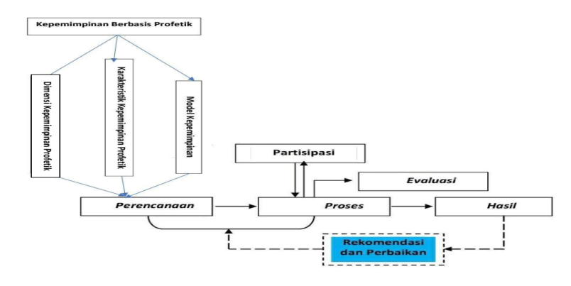

**II.METHOD**

1. **Research Model**

This research is a type of library research, where researchers look for data that is directly related to prophetic-based leadership through the works of Islamic education experts, especially al Ghazali, both in the form of books, scientific articles, or in other forms. By selecting the type of library research, it is expected to help build a systematic review framework while addressing the main problems of this research.

1. **Data Collecting Method**

Data Data collection is done by means of documentation (documentary study). Documentation is a data collection technique that is produced from documents and monumental works that are subject to study. In this case, researchers are required to be critical of the materials, data contained in these works, so that it is expected to find a strong network of the problem under study. Therefore, researchers examine by tracing the works of Islamic education experts, especially the work of al-Ghazali relating to prophetic-based leadership.

Data related to leadership thinking based on prophetic then analyzed, the relationship between the thoughts that exist in one work with another, to be further integrated, so as to form a systematic and whole study results.

1. **Research Procedure**

Based on the principles of library research, the research procedure can be described as follows:

1. Pre-Research Stage
2. Develop a research plan
3. Choosing research scope of study
4. Exploring and assessing the depth of the reading source
5. Select and make use of relevant reading sources
6. Prepare research equipment
7. Reference preparation
8. **Source of Data**

The data source of this research is historical data that has appeared at a certain time by trying to see the actual leadership at that time. This portrait is written in texts narrated by Islamic thinkers and critics as well as articles collected in various Islamic books. These sources are divided into primary sources and secondary sources. The primary sources are sources written by Al-Ghazali, are:

* 1. Ihyā Ulumuddin or Al-Ihyā. This book is the magnum opus of Al-Ghazali which discusses the rules and principles in purifying the soul, shari'ah, thought, and ideology. The four Rubus 'are: a) Rubu' Worship consists of the Book of Science, the Book of Aqeedah, the Book of Thaharah, the Book of Worship, the Book of Zakat, the Book of Fasting, the Book of Hajj, the Book of Quran Recitations, the Book of Dhikr and Prayer and the Book of Tartib Wirid. b) Customary customary rubu which consists of the Book of Adab, the Book of Marriage Adab, the Book of Legal Efforts, the Book of Haram, the Book of Friends and Friends, the Book of Uzlah, the Book of Mafia, the Book of Hearing and Feeling, the Book of Amar Ma'ruf Nahi Mungkar and Book of Morals. c) Rubu 'Al Muhlikat (Destructive Acts), consisting of the Book of Miracles of the Heart, the Book of Dangers of Lust, the Book of Dangers of Lust, the Book of Dangers of the Tongue, the Book of Danger of Anger, Revenge and Spite, the Danger of the World, the Danger of Treasure and the Miser, the Danger of Lust Rank and Riya, Book of Dangers of Takabbur and Ujub, Book of Dangers of Leaves. d) Rubu 'Al Munjiyat (the act of saving), consisting of the Book of Repentance, the Book of Forbearance and Gratitude, the Book of Fear and Hope, the Book of Faqir and Zuhud, the Book of Tawheed and Tawakkal, the Book of Love, Longing, Ridho, The Book of Intentions, Gratitude, Honestly and Ikhlas, the Book of Muroqobah and Muhasabah, the Book of Tafakkur and the Book of Remembering the Dead.
  2. Bidāyah al-Hidāyah. This book is widely referred to as the preamble of Ihyā Ulumuddin. This book discusses the initial process of a servant getting guidance from Allah Ta'ala, the servant needs help and guidance from Him, also explains about obstacles (passive) and obstacles (active) that are scattered around him. Broadly speaking, this book consists of three important parts, namely adab-adab part, obeying immorality, and part of associating with humans that is very useful to be studied for prospective leaders. The Creator and with fellow beings.
  3. Tibr al-Masbuq fi Nasihatul Mulk. This book is a collection of advice given by Al-Ghazali to Sultan Muhammad ibn Malik Syah of the Seljuq Dynasty. Al-Ghazali's main thoughts about politics are outlined in this book. The main content of this collection of exemplary letters can be grouped into two major points, first Al Ghazali prioritizes the strength of the Aqeedah Tauhid and secondly contains moral advice, justice, the virtues of knowledge and scholars.

1. **Data Analysis Techniques**

Data analysis techniques used in this study are historical philosophical and descriptive-analytic, which is an analysis that seeks to explore further about prophetic-based leadership thinking, which is related to historical data, ideas and fundamental structures (fundamental structure) of thinking prophetic-based leadership who then sought a red connection between historical data and thought data by way of historical-philosophical and descriptive-analytic analysis.

Another approach that is also used is the historical approach, which emphasizes the historical reconstruction process. The theory of historical reconstruction begins with exploring the sources that are related to prophetic-based leadership thought products. Followed by looking at the position of thought and relationships associated with the previous concept, both in terms of terms, editorial, and methodology, then analyzed with scientific tools, especially the validity of the data. The final findings of the analysis are adequate results based on scientific standards.

**III.RESULT AND DISCUSSION**

1. **Research Objects Overview**
2. **The Biography of Imam Al-Ghazali**
3. **Scientific Sanad of Al-Ghazali**

Hujjatul Islam Al-Ghazali was born in the city of Thus, a small town in northeastern Iran in 450H./1058M. with the full name Abu Hamid Muhammad bin Muhammad Al-Ghazali (hereinafter referred to as Al-Ghazali). The beginnings of Al-Ghazali's education began in the city of Thus, with the guidance of knowledge from the Sufis. In this city also between the years 465 H. and 470 H. Al-Ghazali studied fiqh and Ash'ari theology and other basic sciences from Ahmad bin Muhammad al-Radzkani al-Thusi, and obtained religious education as well as Arabic and Persian language from Abu Nasr al-Ismai'ili in Jurjan. After returning from Jurjan Al-Ghazali, he had received Sufism education from Yusuf al-Nassaj in Thus.

In 473 H. Al-Ghazali departed for the city of Nisyapur. In this city Al-Ghazali entered the Nizhamiyah madrasa when an al-Juwaini acted as a teaching staff at the madrasa. From al-Juwaini Al-Ghazali obtained knowledge about the science of mantiq and kalam. Al-Juwaini was also the one who gave direction to Al-Ghazali to study philosophy such as al-Farabi and ibn Sina. In 484 H Nizam al-Mulk gave the title of professor to Al-Ghazali as well as leading the Nizamiyah madrasa in Baghdad. It was a significant time in Al-Ghazali's life. On that occasion Al-Ghazali deepened his knowledge of Greek philosophy and the thoughts of Islamic philosophers such as al-Farabi or ibn Sina.

For approximately 11 years Al-Ghazali wandered and once visited his family. Because of Sultan Saljuk's request to return to teach at Nizamiyah, Al-Ghazali taught again starting in 499 H / 1105 AD at the educational institution, but that did not last long. Al-Ghazali then decided to return to the area where he lived namely Thus and spent his life there. In this city of his birth Al-Ghazali established an educational institution that was a madrasa intended for the fuqoha 'and also established a khanqah for Sufis. At the end of his life he only focused his attention on worshiping and teaching his students until he died on the 14th of Jumadil Akhir 505/19 December 1111 AD.

1. **The Works of Al-Ghazali**

During his life al-Ghazali was known to be active as a writer. As a theologian, philosopher, and finally as a Sufi, then Al-Ghazali's writings, if further investigated, will have three features, namely theological, philosophical or mystical dimensions. Some observers of Al-Ghazali have various opinions about the number of papers produced by Al-Ghazali.

Dr. ‘Abdurrahman Badawi in his book Mua'allafat Al-Ghazali, explains the work of al-Ghazali which reached 457 pieces. Among Al-Ghazali's works are as follows:

1. *Ihyâ ‘Ulûmuddîn,* several times experienced reprints including B'lâq prints in 1269, 1279, 1282 and 1289, Istambul prints in 1321 H, Tehran prints in 1293, and Dâr al-Qalam Beirut prints without years.
2. *Al-Adab fî al-Dîn,* published by Majmû’ah al-Rasâ’il, in Cairo in 1328 H./1910 AD
3. *Al-Arba'în fî Ushûl al-Din,* published in Cairo in 1328 H / 1910 AD, and al-Maktabah at-Tijâriyyah in Cairo without years.
4. *Asâs al-Qiyâs,* mentioned Al-Ghazālī in al-mushtashfâ, I / 38, II / 238, and III / 325, Egyptian prints in 1324 H / 1907 AD
5. *Al-Iqtishâd fî al-I'tiqâd,* printed in Cairo, was published by Mushthafa al-Qubani in 1320 H. on the al-Insân al-Kâmil hipgir page by al-Jailani, a print of Cairo in 1328 H. with al-Munqidz , al-Madhnûn, and Tarbiyyah al-Awlad, Bombay without years and translated into Spanish.
6. *Ayyuhâ al-Walad,* printed in Majmû'ah in Cairo in 1328, 1343 H, was published by al-Jawāhir Al-Ghazālī min Rasâi'il Hujjatul Islâm Al-Ghazālī, in Istanbul in 1305 H.
7. *Bidâyah al-Hidâyah,* has been reprinted several times including print of Bâlâq in 1287 H, Cairo in 1277 and 1303, in Ta'lîqât by Muhammad an-Nawâwi al-Jāri in Cairo in 1308 H.
8. *Tahâfut al-Falâsifah,* until several times printed in Cairo in 1302, 1319, 1320, 1321 H. and 1955 AD Printed in Bombay by Thab 'Hijr in 1304. Translated into Latin by C. Calonymus and published in 1525 M with the title Destretio Philosophiac, printed twice in al-Bunduqiyyah in 1527 and 1562 AD
9. *Kîmiyâ al-Sa'âdah,* written in Persian in Calcutta without a year, and printed in lucknow in 1279 AH and in Bombay in 1883 AD
10. *Al-Munqidz min al-Dhalal,* this work was published in Istanbul in 1286 and 1303 H, in Cairo in 1309 and on the margins of the book al-Insân al-Kâmil. Translated into French three times, into English twice and into Turkish and Dutch.
11. **Socio-Political Settings of Al-Ghazali’s Period**

Al-Ghazali figure lived when thought in the arena of the Islamic world gave rise to a high level of diversity, even though the political world in the Islamic world could be categorized as being seen in a period of decline. The highest Islamic authority, by *de Yure* still held by the Bani Abbasids, but by *de facto* the Bani Abbassiyah no longer ruled in these Islamic countries. One of these powers was the Bani Seljuq which was founded by Tugril Bek (1037 - 1063 AD) and historically took control of the city of Baghdad in 1055 AD, about three years before Al-Ghazali was born. This dynasty experienced its golden period in the reign of Alp Arselan (1063-1072 AD) and Sultan Malik Syah (1072-1092 AD) with his famous vizier and quite meritorious for the development of Al-Ghazali's career namely Nizam al-Mulk (1063-1092 AD).

At the same time in Egypt stood the kingdom of the Fatimid Dynasty which was the kingdom of the Shiite dynasty of the Isma'iliyat sect. The existence of these two great dynasties greatly influenced the current political situation. At that time although politically the upheaval of the Islamic world was backward, but the intellectual world of Islam could still be said to stand firmly. Syahrastani in his book al-Milal wa al-Nihal explained many streams that emerged at that time based on the categorization of each school in seeing a problem. Whereas Al-Ghazali in his book *al-Munqid min al-Dhalal* generally classifies the diversity of thought based on their method of obtaining truth.

One example, which was carried out by al-Kunduri, the first Seljuq Selector of the Mu'tazilah, tried to impose his understanding on his people with all their efforts even with violence. This section makes other Madhas, namely Hanbali and Ash'ari depressed, causing many victims from their figures. Such a situation changed 180 degrees when Nizam al-Mulk was appointed vizier of the Bani Seljuk, which happened to be Nizam al-Mulk who embraced Asy'ariyah and was Shafi'ite. However, in the context of defending the Madhab, Nizam al-Mulk took action more ethically than his predecessor, namely some examples by establishing the Nizamiyah educational institution.

On the other hand, the interdependence between the ulama and the ruling class has a quite positive impact on the growth and development of science. The rulers encouraged the creation of an environment conducive to the development of science. While there are scholars who tend to take advantage of this opportunity, namely by competing in the development of knowledge even though sometimes the development of science is not for the sake of science itself, but for the benefit of individuals and get sympathy from the authorities. One example of a situation that illustrates this is that of Nizam al-Mulk who allegedly spent 600,000 dinars to carry out the effort. He and the scholars directed his efforts to anticipate the thoughts of kalam and the philosophy of the people of Mu'tazilah.

This difference in the Ummah and social situation is experienced by Al-Ghazali, with the many triggers of conflict in it which are actually caused by influences from outside the Islamic (Arabic) culture. Namely when the Arabs expanded out of the Arabian peninsula, they came into contact with cultures outside of Arabia.

1. **Al-Ghazali’s Prophetic Leadership**
2. **Al-Ghazali’s Prophetic Leadership Dimension**

Al-Ghazali has a strong mind in the Sunni tradition. In terms of leadership he follows the line of thought of Imam al-Mawardi who wrote the book al-Ahkam al-Sulthoniyah. Al-Ghazali mentioned three terms that refer to leadership namely Imamat, Khilafah and Imarah.

Basically prophetic leadership in the perspective of al-Ghazali has 4 dimensions including competency dimensions, dimensions of existence, organizational dimensions and interpersonal dimensions.

1. Competency Dimensions

The competency dimension is an attitude, knowledge and skills as well as the effective manifestation of these attitudes, knowledge and skills. This dimension has two parts, namely a modest personality and an intelligent personality.

1. Dimension of Existence

The dimension of existence is an important part of leadership. The dimension of existence is something inherent in a leader that must exist and without which its existence as a leader will be doubted.

1. Organizational Dimensions

The organizational dimension is the ability that a leader must have in managing and moving members in carrying out all plans to achieve goals. This dimension has two parts, namely leaders who are able to uphold the human rights of each individual and leaders who are able to uphold national and state activities.

1. Interpersonal Dimensions

The interpersonal dimension is the ability to recognize the person and optimize the potential that a leader must possess. This ability is needed by a leader so that it can be an example and inspiration for members.

1. **Characteristics of Prophetic Based Leadership in the Al-Ghazali Perspective**

In detail the characteristics of leadership according to Al-Ghazālī's view are prophetic-based leadership which is reflected in the leadership styles that exist in each organization which are summarized as follows:

1. Fair

In the book of *Tibr Masbuk fi Nashīhat al-Muluk*, al-Ghazali explains ten kinds of roots that can grow trees and produce a fair attitude for leaders, namely: (1) Knowing the benefits and dangers of power; (2) Always miss the advice of the scholars; (3) Not accepting all forms of wrongdoing; (4) Humility; (5) The ability to see things from the perspective of others; (6) Avoiding ignoring the interests of the people; (7) Excess in life; (8) Loving anyone; (9) Making people happy in matters not prohibited by religion; (10) Avoiding trading in religion to attract the hearts of the people.

1. Responsibility

It is this leadership responsibility that al-Ghazali explained in his ihya ’ulumuddin that leaders have responsibilities towards those they lead and therefore damage to the people (subordinates) is the responsibility of leaders.

1. Hard Work

As a prerequisite for being a professional leader, every leader needs hard, smart work and to deal with all negative possibilities that may occur in developing the institution he leads.

1. Honesty that is Praised and Proven

As a leadership prophetic requirement in the example of the Prophet Muhammad, one of which is honesty that is tested and proven. Honesty is a key behavior that is very effective to build trust (credibility) as a leader.

1. Akhlaqul Karimah

Prophetic-based leaders, should have a character that cannot be separated from the leadership character of the Apostle in carrying out his duties. The character or ahklaqul karimah that he has can distinguish from others.

1. Innovative and Reformative

Followers become actively involved in the process of change when the leader has innovation. Therefore innovative leaders usually have strong personalities so they are able to build emotional ties with followers to realize the ideal goals of the institution.

1. Having Skills and Professionals

Burt Nanus explained about the skills possessed by a leader that this can easily be found in the Prophet Muhammad SAW. as an inseparable part of its leadership, namely: (1) far-sighted (visionary); (2) mastering change (Transformational); (3) organizational design (organization design); (4) anticipatory learning (anticipatories learnin); (5) initiative (initiative); (6) mastery of interdependencies, and (7) high integrity standards.

1. Bringing Conducive Change

In this case, educational activities, transforming education, motivating subordinates, committing to tasks, fulfilling the rights and obligations of each school element in order to avoid social gaps in the education process, and there is openness or transparency in every policy taken by the leader, as well as prioritizing public benefit in for personal gain.

1. **Prophetic Based Leadership Model in the Al-Ghazali Perspective**

The al-Ghazali leadership model is manifested in the steps and mechanisms of work that manifest in a leadership strategy described as follows:

1. Establish vision and mission and implement together

Vision and mission become a direction and the final goal aspired. Having a clear vision and mission gives certainty to the ideals of an institution to anyone. Vision and mission are like intentions in an action that will be done. Therefore the vision and mission must be made correctly.

1. Strengthening Commitment with a clear system

A leader should be able to make his subordinates stand firm in holding the mandate and always committed (patient) to do in accordance with mutual agreement.

1. Conduct training in a structured and continuous manner

According to Al-Ghazali, there are two ways in this exercise, namely: riyadhah and mujahadah. Riyadhah means training to do good continuously and accustoming someone in doing good deeds. Mujahadah means trying hard to control yourself doing good.

1. Conduct an Evaluation

This evaluation can be done regularly and continuously. A leader must always carry out continuous quality control.

In general, al-Ghazal's leadership strategy that leads to the concept of al-Ghazal's leadership if it is associated with educational institutions can be seen in the following figure :

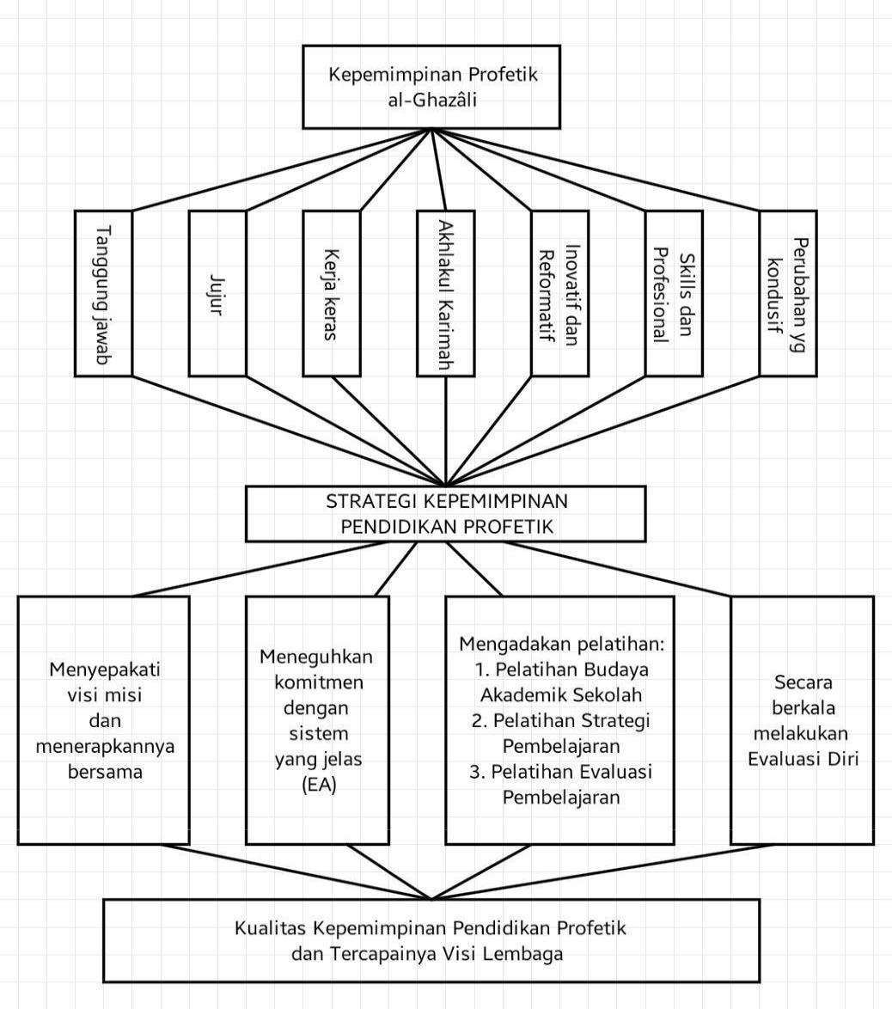

**V.RECOMMENDATION**The author suggests to:

1. Ministry of Religion of the Republic of Indonesia.

The results of this study can be used as assistance to maximize programs in the current ministry environment this is done intensively mainly with regard to leadership so the ministry of religion is able to foster schools in strengthening gait Prophetic based leadership in the perspective of Imam al-Ghozali.

1. Madrasa.

In order to be able to apply the concept of educational leadership integrally and comprehensively prophetic based. As well as giving input at schools to be considered in the implementation of leadership Prophetic-based education in the perspective of Imam al-Ghozali.

1. Principals, teachers & school committees.

Should be able to maximize the concept of leadership in prophetic-based education in Imam al-Ghozali's perspective.

1. Researcher.

The researchers should be able to further develop and deepening leadership studies by building on the results of this study, so that it can provide information about the actualization of the Prophetic based leadership in the perspective of Imam al-Ghozali concept in a wider scope of society.

**IV.CONCLUSION**

1. Conclusion
   1. Al-Ghazali has strong thoughts in the Sunni tradition. In terms of his leadership follows the line of thought of Imam al-Mawardi who wrote Kitab al-Ahkam al-Sulthoniyah. Dimension based prophetic leadership in the perspective of Al Ghazali have 4 dimensions including dimensions competence, dimensions of existence, organizational dimensions and interpersonal dimensions. The competency dimension has two parts namely modest personality and smart person. The dimension of existence has three parts, namely the leader an independent and highly integrated and trustworthy leader. The organization dimension has two parts, namely leaders who are able to uphold rights every individual and leader capable of enforcing activities nation and state, and the interpersonal dimension which has two parts namely leaders who motivate and inspire, and leaders who stimulate.
   2. Characteristics of Educational Leadership Based on Prophetics in Perspective Al-Ghazālī includes: fairness, responsibility, hard work, proven and honesty proven, innovative and reformative, has skills and professionalism, as well bring conducive change
   3. The al-Ghazali prophetic leadership model is manifested in steps and mechanism of work that manifests in a leadership strategy described in the mechanism as follows: set vision and mission and apply together, affirm commitment with a clear system, conduct training in a structured and continuous manner and conduct evaluation.

.

## **VI.REFERENCES**

1. Rulam. 2005. Memahami Metode Penelitian Kualitatif. Malang: Universitas  
   Negeri Malang.

Al-Qamus al-Muhith, Fairuz Abadi, Majduddin Muhammad bin Ya’qub (IV/78),  
Darul jalil Bairut.

Adz-Dzakeiy, Bakran, Hamdani. 2007. Kepemimpinan Kenabian, Profhetic Leadership.  
Yogyakarta: Al-Manar.

al-Abani, M. Nashiruddin. 2005. Ringkasan Shahih Muslim. Jakarta: Gema Insani.

Ali Bin Muhammad al-Mawardi. Al-Ahkam As-Sulthaniyah, Syarikah wa Maktabah  
wa Mathba’ah Musthafa, cetakan ketiga. Kairo: al-babi-al-halbi, 1393 H.

Anagnoste, Sorin, Agoston, Simona and Jukka Surakka, Alina Mihaela Dima. 2012.  
Transformational Leadership and its Influence on Intellectual Capital in theRomanian Business Environment . Proceedingsof the 4th EuropeanConference on Intellectual Capital Arcada University of Applied SciencesHelsinki Finland The Academy of Economic Studies. Bucharest, Romania.

Bahauddin, Taufik. 2001. Brain Ware Management-Generasi Kelima ManajemenManusia. Cet., 3. Jakarta,: Elex Media Komputindo.

Bety, Yuliani, dkk. 2012. Kepemimpinan Transaksional dan Transformasionaldalam Manajemen Berbasis Sekolah. rouf-artikel Pendidikan. (diunduh hari  
Jum’at, 25 Mei 2018).

Creswell, John W. 2014. Research Design, Qualitatif, Quantitative and Mixed MethodsApproachse. London EC1Y 1SP, Asis pasific Pte.Ltd: Sage Publication Inc.

Edna, Pasher & Tuvya, Ronen. 2011. The Complete Guide to Knowledge Management :a Strategic Plan to Leverage your Campany’s Intellectual Capital. USA :  
Wiley.

Ekuma, John, Kelechi. Transformational Leadership: Implications for  
Organizational Competitive Advantage***,*** *International Journal of Human  
Resource Studies* ISSN 2162-3058 2014, Vol. 4, No. 1.

Fatah, Nanang. 1999. Landasan Manajemen Pendidikan. Bandung: Remaja Rosda Karya.

Fathoni, Najmi.2017. Strategi Komunikasi model Sang nabi, Mengupas kecerdasankomunikasi Nabi Muhammad Saw. Jakarta: PT Alek Media Komputindo.

al-Ghazālī, Abū Hamīd Muhammad ibn Muhammad ibn Ahmad,. 1998.Bidāyah alHidāyah, Cetakan I, Dar Shodir, Beirut.

HR. Muslim No 14, al Muqoddimah Bab An-Nahyi ‘anil Hadist Bikullima Samia  
Hidayat, Komaruddin. 2010. 250 Wisdoms Membuka Mata, Menangkap Makna.  
Jakarta: Hikmah.

Hilmi, Mustofa & Mun’im, Fuad Abdul. Ghiyatsul Umam fit Tiyasidzh, Abu Ma’alial-Juwaini. Tahqiq: Alexandria, Darun Nadwah, 1400 H