LIST OF APPENDIXES
Appendix 1: An example of instruction in session 4

Diskusi.4
Hello Tuton Participants!
I hope that you are always fine. Now, we are going to write about describing picture.
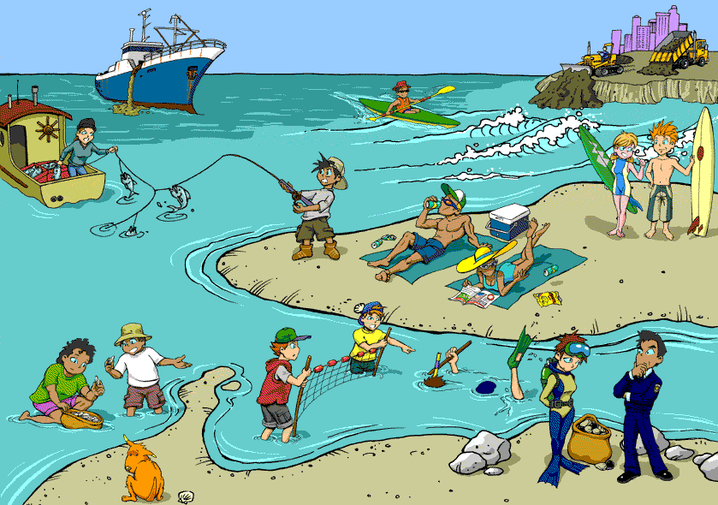
(Taken from: https://4570book.info/amazing-cliparts/polluted-beach-clipart-image.htm)
See above pictures and describes it. Your writing should contain 150-300 words and follow the writing organization as we have learned in the materials of initiation 4.
Happy learning!

Pedoman Penskoran Diskusi 4
100-90
- fully satisfies all the requirements of the task
- uses a wide range of vocabulary with very natural and sophisticated control of lexical features
- uses a wide range of structures with full flexibility and accuracy; rare minor errors occur only as ‘slips’
- uses cohesion in such a way that it attracts no attention
89-80
- covers all requirements of the task sufficiently
- sequences information and ideas logically
- skilfully uses uncommon lexical items but there may be occasional inaccuracies in word choice and collocation
- uses a wide range of structures and the majority of sentences are error-free
79-70
- clearly presents and highlights key features/bullet points but could be more fully extended
- uses a range of cohesive devices appropriately although there may be some under-/over-use
- uses less common lexical items with some awareness of style and collocation; may produce occasional errors in word choice, spelling and/or word formation
- uses a variety of complex structures; produces frequent error-free sentences
69-55
- attempts to address the task but does not cover all key features/bullet points
- presents information and ideas but these are not arranged coherently and there is no clear progression in the response
- uses only basic vocabulary which may be used repetitively or which may be inappropriate for the task
- uses only a very limited range of structures with only rare use of subordinate clauses; some structures are accurate but errors predominate, and punctuation is often faulty
54-39
- answer is barely related to the task
- has very little control of organizational features
- uses an extremely limited range of vocabulary; essentially no control of word formation and/or spelling
- cannot use sentence forms except in memorized phrases
38-10
- answer is completely unrelated to the task
- fails to communicate any message
- can only use a few isolated words
- cannot use sentence forms at all

0: plagiarism is evident.

Appendix 2: Semi-structured interview adapted from Merkel (2019)
  - What do you think of teacher feedback?
  - Do you know dialogic and directive interaction?
  - How did the dialogic interactions aid you in writing your paragraph?
  - How did the dialogic interactions aid you in revising your paragraph?
  - Did the dialogic interactions create any tensions or challenges for you?
  - How might the dialogic interactions aﬀect your writing habits?

