APPENDIXES

CHECKLIST BOXES
Content | Yes | No | Notes
- Does the lesson plan have a topic?
- Does the lesson plan help teachers in conducting activities?
- Does the lesson plan provide the activity that facilitates students in communicating with teachers?
- Does the lesson plan have a brainstorm?
- Does the lesson plan facilitate students to practice new words?
- Does the lesson plan facilitate students to interact with one another?
- Does the lesson plan facilitate assessment?
- Does the topic match the students?
PowerPoint Presentation | Yes | No
- Does the PowerPoint provide Visual?
- Does the PowerPoint provide visible instruction?
- Does the visual support the sentences?
- Does the PowerPoint provide effective word structure?
- Does the PowerPoint colour selection make the words visible?
Webinar | Yes | No
- Does the webinar instruction clear enough?
- Do the webinar tools help students? What are they?
- Does the webinar support teacher in delivering the material?
- Does the webinar support students in optimally understanding the presentation?
- Does the webinar provide tools for teacher-student interaction?
- Does the webinar provide tools for student-student interaction?
- Does the webinar support outside sources like a video?
- Does the webinar enhance speaking for an adult learner?
- Does the webinar support effective learning?
- Is there any webinar tool that repeatedly used? What are they?
- Were the connection stable?

CHECKLIST BOXES per Student
Student’s motivation (per individual) | Yes | No | Notes
- Does student look enthusiastic to study?
- Does student come to the sessions 12 times?
- Does student come to the sessions <9 times?
- Does student come to the sessions <6 times?
- Does student come to the sessions <4 times?
- Does student come to the sessions <1 time?
- Does student come to the sessions 0 times?
- Does student try to comeback after lost connection?
- Was student asked to join the sessions by their company?
- Was student individually enrolling the sessions?
Student’s engagement (Per individual) | Yes | No
- Do students understand the lesson well?
- Do students often ask if they didn’t understand?
- Do students try to elaborate their answer?
- Do students answer the questions briefly?
- Do students look bored?

INTERVIEW QUESTIONS
For Teacher
- Does the topic of lesson plan easy to teach?
- Does the lesson plan help you constructing the activities?
- Does the brainstorm part useful to teach?
- Are the main activities effective to be implemented?
- Does the assessment part help you?
- Are the PowerPoints provide used effective word structure?
- Are the PowerPoint words and colors easy to recognize?
- Which activities is the most enjoyable one?
- Which activity is the hardest to do?

For Students
- Is the topic interesting for you?
- Does the PowerPoint visual help you to understand better?
- Are the instructions of every activities clear enough?
- Are the brainstorming part help you to be more ready in learning?
- Are the main activities joyful and useful for you?
- Which activities is the most enjoyable one?
- Which activity is the hardest to do?
- What is your motivation joining this program?
- What makes you motivated after the first learning session?
- What things make you get demotivated through the learning sessions?

Both
- Did the webinar meet your expectations?
- How would you rate your interaction in the webinar?
- Was it easy to learn speaking in a webinar?
- Was it easy to operate a webinar?
- Did you feel comfortable learning speaking through a webinar?
- What do you like most about teaching/learning speaking in a webinar?
- What do you least like about teaching/learning speaking in a webinar?
- Which tool is the most useful one?
- Which tool is the least useful one?
- Is there anything else you would like us to know about your experience in learning to speak English using a webinar?

SURVEY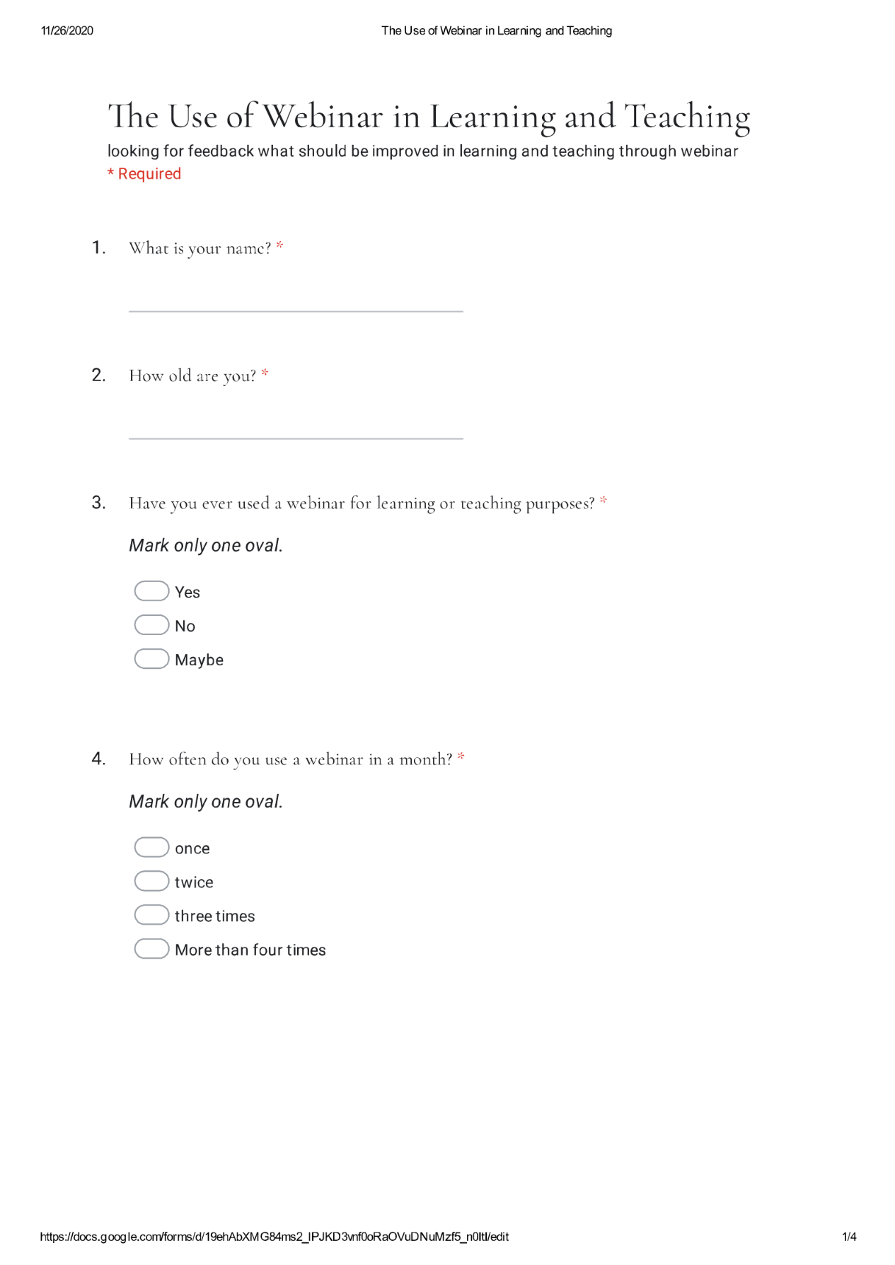
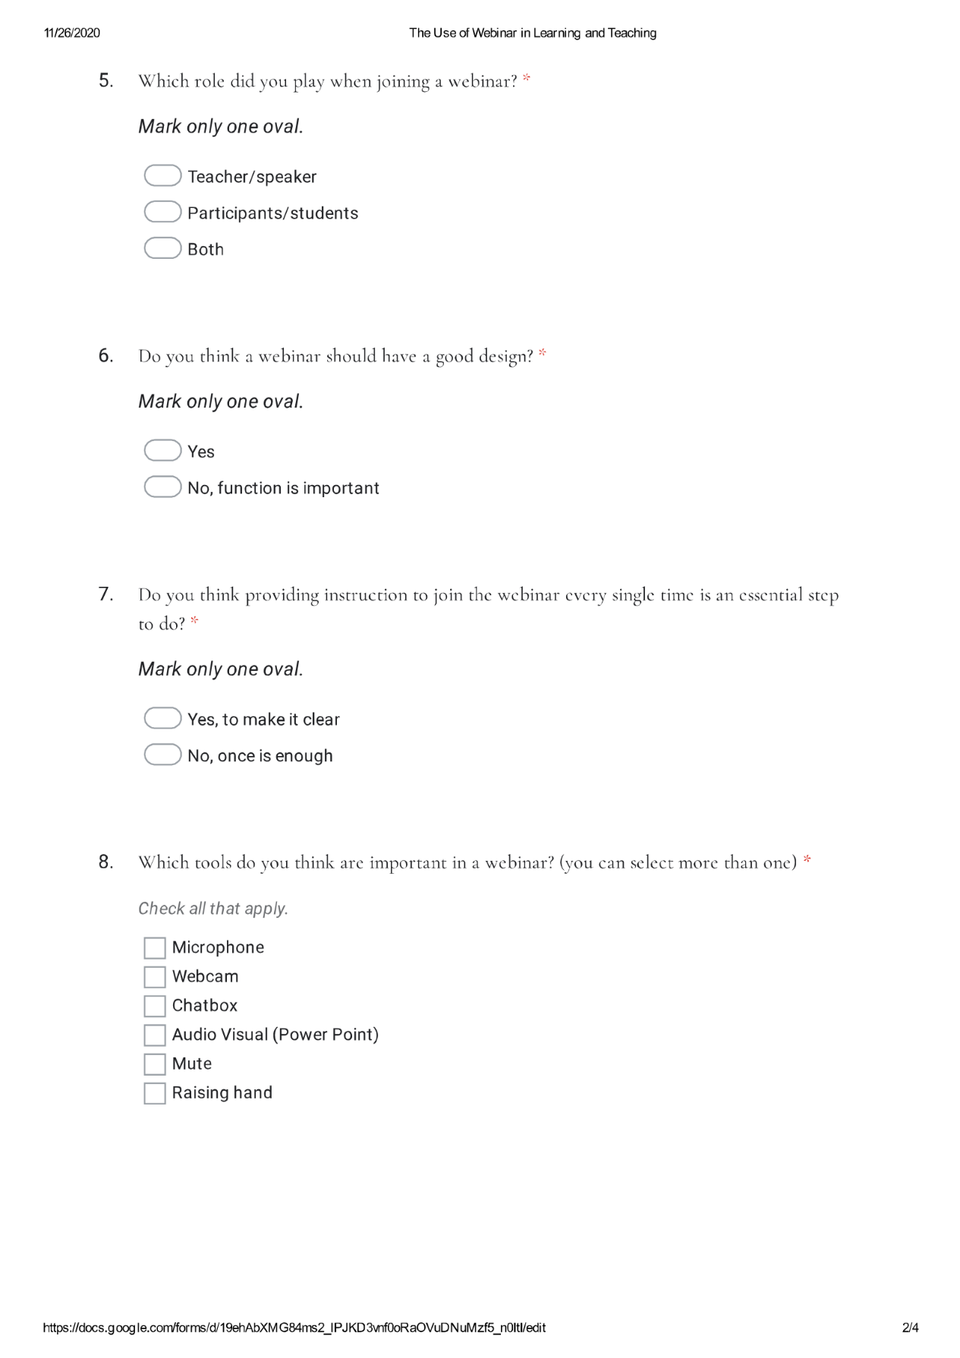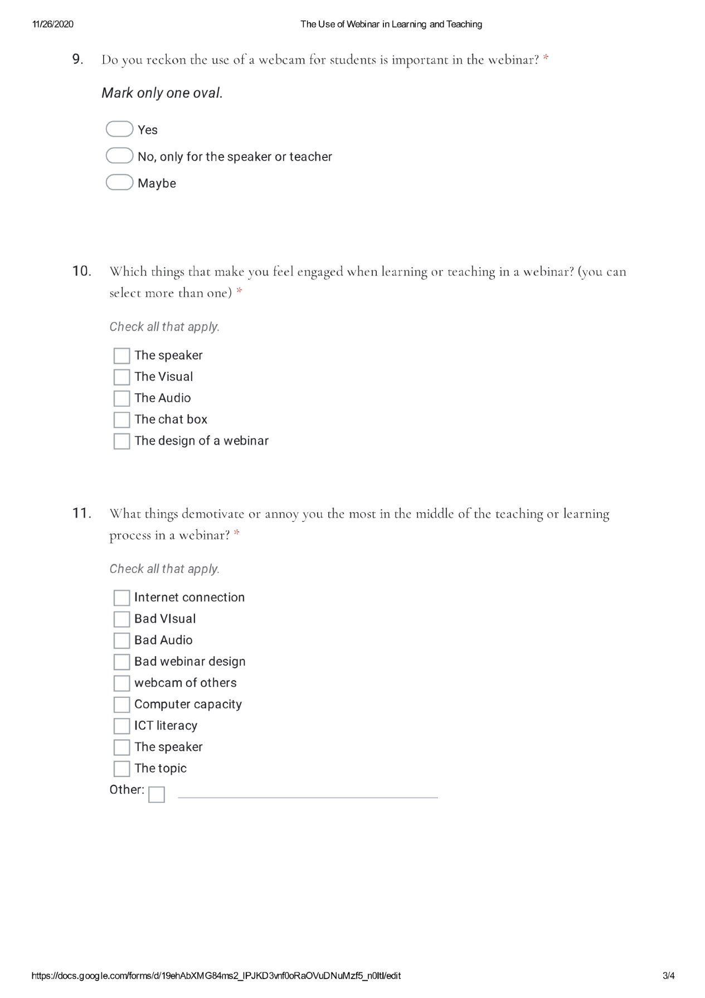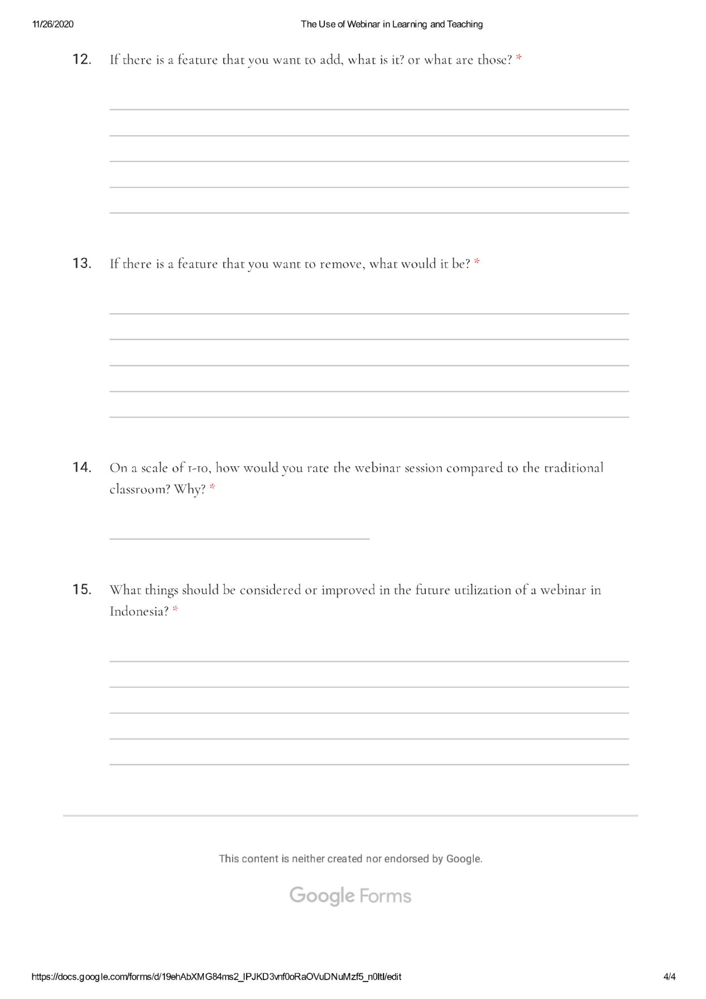

CHECKLIST BOXES per Group
Bankers
Content | Yes | No | Notes
- Does the lesson plan have a topic? | ✔ |  | 6 topics for 12 meetings.
- Does the lesson plan help teachers in conducting activities? | ✔ |  | Yes, teachers didn’t require to create LP.
- Does the lesson plan provide the activity that facilitates students in communicating with teachers? | ✔ |  | Most activities require student and teacher involvement.
- Does the lesson plan have a brainstorm? | ✔ |  | There are brainstorming activities in every session in different forms, quizzes, filling in the gap, matching, etc.
- Does the lesson plan facilitate students to practice new words? | ✔ |  | Only in one per two meetings with the same topic.
- Does the lesson plan facilitate students to interact with one another? | ✔ |  | Yes, there are student-student interactions in every session.
- Does the lesson plan facilitate assessment? | ✔ |  | Yes, in every 6 meetings, so there would be 2 assessments.
- Does the topic match the students? | ✔ |  | Yes, it matched.
PowerPoint Presentation | Yes | No | N.
- Does the PowerPoint provide Visual? | ✔ |  | In one per two meetings with the same topic, the visual is more dominant.
- Does the PowerPoint provide visible instruction? | ✔ |  | The instructions were typed in contrast color with the background.
- Does the visual support the sentences? | ✔ |  | It does support the sentences, yet always uses native English people as the picture which not suitable for Indonesian culture.
- Does the PowerPoint provide effective word structure? | ✔ |  | Only a few of them a bit ambiguous.
- Does the PowerPoint color selection make the words visible? | ✔ |  | Most of them do.
Webinar (per session) | Yes | No | N.
- Does the webinar instruction clear enough? | ✔ |  | Students and teachers received two meeting practices excluding the sessions
- Do the webinar tools help students? What are they? | ✔ |  | Yes, it does, mostly dominated by mic, chatbox, and PowerPoint A/V.
- Does the webinar support teacher in delivering the material? | ✔ |  | Yes, through the blackboard and PowerPoint sharing.
- Does the webinar support students in optimally understanding the presentation? | ✔ |  | Through the blackboard, the teacher could give more explanation.
- Does the webinar provide tools for teacher-student interaction? | ✔ |  | In every session.
- Does the webinar provide tools for student-student interaction? | ✔ |  | In every session.
- Does the webinar support outside sources like a video? | ✔ |  | Yes, through the link.
- Does the webinar enhance speaking for an adult learner? | ✔ |  | Yes, it does. Through the thematic learning and communicative speaking learning
- Does the webinar support effective learning? | ✔ |  | Less theory, more practice.
- Is there any webinar tool that repeatedly used? What are they? | ✔ |  | Mic, screen, chatbox.
- Was the connection stable? | ✔ |  | Yes, they were doing their lesson in the office.

CHECKLIST BOXES per Group
Health
Content | Yes | No | Notes
- Does the lesson plan have a topic? | ✔ |  | 6 topics for 12 meetings.
- Does the lesson plan help teachers in conducting activities? | ✔ |  | Yes, teachers didn’t require to create LP.
- Does the lesson plan provide the activity that facilitates students in communicating with teachers? | ✔ |  | Most activities require student and teacher involvement.
- Does the lesson plan have a brainstorm? | ✔ |  | There are brainstorming activities in every session in different forms, quizzes, filling in the gap, matching, etc.
- Does the lesson plan facilitate students to practice new words? | ✔ |  | Only in one per two meetings with the same topic.
- Does the lesson plan facilitate students to interact with one another? | ✔ |  | Yes, there are student-student interactions in every session.
- Does the lesson plan facilitate assessment? | ✔ |  | Yes, in every 6 meetings, so there would be 2 assessments.
- Does the topic match the students? | ✔ |  | Yes, it matched.
PowerPoint Presentation | Yes | No | N.
- Does the PowerPoint provide Visual? | ✔ |  | In one per two meetings with the same topic, the visual is more dominant.
- Does the PowerPoint provide visible instruction? | ✔ |  | The instructions were typed in contrast color with the background.
- Does the visual support the sentences? | ✔ |  | It does support the sentences, yet always uses native English people as the picture which not suitable for Indonesian culture.
- Does the PowerPoint provide effective word structure? | ✔ |  | Only a few of them a bit ambiguous.
- Does the PowerPoint color selection make the words visible? | ✔ |  | Most of them do.
Webinar (per session) | Yes | No | N.
- Does the webinar instruction clear enough? | ✔ |  | Students and teachers received two meeting practices excluding the sessions
- Do the webinar tools help students? What are they? | ✔ |  | Yes, it does, mostly dominated by mic, chatbox, and PowerPoint A/V.
- Does the webinar support teacher in delivering the material? | ✔ |  | Yes, through the blackboard and PowerPoint sharing.
- Does the webinar support students in optimally understanding the presentation? | ✔ |  | Through the blackboard, the teacher could give more explanation.
- Does the webinar provide tools for teacher-student interaction? | ✔ |  | In every session.
- Does the webinar provide tools for student-student interaction? | ✔ |  | In every session.
- Does the webinar support outside sources like a video? | ✔ |  | Yes, through the link.
- Does the webinar enhance speaking for an adult learner? | ✔ |  | Yes, it does. Through the thematic learning and communicative speaking learning
- Does the webinar support effective learning? | ✔ |  | Less theory, more practice.
- Is there any webinar tool that repeatedly used? What are they? | ✔ |  | Mic, screen, chatbox.
- Was the connection stable? | ✔ |  | Yes, they were doing their lesson in the office.

CHECKLIST BOXES per Group
Smartphone
Content | Yes | No | Notes
- Does the lesson plan have a topic? | ✔ |  | 6 topics for 12 meetings.
- Does the lesson plan help teachers in conducting activities? | ✔ |  | Yes, teachers didn’t require to create LP.
- Does the lesson plan provide the activity that facilitates students in communicating with teachers? | ✔ |  | Most activities require student and teacher involvement.
- Does the lesson plan have a brainstorm? | ✔ |  | There are brainstorming activities in every session in different forms, quizzes, filling in the gap, matching, etc.
- Does the lesson plan facilitate students to practice new words? | ✔ |  | Only in one per two meetings with the same topic.
- Does the lesson plan facilitate students to interact with one another? | ✔ |  | Yes, there are student-student interactions in every session.
- Does the lesson plan facilitate assessment? | ✔ |  | Yes, in every 6 meetings, so there would be 2 assessments.
- Does the topic match the students? | ✔ |  | Yes, it matched.
PowerPoint Presentation | Yes | No | N.
- Does the PowerPoint provide Visual? | ✔ |  | In one per two meetings with the same topic, the visual is more dominant.
- Does the PowerPoint provide visible instruction? | ✔ |  | The instructions were typed in contrast color with the background.
- Does the visual support the sentences? | ✔ |  | It does support the sentences, yet always uses native English people as the picture which not suitable for Indonesian culture.
- Does the PowerPoint provide effective word structure? | ✔ |  | Only a few of them a bit ambiguous.
- Does the PowerPoint color selection make the words visible? | ✔ |  | Most of them do.
Webinar (per session) | Yes | No | N.
- Does the webinar instruction clear enough? | ✔ |  | Students and teachers received two meeting practices excluding the sessions
- Do the webinar tools help students? What are they? | ✔ |  | Yes, it does, mostly dominated by mic, chatbox, and PowerPoint A/V.
- Does the webinar support teacher in delivering the material? | ✔ |  | Yes, through the blackboard and PowerPoint sharing.
- Does the webinar support students in optimally understanding the presentation? | ✔ |  | Through the blackboard, the teacher could give more explanation.
- Does the webinar provide tools for teacher-student interaction? | ✔ |  | In every session.
- Does the webinar provide tools for student-student interaction? | ✔ |  | In every session.
- Does the webinar support outside sources like a video? | ✔ |  | Yes, through the link.
- Does the webinar enhance speaking for an adult learner? | ✔ |  | Yes, it does. Through the thematic learning and communicative speaking learning
- Does the webinar support effective learning? | ✔ |  | Less theory, more practice.
- Is there any webinar tool that repeatedly used? What are they? | ✔ |  | Mic, screen, chatbox.
- Was the connection stable? | ✔ |  | Yes, they were doing their lesson in the office.

CHECKLIST BOXES per Group
Saving
Content | Yes | No | Notes
- Does the lesson plan have a topic? | ✔ |  | 6 topics for 12 meetings.
- Does the lesson plan help teachers in conducting activities? | ✔ |  | Yes, teachers didn’t require to create LP.
- Does the lesson plan provide the activity that facilitates students in communicating with teachers? | ✔ |  | Most activities require student and teacher involvement.
- Does the lesson plan have a brainstorm? | ✔ |  | There are brainstorming activities in every session in different forms, quizzes, filling in the gap, matching, etc.
- Does the lesson plan facilitate students to practice new words? | ✔ |  | Only in one per two meetings with the same topic.
- Does the lesson plan facilitate students to interact with one another? | ✔ |  | Yes, there are student-student interactions in every session.
- Does the lesson plan facilitate assessment? | ✔ |  | Yes, in every 6 meetings, so there would be 2 assessments.
- Does the topic match the students? | ✔ |  | Yes, it matched.
PowerPoint Presentation | Yes | No | N.
- Does the PowerPoint provide Visual? | ✔ |  | In one per two meetings with the same topic, the visual is more dominant.
- Does the PowerPoint provide visible instruction? | ✔ |  | The instructions were typed in contrast color with the background.
- Does the visual support the sentences? | ✔ |  | It does support the sentences, yet always uses native English people as the picture which not suitable for Indonesian culture.
- Does the PowerPoint provide effective word structure? | ✔ |  | Only a few of them a bit ambiguous.
- Does the PowerPoint color selection make the words visible? | ✔ |  | Most of them do.
Webinar (per session) | Yes | No | N.
- Does the webinar instruction clear enough? | ✔ |  | Students and teachers received two meeting practices excluding the sessions
- Do the webinar tools help students? What are they? | ✔ |  | Yes, it does, mostly dominated by mic, chatbox, and PowerPoint A/V.
- Does the webinar support teacher in delivering the material? | ✔ |  | Yes, through the blackboard and PowerPoint sharing.
- Does the webinar support students in optimally understanding the presentation? | ✔ |  | Through the blackboard, the teacher could give more explanation.
- Does the webinar provide tools for teacher-student interaction? | ✔ |  | In every session.
- Does the webinar provide tools for student-student interaction? | ✔ |  | In every session.
- Does the webinar support outside sources like a video? | ✔ |  | Yes, through the link.
- Does the webinar enhance speaking for an adult learner? | ✔ |  | Yes, it does. Through the thematic learning and communicative speaking learning
- Does the webinar support effective learning? | ✔ |  | Less theory, more practice.
- Is there any webinar tool that repeatedly used? What are they? | ✔ |  | Mic, screen, chatbox.
- Was the connection stable? | ✔ |  | Yes, they were doing their lesson in the office.

CHECKLIST BOXES per Student
Banker 1
Student’s motivation (per individual) | Yes | No | Notes
- Does the student look enthusiastic to study? | ✔ |  | The student looked enthusiastic by elaborating his/her answer and asking if they didn’t understand.
- Does the student come to the sessions 12 times? | ✔
- Does the student come to the sessions >8 to <12 times? |  | ✔
- Does the student come to the sessions >5 times to <8 times? |  | ✔
- Does the student come to the sessions >2 times to <5 times? |  | ✔
- Does the student come to the sessions 1 time? |  | ✔
- Does the student come to the sessions 0 times? |  | ✔
- Does the student try to come back after a lost connection? |  | ✔ | The connection had no problem.
- Was the student asked to join the sessions by their company? | ✔
- Was the student individually enrolling in the sessions? |  | ✔
Student’s engagement (Per individual) | Yes | No
- Do students understand the lesson well? | ✔ |  | The student followed the instruction well and tried his/her best in answering.
- Do students often ask if they didn’t understand? |  | ✔ | The student seldom asked he/she tried to answer as they had been understood.
- Do students try to elaborate on their answers? | ✔ |  | The student’s answer is not in simply sentence as yes or no.
- Do students answer the questions briefly? |  | ✔ | The student answered elaborately.
- Do students look bored? |  | ✔ | The student often involved well in every activity.

CHECKLIST BOXES per Student
Banker 2
Student’s motivation (per individual) | Yes | No | Notes
- Does the student look enthusiastic to study? | ✔ |  | The student looked enthusiastic by elaborating his/her answer and asking if they didn’t understand.
- Does the student come to the sessions 12 times? |  | ✔
- Does the student come to the sessions >8 to <12 times? | ✔ |  | 10 times, 2 absent because family matter.
- Does the student come to the sessions >5 times to <8 times? |  | ✔
- Does the student come to the sessions >2 times to <5 times? |  | ✔
- Does the student come to the sessions 1 time? |  | ✔
- Does the student come to the sessions 0 times? |  | ✔
- Does the student try to come back after a lost connection? |  | ✔ | The connection had no problem.
- Was the student asked to join the sessions by their company? | ✔
- Was the student individually enrolling in the sessions? |  | ✔
Student’s engagement (Per individual) | Yes | No
- Do students understand the lesson well? | ✔ |  | The student followed the instruction well and tried his/her best in answering.
- Do students often ask if they didn’t understand? | ✔ |  | The student asked often, especially specific vocab to use to answer the questions.
- Do students try to elaborate on their answers? | ✔ |  | The student’s answer is not in simply sentence as yes or no.
- Do students answer the questions briefly? | ✔ |  | For couple of first meetings.
- Do students look bored? |  | ✔ | The student often involved well in every activity.

CHECKLIST BOXES per Student
Banker 3
Student’s motivation (per individual) | Yes | No | Notes
- Does the student look enthusiastic to study? | ✔ |  | The student looked enthusiastic by elaborating his/her answer and asking if they didn’t understand.
- Does the student come to the sessions 12 times? |  | ✔
- Does the student come to the sessions >8 to <12 times? | ✔ |  | 9 times, 1 without reason, 2 health problem.
- Does the student come to the sessions >5 times to <8 times? |  | ✔
- Does the student come to the sessions >2 times to <5 times? |  | ✔
- Does the student come to the sessions 1 time? |  | ✔
- Does the student come to the sessions 0 times? |  | ✔
- Does the student try to come back after a lost connection? |  | ✔ | The connection had no problem.
- Was the student asked to join the sessions by their company? | ✔
- Was the student individually enrolling in the sessions? |  | ✔
Student’s engagement (Per individual) | Yes | No
- Do students understand the lesson well? | ✔ |  | The student followed the instruction well and tried his/her best in answering.
- Do students often ask if they didn’t understand? |  | ✔ | The student seldom asked he/she tried to answer as they had been understood.
- Do students try to elaborate on their answers? |  | ✔ | The student seemed to be afraid to make mistakes
- Do students answer the questions briefly? | ✔ |  | The student answered briefly..
- Do students look bored? |  | ✔ | The student often involved well in every activity.

CHECKLIST BOXES per Student
Health 1
Student’s motivation (per individual) | Yes | No | Notes
- Does the student look enthusiastic to study? | ✔ |  | The student looked enthusiastic by elaborating his/her answer and asking if they didn’t understand.
- Does the student come to the sessions 12 times? |  | ✔
- Does the student come to the sessions >8 to <12 times? | ✔ |  | 10 times, 2 meetings.
- Does the student come to the sessions >5 times to <8 times? |  | ✔
- Does the student come to the sessions >2 times to <5 times? |  | ✔
- Does the student come to the sessions 1 time? |  | ✔
- Does the student come to the sessions 0 times? |  | ✔
- Does the student try to come back after a lost connection? |  | ✔ | The connection had no problem.
- Was the student asked to join the sessions by their company? | ✔
- Was the student individually enrolling in the sessions? |  | ✔
Student’s engagement (Per individual) | Yes | No
- Do students understand the lesson well? | ✔ |  | The student followed the instruction well and tried his/her best in answering.
- Do students often ask if they didn’t understand? | ✔ |  | The student asked the specific vocab that he/she forgot.
- Do students try to elaborate on their answers? | ✔ |  | The student’s answer is not in simply sentence as yes or no for last meetings.
- Do students answer the questions briefly? | ✔ |  | The student answered briefly in most of 6 meetings.
- Do students look bored? |  | ✔ | The student often involved well in every activity.

CHECKLIST BOXES per Student
Health 2
Student’s motivation (per individual) | Yes | No | Notes
- Does the student look enthusiastic to study? | ✔ |  | The student looked enthusiastic by elaborating his/her answer and asking if they didn’t understand.
- Does the student come to the sessions 12 times? |  | ✔
- Does the student come to the sessions >8 to <12 times? | ✔ |  | 10 times, 2 times for meetings.
- Does the student come to the sessions >5 times to <8 times? |  | ✔
- Does the student come to the sessions >2 times to <5 times? |  | ✔
- Does the student come to the sessions 1 time? |  | ✔
- Does the student come to the sessions 0 times? |  | ✔
- Does the student try to come back after a lost connection? | ✔ |  | The student got kicked out from the webinar, yet came back to the class as soon as he/she got the connection back.
- Was the student asked to join the sessions by their company? | ✔
- Was the student individually enrolling in the sessions? |  | ✔
Student’s engagement (Per individual) | Yes | No
- Do students understand the lesson well? | ✔ |  | The student followed the instruction well and tried his/her best in answering.
- Do students often ask if they didn’t understand? |  | ✔ | The student seldom asked he/she tried to answer as they had been understood.
- Do students try to elaborate on their answers? | ✔ |  | The student’s answer is not in simply sentence as yes or no for a few meetings.
- Do students answer the questions briefly? | ✔ |  | The student answered briefly in most of 5 meetings.
- Do students look bored? |  | ✔ | The student often involved well in every activity.

CHECKLIST BOXES per Student
Health 3
Student’s motivation (per individual) | Yes | No | Notes
- Does the student look enthusiastic to study? | ✔ |  | The student looked enthusiastic by elaborating his/her answer and asking if they didn’t understand.
- Does the student come to the sessions 12 times? |  | ✔
- Does the student come to the sessions >8 to <12 times? | ✔ |  | 10 times, 2 for meetings.
- Does the student come to the sessions >5 times to <8 times? |  | ✔
- Does the student come to the sessions >2 times to <5 times? |  | ✔
- Does the student come to the sessions 1 time? |  | ✔
- Does the student come to the sessions 0 times? |  | ✔
- Does the student try to come back after a lost connection? |  | ✔ | The connection had no problem.
- Was the student asked to join the sessions by their company? | ✔
- Was the student individually enrolling in the sessions? |  | ✔
Student’s engagement (Per individual) | Yes | No
- Do students understand the lesson well? | ✔ |  | The student followed the instruction well and tried his/her best in answering.
- Do students often ask if they didn’t understand? |  | ✔ | The student seldom asked he/she tried to answer as they had been understood.
- Do students try to elaborate on their answers? | ✔ |  | The student’s answer is not in simply sentence as yes or no.
- Do students answer the questions briefly? |  | ✔ | The student answered elaborately.
- Do students look bored? |  | ✔ | The student often involved well in every activity.

CHECKLIST BOXES per Student
Saving 1
Student’s motivation (per individual) | Yes | No | Notes
- Does the student look enthusiastic to study? | ✔ |  | The student looked enthusiastic by elaborating his/her answer and asking if they didn’t understand.
- Does the student come to the sessions 12 times? | ✔
- Does the student come to the sessions >8 to <12 times? |  | ✔
- Does the student come to the sessions >5 times to <8 times? |  | ✔
- Does the student come to the sessions >2 times to <5 times? |  | ✔
- Does the student come to the sessions 1 time? |  | ✔
- Does the student come to the sessions 0 times? |  | ✔
- Does the student try to come back after a lost connection? |  | ✔ | The connection had no problem.
- Was the student asked to join the sessions by their company? |  | ✔
- Was the student individually enrolling in the sessions? | ✔
Student’s engagement (Per individual) | Yes | No
- Do students understand the lesson well? | ✔ |  | The student followed the instruction well and tried his/her best in answering.
- Do students often ask if they didn’t understand? | ✔ |  | The student seldom asked he/she tried to answer as they had been understood.
- Do students try to elaborate on their answers? | ✔ |  | The student’s answer is not in simply sentence as yes or no.
- Do students answer the questions briefly? | ✔ |  | The student asked often, especially specific vocab to use to answer the questions.
- Do students look bored? |  | ✔ | The student often involved well in every activity.

CHECKLIST BOXES per Student
Smartphone 1
Student’s motivation (per individual) | Yes | No | Notes
- Does the student look enthusiastic to study? | ✔ |  | The student looked enthusiastic by elaborating his/her answer and asking if they didn’t understand.
- Does the student come to the sessions 12 times? |  | ✔
- Does the student come to the sessions >8 to <12 times? | ✔ |  | 9 times. 3 meetings off, because of feeling unwell.
- Does the student come to the sessions >5 times to <8 times? |  | ✔
- Does the student come to the sessions >2 times to <5 times? |  | ✔
- Does the student come to the sessions 1 time? |  | ✔
- Does the student come to the sessions 0 times? |  | ✔
- Does the student try to come back after a lost connection? |  | ✔ | The connection had no problem.
- Was the student asked to join the sessions by their company? | ✔
- Was the student individually enrolling in the sessions? |  | ✔
Student’s engagement (Per individual) | Yes | No
- Do students understand the lesson well? | ✔ |  | The student followed the instruction well and tried his/her best in answering.
- Do students often ask if they didn’t understand? |  | ✔ | The student seldom asked he/she tried to answer as they had been understood.
- Do students try to elaborate on their answers? | ✔ |  | The student’s answer is not in simply sentence as yes or no for a few last meetings.
- Do students answer the questions briefly? | ✔ |  | The student answered briefly in most of 4 meetings.
- Do students look bored? |  | ✔ | The student often involved well in every activity.

INTERVIEW TRANSCRIPT
TEACHER INTERVIEW 1
- Q: Does the topic of the lesson plan easy to teach?
A: Because the LP is always provided before the session, yes, it does.
- Q: Does the lesson plan help you constructing the activities?
A: I don’t need to create activities, so yes, it is very helpful by providing activities.
- Q: Does the brainstorming part useful to teach?
A: Yes, it helps students getting ready, before the main activities.
- Q: Are the main activities effective to be implemented?
A: Since it has student-teacher and student-student activities, I think so.
- Q: Does the feedback part help you?
A: It’s going to be effective if the students don’t take it for granted.
- Q: Are the PowerPoints provided used effective word structure?
A: Most of them, however, some of them not.
- Q: Are the PowerPoint words and colors easy to recognize?
A: Yes, I guess.
- Q: Which activities are the most enjoyable ones?
A: For me, it’s the brainstorming one, because I can have a little laugh with the students.
- Q: Which activity is the hardest to do?
A: Student-student activity. I always have the intention to interrupt their conversation, if they made mistakes.
Webinar
- Q: How would you rate your interaction in the webinar?
A: 8.5/10, I prefer traditional classroom, but webinar is useful when you don’t have time and space.
- Q: Was it easy to teach/learn speaking in a webinar?
A: Teaching in webinar was kind of hard for me for the first time, but as time goes by, I’m getting used to it.
- Q: Was it easy to operate a webinar?
A: Yes, it is. It’s not different with zoom.
- Q: Did you feel comfortable teaching/ learning to speak English through a webinar?
A: I do feel comfortable, however, it takes time to learn to use it when I started to teach using it.
- Q: What do you like most about teaching/learning speaking in a webinar?
A: I like that we can learn without seeing each other in person.
- Q: What do you least like about teaching/learning speaking in a webinar?
A: It requires a good device and a good connection. Sometimes, it annoyed me when the connection was not that good.
- Q: Which tool is the most useful one?
A: The document sharing and blackboard features.
- Q: Which tool is the least useful one?
A: think it’s the … maybe the webcam feature for students, since they never used it.
- Q: Is there anything else you would like us to know about your experience in learning to speak English using a webinar?
A: In my opinion, teaching speaking through webinar is a good match, there is always two way of communications.

TEACHER INTERVIEW 2
- Q: Does the topic of the lesson plan easy to teach?
A: The beginner level yes, sometimes it’s way too easy.
- Q: Does the lesson plan help you constructing the activities?
A: I don’t need to create the activities, but sometimes I improvised.
- Q: Does the brainstorming part useful to teach?
A: Yes, to prepare the students.
- Q: Are the main activities effective to be implemented?
A: Yes, because it involved the students in each of the activities.
- Q: Does the feedback part help you?
A: Yes, it helps the students remember what they needed to learn.
- Q: are the PowerPoints provided used effective word structure?
A: Yes, it is.
- Q: Are the PowerPoint words and colors easy to recognize?
A: Yes, It is.
- Q: Which activities are the most enjoyable ones?
A: Yes, it helps the students remember what they needed to learn.
- Q: Which activity is the hardest to do?
A: No activity is hard.
Webinar
- Q: How would you rate your interaction in the webinar?
A: 10/10, because I worked as an online teacher.
- Q: Was it easy to teach/learn speaking in a webinar?
A: Since I like the computer, it’s not that hard.
- Q: Was it easy to operate a webinar?
A: Yes, a similar answer to the previous one.
- Q: Did you feel comfortable teaching/ learning to speak English through a webinar?
A: Yes, it also makes me happy because I can improve my computer skill as well.
- Q: What do you like most about teaching/learning speaking in a webinar?
A: To use technology in teaching or implementing ICT is always good innovation in education.
- Q: What do you least like about teaching/learning speaking in a webinar?
A: I could not see the student's face and expression.
- Q: Which tool is the most useful one?
A: The student-student one, it tested my patience not to interrupt students while they made mistakes.
- Q: Which tool is the least useful one?
A: The webcam for students, to be honest.
- Q: Is there anything else you would like us to know about your experience in learning to speak English using a webinar?
A: No, I guess, but implementing technology is always a good innovation for education.

INTERVIEW Student 1 (Banker)

- Q: Is the topic interesting for you?
A: Yes, it is interesting.
- Q: Does the PowerPoint visual help you to understand better?
A: What mean by visual? Oohhh…. Yes, it helps me to understand better.
- Q: Are the instructions for every activity clear enough?
A: Yes, I think
- Q: Does the brainstorming part help you to be more ready in learning?
A: Yes, it makes me think before learning.
- Q: Are the main activities joyful and useful for you?
A: Yes, it’s so enjoyful.
- Q: Which activities are the most enjoyable ones?
A: I really like learning new vocabulary.
- Q: Which activity is the hardest to do?
A: Practice how to pronounce new word, but I like it.
- Q: What is your motivation in joining this program?
A: Because my company order me and I like English.
- Q: What makes you motivated after the first learning session?
A: More practice than theory.
- Q: What things make you get demotivated through the learning sessions?
A: When signal is bad.

- Q: How would you rate your interaction in the webinar?
A: Nine, I like it. It helps me learn new language although I’m far.
- Q: Was it easy to teach/learn speaking in a webinar?
A: The admin teached me first, so it is easy now.
- Q: Was it easy to operate a webinar?
A: Yes, it’s easy.
- Q: Did you feel comfortable teaching/ learning to speak English through a webinar?
A: I am comfortable, I always use zoom too.
- Q: What do you like most about teaching/learning speaking in a webinar?
A: I can talk with teacher, although I’m far.
- Q: What do you least like about teaching/learning speaking in a webinar?
A: What is least? Ooohhh.. no, I enjoy everything, I like it.
- Q: Which tool is the most useful one?
A: Chat box, because I can ask if I don’t understand
- Q: Which tool is the least useful one?
A: Timer, makes me sad, if the time ends
- Q: Is there anything else you would like us to know about your experience in learning to speak English using a webinar?
A: Nothing, I like everything.

INTERVIEW Student 2 (Banker)

- Q: Is the topic interesting for you?
A: Yes, I love it.
- Q: Does the PowerPoint visual help you to understand better?
A: Yes, I understand better.
- Q: Are the instructions for every activity clear enough?
A: Yes, no problem.
- Q: Does the brainstorming part help you to be more ready in learning?
A: Yes, I love it, I like the quiz. Make me think.
- Q: Are the main activities joyful and useful for you?
A: Yes, I like it and it’s so enjoyful.
- Q: Which activities are the most enjoyable ones?
A: I like watching video and learn new word.
- Q: Which activity is the hardest to do?
A: Speaking with teacher, but I love it.
- Q: What is your motivation in joining this program?
A: I like to learn English and for my promotion.
- Q: What makes you motivated after the first learning session?
A: The teacher is kind and I learned a lot.
- Q: What things make you get demotivated through the learning sessions?
A: When my internet is bad.
Webinar
- Q: How would you rate your interaction in the webinar?
A: 10. I like it.
- Q: Was it easy to teach/learn speaking in a webinar?
A: It’s hard, but I try my best.
- Q: Was it easy to operate a webinar?
A: Not really. But, I can do it.
- Q: Did you feel comfortable teaching/ learning to speak English through a webinar?
A: Yes, I love learning in webinar.
- Q: What do you like most about teaching/learning speaking in a webinar?
A: I don’t need to go to learn.
- Q: What do you least like about teaching/learning speaking in a webinar?
A: When internet down.
- Q: Which tool is the most useful one?
A: I like the chatbox, I can ask when I don’t understand.
- Q: Which tool is the least useful one?
A: Webcam, I want to use webcam.
- Q: Is there anything else you would like us to know about your experience in learning to speak English using a webinar?
A: It helps me learning English, I love it.

INTERVIEW Student 3 (Banker)

- Q: Is the topic interesting for you?
A: Yes, interesting.
- Q: Does the PowerPoint visual help you to understand better?
A: I can learn English and the picture is good.
- Q: Are the instructions for every activity clear enough?
A: It’s good.
- Q: Does the brainstorming part help you to be more ready in learning?
A: I like it. The game is good.
- Q: Are the main activities joyful and useful for you?
A: Yes, I can speak with teacher and student.
- Q: Which activities are the most enjoyable ones?
A: I like to speak, practice makes perfect.
- Q: Which activity is the hardest to do?
A: Accent is hard.
- Q: What is your motivation in joining this program?
A: I want to learn and hope can get promotion.
- Q: What makes you motivated after the first learning session?
A: When I can speak and learning English.
- Q: What things make you get demotivated through the learning sessions?
A: Practicing accent.
Webinar
- Q: How would you rate your interaction in the webinar?
A: 10. Because I can speak.
- Q: Was it easy to teach/learn speaking in a webinar?
A: No, I can use it.
- Q: Was it easy to operate a webinar?
A: Easy, because I can use zoom too.
- Q: Did you feel comfortable teaching/ learning to speak English through a webinar?
A: I like it and comfortable.
- Q: What do you like most about teaching/learning speaking in a webinar?
A: I can speak when I’m home.
- Q: What do you least like about teaching/learning speaking in a webinar?
A: Least? Ok. I think webicam, because I cannot see other.
- Q: Which tool is the most useful one?
A: I like the powerpoint, I can learn from it.
- Q: Which tool is the least useful one?
A: Webcam, I want to see other face.
- Q: Is there anything else you would like us to know about your experience in learning to speak English using a webinar?
A: No, everything is good.

INTERVIEW Student 4 (Health)

- Q: Is the topic interesting for you?
A: Yes, I love it. It’s interesting.
- Q: Does the PowerPoint visual help you to understand better?
A: Yes, It helps me a lot.
- Q: Are the instructions for every activity clear enough?
A: No problem.
- Q: Does the brainstorming part help you to be more ready in learning?
A: So many games I like it.
- Q: Are the main activities joyful and useful for you?
A: Yes I can talk with other and learn.
- Q: Which activities are the most enjoyable ones?
A: I like talking, because we talk the topic I know.
- Q: Which activity is the hardest to do?
A: The accent is hard. Speak like bule.
- Q: What is your motivation in joining this program?
A: I want to learn so I join the program via my company.
- Q: What makes you motivated after the first learning session?
A: I really want to learn so I have motivation.
- Q: What things make you get demotivated through the learning sessions?
A: When I don’t understand what the teacher said.
Webinar
- Q: How would you rate your interaction in the webinar?
A: 10. I can have a place to speak with others.
- Q: Was it easy to teach/learn speaking in a webinar?
A: It’s easy enough.
- Q: Was it easy to operate a webinar?
A: Yes, I can do it.
- Q: Did you feel comfortable teaching/ learning to speak English through a webinar?
A: Yes, I love talking with people in webinar.
- Q: What do you like most about teaching/learning speaking in a webinar?
A: I can learn when I’m busy.
- Q: What do you least like about teaching/learning speaking in a webinar?
A: When wifi is so slow.
- Q: Which tool is the most useful one?
A: Chat box. I like chat with other, when I don’t understand.
- Q: Which tool is the least useful one?
A: Webcam, I want to show my expression.
- Q: Is there anything else you would like us to know about your experience in learning to speak English using a webinar?
A: 100 for learning in webinar.

INTERVIEW Student 5 (Health)

- Q: Is the topic interesting for you?
A: Yes, of course.
- Q: Does the PowerPoint visual help you to understand better?
A: Power point is too simple.
- Q: Are the instructions for every activity clear enough?
A: It’s clear.
- Q: Does the brainstorming part help you to be more ready in learning?
A: I really like ice breaking like it.
- Q: Are the main activities joyful and useful for you?
A: Yes, that make me speak English.
- Q: Which activities are the most enjoyable ones?
A: Speak with other student. I like it.
- Q: Which activity is the hardest to do?
A: Talking with accent.
- Q: What is your motivation in joining this program?
A: I selected by the company to join the program.
- Q: What makes you motivated after the first learning session?
A: I want to be smart and can speak English.
- Q: What things make you get demotivated through the learning sessions?
A: No.
Webinar
- Q: How would you rate your interaction in the webinar?
A: Five star.
- Q: Was it easy to teach/learn speaking in a webinar?
A: First hard, then I try, now easy.
- Q: Was it easy to operate a webinar?
A: So-so, but now I can.
- Q: Did you feel comfortable teaching/ learning to speak English through a webinar?
A: So comfortable.
- Q: What do you like most about teaching/learning speaking in a webinar?
A: I can learn from far away.
- Q: What do you least like about teaching/learning speaking in a webinar?
A: What is least? Oh ok.. I don’t like when time is running out.
- Q: Which tool is the most useful one?
A: Mic. I like to speak with others.
- Q: Which tool is the least useful one?
A: Webcam, I want to look other face.
- Q: Is there anything else you would like us to know about your experience in learning to speak English using a webinar?
A: Fine.

INTERVIEW Student 6 (Health)

- Q: Is the topic interesting for you?
A: Yes, so interesting.
- Q: Does the PowerPoint visual help you to understand better?
A: I like picture. It is good.
- Q: Are the instructions for every activity clear enough?
A: I agree.
- Q: Does the brainstorming part help you to be more ready in learning?
A: I like games, it’s no boring.
- Q: Are the main activities joyful and useful for you?
A: I like it. But I’m afraid to talk.
- Q: Which activities are the most enjoyable ones?
A: I love to learn English when PSBB.
- Q: Which activity is the hardest to do?
A: I cant talk like bule.
- Q: What is your motivation in joining this program?
A: Company asked me to learn.
- Q: What makes you motivated after the first learning session?
A: I can learn English.
- Q: What things make you get demotivated through the learning sessions?
A: When time is over.
Webinar
- Q: How would you rate your interaction in the webinar?
A: A++ I love it.
- Q: Was it easy to teach/learn speaking in a webinar?
A: No problem. It’s not hard.
- Q: Was it easy to operate a webinar?
A: It’s same with zoom. No problem.
- Q: Did you feel comfortable teaching/ learning to speak English through a webinar?
A: I am comfortable, I always use zoom too.
- Q: What do you like most about teaching/learning speaking in a webinar?
A: I like it, I can learn so good.
- Q: What do you least like about teaching/learning speaking in a webinar?
A: Least? Ok. No I think.
- Q: Which tool is the most useful one?
A: Chat box, I can talk with other when I don’t know the word.
- Q: Which tool is the least useful one?
A: Webcam. I want to see other face.
- Q: Is there anything else you would like us to know about your experience in learning to speak English using a webinar?
A: No problem, I like everything.

INTERVIEW Student 7 (saving)

- Q: Is the topic interesting for you?
A: Yes, nice.
- Q: Does the PowerPoint visual help you to understand better?
A: I like good picture.
- Q: Are the instructions for every activity clear enough?
A: No problem.
- Q: Does the brainstorming part help you to be more ready in learning?
A: I love games. It’s fun.
- Q: Are the main activities joyful and useful for you?
A: Yes, the teacher is so nice.
- Q: Which activities are the most enjoyable ones?
A: I like to practice English.
- Q: Which activity is the hardest to do?
A: Talking with accent.
- Q: What is your motivation in joining this program?
A: I join this program to talk with my husband.
- Q: What makes you motivated after the first learning session?
A: I want to talk English good.
- Q: What things make you get demotivated through the learning sessions?
A: Nothing.
Webinar
- Q: How would you rate your interaction in the webinar?
A: Very very good.
- Q: Was it easy to teach/learn speaking in a webinar?
A: It’s hard, but now I can.
- Q: Was it easy to operate a webinar?
A: Now I can.
- Q: Did you feel comfortable teaching/ learning to speak English through a webinar?
A: Yes comfortable.
- Q: What do you like most about teaching/learning speaking in a webinar?
A: I can learn speaking.
- Q: What do you least like about teaching/learning speaking in a webinar?
A: What is least? Oh . I don’t like when time is runningout, I want practice.
- Q: Which tool is the most useful one?
A: I like to practice speaking.
- Q: Which tool is the least useful one?
A: I don’t know.
- Q: Is there anything else you would like us to know about your experience in learning to speak English using a webinar?
A: It’s good.

INTERVIEW Student 8 (Smartphone)

- Q: Is the topic interesting for you?
A: Yes, interesting.
- Q: Does the PowerPoint visual help you to understand better?
A: It can be better I think.
- Q: Are the instructions for every activity clear enough?
A: No problem.
- Q: Does the brainstorming part help you to be more ready in learning?
A: Yes, I like playing games.
- Q: Are the main activities joyful and useful for you?
A: I can practice my skill with learning.
- Q: Which activities are the most enjoyable ones?
A: Learning new word.
- Q: Which activity is the hardest to do?
A: Accent is so hard.
- Q: What is your motivation in joining this program?
A: I really need the certificate.
- Q: What makes you motivated after the first learning session?
A: When I can talk.
- Q: What things make you get demotivated through the learning sessions?
A: Learn Accent.
Webinar
- Q: How would you rate your interaction in the webinar?
A: Very nice.
- Q: Was it easy to teach/learn speaking in a webinar?
A: Easy for me.
- Q: Was it easy to operate a webinar?
A: No problem.
- Q: Did you feel comfortable teaching/ learning to speak English through a webinar?
A: Comfortable I think.
- Q: What do you like most about teaching/learning speaking in a webinar?
A: I can learn when far.
- Q: What do you least like about teaching/learning speaking in a webinar?
A: Least? Ok. I think webcam. Like zoom.
- Q: Which tool is the most useful one?
A: I like the chatbox. I can talk with other.
- Q: Which tool is the least useful one?
A: When internet is down.
- Q: Is there anything else you would like us to know about your experience in learning to speak English using a webinar?
A: all is well.

SURVEY DATA
What is your name?108 responses
Farah Sahirah Zahra
Maya Marsevani
Hanna
Ruri
Krisna Yoga
Gunawan
Brilian
Azharra Al Farid
Aldy Maulana
Winda
Anisatul Karimah
annisa p distya
Satrio
Icha
Syifa Nauval Muftia
Hanifia
Agustrianita
Suci
Dwi
Santigieta
Catharina Awang
Dinanty Nurshabrina
Fatyana Rachma Saputri
Tia
Iqbal Nurfikri
Sarrah
Maidhina
Nur Isnaini Wulan Agustin
Sarah Anisarahma
Bima Amalia Ramadan
Fierda Mantika
Dian Puspa
Muhammad Ghufran S
Fifin
Ghea Flasentika
Aditama Melati
Gagan
Soraya
Fatya Razak
Niken Salsabila
Dyra Daniera
Ugi Nurjaman
Yulianti
Andina Pravita, S.Pd
Andrean Maulana
Naima
Rizky Marwan
Bayu Vandya
Dessy Senjawati
Edwin Perdana Putra
Wida Ratna sari
Rezza
Tina
Hafshah
Mira
Rivandi Hilman Ramadhan
Wini Mandalalia
Reizza
Suci Summer
Fatimah
Chandra Iriani
Yoga
Devi Andriyani
Siti Kurniasih
Dian Saraswati
Alin
Enung Nurhayati
Reni
Diana
Efi Nuraida
Zustina Priyatni
Erna Shinta Nurdianty
Maitsa
Suci Im
Karin Ayulia
Nurul Aini Hermawan
Ayi Cahyati
Riva
Asriani Khoirunisa H
Restu Apriena
Reza
Ellis Aryati
Nugraha Budiman
Diyanti Kusumastuti
Elly Cholisoh
Anglia
Dewi Ayu Surtikanthi
Muthi Azizah FC
Nani Yuhaeni
Fitri YS
Nabila V
Neneng Wahyu
Santie Destiari
Dinda Azhari
Moh. Alif Abdul Latif
Annisa
Hadianto
Hasna
Erinawati
Roki Ranjani Sanjadireja

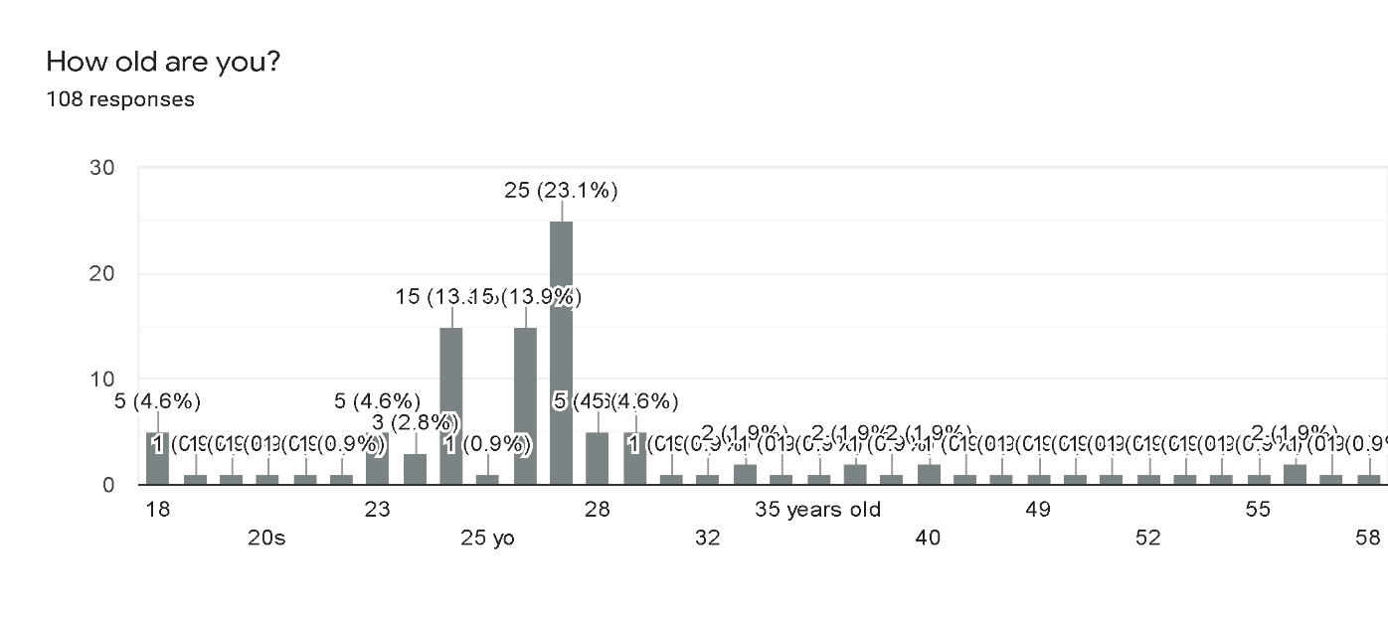

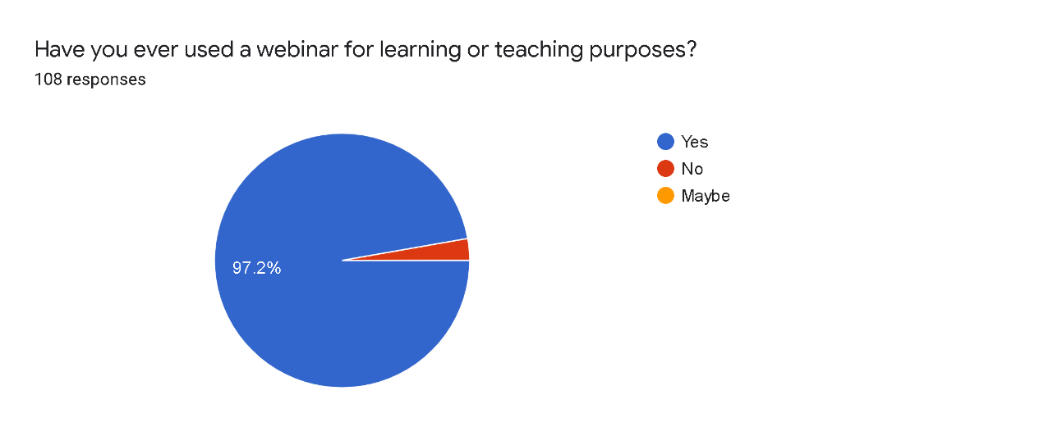
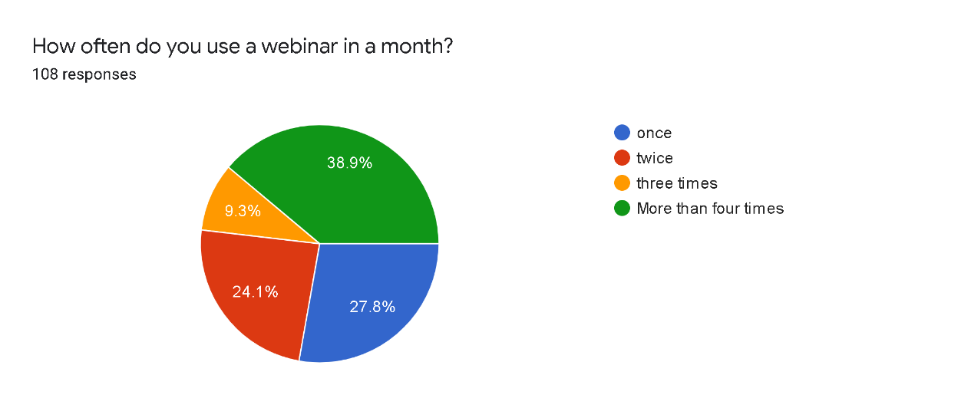
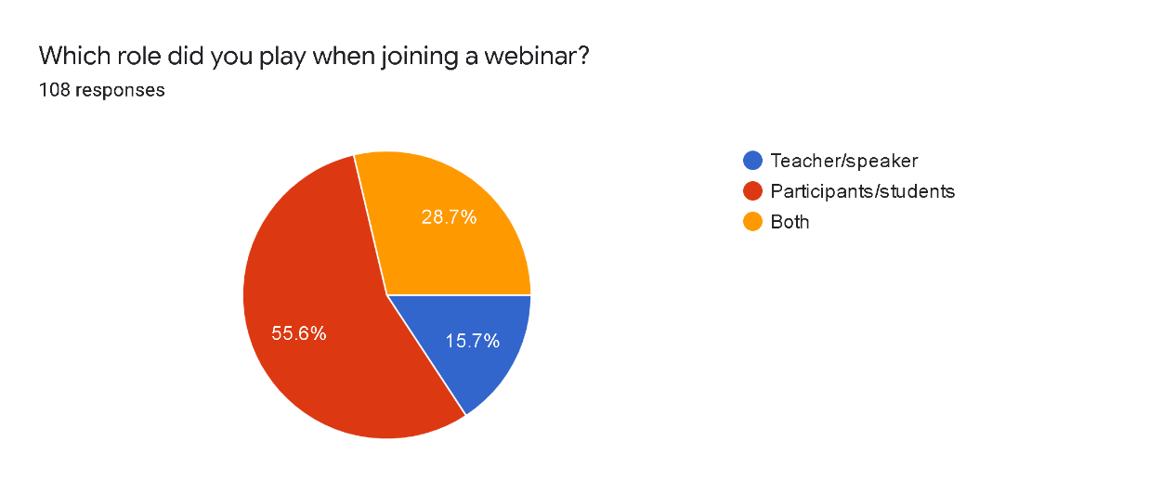

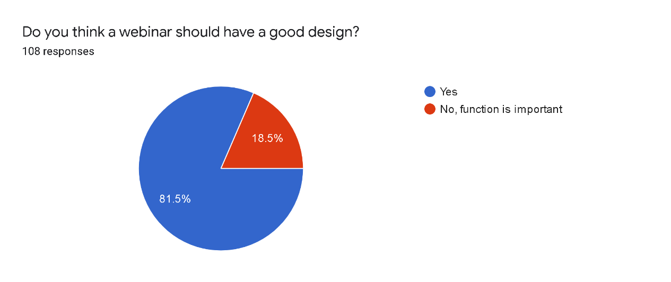
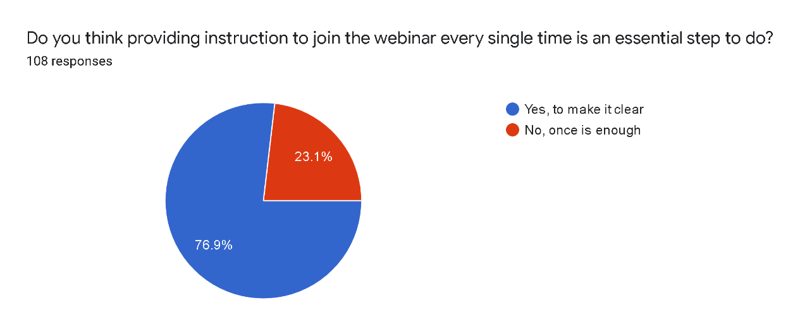
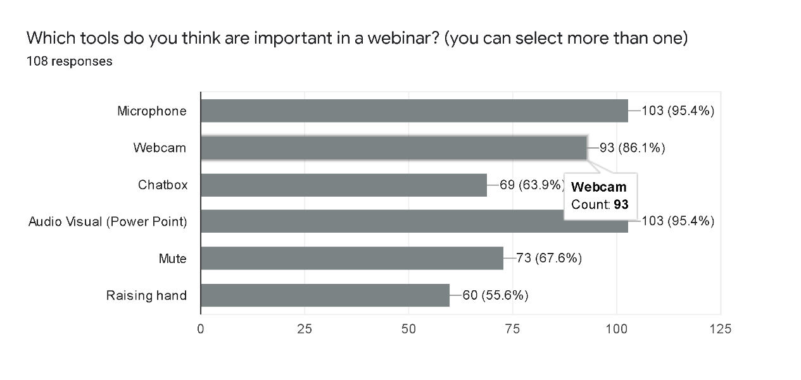

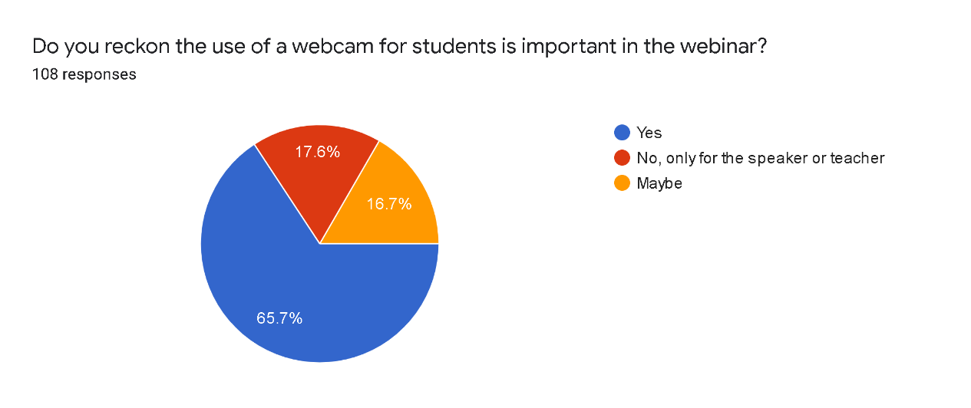
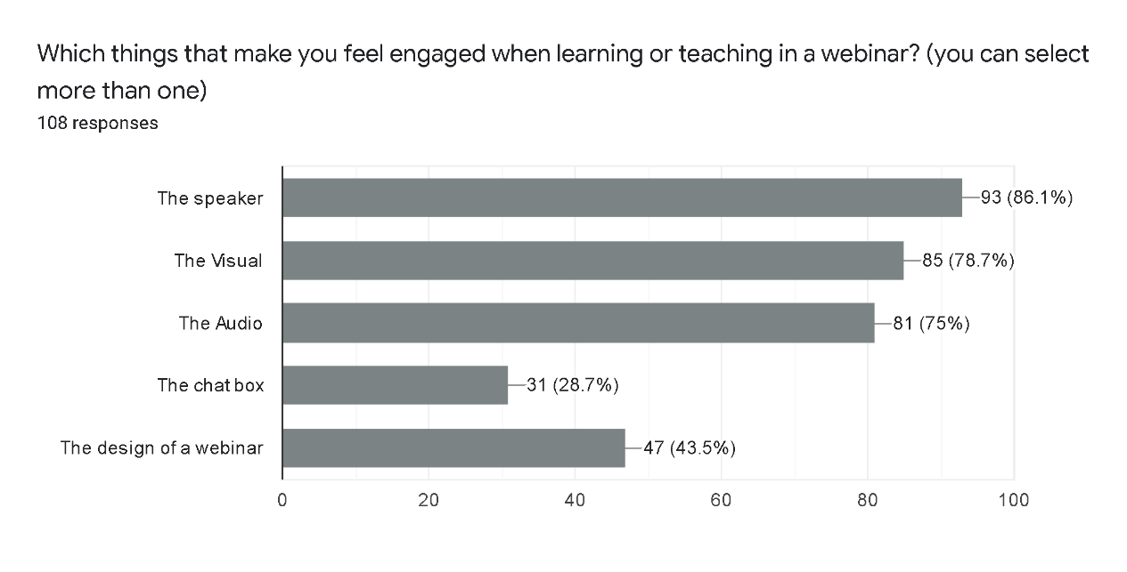
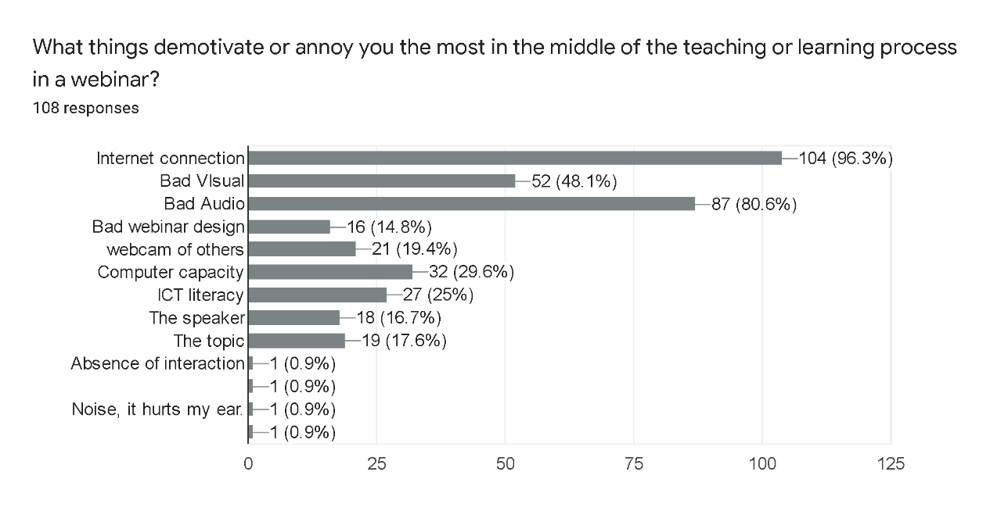
If there is a feature that you want to add, what is it? or what are those?108 responses
-
Nothing
discussion like jamboard google
Attendance list
None
Internet connection
No
Security, screen sharing, recording
Animation
attendance list
Filter?
Games
Maybe more capacity of participant
The feature i want add such as presence list before entering the webinar
to download the powerpoint/webinar material through the platform itself
Asking a question
VR
Feature that enables teachers to show ppt/other media while looking at all students’ reaction during presentation to make sure they are engaged in the learning activity
I want to add the screen for video and recording automatically
Indonesian transcription
Quiz
breaking room / discussion room (not all platform provides provides it)
Nope
Splitting the room for group discussion and then joining again.
No, everything is perfect for me
An active board (not the whiteboard provided, a different one)
Auto Save of PowerPoint Slide, Background
Better internet connection
Applications reply to certain chats or to certain people we want
Screen share
no, there isnt so far. it's just technically slow internet connection that ruins a webinar
Unlimited time
Automatically anti-noise would be very good.
I guess theres nothing to add but maybe improve the quality of each feature
Lock the chat box
Di ajak lagi
Interactive board
Nothing
automatic design of the webinar
Group feature: in a class, participants can be divided into few groups without adding a new link
To mute all the participants in one click (for the speakers/moderators)
Change background without greenscreen
Notification and screenshot
Interactive
Automatic upload to google drive
Green Screen
for zoom, it is the integrated whiteboard (Jamboard seems not working well).
Anithing as long as it is interactive feature.
Sorting feature, especially when the participants raised their hands.
I can be explaining while writing
Power point sharing for all members
Direct access to the power point.
Music or video
Webinar design that easy to choose
anything, as long as it is interesting
rewind
Notebook feature for the participants.
Quiz and attendance list
Quiz and polling
QnA
4D
Communicative slide
Papan tulis
Premium web feature
Recorder
HD video
auto answer
upload
A feature to see all students when we have a break out room in zoom meeting for colaborative learning so the teacher can see the students activities
Vote

If there is a feature that you want to remove, what would it be?108 responses
-
Nothing
None
none
Nope
Barriers
No
I don't know
Webcam
I don’t think that there is any, in fact, there should be more features to add
Raising hands
null
Chat box
I don't want to remove any features
mute video
Nothing needs to remove
There is not
Chatbox
Time limit
the freeze filter on google meet or any other hacks that keeps participants away from the session
The option of turning off webcam. Everyone should visible attending the class
I prefer a small thumbnail for user appearance. 'Cause it looks like unnecessary if they are not in chat/camera on/say something, but shows in a big thumbnail.
Pin the participant. It is sometimes humiliating when you get pinned without any reason in the middle of webinar.
Belajar
no i think there's no need to remove anything
Webcam of other participants (as a participant)
Not yet
Mute
Audio volume adjustment
All features matter
Boring features
nothing
chat box
Noise
game
boring features
raising hand
chatbox in the middle of explanation
chat
Clap

On a scale of 1-10, how would you rate the webinar session compared to the traditional classroom? Why?108 responses
7
5
6
5 its hard to engage students in learning, when they want to engage the platform somtimes does not allow it
8
4
10
Scale : 8, bcz it can be flexible snd cost-effective
4, prefer classroom
6, it does not work as effectively as traditional classroom for me, since I learn better through visual rather than audio
7, The reason is traditional classroom better than webinar .Bad connection is the problem in webinar class
I am not sure in what aspect I should compare them. However, I will rate it in terms of effectiveness, it's 5. This is because there sometimes are problems which empede communication, interaction, and understanding. Some of those problems are correlated with internet connection, students' motivation, teachers' and students' being exhausted, etc.
7, more comprehensive but needs more energy to focus
4. Traditional classroom offers real engagement.
6 because sometimes it is not really effective
8, since the lack of f2f communication
6. It’s helpful in a way we can access various kinds of teaching materials but it’s challenging since students’ engagement is hard to maintain
5, because sometimes the participants do not pay attention. Webinar session also requires good internet connection and devices but some of students do not have that.
8, participants/students are able to access class from anywhere, anytime...
9 (practicality)
As a kindergarten teacher 6, because too many obstacles and make the kids bored, but as a participant, 8, because we can learn anywhere we want
8. It is easier for students to understand the materials because there is no noise. Students can focus on their gadget screen like they focus on studying alone. It feels like a private tutoring.
8. I believe that the webinar session is as effective as traditional classroom. Although the interaction is done virtually, if all particpants and the host are aware of eah other presence, there's nothing to worry about. In webinar session, teacher can easily integrate fun online games and use a wider range of tools.
10 , more practical
3
4, its easier to do in a traditional way
6. Face to face is more trusty and engage able
Webinar 5. Traditional classroom 10. Teaching in the classroom is more effective.
8, in terms of its flexibility
5. Because I got less from webinar, I mean I cannot understand the lesson well using webinar. Worse than I must go to campus to join the class.
8. Because I think it can encourage distance education. But, in different circumstances, traditional face-to-face is better, especially for teachers who are still lack of technology literacy
8. Both of them have their negative and positive impact, especially effectiveness.
5. It is way more effective when we get to see friends and teacher physically. Its either increasing our emotional or having fun in the middle of the class.
6, due to connection problems and the bad quality of audios
6, because traditional classroom makes more interactive between the speaker and the participant
9
5 because for free or trial we can't use more time (time has a limit time from the aplication that we use) and we also can't interactive with student because internet conection between teacher and student not optimal.
7. The time is flexible and everyone around the globe can join it. However, bad internet connection could be a problem.
10 .. in the middle of pandemic outbreak it’s better be like this. Save time and money for transport
6. presence and direct communication is more important
6. Traditional classroom is still much better compared to webinar session because I think interaction between teacher-students or student-student are very important. However, this is very helpful in this situation (pandemic).
5. Direct interaction couldn't be replaced.
5. Direct Interaction. I couldn't directly control the students/participants.
3. in terms of practical, webinar is good. however, it requires good internet connection which is hard to find in Indonesia plus the gadget specification couldn't support it.
7. too much distraction from other applications.
7. direct interaction is still needed to watch the students.
8. people who joined webinar, usually have their own personal motives. they will be active and easily engaged.
5. no direct interaction.
5. helpful in the middle of the pandemic. however, direct interaction is way much better.
5. hard to interact.
7. helps shy people to be more confident.
1, the limitation of connection
7. I can be multitasking and more conducive.
8. the ability to engage is important
5. direct interaction is still more valuable.
6. it's hard to get future questions to the speaker.
7, Face to face is better
5. direct interaction is better.
5. Direct interaction is better.
7.
9. easy to use and flexible
5. DIrect interaction is better.
7. less social interaction
7.
4. direct interaction is best.
5. there is no direct interaction
5. direct interaction is better
4. too much lag
6.. less engagement especially for the young English learners
5. To much distraction
What things should be considered or improved in the future utilization of a webinar in Indonesia?108 responses
Internet connection
better platform that can accommodate the needs
-
The use of webcam to engage between speakers and participants
Internet connection.
How the teacher deal with camera
internet connection
Stable and fast internet for all around Indonesia
Better internet connection, webcam and audio
Connection is a must
Internet
I believe it should be the connection, since webinar works at its best performance during smooth internet connection
generalize first the internet connection in Indonesia
Time management
First of all, many cases happen due to internet connection and other technical things. For example, not few of mys students were unable to join webinar as their electricity is off or the internet connection is unstable.
webinar should be more interactive such as showing suprise guest star, games, video, etc
Time management, use of engaging media, and stable internet connection
The quality of internet question
Stable internet connection for everyone, ITC literacy
To this extend, all things are good that it can accomodate what speaker and audiences need
1. It's better to add the duration for aplication such as zoom (more than 40 minutes) 2. The participants are more than 100 3. The cost for the internet is cheaper
The internet connection
Improve the internet connection
equal distribution of internet access throughout Indonesia and socialization how to use the features of the webinar
Featured that can make internet connection more stable 😁
More free internet connection in every corner of public places.
The ICT skill and awareness of webinar function should be improved. Many people arent aware of the tools function and often considered webinar as less important than the actuall face to face meeting/classroom session. Their paradigm should be changed.
Design is one of the things. And sometime in webinar there is too much participants so it is very hard to interact with the speaker. Participant number limitation would be a great addition for the future webinar in Indonesia.
A stable internet connection is a must.
Internet connection and interactive applications
ICT Literary for teacher and students
Internet connection.
when we hold a webinar, we also have to consider whether the platform we are using can be easily reached from any region
Free internet connection, strong signal.
Akses Internetnya harus rata dulu di seluruh indonesia. Baru bisa ngomongin webinar.
internet connection 😂
The connection, the way speaker speak in front of the camera, and the materials.
The role of teachers to organise and manage the webinars. In order to make students engage
Audio quality
Internet connection, 'cause our BTS (provider) has no optimal work when without electricity (power failure).
I guess the technology itself is already great but the teacher or speaker must have an extra lesson to use all of the feature therefore we could enjoy our lesson too. Not by blaming the tech or us the participant or student.
I don't have any idea for now
Perlu di kembangkan
Internet conection
A mic for the speaker should be clear as well as the camera
Free of internet
the quality of the speaker and topic
Clear instruction and rules.
Interactive design of the webinar
Internet connection and design
Good connection
Attractiveness
The size of the webinar application and stable connection
Internet connection and better webcam quality.
Internet connection and cheap phone that supports webinar.
Internet connection must be improved, to avoid buffering in the middle of the session.
The topic of webinar should be interesting, so people won't get bored.
the data usage should be lower.
The teacher should get training in how to use webinar properly.
local Indonesia software with a free license for all teachers and students
The moderator has to be trained, so the webinar will be flawless.
Lots of training and workshop on how to use webinar properly.
Webinar should facilitate like conventional classroom.
Interaction in webinar has to be similar with interaction in traditional classroom.
The better webinar design.
Interesting topic, more communicative and good internet connection.
easy use application, because elder seems to find it hard to operate webinar and choose YouTube, cause it is easier.
the speaker should be able to make the class motivated.
the topic should be interesting.
gadget distribution should be balance
Better internet connection.
public Wi-Fi could be the key.
training for using webinar.
duration of the session and internet connection.
better internet connection
Learner autonomy
Design
internet speed.
Training and workshop of webinar
participants' interactions
data safety and internet connection
Topic and the ability of the speakers
participant limitation.
easy access to good internet
two way communication between the speaker and participants
4G to 5G
better internet connection, audio and power point
Webinar sessions Will be more atractive if the fasilitator / teachers could prepare well
Designing, organizing, and executing the webinar

