attachment

Forgiveness among Javanese Ethnic Students: A Mountainous, Highland, Lowland, and Coastal Culture Background Comparison
Andar Ifazatul Nurlatifah

Summary Statistic
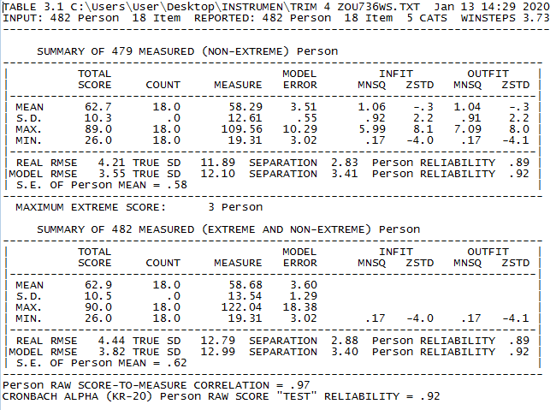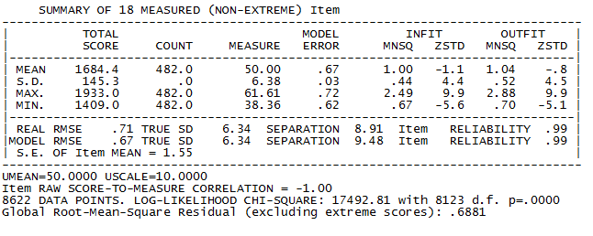

Item Misfit Order
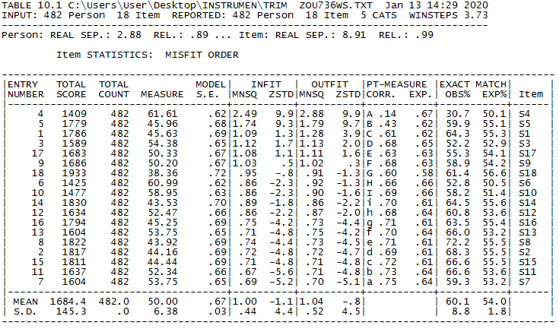
item measure order
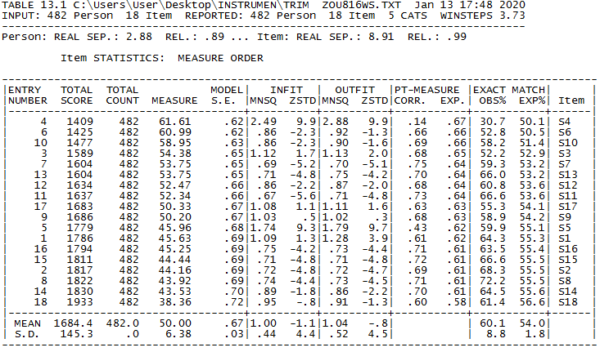

unidimentionality
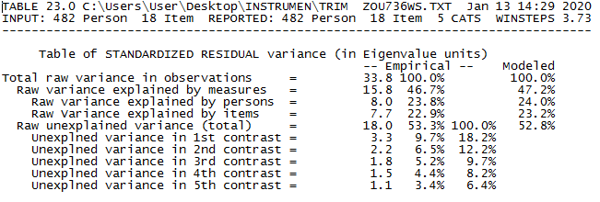

Descriptive Statistics
 |  | N |  | Minimum |  | Maximum |  | Mean |  | Std. Deviation
topographicculture |  | 482 |  | 1.00 |  | 4.00 |  | 2.4544 |  | .87646
lessenrevenge |  | 482 |  | 6.00 |  | 30.00 |  | 22.0539 |  | 4.10278
lessenavoidance |  | 482 |  | 4.00 |  | 32.00 |  | 12.8900 |  | 3.27060
benevolence |  | 482 |  | 8.00 |  | 81.00 |  | 21.5166 |  | 5.03715
forgiveness |  | 482 |  | 31.00 |  | 141.00 |  | 56.4606 |  | 8.87400
revengecategory |  | 482 |  | 1.00 |  | 5.00 |  | 4.0415 |  | .94238
avoidancecategori |  | 482 |  | 1.00 |  | 5.00 |  | 3.3672 |  | 1.09810
benevolencecategory |  | 482 |  | 1.00 |  | 5.00 |  | 3.9004 |  | .96640
Valid N (listwise) |  | 482
revenge category
 |  |  | Frequency |  | Percent |  | Valid Percent |  | Cumulative Percent
Valid | sangat rendah |  | 7 |  | 1.5 |  | 1.5 |  | 1.5
Valid | rendah |  | 20 |  | 4.1 |  | 4.1 |  | 5.6
Valid | sedang |  | 102 |  | 21.2 |  | 21.2 |  | 26.8
Valid | tinggi |  | 170 |  | 35.3 |  | 35.3 |  | 62.0
Valid | sangat tinggi |  | 183 |  | 38.0 |  | 38.0 |  | 100.0
Valid | Total |  | 482 |  | 100.0 |  | 100.0
avoidance categori
 |  |  | Frequency |  | Percent |  | Valid Percent |  | Cumulative Percent
Valid | sangat rendah |  | 25 |  | 5.2 |  | 5.2 |  | 5.2
Valid | rendah |  | 68 |  | 14.1 |  | 14.1 |  | 19.3
Valid | sedang |  | 185 |  | 38.4 |  | 38.4 |  | 57.7
Valid | tinggi |  | 113 |  | 23.4 |  | 23.4 |  | 81.1
Valid | sangat tinggi |  | 91 |  | 18.9 |  | 18.9 |  | 100.0
Valid | Total |  | 482 |  | 100.0 |  | 100.0
benevolence category
 |  |  | Frequency |  | Percent |  | Valid Percent |  | Cumulative Percent
Valid | sangat rendah |  | 8 |  | 1.7 |  | 1.7 |  | 1.7
Valid | rendah |  | 24 |  | 5.0 |  | 5.0 |  | 6.6
Valid | sedang |  | 131 |  | 27.2 |  | 27.2 |  | 33.8
Valid | tinggi |  | 164 |  | 34.0 |  | 34.0 |  | 67.8
Valid | sangat tinggi |  | 155 |  | 32.2 |  | 32.2 |  | 100.0
Valid | Total |  | 482 |  | 100.0 |  | 100.0
forgiveness category
 |  |  | Frequency |  | Percent |  | Valid Percent |  | Cumulative Percent
Valid | rendah |  | 22 |  | 4.6 |  | 4.6 |  | 4.6
Valid | sangat rendah |  | 1 |  | .2 |  | .2 |  | 4.8
Valid | sangat tinggi |  | 85 |  | 17.6 |  | 17.6 |  | 22.4
Valid | sedang |  | 152 |  | 31.5 |  | 31.5 |  | 53.9
Valid | tinggi |  | 222 |  | 46.1 |  | 46.1 |  | 100.0
Valid | Total |  | 482 |  | 100.0 |  | 100.0

data normality test
One-Sample Kolmogorov-Smirnov Test
 |  | lessen revenge | lessenavoidance | benevolence | forgiveness
N |  | 482 | 482 | 482 | 482
Normal Parameters^{a,b} | Mean | 22.0539 | 12.8900 | 21.5166 | 56.4606
Normal Parameters^{a,b} | Std. Deviation | 4.10278 | 3.27060 | 5.03715 | 8.87400
Most Extreme Differences | Absolute | .094 | .135 | .112 | .058
Most Extreme Differences | Positive | .094 | .086 | .112 | .057
Most Extreme Differences | Negative | -.080 | -.135 | -.112 | -.058
Test Statistic |  | .094 | .135 | .112 | .058
Asymp. Sig. (2-tailed) |  | .000^{c} | .000^{c} | .000^{c} | .001^{c}
a. Test distribution is Normal.
b. Calculated from data.
c. Lilliefors Significance Correction.

Kruskal-Wallis
Ranks
 | topographicculture | N | Mean Rank
lessenrevenge | 1.00 | 91 | 267.63
lessenrevenge | 2.00 | 115 | 247.12
lessenrevenge | 3.00 | 242 | 229.81
lessenrevenge | 4.00 | 34 | 235.78
lessenrevenge | Total | 482
lessenavoidance | 1.00 | 91 | 242.79
lessenavoidance | 2.00 | 115 | 239.94
lessenavoidance | 3.00 | 242 | 231.07
lessenavoidance | 4.00 | 34 | 317.57
lessenavoidance | Total | 482
benevolence | 1.00 | 91 | 241.13
benevolence | 2.00 | 115 | 238.52
benevolence | 3.00 | 242 | 238.56
benevolence | 4.00 | 34 | 273.49
benevolence | Total | 482
forgiveness | 1.00 | 91 | 252.58
forgiveness | 2.00 | 115 | 241.92
forgiveness | 3.00 | 242 | 230.58
forgiveness | 4.00 | 34 | 288.16
forgiveness | Total | 482

Test Statistics^{a,b}
 | lessenrevenge | lessenavoidance | benevolence | forgiveness
Chi-Square | 5.196 | 11.688 | 1.970 | 5.890
df | 3 | 3 | 3 | 3
Asymp. Sig. | .158 | .009 | .579 | .117
a. Kruskal Wallis Test
b. Grouping Variable: topographicculture

Mann-Whitney

Ranks
 | LAND | N | Mean Rank | Sum of Ranks
TRIMR | 1.00 | 91 | 108.26 | 9851.50
TRIMR | 2.00 | 115 | 99.73 | 11469.50
TRIMR | Total | 206
TRIMA | 1.00 | 91 | 104.26 | 9488.00
TRIMA | 2.00 | 115 | 102.90 | 11833.00
TRIMA | Total | 206
TRIMB | 1.00 | 91 | 104.14 | 9476.50
TRIMB | 2.00 | 115 | 103.00 | 11844.50
TRIMB | Total | 206
TOTALTRIM | 1.00 | 91 | 106.09 | 9654.00
TOTALTRIM | 2.00 | 115 | 101.45 | 11667.00
TOTALTRIM | Total | 206

Test Statisticsª
 | TRIMR | TRIMA | TRIMB | TOTALTRIM
Mann-Whitney U | 4799.500 | 5163.000 | 5174.500 | 4997.000
Wilcoxon W | 11469.500 | 11833.000 | 11844.500 | 11667.000
Z | -1.023 | -.165 | -.137 | -.555
Asymp. Sig. (2-tailed) | .306 | .869 | .891 | .579
a. Grouping Variable: LAND

Ranks
 | LAND | N | Mean Rank | Sum of Ranks
TRIMR | 1.00 | 91 | 186.04 | 16930.00
TRIMR | 3.00 | 242 | 159.84 | 38681.00
TRIMR | Total | 333
TRIMA | 1.00 | 91 | 172.92 | 15735.50
TRIMA | 3.00 | 242 | 164.77 | 39875.50
TRIMA | Total | 333
TRIMB | 1.00 | 91 | 168.21 | 15307.50
TRIMB | 3.00 | 242 | 166.54 | 40303.50
TRIMB | Total | 333
TOTALTRIM | 1.00 | 91 | 178.12 | 16209.00
TOTALTRIM | 3.00 | 242 | 162.82 | 39402.00
TOTALTRIM | Total | 333

Test Statisticsª
 | TRIMR | TRIMA | TRIMB | TOTALTRIM
Mann-Whitney U | 9278.000 | 10472.500 | 10900.500 | 9999.000
Wilcoxon W | 38681.000 | 39875.500 | 40303.500 | 39402.000
Z | -2.225 | -.694 | -.142 | -1.294
Asymp. Sig. (2-tailed) | .026 | .488 | .887 | .196
a. Grouping Variable: LAND

Ranks
 | LAND | N | Mean Rank | Sum of Ranks
TRIMR | 1.00 | 91 | 65.32 | 5944.50
TRIMR | 4.00 | 34 | 56.78 | 1930.50
TRIMR | Total | 125
TRIMA | 1.00 | 91 | 57.61 | 5242.50
TRIMA | 4.00 | 34 | 77.43 | 2632.50
TRIMA | Total | 125
TRIMB | 1.00 | 91 | 60.78 | 5531.00
TRIMB | 4.00 | 34 | 68.94 | 2344.00
TRIMB | Total | 125
TOTALTRIM | 1.00 | 91 | 60.37 | 5493.50
TOTALTRIM | 4.00 | 34 | 70.04 | 2381.50
TOTALTRIM | Total | 125

Test Statisticsª
 | TRIMR | TRIMA | TRIMB | TOTALTRIM
Mann-Whitney U | 1335.500 | 1056.500 | 1345.000 | 1307.500
Wilcoxon W | 1930.500 | 5242.500 | 5531.000 | 5493.500
Z | -1.179 | -2.742 | -1.125 | -1.330
Asymp. Sig. (2-tailed) | .238 | .006 | .261 | .183
a. Grouping Variable: LAND

Ranks
 | LAND | N | Mean Rank | Sum of Ranks
TRIMR | 2.00 | 115 | 187.55 | 21568.50
TRIMR | 3.00 | 242 | 174.94 | 42334.50
TRIMR | Total | 357
TRIMA | 2.00 | 115 | 183.33 | 21083.00
TRIMA | 3.00 | 242 | 176.94 | 42820.00
TRIMA | Total | 357
TRIMB | 2.00 | 115 | 178.89 | 20572.50
TRIMB | 3.00 | 242 | 179.05 | 43330.50
TRIMB | Total | 357
TOTALTRIM | 2.00 | 115 | 184.80 | 21252.00
TOTALTRIM | 3.00 | 242 | 176.24 | 42651.00
TOTALTRIM | Total | 357

Test Statisticsª
 | TRIMR | TRIMA | TRIMB | TOTALTRIM
Mann-Whitney U | 12931.500 | 13417.000 | 13902.500 | 13248.000
Wilcoxon W | 42334.500 | 42820.000 | 20572.500 | 42651.000
Z | -1.084 | -.551 | -.014 | -.733
Asymp. Sig. (2-tailed) | .278 | .582 | .989 | .464
a. Grouping Variable: LAND

Ranks
 | LAND | N | Mean Rank | Sum of Ranks
TRIMR | 2.00 | 115 | 75.83 | 8721.00
TRIMR | 4.00 | 34 | 72.18 | 2454.00
TRIMR | Total | 149
TRIMA | 2.00 | 115 | 69.71 | 8017.00
TRIMA | 4.00 | 34 | 92.88 | 3158.00
TRIMA | Total | 149
TRIMB | 2.00 | 115 | 72.63 | 8353.00
TRIMB | 4.00 | 34 | 83.00 | 2822.00
TRIMB | Total | 149
TOTALTRIM | 2.00 | 115 | 71.67 | 8242.00
TOTALTRIM | 4.00 | 34 | 86.26 | 2933.00
TOTALTRIM | Total | 149

Test Statisticsª
 | TRIMR | TRIMA | TRIMB | TOTALTRIM
Mann-Whitney U | 1859.000 | 1347.000 | 1683.000 | 1572.000
Wilcoxon W | 2454.000 | 8017.000 | 8353.000 | 8242.000
Z | -.436 | -2.767 | -1.235 | -1.734
Asymp. Sig. (2-tailed) | .663 | .006 | .217 | .083
a. Grouping Variable: LAND

Ranks
 | LAND | N | Mean Rank | Sum of Ranks
TRIMR | 3.00 | 242 | 138.03 | 33404.00
TRIMR | 4.00 | 34 | 141.82 | 4822.00
TRIMR | Total | 276
TRIMA | 3.00 | 242 | 132.35 | 32029.00
TRIMA | 4.00 | 34 | 182.26 | 6197.00
TRIMA | Total | 276
TRIMB | 3.00 | 242 | 135.96 | 32903.50
TRIMB | 4.00 | 34 | 156.54 | 5322.50
TRIMB | Total | 276
TOTALTRIM | 3.00 | 242 | 134.52 | 32553.00
TOTALTRIM | 4.00 | 34 | 166.85 | 5673.00
TOTALTRIM | Total | 276

Test Statisticsª
 | TRIMR | TRIMA | TRIMB | TOTALTRIM
Mann-Whitney U | 4001.000 | 2626.000 | 3500.500 | 3150.000
Wilcoxon W | 33404.000 | 32029.000 | 32903.500 | 32553.000
Z | -.260 | -3.446 | -1.415 | -2.214
Asymp. Sig. (2-tailed) | .794 | .001 | .157 | .027

Andar Ifazatul Nurlatifah, IAIN Salatiga, andarifa@iainsalatiga.ac.id

