ANOVAª
Model |  | Sum of Squares | df | Mean Square | F | Sig.
1 | Regression | ,324 | 2 | ,162 | 2,873 | ,060^{b}
1 | Residual | 8,795 | 187 | ,056
1 | Total | 9,119 | 189
a. Dependent Variable: TA
b. Predictors: (Constant), SR, ROA

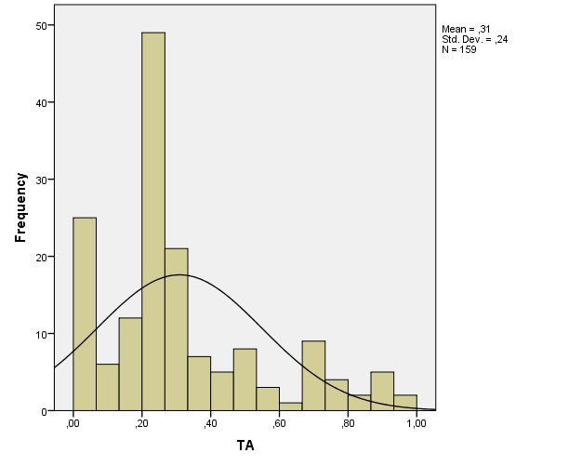

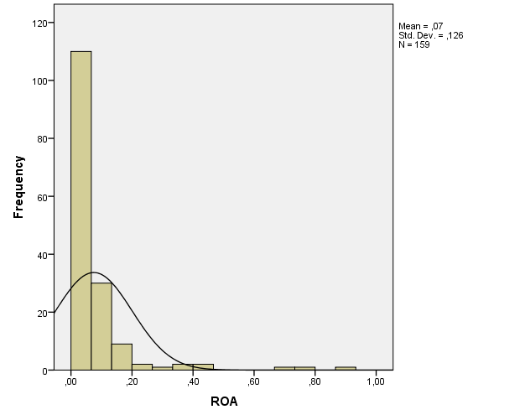

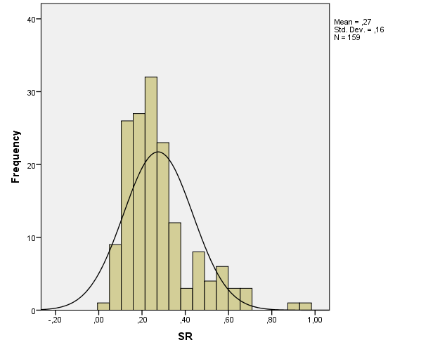

Variables Entered/Removedª
Model | Variables Entered | Variables Removed | Method
1 | sqrtROA, SR^{b} | . | Enter
a. Dependent Variable: TA
b. All requested variables entered.

Model Summary^{b}
Model | R | R Square | Adjusted R Square | Std. Error of the Estimate | Durbin-Watson
1 | ,208ª | ,043 | ,031 | ,23648 | 1,373
a. Predictors: (Constant), sqrtROA, SR
b. Dependent Variable: TA

ANOVAª
Model |  | Sum of Squares | Df | Mean Square | F | Sig.
1 | Regression | ,395 | 2 | ,197 | 3,530 | ,032^{b}
1 | Residual | 8,724 | 156 | ,056
1 | Total | 9,119 | 158
a. Dependent Variable: TA
b. Predictors: (Constant), sqrtROA, SR

Coefficientsª
Model |  | Unstandardized Coefficients |  | Standardized Coefficients | t | Sig. | Collinearity Statistics
 |  | B | Std. Error | Beta | t | Sig. | Tolerance | VIF
1 | (Constant) | ,383 | ,044 |  | 8,656 | ,000
1 | SR | ,004 | ,119 | ,003 | ,034 | ,973 | ,980 | 1,021
1 | sqrtROA | -,329 | ,125 | -,208 | -2,634 | ,009 | ,980 | 1,021
a. Dependent Variable: TA

One-Sample Kolmogorov-Smirnov Test
 |  | Unstandardized Residual
N |  | 159
Normal Parameters^{a,b} | Mean | ,0000000
Normal Parameters^{a,b} | Std. Deviation | ,23497742
Most Extreme Differences | Absolute | ,151
Most Extreme Differences | Positive | ,151
Most Extreme Differences | Negative | -,073
Test Statistic |  | ,151
Asymp. Sig. (2-tailed) |  | ,200^{c}
a. Test distribution is Normal.
b. Calculated from data.
c. Lilliefors Significance Correction.

Coefficientsª
Model |  | Unstandardized Coefficients |  | Standardized Coefficients | t | Sig.
 |  | B | Std. Error | Beta | t | Sig.
1 | (Constant) | ,230 | ,028 |  | 8,159 | ,000
1 | SR | -,002 | ,075 | -,002 | -,030 | ,976
1 | sqrtROA | -,222 | ,080 | -,220 | -2,792 | ,070
a. Dependent Variable: ABSUT

