Analysis of Tourism Education to Promote Innovation in Gastronomy

Andreas Suwandi, ⁽¹⁾, Nindita Fajria Utami ⁽²⁾, Endah Fitriyani⁽³⁾ , Shandra Rama Panji Wulung ⁽⁴⁾
(1)(3)(4)Program Studi Pendidikan Pariwisata
(2)Pendidikan Sosiologi
Universitas Pendidikan Indonesia
andreassuwandi@upi.edu

Submitted : 26 Maret 2021

ABSTRACT

The organization of tourism education is now important for the administration of gastronomic tourism. Vocational High Schools in the field of food expertise have a significant role in the development and promotion of gastronomic tourism in Bandung. Bandung has various types of food and drinks. At present there is no mapping of gastronomic education in Bandung. The purpose of this research is to monitor the gastronomic mapping through the role of providing education namely the Vocational High School, diploma and bachelor’s degree in the promotion and promotion of gastronomic tourism in Bandung. The research method used through qualitative collection with secondary data collection techniques in the form of documentary evidence. The analytical method uses content analysis and descriptive. The results showed that gastronomy education was classified into three levels, namely vocational high school, diploma, and bachelor's degree. This study also maps the distribution of gastronomic education through the role of tourism education to promote gastronomy in Bandung

Keywords: Gastronomy, tourism education, vocational school

- INTRODUCTION
Indonesian food has potential as a varied and innovative global product. Indonesian traditional food consists of all types of food that are made and processed native to Indonesia, using local ingredients and by various and varied processing methods, and have regional special types, ranging from main foods, snack foods and drinks commonly consumed by the people of the area . One of Indonesia's foods that can compete as a global product is ulukutek lenca, colenak and Tutug oncom. These foods come from the Bandung area. Tutuq oncom rice is a food made from rice mixed with Indonesian special oncom currently does not have a standard recipe. Ulukutek lenca, colenak and Tutug oncom rice are not yet recognized as Indonesian special foods from the city of Bandung. This is a very disappointing promotion and there is no administration of gastronomic tourism as a medium that diverts regional food recipes. Therefore there is a need for participatory steps from educational institutions starting from Vocational High Schools, Diplomas, and scholars to develop culinary tourism specifically in developing regional foods.
The typical food of the city of Bandung has the name and basic ingredients of cuisine which has the potential to become global food. Various foods and drinks typical of the city of Bandung, namely: ulukutek lenca, colenak, tutuq oncom rice, surabi, seblak, lead rice, peyeum, aci baso, goyobod ice and cendol ice. Food and drinks typical of the city of Bandung has a creative and diverse way of cooking and serving. The potential of food and beverages in the city of Bandung can develop and have a high gastronomic value to be offered in global food competition. The role of special educational institutions in the field of tourism is to promote and administer Bandung's regional specialties starting from collecting standard recipes, names of regional specialties and the history of the food itself.

- LITERATURE REVIEW
Tourism Education Organization
Tourism education is formed to meet the needs of the tourism industry to become a competent person in accordance with industry standards (Nelson and Dobson, 2001). According to Riegel (1991) tourism education substantially consists of three key elements: knowledge, skills and values. The substantive element of knowledge is an essential element for applying theories related to the Tourism Industry, the element of skill is something that trains the professionalism of its abilities, and the value element is the key to the success of tourism education in accordance with the needs of the world of tourism.
Development Model according to Walker and Jeremy (2001), namely the development of tourism education in the field of hotels and business travel.
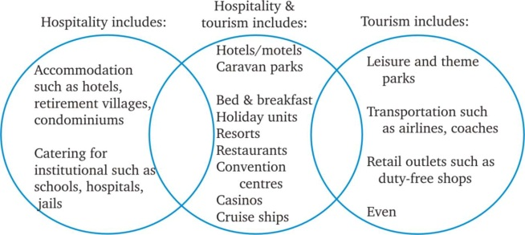
Figure 1: Tourism Education Development Model
Tourism Education according to walker (2002) in the form of travel includes business travel, hotels, food and beverage services or restaurants and recreational tourism. This is the foundation of Tourism Education in order to develop and contribute to the world of tourism.
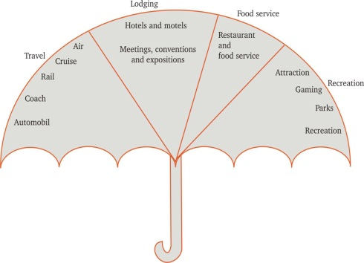
Figure 2: Scope of The Hospiality and Tourism Industry (Walker, 2002)
Tourism Education Institutions in Indonesia include:
- Vocational High School (SMK) is a vocational secondary education program that has a hospitality program in Hospitality Accommodation, Tourist Travel Business and Catering.
- Diploma (D1, D2, D3) is a diploma education program that offers Hospitality, Food Management and Tourism Travel programs.
- Bachelor (S1) is a higher education program that offers hospitality management expertise programs, Food and Business Travel Tourism.
The relevance of the curriculum in tourism education institutions is needed to ensure harmony between the needs of the industry and the competencies of graduates produced. The purpose of the tourism education curriculum is to prepare students who are moral, professional, and independent. Tourism education must be designed to produce graduates who have operational and managerial abilities so that it can be applied in the world of work (Wei-Lu, 1999). Skill is defined as a person's ability obtained through the process of learning and training (Clark, 1995). Jafari (2002) links the proportion and composition of these jobs with the education and training needs described in a pyramid where top management is the smallest and unskilled workforce is very large. In this connection, he described the relationship between the education and training process with the world of work called the Tourism Education-Training Continuum.
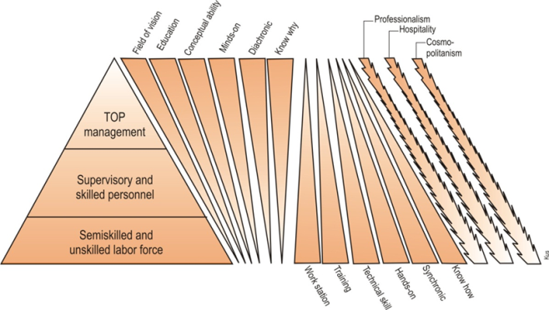
Figure 3: Tourism Education Training Continuum (Jafari, 2002)
The role of tourism education institutions at the secondary level, diploma and higher education not only has good managerial skills and abilities, but its role can promote gastronomic tourism that has been studied. This is in line with mutually inclusive processes in this model, tourism education has the same relationship as a symbiotic relationship 'ie having a balance between skill, managerial and activities promoting gastronomic tourism (Shaw and Nightengale, 1995).
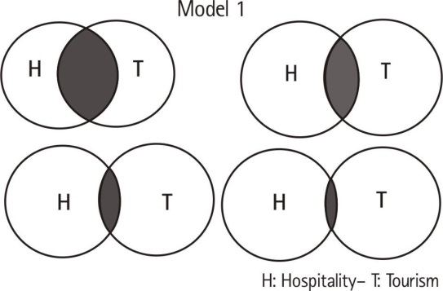
Figure 4: Tourism and Hospitality Educational Model 1 (Chen and David, 1999)
Gastronomic Tourism
Gastronomic tourism is part of special interest tourism. Therefore gastronomic tourism refers to trips made with the aim of enjoying food and drinks as a major factor in determining the decision to visit a place. Turgarini (2013: 1) revealed a study of aspects of gastronomy, namely practical gastronomy, theoretical gastronomy, technical gastronomy, food gastronomy, and molecular gastronomy (Molecular Gastronomy). These five aspects have different characteristics and are applied according to the field of gastronomy to be performed. For example, practical gastronomy can be a reference in studying aspects of gastronomy including processing from raw materials into food and judging from cultural aspects. Gastronomy combined with tourism has become a tourism resource for the creation of new products. Gastronomic coverage does not only look at food in terms of meeting physiological needs but the assessment of food as an aspect of culture and assets for the region. It was also stated that gastronomy is the art and science of eating well. As for the gastronomic understanding, that is someone who is experienced in gastronomy.
The development of cooking skills as a tourist attraction, basically sends quality to consumers not only on food ingredients, but also includes the overall quality of service. Based on a series of descriptions that have been submitted, in the development of traditional Indonesian cooking skills as an attraction for cultural tourism, we need to understand the following:
- Tourists don't want monuments, landmarks, and nature or man-made, they want other experiences.
- Tourists will make food as part of the experience when traveling to Indonesia. They will enjoy the taste and taste of the food there, and then bring the story of delicacy when returning to the country. Besides that, in fact most of their expenses are budgeted for food, so food, taste, cleanliness and environmental friendliness become something big in culinary tourism.
- Intangible cultural heritage, such as local food, is designed to encourage economic development, especially through tourism, so according to him research and development needs to be done.
- Local cooking and culinary skills must be linked to other tourism products suchas hotels and restaurants, spas, festivals, traditions, museums, and other activities.
Culinary tourism is recognized as a way to carry out local culinary culture, stimulate tourism demand, and increase destination competitiveness, so gastronomic tourism has also emerged as an increasingly important component of destination marketing (Hashimoto and Telfer 2006; Long 2004). By exploring traditional foods (new foods felt by them), tourists will feel they will get more experience in the direction of local culture. Then, the people share their local culture with tourists through this media, the local people make a representation of the identity of the destination. The formation of identity and image creation are related to local food, so that it can attract the intended market, and benefit the development of gastronomic tourism at the same time. In addition, food also holds an important place in thinking globally and acting locally.

- RESEARCH METHOD
The approach in this study uses qualitative methods that are useful for testing and developing an understanding of a phenomenon that is little known, and for enabling the discovery of in-depth information about a research subject. Data collection methods use secondary data such as journal articles, reports, organizational web pages, and policy documents that are reviewed to get a broader perspective of the issue of tourism and human resource development. Further data needs in the form of a tourism education curriculum whose information is obtained through the website of the tourism education providers and direct communication. The choice of curriculum is limited based on the level of vocational school education. After receiving all documents, a thematic analysis of the curriculum is carried out.

- RESULT AND DISCUSSION
Based on observations made by researchers, by communicating directly on tourism education providers, literature studies, and observations using the website, tourism education data in Bandung City that focus on the development of gastonomic tourism, especially in promoting regional food can be found in educational providers who have majors catering and hospitality. The culinary department has a clear curriculum to learn about regional foods that must be mastered by students, the hospitality department and hospitality management learn the science of gastronomy even though it is not as focused as the culinary department, but in some hospitality departments it also learns how to promote regional food, make a menu for regional food so that it can develop even better. So the researchers included education providers who have a food, hospitality and hospitality management curriculum included in the category of mapping tourism tourism institutions specifically to promote and administer gastronomy, especially in the city of Bandung.
Figure 5 below shows the mapping of tourism education in support of gastronomy, especially in the city of Bandung based on education levels. It can be seen that the total number of educational institutions that focus on developing gastronomy is 28 majors out of 35 tourism education institution organizers from the senior high school level. At the SMK level there are 14 majors that study gastronomy from 19 SMKs, from the level of educational institutions there are 1 majors from 3 educational institutions, from the academy level there are 7 majors from 8 tourism academies, and the undergraduate level there are 6 majors from 5 Universities and Colleges.
From the observations, it was also found that there are not many curricula from the hospitality / hospitality majors that have specific gastronomic curriculums, so that it can become an issue in the future to be followed up by academics and practitioners. Making Bandung as a culinary tourism icon would be better if all stakeholders from the government, private sector, academics all played an active role to improve Bandung's gastronomic innovation.

Figure 5: Mapping of Tourism Gastronomy Education in Bandung

- CONCLUSION

Based on the results of the study, the conclusion of this study is to answer the research objectives, namely to carry out gastronomic mapping through the role of providing education, namely Vocational High Schools, diplomas and scholars in the promotion and promotion of gastronomic tourism in Bandung with the results of the study showing that cooking skills education is classified into three levels , namely vocational high schools, diplomas, and scholars with total acquisition there are 28 majors from 35 tourism education institutions in Bandung that support innovation in the field of gastronomy. Through the role of tourism education, especially in the field of gastronomy, the choice of Bandung as a culinary tourism city should have a big role, because with the many educated staff in the field of gastronomy it will help develop the gastronomic innovation in the city of Bandung. It is expected that for further research, to do a broader mapping, until the Bandung regency so that all supporting data can be obtained to promote and improve gastronomy in Bandung viewed from the educational organizing agency. So that if it is felt that it is still lacking in being educated in the field of gastronomy, it can be a strategic reference in making policies to support the gastronomy of Bandung and Indonesia.

REFERENCES
Airey D., (2002), ‘Growth and Change in Tourism Education’ Rethinking of Education and Training for Tourism (ed) Vukonic B and Cavlek N, Graduate School of Economics and Business, University of Zagreb, 2002, pp 13-22
Airey D., (2003) Tourism education the dilemma of succes? Tedqual 6/1, 2003.
Airey, D., (1995), Tourism Degrees -Past, Present and Future, Inaugural Lecture, 31 January 1995, (Nottingham: Nottingham Business School).
Amoah, V. and Baum, T. (1997) Tourism education: policy versus practice. International Journal of Contemporary Hospitality Management, Vol.9, No.1 pp5–12
Baker, Kevin and and Jeremy Huyton (2001). Hospitality management: an introduction. Hospitality press. Melbourne.
Bartlett, A. L., Upneja, A., & Lubetkin, M. E. (1998). Benchmarking hospitality management curricula: a comparison of top US programs. Journal of Hospitality and Tourism Educator, 10 (3), 41- 46.
Baum, T. (1991). Competencies for hotel management: industry expectations of ducation. International Journal of Contemporary Hospitality Management, 2 (4), 13-6.
Bragg, Debra D (2001). Opportunities and Challenges for the new Vocationalism in American Community Colleges. (pp. 5-16.)
Burkart, A.J. and Medlik, S., (1974), Tourism, Past Present and Future, (London: Heinemann).
Butler, R.W., (1980), ‘The Concept of A Tourism Area Cycle of Evolution; impli-cations for management of resources’, Canadian Geographer, 24(1): 5-12.
Casado, M.A. (1992) Higher education hospitality schools: meeting the needs of the industry, Hospitality and Tourism Educator, Vol. 4 No 2, pp. 41-44.
Chen, K.C and Groves, D. (1999) The importance of examining philosophical relationships between tourism and hospitality curricula. International Journal of Contemporary Hospitality Management, Vol.11, No.1, pp.37-42
Clark, M. (1995). Interpersonal skills for hospitality management (1st ed.).
Dale, C and Robinson, N (2001) The theming of tourism education: a three-domain approach. International Journal of Contemporary Hospitality Management, Vol.13, No.1, pp.30-34
Eduardo F, Garcia and Adela M. 2002. A Modest proposal: on the tourism policy and destination management research programme. Tedqual 5/1, 2002.
Elfrink, J.A. and Anthony, K.F. (1995) A survey of student assessment in hospitality education: implications for the future, Hospitality Research Journal, Vol. 18, No. 3, pp. 143-53.
Fahy, J. (1998). The role of resources in global competition. In G. Hooley, R. Loveridge, & D. Wilson (Eds.), Internationalisation: Process, context and markets (pp. 122–135). London: McMillan Press.
Jacobs (2001), James. Community Colleges and the Workforce Investment Act: Promises and Problems of the New Vocationalism. (pp 93-100).
Jafari, J. 2002. Tourism education and training model, Getting to core of destination planning and management. Tedqual 5/1, 2002.
Ladki, S. M. (1993). Hospitality education: the identity struggle. International Journal of Hospitality Management, 12 (3), 243-251.
McIntosh, R.W. (1992) Early tourism education in the United States, Journal of Tourism Studies, Vol. 3, No. 1, pp. 2-3.
McIntosh, RW and C. Goeldner. 1998. Tourism: principles, practices, philosophies. 5th ed. John Wiles & Sons. Singapore
Pavesic, D. (1993) Hospitality Education 2005: Curricular and Programmatic Trends Hospitality Research Journal, Vol. 17, No.1, pp. 285-294.
Pavesic, D. (1996) Determinants of quality in hospitality undergraduate programs, Hospitality and Tourism Educator, Vol.8, No.2/3, pp.96-103.
Pollock, Anna. 2004. Tourism: A New Role in a New Century. Keynote Speaker PATA Conference, Korea.
Riegel, C. (1995) An introduction to career opportunities in hospitality and tourism, in a guide to college programmes in hospitality and tourism, New York: John Wiley and Sons
Schmidgall, R.S. and Woods, R.H. (1994) CHRIE member perceptions of tenure requirements in hospitality education programmes, Hospitality Research Journal, Vol. 18. No. 1, pp. 101-120.
Shaw, M. and Nightengale, M. (1995) Scholarship reconsidered: implications for hospitality education, Hospitality Research Journal, Vol. 18, No. 3, pp. 81-93.
Tribe, J., (1997), ‘The Indiscipline of Tourism’ Annals of Tourism Research 24(3): 628-657.
Tribe, J., (2000), ‘Balancing the vocational: the theory and practice of liberal education in tourism’ Tourism and Hospitality Research 2(1) 2000: 9-25.
Walker, John, R. (2002) Introduction to hospitality. Prentice Hall.
Wei-Lu (1999) Important skills for taiwanese hospitality and tourism graduates as perceived by hospitality educators and human resorce managers. Thesis, University of Wisconsin-Stout.

