Lampiran
Statistic deskriptif

Descriptive Statistics
 | N | Minimum | Maximum | Mean | Std. Deviation
FINANCIAL DISTRESS | 190 | .79 | 7.45 | 2.2219 | 1.11440
ROA | 190 | .00 | 20.48 | 4.1473 | 5.68255
DER | 190 | .08 | 1.95 | .7041 | .46403
INFLASI | 190 | 3.02 | 3.61 | 3.4054 | .22903
Valid N (listwise) | 190

Uji Normalitas

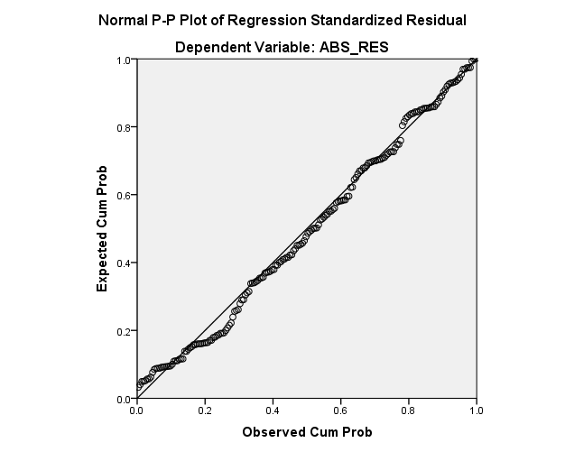

Uji Multikolineritas

Coefficientsª
Model |  | Unstandardized Coefficients |  | Standardized Coefficients | t | Sig. | Collinearity Statistics
 |  | B | Std. Error | Beta |  |  | Tolerance | VIF
1 | (Constant) | -.095 | .190 |  | -.499 | .618
 | ROA | -.007 | .002 | -.292 | -3.893 | .000 | .873 | 1.146
 | DER | .017 | .029 | .059 | .567 | .571 | .460 | 2.175
 | INFLASI | .089 | .060 | .154 | 1.476 | .142 | .454 | 2.201
a. Dependent Variable: ABS_RES
Uji Heteroskedastisitas (uji park)

Coefficientsª
Model |  | Unstandardized Coefficients |  | Standardized Coefficients | t | Sig.
 |  | B | Std. Error | Beta
1 | (Constant) | -10.641 | 3.348 |  | -3.178 | .002
 | ROA | -.037 | .031 | -.092 | -1.198 | .232
 | DER | .300 | .520 | .061 | .577 | .564
 | INFLASI | 1.905 | 1.060 | .191 | 1.797 | .074
a. Dependent Variable: RES3_Ln

Uji Autokorelasi

Model Summary^{b}
Model | R | R Square | Adjusted R Square | Std. Error of the Estimate | Durbin-Watson
1 | .838ª | .701 | .697 | .05340 | 1.551
a. Predictors: (Constant), LnZ@1, LnX1@1, LnX2@1
b. Dependent Variable: LnY@1

Hasil Analisis Regresi
Uji F
ANOVAª
Model |  | Sum of Squares | df | Mean Square | F | Sig.
1 | Regression | 144.531 | 3 | 48.177 | 98.827 | .000^{b}
 | Residual | 90.186 | 185 | .487
 | Total | 234.717 | 188
a. Dependent Variable: FINANCIAL DISTRESS
b. Predictors: (Constant), INFLASI_LN, ROA_LN, DER_LN

Pengaruh ROA (X1) dan DER (X2) terhadap financial distress

Model Summary
Model | R | R Square | Adjusted R Square | Std. Error of the Estimate
1 | .785ª | .616 | .610 | .69820
a. Predictors: (Constant), INFLASI_LN, ROA_LN, DER_LN

Coefficientsª
Model |  | Unstandardized Coefficients |  | Standardized Coefficients | t | Sig.
 |  | B | Std. Error | Beta
1 | (Constant) | 9.382 | 1.781 |  | 5.268 | .000
 | ROA_LN | -.101 | .030 | -.164 | -3.372 | .001
 | DER_LN | 1.644 | .136 | 1.077 | 12.124 | .000
 | INFLASI_LN | -5.046 | 1.400 | -.316 | -3.604 | .000
a. Dependent Variable: FINANCIAL DISTRESS

Uji moderating regression analysis (MRA)
- ROA
Model Summary
Model | R | R Square | Adjusted R Square | Std. Error of the Estimate
1 | .563ª | .317 | .305 | .93119
a. Predictors: (Constant), ROAi, INFLASI_LN, ROA_LN

Coefficientsª
Model |  | Unstandardized Coefficients |  | Standardized Coefficients | t | Sig.
 |  | B | Std. Error | Beta
1 | (Constant) | -8.807 | 1.256 |  | -7.009 | .000
 | ROA_LN | -.119 | .073 | -.193 | -1.633 | .104
 | INFLASI_LN | 8.931 | 1.038 | .559 | 8.606 | .000
 | ROAi | .008 | .007 | .154 | 1.284 | .201
a. Dependent Variable: FINANCIAL DISTRESS

- DER

Model Summary
Model | R | R Square | Adjusted R Square | Std. Error of the Estimate
1 | .809ª | .655 | .649 | .66012
a. Predictors: (Constant), DERi, INFLASI_LN, DER_LN

Coefficientsª
Model |  | Unstandardized Coefficients |  | Standardized Coefficients | t | Sig.
 |  | B | Std. Error | Beta
1 | (Constant) | 2.990 | 2.017 |  | 1.482 | .140
 | DER_LN | .105 | .281 | .069 | .374 | .709
 | INFLASI_LN | -1.656 | 1.454 | -.104 | -1.139 | .256
 | DERi | .533 | .091 | .818 | 5.834 | .000
a. Dependent Variable: FINANCIAL DISTRESS

