LOCAL CONTENT PROMOTION IN FORMING MALANG CITY PUBLIC LIBRARY’S BRAND EQUITY

oleh
Reza Mahdi
Fery Wahyu Ramadhan
Library Science, Faculty of Letter, State University of Malang

ABSTRACT
Local content is content that is owned by a library with a particular subject, for example the local content of a city or regional public library is a collection of books and non-book libraries that talk about the city or area of the library. But for the Public Library of Malang City, local content is divided into two types, namely collections of authors from Malang and collections that talk about Malang. The local content of Malang City Public Library must be highlighted, one of them is by doing a promotion, to become a differentiator of the public library with other public libraries. This research is a qualitative research with descriptive method. Data retrieval is done by observing and interviewing the librarians of Malang City Public Library and Malang Community.

Keywords: Local Content, Public Library, Library Promotion

INTRODUCTION
Branding is one that must be done in creating the identity of a product or service so that users can easily remember it. In this case, a brand of product or service is needed in determining the identity of some product or service, so that will easily recognized by the user. Products or services can be the same, but what differentiates these products or services from others is through branding, because it is a strategy of giving brand strength to products or services (Kotler & Keller, 2009). Here there is an effort to form a brand so that there are many uses.
However, creating a brand is not enough if the product is not specifically identified. People know the product just limited as they know but do not know what is specific about the product or services. Therefore all we need is some value or it’s called by brand equity, which is the unique of some product or service that we want to promote. This equity will produce how strong an identity of the product or service produced by the agency / institution, focusing on the products and services produced by the agency / institution (Widjanarko, 2003).
Public city library as the cultural and literacy center of course have to introduce the city / area that manage it’s library. When we go to the city library what looks different from the library of this area with the others. Local content from the city library is what distinguishes a city from another library.
Therefore the promotion of local content that is closely related to the area such as art and culture, where the library is located is very important. For example, there are visitors who want to find references about what is Malang and the culture of it, Malang Public Library is the answer to that problem. From there it can be seen that the brand equity of the Malang City Public Library is a source of information when looking for collections on the history, culture, and customs of the city of Malang.

LITERATURE REVIEW
- Branding and Brand Equity

Branding or brand determination is a tool used by marketers to differentiate their products from competing products (Setiyaningrum, Udaya, & Efendi, 2015). Even the product same as the other brand, branding make it different. This needed to be considered by the marketers, as the appearance of the various same product, especially in shaping a brand equity. In a marketing world, brand equity is defined as number of assets and liabilities related to the brand (brand), symbols (such as logos) and names, which increase or decrease the value of a product and service for the institution / customer for its customers (Ferrinadewi, 2008 in Ratana, 2018).
Aaker, the professor that focuses on marketing and branding strategy classify the dimensions into brand awareness, brand loyalty, brand association and precieved quality (Baalbaki & Guzman, 2016). Brand awareness is some strength from product of service (brand) which we can measure as the consumer’s ability to identify brand under different conditions (Keller, 2008 in Patil, 2017). Some product or service maybe same as the other, but with branding people will able to identify and know what’s the different with the other same product or service. Then, brand loyalty is the heart of brand equity because it’s a strategy to make society often or always use some brand (product or service) (Baalbaki & Guzman, 2016, p. 33). So the shaping a brand loyalty so a brand will create a loyalness for the society to use it for the long period of time rather than the competeting product or service. The brand association is not less important than the two dimensions that have been mentioned. It is important if the brand owned by the manufacturer is similar in terms of attributes with other brands or if the company is important to be chosen (Mayasari, 2018). It’s almost similar with the brand awareness but in here we shape the identity to it’s brand, so the society will aware to that brand. So, it can be say brand association is the predecessor of brand awareness. The last but not least is precieved quality. It’s very important to, because in this dimension, we talk about the product or service assessment from the society based on their perception (Saleem, Rahman, & Omar, 2015). So it’s all about the first impression of what are we making for them, because mostly people give a perception based on their first using experience.

- City Public Library

Based on the National Standard of Library, Public city library as one of the literacy centers of a region that manage it, have functions for lifelong learning, regardless of age, race, religion, socio-economic status, and gender (Perpustakaan Nasional Republik Indonesia, 2011). It must provide access for all people regardless of the reed, whoever he/her is. The collections in there must reflect current trends and the evolution of society, as well as the memory of human endeavour and imagination. (International Federation of Library and Information Associations & Institutions, 2016).

- Local Content

This is a different type of collection in the library. The term of local content means local material or information that is inserted into another container (Utomo, 2019). Rather than general collection, this content have a certain theme. This type of collection has content that specifically talk about certain areas or environments in accordance with certain restrictions (Mazidah, 2017). The example, when there is a library that leads by political governmental organization, they will utilize the local content that have a subject correlated to organization’s core business (about politic), to promote the library. The other such as a library in some city that has local content about the city that control the library, such as social, history, and culture.
So based on the explanation above, we can conclude that the local content is a information that represent the specified environments, then become the identity of the library itself.

- Library Promotion

In a 4 marketing mix that been conducted by Philip Koetler (marketring professor), promotion is the one of important things that marketers should do. In that case, even though the product or service offered to consumers is good, they are not sure of the benefits of the product or service if they have never heard or felt it (Prisgunanto, 2014). So if we correlated to the library, promote what’s in the library (S. K. Patil & Pradhan, 2014). Librarian as a marketer and the products such as library content (books, journal, proceeding, audiovisual collection), as well the library services for example, co-working space, seminar, literature finding, and other else.

METHOD
In this study, a qualitative approach is used, namely the research whose object is examined in a reasonable or natural condition in natural and inventive conditions (Mamik, 2015). The data collection technique is to collect two data, first the primary data, then the secondary data. Primary data obtained from observation and interviews. While secondary data obtained from the literature - the literature that supports the discussion of this
Observation conducted to describe the environment that we look at it include activities, person that involved in the environment, and meaning of events based on involved individual perspective (Herdiansyah, 2013). So we can say in observation the researcher present in there. The object of this observation can be divided into three, they are place, actor, and activity. For the place, namely in the Malang City Public Library, then the actor or actor responsible for managing local content is the librarian. The last activity is, whether the promotion has been going well or has not started at all.
Interview is an activity of meeting two or more people to exchange information and ideas through question and answer so that they can shape the meaning of the problem or topic that exists (Sugiyono, 2009). The interview conducted on librarians from the Malang City Public Library and the Malang community. Finally, the location of this study is in the Malang City Public Library (observation and interview).

RESULT AND DISSCUSSION
- The Malang Public Library Promotion

Based on interviews conducted with the librarians in there named S and U, there are two types of local content in the Malang City Public Library. First, the local content is a collection written by authors from Malang, for example lecturers from universities in Malang. Then the collection was published for example by UM Press (publisher from Malang State University). Then, the second type is content that is themed about Malang, for example history, culture, social, and culinary. Content that talks about Malang is also displayed in photos on the staircase of Malang City Public Library such as “Kota Malang Tempo Dulu”. Then the collection of books which are local content such as a book entitled Malang Sejuta Prestasi (year 2011), then Malang Tempo Doloe.
This collection of local content has been done since 2016, but the local content has not been more grouped. This year's plan from the Malang City Public Library is to gather writers, publishers, and cultural experts to write about Malang. Later when there are already many collections about that, the library can group the collection themselves.
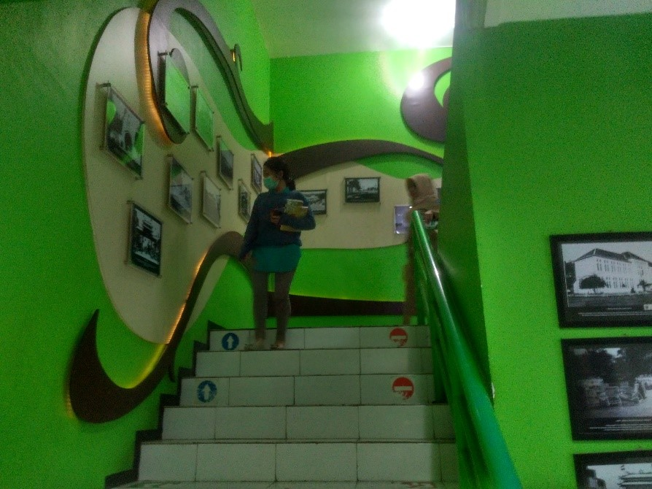

Figure 1 : The stairs go up to the Malang City Public Library Collection room which is also a gallery of local content in the past Malang photos

For its promotion, Malang City Public Library uses websites and social media such as Twitter, Instagram and Facebook. Promotions have been made on services such as braille corners in the library near the reference room. Then the library promotion was also held at RRI (Radio Republik Indonesia) Malang. However, on the social media, the library has not promoted its local content because it is still in collecting process. But other things organized by the library, for example, they are going to make a book writing competition which is one of the initial stages of developing local content from the Malang Public Library, because the participants must write about Malang.

Figure 2 : Some local content located in Malang entitled Malang Sejuta Prestasi and Malang Tempo Doeloe

- Society Opinion

Some people who have been interviewed say that local content is very important to be highlighted by the Malang City Public Library by promoting them. Students from the Islamic University of Malang majoring in mathematics named (initial) I and M argue that local content in the library is very important to be highlighted, so that the outside community knows about Malang, moreover Malang as an education city because of the many universities that exist. Then another opinion from them is outsiders have to know about Malang, for example, about good culinary and reliable writers.
Opinions about local content also come from (initial) D who works as a hair cutter. He often go there because the facilities were complete and the infrastructure was good, so when he wanted to do another job with a laptop, besides working as a haircutter, he went to the library. He said that the local content is important to display, because the history of Malang city and others about the city must be highlighted in order to have a distinctive characteristic of Malang City Public Library with other Public Libraries.
Finally, the opinions of two Malang Sidewalk Library (Perpus Trotoar Kota Malang) students and teams, named (initial) H from Malang Islamic University and Z from Universitas Brawijaya, argue that local content in the Malang City Public Library must be present and highlighted such as local culture, history, and culinary. According to H, knowledge of Malang city has begun to erode along with the times, therefore the Malang City Public Library has a role to give knowledge about it. H believes that promotion can be done by creating an application that contains information about the local content of the library. Then the opinion of Z regarding the promotion of the library, which is by promoting local library content at events such as Malang Heritage and Malang Tempoe Doloe, whose collections can be promoted by Malang historians.

- Social Media as a Promotion Tool

Today, many people use social media to interact with others. For example, to share experiences to sell a product though. The biggest community Indonesia, internet users is the market and a promotion itself if can make the peer to peer philosophy in the social media marketing working well (Grataridarga, 2018). Of course the library can also implement the promotion of its services and products through social media that many people use it.
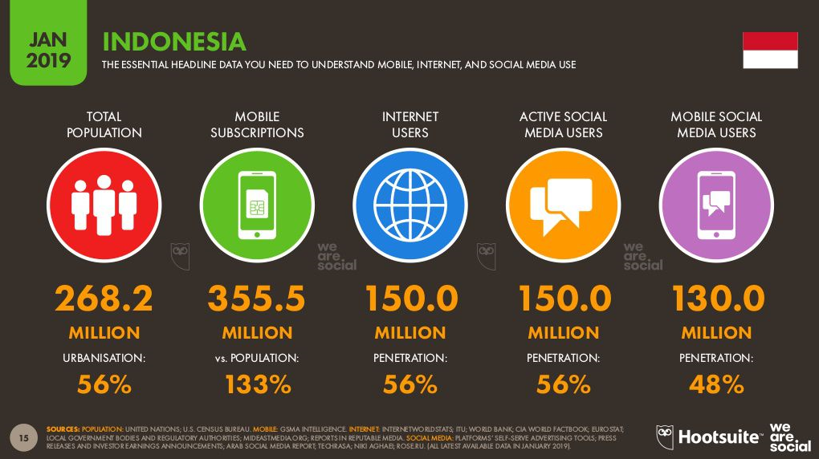
The Indonesian Internet Service Provider Association (APJII) has conducted a survey conducted in 2017 against internet users in Indonesia. It is said that the percentage of people using social media is around 87.13% of the population (Asosiasi Penyelenggara Jasa Internet, 2017). Then the latest survey, named Indonesia Digital Report 2019 which was carried out in January 2019 states, Indonesian people have 150 million social media users (Hootsuites, 2019). Judging by the number, it is not surprising that many people use social media to promote their products or services and it’s also possible for libraries to use social media to promote it’s content.
Figure 3 : Data on Indonesian Internet Users surveyed by Hootsuite. We can see the social media data that displayed as an element that is often used on the internet by the Indonesian Community.

The library can promote its local content through social media such as Instagram, Facebook, Twitter and YouTube. On Instagram, libraries can upload short content about a collection of local content they have, such as a short review or video. Then on Twitter, librarian can do a little talk on local content in the library. On Facebook as well as Instagram, make reviews and videos related to local content. Finally, on YouTube we can promote local content with videos, for example in a complete library profile, specifically the local content.

- Make an Infographic

One good method to promote the library is to make an infographic containing local content in Malang City Public Library. In the meaning, infographics are divided into two words, named info and graphics or information and graphics, which are visualizations of information, knowledge, data, ideas, graphics, schedules and more so that all can be presented visually interesting (more than text) that will make readers understand it more quickly and precisely (Kurniasih, 2016). A complex message will be easier to understand, simple, attract attention. Not only that, infographic can explain a data more easily and periodically monitor any parameters of data changes that exist (Resnatika, Sukaesih, & Kurniasih, 2018).
The Malang Public Library can utilize it, for example by making infographics about the politics of Malang city by later referring to collections in the Malang City Public Library. Then for example about reviewing collections that will be packaged in such a way with interesting infographics, so that people can be interested in reading the book. This infographic can also be used as content on library social media.

- Local Culture Discussions

People today have a tendency to go to the library if there are interesting activities such as the discussion and others. As previously known, local culture can also include local content in the Malang City Public Library. Knowledge management that is carried out from the cultural person to the library will certainly produce new knowledge which will later become a product of libraries that have specific subjects. This culture can be expressed as a holistic lifestyle, a way of life that develops and is owned by a group of people or society (Nasution, 2016). Example, one of the distinctive culture of Malang is the existence of the term Walikan Language (balikan) which is a distinct advantage because it does not exist in other regions. The library then do some discussions activity by invite the public about that.
Figure 4 : The Betawi Corner at Nyi Ageng Serang Public Library
Activities that have cultural elements and locality can be a way of promotion because, like BPAD Special Region of Yogyakarta, have cultural discussion activities with persons who are experts in their fields and involve the community in them by inviting all elements of society, such as government, practical, academics (lecturers, students and researchers) as one of the efforts besides providing knowledge about new things and disseminating cultural knowledge that is the identity of a region. Of course this activity can be intitiated by the library as one of the institutions that provide information for visitors with various groups in Malang City.

- Special Spots or Library Corner for Promotion

Create special spots for existing local content, for example, the Nyi Ageng Serang Public Library (Jakarta City Library). The special spot is called Betawi Corner (Betawi corner), which is located in the reference room, a separate room containing collections about Jakarta in terms of social and cultural aspects. The library can also create a special spot / room that has a collection of distinctive features that become Malang's identity (art, culture, travel, etc.).

- The Impact to Library’s Brand Equity

Promotion increase library brand equity because people will later understand that the library contains the social and cultural of the city, then embedded in their mind as the identity of the library (brand association). Then the library's image will be good, because there are things that are different from the city library, such collections that are specific to the city / district so that anthropologists, researchers, and other society or community can easily search for material when researching the city (pecieved quality). They may often visit the library if they want to know about the city's social and culture (brand loyalty). Thus, the public will be aware of the specifics of the library, that contain the local content in there (brand awareness).

conclusion
Branding is needed in various products or services, namely as brand formation so that it becomes a differentiator with others. In branding there is brand equity which is the value of the product or service so that the community will know specifically about the differences. There are so many City Public Libraries in each city on the province, but the thing that differentiates it from the city public library is from local content. From there, local content should be highlighted so that the city public library has good value in the community by conducting promotions. Promotion of local content can be done through the local content in social media, then the other way is make some discussion about it, make an infographic, and making a corner like Betawi Corner at Nyi Ageng Serang Library .
The Malang City Public Library as a literacy center for the Malang community has begun to collect a lot of its local content so that it can be more grouped and eventually can be more highlighted to the community. The Malang community also argued that it was very important that the local content of Malang City Public Library be more highlighted by conducting promotions on social media, through applications, or various events. This was done so that there was a prominent difference from the Malang City Public Library with other public libraries.

REFERENCES
Asosiasi Penyelenggara Jasa Internet. (2017). Penetrasi & Perilaku Pengguna Internet Indonesia. 2018(31 August 2018), Hasil Survey.
Baalbaki, S., & Guzman, F. (2016). Consumer-based brand. In The Routledge Companion to Contemporary Brand Management (pp. 32–47). Retrieved from https://www.researchgate.net/publication/309478932_Consumer-based_brand_equity
Grataridarga, N. (2018). Special Collections as Information Policy for Culture of Indonesia. KnE Social Sciences, 3(11), 1042. https://doi.org/10.18502/kss.v3i11.2828
Herdiansyah, H. (2013). Wawancara, Observasi, dan Focus Groups : Sebagai Instrumen Penggalian Data Kualitatif (1st ed.). Jakarta: Rajawali Pers.
Hootsuites. (2019). Indonesia Digital Report.
International Federation of Library and Information Associations & Institutions. (2016). IFLA/UNESCO Public Library Manifesto 1994. Retrieved July 22, 2019, from IFLA Webpage website: https://www.ifla.org/publications/iflaunesco-public-library-manifesto-1994
Kotler, P., & Keller, K. L. (2009). Manajemen Pemasaran. Jakarta: Erlangga.
Kurniasih, N. (2016). Infografis. Seminar Nasional “Komunikasi, Informasi Dan Perpustakaan Di Era Global,” 456–465. https://doi.org/10.13140/RG.2.2.27145.03680
Mamik. (2015). Metodologi Kualitatif (N. Retnowati, Ed.). Sidoarjo: Zifatama Publisher.
Mayasari, C. (2018). Pengaruh Asosiasi Merek Terhadap Keputusan Pembelian. Manajemen Bisnis, 4(1), 18–27. https://doi.org/10.22219/jmb.v4i1.5250
Mazidah, Z. R. (2017). Kebijakan Layanan Koleksi Lokal Konten Tercetak Pada Era Digital Di Perpustakaan Perguruan Tinggi DKI Jakarta. 1–9. Retrieved from http://digilib.esaunggul.ac.id/public/UEU-paper-8923-UEU-paper-8918-21_0024.pdf
Nasution, M. K. M. (2016). Budaya Lokal dan Keterbukaan Informasi. In Conference: Sosialisasi Undang-Undang - WR3 USU. https://doi.org/10.13140/RG.2.2.28335.94886
Patil, P. H. (2017). Brand awareness and brand preference. International Research Journal of Management and Commerce, 4(7), 14–24. Retrieved from https://www.researchgate.net/publication/319711029_BRAND_AWARENESS_AND_BRAND_PREFERENCE
Patil, S. K., & Pradhan, P. (2014). Library Promotion Practices and Marketing of Library Services: A Role of Library Professionals. Procedia - Social and Behavioral Sciences, 133, 249–254. https://doi.org/10.1016/j.sbspro.2014.04.191
Perpustakaan Nasional Republik Indonesia. (2011). Standar Nasional Perpustakaan : Standar Nasional Perpustakaan Provinsi. Jakarta: Perpustakaan Nasional Republik Indonesia.
Prisgunanto, I. (2014). Komunikasi Pemasaran Era Digital. Jakarta: Prisani Cendekia.
Ratana, M. (2018). Pengaruh Social Media terhadap Ekuitas Merek. Jurnal Penelitian Komunikasi, 22(1), 13–28. https://doi.org/10.31445/jskm.2018.220102
Resnatika, A., Sukaesih, S., & Kurniasih, N. (2018). Peran infografis sebagai media promosi dalam pemanfaatan perpustakaan. Jurnal Kajian Informasi Dan Perpustakaan, 6(2), 183–196. https://doi.org/10.24198/jkip.v6i2.15440
Saleem, S., Rahman, S. U., & Omar, R. M. (2015). Measuring Customer Based Beverage Brand Equity: Investigating the Relationship between Perceived Quality, Brand Awareness, Brand Image, and Brand Loyalty. International Journal of Marketing Studies, 7(1). https://doi.org/10.5539/ijms.v7n1p66
Setiyaningrum, A., Udaya, J., & Efendi. (2015). Prinsip Prinsip Pemasaran Pengenalan Plus Tren Terkini Tentang Pemasaran Global Pemasaran Jasa Gren Marketing Entrepreneural Marketing & E-Marketing. Yogyakarta: Andi Offset.
Sugiyono. (2009). Metode Penelitian Kuantitatif, Kualitatif dan R & D. (Bandung). Alfabeta.
Utomo, E. P. (2019). Digitalisasi Koleksi Local Content di Perpustakaan Perguruan Tinggi. Pustakaloka, 11(1), 100. https://doi.org/10.21154/pustakaloka.v11i1.1514
Widjanarko, H. (2003). Pengaruh Dimensi Ekuitas Merek Terhadap Niat Pembeli. 9(49), 324–339. https://doi.org/10.24034/j25485024.y2005.v9.i3.2383

