

EDULIB
Journal of Library and Information Science
Journal homepage: http://ejournal.upi.edu/index.php/edulib/index

Edulib 16(1) (2026) 1-18

Visual Narratives on Instagram: Repackaging Popular Issues During Prabowo Gibran Cabinet

Yogiswara Javmika*, Erika

BINUS University, Indonesia
*Correspondence E-mail: yjavmika@binus.edu

A B S T R A C T |  | A R T I C L E I N F O
This research employed a descriptive qualitative approach. The objects of the study were comic strips uploaded on three Instagram accounts: Mice Cartoon, Paracomika, and Poliklitik, selected based on predetermined criteria. Data were collected through interviews and observations. Interviews with Paracomika explored topic selection, information gathering, repackaging processes, and comic production. Observations were conducted on 30 comic strips to examine themes, visual presentation, and audience engagement reflected in likes and comments. The findings show that comic artists primarily use information from online news portals and trending public discussions as the basis for content creation. Selected issues were transformed into comic strips through scripting, storyboarding, and visual narrative techniques. Socio-political issues generated the highest audience engagement. Satire, humor, symbolism, and simplified visual storytelling were commonly used to make complex issues easier to understand and more attractive to readers. Instagram comic strips function as an effective medium for repackaging information into accessible visual narratives. They not only attract high public engagement but also demonstrate the potential of digital comics as alternative channels for communicating contemporary social and political issues.  © 2025 Edulib |  | Article History:  Submitted/Received 09 Okt 2025  First Revised 10 Nov 2025  Accepted 12 Dec 2025  First Available Online 4 May 2026  Publication Date 4 May 2026  ____________________  Keywords:  Comic artist, comic strip, information repackaging, Instagram, visual narrative.

- INTRODUCTION
The rapid growth of social media has significantly transformed the way information is produced, distributed, and consumed in contemporary society. Among various platforms, Instagram has become one of the most influential visual-based media, enabling users to share photographs, videos, infographics, and other creative content in highly interactive environments. Data published by Meta Platforms reported that Indonesia had more than 103 million Instagram users in early 2025, indicating the platform’s strong penetration and cultural relevance in digital communication. The increase in users also demonstrates how Instagram has evolved beyond entertainment into a strategic channel for information dissemination, branding, education, activism, and public discourse. Visual communication on social media is increasingly shaped by design creativity, image composition, symbolic representation, and multimodal storytelling, all of which influence user attention and engagement (Kemp, 2025; Josephson et al., 2020; Nasrullah, 2021).
The expansion of Instagram’s carousel feature, which allows multiple images in a single post, has further encouraged narrative-based communication. This feature supports sequential storytelling, making it highly compatible with comic strips. Unlike single-image posts, carousel comics can present plots, character interaction, satire, conflict, and resolution through structured panels. As a result, comic artists increasingly utilize Instagram as a publishing space to reach large audiences without relying on conventional print media. Previous studies have shown that digital comics are adaptive communication tools because they combine entertainment value with persuasive and informative messages (Putra & Yasa, 2019; Cohn, 2013; Picado, 2022). In this context, comic strips are no longer limited to humor or leisure reading but have become vehicles for commentary, advocacy, and information repackaging.
Information repackaging refers to the process of transforming existing information into new forms that are more accessible, understandable, and attractive to specific audiences. In library and information science, repackaging commonly involves converting complex or technical materials into concise formats suitable for users’ needs (Alfiana & CMS, 2020; Shinta & Rachman, 2020). In the digital era, however, information repackaging has expanded into multimedia forms such as short videos, memes, podcasts, and comics. Through comic strips, lengthy political news, economic debates, and social controversies may be translated into simplified visual narratives that are easier for audiences to understand and share. This transformation is particularly relevant for younger audiences who prefer fast, visual, and interactive content rather than conventional text-heavy news sources (Sun et al., 2025; Walter & Ophir, 2024).
In Indonesia, the inauguration of the Prabowo–Gibran administration in October 2024 generated widespread public attention and triggered extensive discussion across media platforms. Various issues such as cabinet composition, budget efficiency, free nutritious meal programs, governance reforms, education policies, and public controversies became highly debated topics in society. These developments created fertile material for comic artists who regularly interpret current affairs through satire, parody, caricature, and symbolic storytelling. Accounts such as Mice Cartoon, Paracomika, and Poliklitik actively uploaded comic strips responding to contemporary issues during the early months of the new administration. Their content gained substantial interaction in the form of likes, comments, reposts, and discussions, indicating that comic strips may function as alternative channels of political and social communication.
Nevertheless, the increasing use of comics as information channels also raises important concerns. Unlike formal journalism, comic strips frequently rely on exaggeration, symbolism, irony, and satire. While these strategies may strengthen emotional appeal and entertainment value, they may also create ambiguity, misinterpretation, or ideological bias. In highly polarized political environments, humorous representations can shape public perception in subtle but powerful ways. Therefore, readers often need prior contextual knowledge of the original issues to accurately interpret the intended meaning of comic narratives (Entman, 1993; Chandler, 2025; Leone, 2024). This shows that comic strips are not neutral visual objects, but interpretive media that frame reality through selective representation.
Several previous studies have examined comics as promotional tools, entertainment products, educational media, and political satire. Research has explored visual narratives in comics (Cohn, 2013), framing in graphic communication (Schmid, 2021), semiotics of images (Chandler, 2025), and the persuasive role of humor in digital media (Minoza, 2024). Other studies have discussed social media engagement and influencer communication patterns (Wiley, 2024; Agency Analytics, 2025). These studies form the state of the art by showing that comics and visual media are increasingly relevant in digital communication ecosystems. However, most previous research treats comics either as entertainment artifacts or as communication tools in general contexts. Limited attention has been given to comic strips as a form of information repackaging that translates political and social issues into sequential visual narratives on Instagram.
This condition reveals a clear research gap. First, studies rarely integrate the perspective of library and information science with digital comic communication. Second, little empirical research has focused on Indonesian Instagram comic accounts responding to current governmental issues. Third, audience engagement with repackaged information through comic strips remains underexplored, especially during politically significant transitional periods such as the beginning of a new cabinet administration. Consequently, there is insufficient understanding of how comic artists seek information, transform news into narratives, and generate public interaction through visual storytelling.
The novelty of this study lies in three main aspects. First, it positions Instagram comic strips as a contemporary form of information repackaging rather than merely entertainment content. Second, it analyzes popular socio-political issues during the Prabowo–Gibran cabinet as a real-time communication context. Third, it combines visual narrative analysis with audience engagement indicators to understand both content production and public response. By doing so, this research contributes not only to media studies but also to library and information science, especially regarding how information is reformatted and redistributed in digital environments.

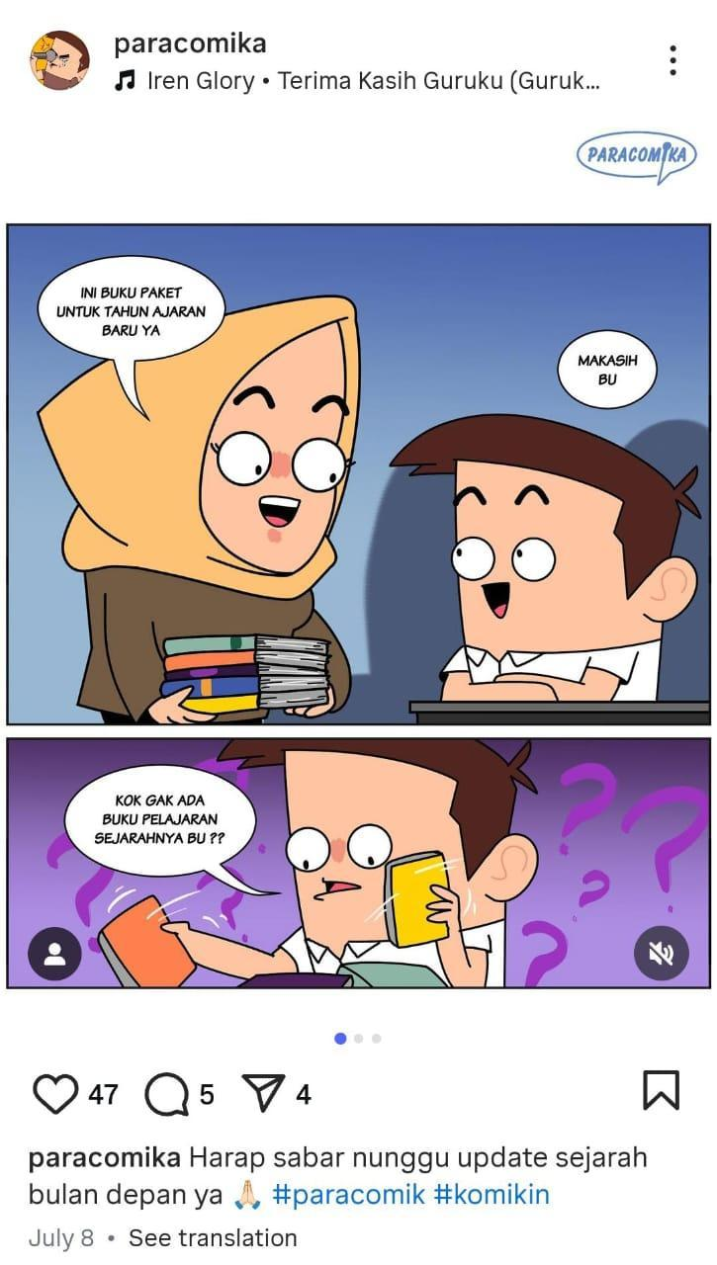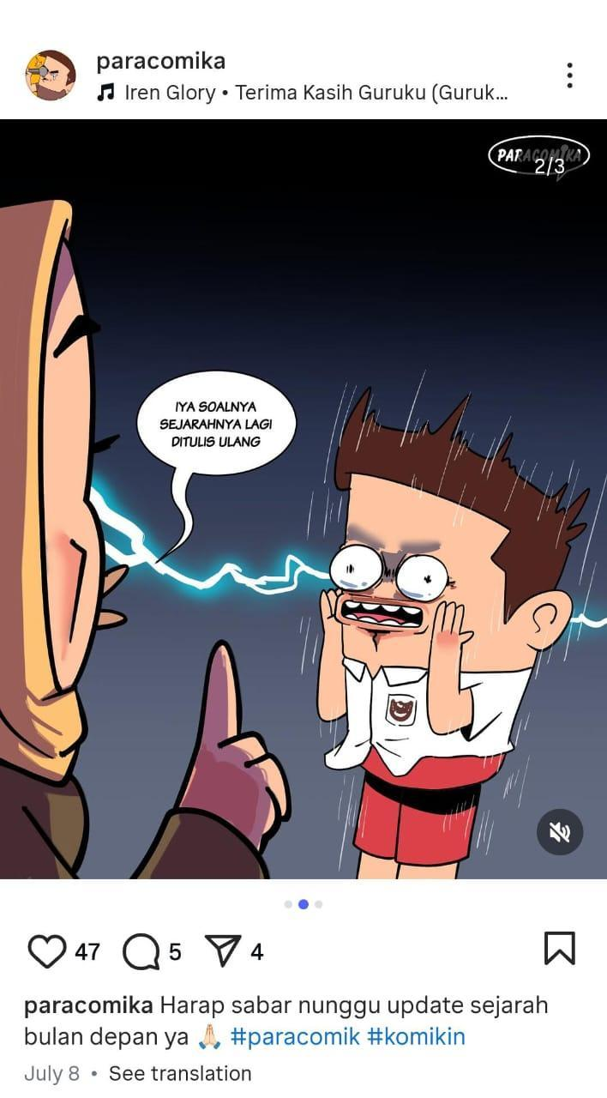
Figure 1. Example of satirical style in comic strips
Source: Instagram account @paracomika

Based on this background, this study aims to examine the process of comic artists repackaging information on popular issues through visual narratives in comic strips on Instagram during the early period of the Prabowo–Gibran administration. Specifically, this study addresses the following questions: (1) How are social issues visually represented in comic strips on Instagram during the Prabowo–Gibran cabinet period? (2) What visual communication styles are used by comic artists to convey messages about popular issues? (3) What dominant themes emerged in comic strips during this period? and (4) How is information repackaged through narrative style and visual presentation in Instagram comic strips?

- METHODS
Authors used a descriptive method with a qualitative approach to examine the process of repackaging information through visual narratives in the form of comic strips created by comic artists. Data collection was carried out through interviews and observations of the artists’ comic strips. The interviews explored the stages of comic creation, including determining the theme, gathering information sources, filtering accurate information, developing a storyboard, and producing the final comic. Meanwhile, observations focused on analyzing the comic strips uploaded to the research informants’ Instagram accounts. This analysis considered the issues raised, narrative style, visual elements, and analytical notes to assess whether the issues presented were accurate or misleading. The author also examined the number of likes and comments as additional observation material to evaluate readers’ or followers’ engagement with the comic strips. The purpose was to determine whether the issues highlighted originated from credible news sources or rumors, thereby ensuring that the published comics did not contain hoax illustrations. Engagement served as a benchmark for measuring readers’ connection to the comic strips, with high engagement indicating that the issues presented were generally considered valid within society.
Based on this data collection method, the author determined the criteria for the Instagram accounts of the artists studied. Several criteria were used to select the Instagram accounts: (i) Number of followers. The number of followers of the accounts selected for research represents the Micro-influencer level (10,000–100,000 followers) and Macro-influencer level (100,000–350,000 followers) (Wiley, 2024). (ii) Upload frequency at least once a week. The frequency of uploads influences the Instagram algorithm, enabling posts to reach audiences beyond existing followers. This metric is utilized to assess the level of engagement with comic strip content. (iii) Content. Discussing popular issues about social, political, legal, and economic from October 2024 to August 2025. (iv) Engagement. Likes on social media platforms serve as a key form of social proof, providing content with a visible marker of approval. Consequently, a substantial volume of likes serves as an authoritative signal to prospective consumers, indicating that the content is valuable and, by extension, that the associated brand is worthy of attention and engagement. The benchmark for an adequate number of post likes is relative, depending significantly on the social media platform and the size of the user's following. On Instagram, for example, an acceptable average rate for likes per post is in the 3–6% range of followers (Agency Analytics, 2025).
From the criteria above, the selected Instagram accounts are Mice Cartoon, Poliklitik, and Paracomika.

3. RESULTS AND DISCUSSION

3.1 Informant Description
Comic strip is a sequence of closely placed images, typically laid out in a horizontal arrangement, intended to be read as a narrative or in chronological order (Kunzle, 2025). The storyline is generally created specifically for this format. Text may be included within or around the images, though it is not always necessary. When the text becomes the primary element over the visuals, the images serve mainly as illustrations for the written content. The creator is usually called comic artists.
A comic artist is responsible for crafting the visual elements of comics and graphic novels, including the layout of panels, character designs, backgrounds, and accompanying text (Indeed Editorial Team, 2025). The following table is a description of comic artists who were informants in this research:

Table 1. Informant Description
No | Informant or Account Owner | Instagram Account | Number of Follower* | Minimum Likes (3%-6%)** | Upload Frequency
1 | Andri Sakti | @paracomika | 25.900 | 777 | 3-4/week
2 | Muhammad Misrad | @micecartoon | 236.000 | 7080 | 1-2/week
3 | Anonymous | @poliklitik | 197.000 | 5910 | 2-3/ week
*As of 2025, September 16
** (Agency Analytics, 2025)
  - Interview Results with Paracomika
Paracomika started in 2019. Initially, the comics focused on themes related to the daily lives of stand-up comedians (komika). However, this scope eventually expanded to address themes connected to highly discussed issues, particularly in the socio-political theme. Instagram platform was chosen due to its capacity for reaching a wide and accessible audience. The carousel feature on Instagram makes it easier for comic artists to publish their work independently (Suminto & Renzina, 2023). Social media has become a digital public space that allows users not only to communicate but also to express culture through visuals (Nasrullah, 2021). This makes social media a fertile ground for visual narratives such as comic strips to address socio-political issues. Paracomika consistently selects specific issues that are closely relevant to daily life.

3.3 Information Seeking in Selecting Issue and Topic
Information seeking in Instagram comic creation reflects the characteristics of modern, non-linear information environments as in ISMIE framework (Sun, et al. 2025).
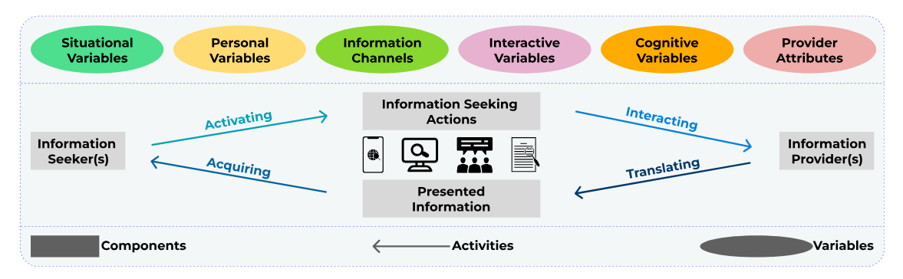
Figure 2. Information Seeking in Modern Information Environment (ISMIE) Framework

Paracomica’s information-seeking behavior is not driven solely by explicit knowledge gaps but is often activated by trending and socially salient issues circulating across digital platforms. These findings suggest a shift from traditional goal-oriented information seeking toward contextual, socially embedded practices influenced by digital media dynamics.

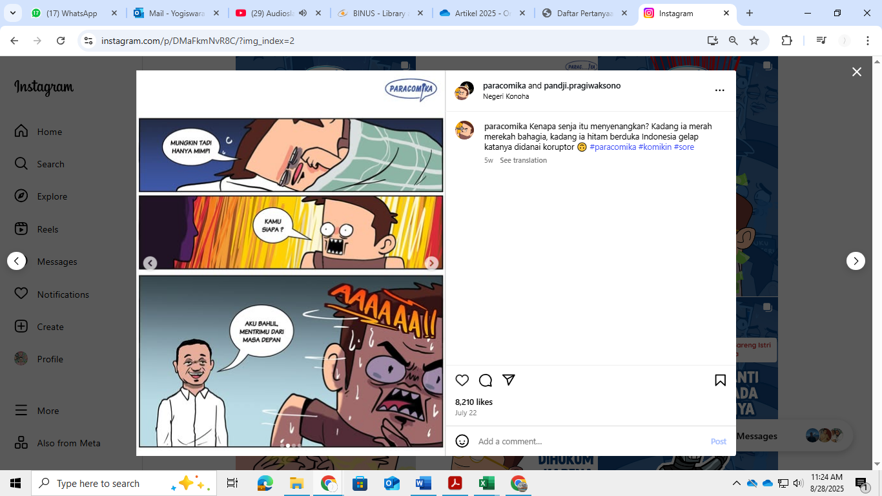
Figure 3. Integration of Two Themes into a Single Paracomika Word

3.4 Information Repackaging Process
Paracomika operate simultaneously as information seekers and information providers, translating and repackaging information into visual narratives through satire, metaphor, and sequential imagery. Information repackaging in digital environments involves transforming news or social issues into accessible formats through selection, interpretation, and visual presentation (Shinta & Rachman, 2021; Alfiana, 2020). In social media comics, this process overlaps with visual storytelling and multimodal narrative structures, where meaning emerges from the interaction of text, images, and panel sequencing (Chen et al., 2026; Febrianti et al., 2023). More panels tend to slow down the storytelling pace, allowing for buildup and timing of visual jokes, while fewer panels or compressed sequences can accelerate pacing and deliver punchlines more abruptly (Picado, 2022). This process corresponds with translation activity in which information is transformed before reaching audiences and shaped by intervening variables such as audience expectations and platform design (Sun et al., 2025).
The sources of information utilized by Paracomika originate from social media, online news media, official news portals, or their idea bank. Paracomika does a brief preparation from the resources. This alligned with a theory which explained that “in information repackaging it is important to create a summary of information sourced from selected materials” (Dongardive, 2013).
Once a topic is finalized, Paracomika proceeds directly to the creation of the comic, as all necessary aspects have already been thoroughly considered during the initial topic selection phase, which is following steps by (Dongardive, 2013; Atmi et al., 2025). The steps such as brief analysis, design criteria for packaging, packaging selection, creation of information packaging, and feedback system design.

3.5 Creative and Narrative Process
The creation of Paracomika comic strip begins with a script, which is then translated into visuals and narratives. Visual narratives, whether as single images or sequential panels, derive their narrative quality from how panels are arranged to convey the passage of time and structure a story with a clear beginning, middle, and end. This panel sequencing is not only a creative choice that influences production time but also a fundamental aspect of narrative reasoning itself. Recent work by shows through a hierarchical knowledge graph framework that models comics at multiple levels of narrative abstraction, linking characters, actions, spatial and temporal relations across panels to support structured understanding of story progression and timeline reconstruction (Chen, 2025; Paval et al, 2025).
Paracomika also adds captions related to the comic strips to explain more about the story. Combining words with visuals can communicate meaning and engage audiences offering interpretations that differ from images presented without text (Josephson, 2020). That visual stories must deliver their message concisely, often within a limited space and with minimal text support. Character depictions and the story narrative in Paracomika are deliberately hyperbolized to enhance the humorous and satirical effects. They don’t use framing in their visual narrative. However, even though the artists seem neutral, the readers have different perceptions in interpreting the comic strips. The concepts of frames and framing encompass various elements that guide attention, shape perception, and influence interpretation (Schmid, 2021; Chon, et.al, 2023).
A natural starting point for examining framing in graphic narratives is the comics panel itself. Each panel guides the reader’s focus on specific events, determining what details are shown or omitted at a given moment and which aspects are emphasized. Framing involves processes of selection and emphasis. It highlights certain elements of perceived reality within a text to shape how an issue is defined, interpreted, morally judged, and potentially addressed (Entman, 1993; Walter & Ophir, 2024; Dong & Nizam, 2025).

3.6 Public Response and Ethics
Paracomika has received negative feedback in the comment sections; however, comments deemed destructive or divisive are generally not engaged with or responded to. While comics serve as effective tools for social commentary and political satire, they also present distinct challenges (Minoza, 2024). The reliance on visual elements can lead to misinterpretation, and satire may blur the line between critique and offense. Consequently, negative feedback from some audiences is to be expected.
Regarding ethical considerations when creating work with sensitive messages or complex issues, Paracomika adapts its approach based on its target audience. For instance, when critiquing President Prabowo, the criticism is directed towards his role as president, not his personal character. The collective ensures the work does not frame a specific agenda, preferring to allow the audience to independently derive the intended message. Based on observation, comic artists rarely reply to comments from their followers.

- Results of Comic Strip Observation
Table 2. Observations of Paracomika Comic Strips
No | Date Uploaded | Link and No. of likes | Issue | Narration Style | Visual Element | Visual Narrative Style (Cohn, 2013)
1 | 11-Mar-25 | Link = https://www.instagram.com/paracomika/p/DHEDW4uvsEZ/  Like= 9241  Comment = 168 | Politics | Satire | Multicolor, 1 panel, 1 slide, short text | Establisher
2 | 4-Mar-25 | Link: https://www.instagram.com/paracomika/p/DGvsxr8PeWu/?img_index=1  Like = 2.569  Comment = 102 | Politics | Satire | Multicolor, 1 panel, 1 slide, blue bacground | Establisher
3 | 5-Mar-25 | Link = https://www.instagram.com/paracomika/p/DGzgh6jPaom/  Like - 2.712  Comment = 49 | Social Politics | Satire | Multicolor, 1 panel, 1 slide, flood situation as background | Establisher
4 | 5-Aug-25 | Link: https://www.instagram.com/paracomika/p/DM-NuW1Pn21/  Like = 8.458  Comment = 176 | Social Politics | Satire | Multicolor, 3 slides, island and sea as background | Initial - Prolongation - Peak
5 | 4-Aug-25 | Link: https://www.instagram.com/paracomika/p/DM7SxN9v0iW/  Like = 7.140  Comment = 473 | Social Politics | Satire | Multicolor, 1 panel, 1 slide, blue bacground | Establisher
6 | 22-Jul-25 | Link: https://www.instagram.com/paracomika/p/DMaFkmNvR8C/  Like = 8.208  Comment = 232 | Social Politics | Satire | Multicolor, 3 slides, colorful background | Establisher - Initial - Peak
7 | 27-Mar-25 | Link: https://www.instagram.com/paracomika/p/DHss3WtPgnZ/  Like = 4.372  Comment = 57 | Sports | Satire | Multicolor, 3 slides, colorful background | Initial - Peak
8 | 13-Feb-25 | Link: https://www.instagram.com/paracomika/p/DGAcphZv3Pd/?img_index=3  Comment = 5.086  Like = 125 | Politics | Satire | Multicolor, 2 slides, orange background | Initial - Peak
9 | 23-Dec-24 | Link: https://www.instagram.com/paracomika/p/DD6X0wnPlqb/?img_index=1  Like = 2.268  Comment = 66 | Law | Satire | Multicolor, 1 panel, 1 slide, blue bacground | Establisher
10 | 20-Dec-24 | Link: https://www.instagram.com/paracomika/p/DDyVBwnvJ_b/?img_index=1  Like = 10.718  Comment = 342 | Social Politics | Sarcasm | Multicolor, 1 panel, 1 slide, blue bacground | Establisher

Table 3. Observations of Micecartoon Comic Strips
No | Date Uploaded | Caption & Link | Issue | Narration Style | Visual Element | Visual Narrative Style (Cohn, 2013)
1 | 3-Dec-24 | Link: https://www.instagram.com/p/DDHvFqHy7as/?igsh=emlwNG9qZ2MxeHQz  Like = 60.800  Comment = 1.548 | Social | Cynicism, Satire | Multicolor, orange background, 1 pannel 1 slide | Establisher
2 | 4-Dec-24 | Link: https://www.instagram.com/p/DDJQw_xyXkM/?igsh=bGQ0eHpxYWtjbzc0  Like = 18.200  Comment = 140 | Social | Cynicism, Satire | Multicolor, pink background, 1 pannel 1 slide | Establisher
3 | 10-Dec-24 | Link: https://www.instagram.com/p/DDZL3gEyPyg/?igsh=NGIwM2MzODQzM3Vw  Like = 11.600  Comment + 408 | Law | Cynicism | Multicolor with 5 slides, 1 pannel each slide | Establisher - Initial - Prolongations - Peak
4 | 2-Mar-25 | Link: https://www.instagram.com/p/DGsZKjAy_to/?igsh=MXg2ZXF0MzF5eHNn  Like = 34.700  Comment = 135 | Social | Irony, Sarcasm | Multicolor with 5 slides, last slide contain of 4 pannels | Establisher - Initial - Prolongation - Peak
5 | 23-Mar-25 | Link: https://www.instagram.com/p/DHiAL2lSilA/?igsh=emI2bXFkMTh3aXdv  Like= 21.300  Comment = 340 | Social | Cynicism | Multicolor, blue background, 1 pannel 1 slide | Establisher
6 | 19-Aug-25 | Link: https://www.instagram.com/p/DNhc_Peyh5U/?igsh=cDZ6ZmU5OG9pam9h  Likes: 44.100  Comment: 235 | Social Politics | Irony, Paradox | Multicolor, blue background, 1 pannel 1 slide | Establisher
7 | 31-Aug-25 | Link: https://www.instagram.com/p/DOApvHTkgQ2/?igsh=MWlkNGp1bTFiejM0aA==  Likes: 18.100  Comment: 108 | Social Politics | Explicit, Metaphor | Multicolor with black & white dominance, 1 slide 1 pannel | Establisher
8 | 30-Aug-25 | Link: https://www.instagram.com/p/DN95xxuktx6/?igsh=MWV2aW9zbmVrcTgzbw==  Likes: 14.434  Comment: 178 | Social Politics | Cynicism | Multicolor, blue background, 1 pannel 1 slide | Establisher
9 | 4-Feb-25 | Link: https://www.instagram.com/p/DFppxQJy9jW/?igsh=cW10MWxjM2Q2amlv  Likes: 13.900  Comment: 379 | Economy | Explicit | Multicolor, red background, 1 pannel 1 slide | Establisher
10 | 13-Feb-25 | Link: https://www.instagram.com/p/DGAhPyuSLZZ/?igsh=eDVjYXk0a2F4M2Q=  Likes: 9879  Comment: 152 | Economy | Irony | Multicolor, blue background, 1 pannel 1 slide | Establisher

Table 4. Observations of Poliklitik Comic Strips
No | Date Uploaded | Caption & Link | Issue | Narration Style | Visual Element | Visual Narrative Style (Cohn, 2013)
1 | 29-Aug-25 | Link: https://www.instagram.com/p/DN8W80CEizT/?igsh=MW44czhqOGV2ZXB1cQ==  Likes: 31.711  Comment: 343 | Social Politics | Satire | Multicolor, green background, 2 pannels 1 slide | Initial - Peak
2 | 4-Aug-25 | Link: https://www.instagram.com/p/DM765IQyB6R/?igsh=MWFxajdnZm9rYWF6Ng==  Likes: 16.435  Comment: 85 | Social Politics | Paradox, Metaphor | Multicolor, blue background, 2 slides, 1 pannel in each slide | Initial - Peak
3 | 31-Jul-25 | Link: https://www.instagram.com/p/DMxkwlHSta9/?igsh=MWs5dHJ1OWQ0aWJ6cA==  Likes: 11.134  Comment: 800 | Social Politics | Paradox, Metaphor | Multicolor, blue background, 1 pannel 1 slide | Establisher
4 | 20-May-25 | Link: https://www.instagram.com/p/DJ3iv05SKeE/?igsh=cWhja2plaXRwaWJz  Likes: 11.332  Comment: 146 | Economy | Simile, Metaphor, Irony | Multicolor, 2 pannels 1 slide | Initial - Peak
5 | 25-Apr-25 | Link: https://www.instagram.com/p/DI28Eg4hb2b/?igsh=ODU1NmVncmxoeTRz  Likes: 12.789  Comment: 223 | Politics | Cynicism, Irony | Multicolor, teal blue background, 3 pannels 1 slide | Establisher - Initial - Peak
6 | 14-Apr-25 | Link: https://www.instagram.com/p/DIa6ynIyGTu/?igsh=dW03ajh6aXJ5cjJz  Likes: 21.497  Comment: 196 | Education | Metaphore, Cynicism | Multicolor, brown-grey gradation background, 1 pannel 1 slide | Establisher
7 | 6-Apr-25 | Link: https://www.instagram.com/p/DIF_yXbPkww/?igsh=MTR0dmZrdHVtNGZsag==  Likes: 34.014  Comment: 977 | Education | Explicit | Multicolor, sage background, 1 pannel 1 slide | Establisher
8 | 3-Apr-25 | Link: https://www.instagram.com/p/DH-U0oXvIJq/?igsh=MXVqMm9pbDQ5aXVhOQ==  Likes: 19.505  Comment: 676 | Social | Explicit, Hyperbol, Cynicism | Multicolor, 2 pannels 1 slide | Initial - Peak
9 | 8-Feb-25 | Link: https://www.instagram.com/p/DFzY5GGPGPA/?igsh=MXNwazV2eXVyemxyYQ==  Likes: 50.966  Comment: 2593 | Education and Law | Explicit, Irony, Paradox | Multicolor, 2 pannels 1 slide | Initial - Peak
10 | 27-Feb-25 | Link: https://www.instagram.com/p/DGkGH9yvcKJ/?igsh=ZHkybzl0NXI1dmF0  Likes: 27.391  Comment: 361 | Education and Law | Explicit, Irony | Multicolor, 1 slide 1 pannel | Establisher

3.7 General Overview
This study examined 30 comic strip posts from three Instagram accounts published following the inauguration of the Prabowo–Gibran Cabinet. The dataset included upload date, caption, addressed issue, narrative style, dominant visual elements, information source, number of likes and comments, and analytical notes.
On average, the posts received 18,172 likes and 394 comments, reflecting a high level of audience engagement. These metrics suggest that the comic strips are effective in communicating current issues to Instagram users.

3.8 Distribution of Issues Addressed
The analysis identified diverse themes addressed by comic artists. Socio-political issues were most prevalent (11 posts), followed by socials (5), politics (4), economics (3), education (2), law (2), education and law (2), and sport (1).
These findings indicate that comic strips serve as a medium for repackaging information about various events that attract public attention. The frequent selection of major societal issues highlights the artists' focus on contemporary national discourse.

3.9 Narrative Style in Comics
The narrative style analysis revealed a predominant use of satire (10 posts), followed by cynicism (3), and various other styles, including metaphor, paradox, irony, sarcasm, and simile.
Language style is a way of expressing thoughts through language in a distinctive way that shows the soul or personality of the writer (language user). Some language styles that are used by Paracomika categorized in Table 5 explained by (Stark 2016 & Prandi, 2017).
Table 5. Language Style
No | Style | Definition
Figurative Language
1 | Simile | Explicit comparison
2 | Methapor | An analogy that compares 2 things directly but in a short form
3 | Irony, cynicism, sarcasm | Irony is a reference to saying something with a different meaning or purpose than what is contained in the words. Cynicism is a satire that takes the form of doubt which contains mockery of sincerity and sincerity. Sarcasm is a cruder reference to irony and cynicism.
4 | Satire | Descriptions that must be interpreted differently from their surface meaning
Rhetorical language
1 | Hyperbole | a style of language that contains an exaggerated statement
2 | Paradox | a style of language that contains a clear contradiction to existing facts

The frequent use of satire reinforces the comic strip's role as a medium for social critique, enabling the communication of critical perspectives on government policies and social phenomena while maintaining entertainment value.

3.10 Semiotics in Comic Strips Observations
Based on the observation result, sometimes it needs semiotics to understand the comic strips because of less narrative explanation. Semiotics examine the relationship between signs, meanings, and their interpreters, arguing that all communicative forms, including images, symbols, and sequencing in comics (Chandler, 2025).
For the example, comic strip by Mice Cartoon number 12 from the table that only emoticon with illustration of the 4th President of Republic Indonesia. This needs an effort to be understandable if we don’t know the context related to the news even though it has dialog. Another sample by Mice Cartoon number 13 that illustrated a brown burst balloon with caption Hatiku sangat kacauuu!. The brown balloon refers to Indonesia Police who wear brown uniform. Meanwhile the burst effect refers to the case of police who shot high school student in Semarang. This sample needs to be understandable that explained in semiotic ideology on how people construct meaning through non-verbal communication (Leone, 2024).

3.11 Audience Response
The high average engagement rate, reflected in thousands of likes and hundreds of comments per post, suggests that audiences both enjoy the comics and actively engage with the issues presented. This interaction highlights the comic strip's function as a digital forum where public opinion is shaped through the integration of text, visuals, and humor. Comics evoke strong emotional responses, which enhances their effectiveness as a medium for satire (Minoza, 2024). By employing exaggeration, caricature, and humor, comics effectively illuminate the absurdities of political systems and social norms in ways that engage readers.
This observation supports the perspective that Instagram comic strips constitute a distinct ecosystem for the dissemination of information. They also exemplify information repackaging. News originating in mass media or public discourse is selected, filtered, and transformed into visual narratives that are accessible to a broad audience.

4. CONCLUSION

The study concludes that Instagram comic strips serve as dynamic platforms for visual storytelling and information repackaging, particularly in relation to socio-political issues following the inauguration of the Prabowo–Gibran cabinet.
- These comics simplify and reinterpret information from media and public discourse into visual narratives that are more relatable, accessible, and engaging for digital audiences by using language style, narration style and visual elements.
- Satire, cynicism, and explicit are employed as key strategies to convey messages about popular issues
- Instagram comics strips generate significant public engagement, demonstrating their potential as informal yet influential tools to communicate socio-political, economic, law, education, and other related issues.
- They show how information is repackaged through narrative style and visual presentation: issues are broken down into sequential panels that follow a clear storyline (establishing, building, peaking, and resolving events), while visual elements such as caricature, metaphor, and symbolic exaggeration frame complex realities into forms that are easier to understand and discuss.

5. AUTHORS’ NOTE (DO NOT DELETE)

The authors declare that there is no conflict of interest regarding the publication of this article. Authors confirmed that the paper was free of plagiarism.

6. REFERENCES
Agency Analytics. (2025). Likes - KPI definition & tips. AgencyAnalytics. https://agencyanalytics.com/kpi-definitions/likes
Alfiana, A., & CMS, S. (2020). Layanan Kemas ulang informasi berbasis digital. Pustabiblia: Journal of Library and Information Science, 4(2), 245–264. https://doi.org/10.18326/pustabiblia.v4i2.245-264
Atmi RT, Putri CF, Babbar P (2025), "Digital information repackaging: best practices from university library website managers". Library Hi Tech News, Vol. 42 No. 4 pp. 12–17, doi: https://doi.org/10.1108/LHTN-07-2024-0122
Chandler, D. (2025). Semiotics: The Basics. In Routledge & CRC Press (5th ed.). Routledge.
Cohn, N. (2013). Visual Narrative Structure. Cognitive Science, 34, 413–452. https://doi.org/10.1111/cogs.12016
Cohn, N., Hacımusaoğlu, I., & Klomberg, B. (2022). The framing of subjectivity: Point-of-view in a cross-cultural analysis of comics. Journal of Graphic Novels & Comics, 14(3), 336–350. https://doi.org/10.1080/21504857.2022.2152067
Dong, X., & Nizam, M. N. (2025). The upgrade of framing theory in the social media era. Journal of Sociology and Education, 1(7). https://doi.org/10.63887/jse.2025.1.7.58
Dongardive, P. (2013). Information repackaging in library services. International Journal of Science and Research (IJSR), 2(11), 204–209
Entman, R. M. (1993). Framing: Toward clarification of a fractured paradigm. Journal of Communication, 43(4), 51–58. https://doi.org/10.1111/j.1460-2466.1993.tb01304.x
Indeed Editorial Team. (2025, March 26). Cartoonist vs. Comic Artist: What’s the difference? | indeed.com. Cartoonist vs. Comic Artist: What’s the Difference? https://www.indeed.com/career-advice/finding-a-job/cartoonist-vs-comic-artist
Indonesia, R. P. (2024, March 16). Tren visual di media sosial: Gambar dan video Secara Efektif. Rumah Produksi Indonesia. https://rumahproduksiindonesia.com/tren-visual-di-media-sosial-gambar-dan-video-secara-efektif/
Josephson, S, Kelly, J.D, & Smith, K. (Eds). (2020). Handbook of Visual Communication. Routledge.
Kemp, S. (2025, February 25). Digital 2025: Indonesia - DataReportal – global digital insights. DataReportal.https://datareportal.com/reports/digital-2025-indonesia?rq=indonesia%2B2025
Kunzle, D. M. (2025, February 18). Comic strip. Encyclopædia Britannica. https://www.britannica.com/art/comic-strip
Lagopoulos, A. Ph., & Boklund-Lagopoulou, K. (2020). Theory and Methodology of Semiotics. De Gruyter.
Leone, M. (2024). Semiotic Ideologies. Brill.
Minoza, H. (2024, July 9). The role of comics in social commentary and political satire. New York Weekly. https://nyweekly.com/entertainment/the-role-of-comics-in-social-commentary-and-political-satire/
Nasrullah, R. (2021). Media Sosial : perspektif komunikasi, budaya dan sosioteknologi. Simbiosa Rekatama Media.
Paval, S., Yamshchikov, I. P., & Meißner, P. (n.d.). ComicScene154: A Scene Dataset for Comic Analysis. arXiv (Cornell University). https://doi.org/10.48550/arxiv.2508.16190
Polishchuk, D. (2022, August 18). What is a good Instagram engagement rate?. PromoRepublic. https://promorepublic.com/en/blog/what-is-a-good-instagram-engagement-rate/#:~:text=Less%20than%201%25%20=%20low%20engagement,LinkedIn
Picado, B. (2022). The Pace of a Visual Joke: Narrative Rhythm in Daily Strip Comics. Fictions: Studi Sulla Narratività, XXII(1). https://doi.org/10.19272/202206901007
Prandi, M. (2017). Conceptual conflicts in metaphors and figurative language. In Routledge & CRC Press. Routledge.
Putra, G. L. K., & Yasa, G. P. (2019). Komik Sebagai Sarana Komunikasi promosi dalam media sosial. Jurnal Nawala Visual, 1(1), 1–8. https://doi.org/10.35886/nawalavisual.v1i1.1
Schmid, J.C.P. (2021). Frames and Framing in Documentary Comics. Palgrave Macmillan.
Shinta, C., & Rachman, M. A. (2020). Kemas Ulang informasi sebagai upaya pemanfaatan INFORMASI dan data di Perpustakaan Institut Pertanian Bogor. Bibliotech : Jurnal Ilmu Perpustakaan Dan Informasi, 5(1), 27–38. https://doi.org/10.33476/bibliotech.v5i1.1319
Stark, R. (2016). Figurative Language and Other Literary Devices (Grades 5 - 8). Educational Impressions.
Suminto, M. A., & Renzina, Y. D. (2023). International Conference Comics in The Age of Digitalization : Challenge and Opportunities. In Proceeding International Conference Comics in The Age of Digitalization : Challenge and Opportunities (pp. 75–94). Yogyakarta; ISI Yogyakarta. Retrieved 2025.
Sun, S., Hettiachchi, D., & Spina, D. (2025). ISMIE: A Framework to Characterize Information Seeking in Modern Information Environments (pp. 385–395). https://doi.org/10.1145/3767695.3769509
Walter, D. & Ophir, Y. (2024). Meta-theorizing framing in communication research (1992–2022): toward academic silos or professionalized specialization?. Journal of Communication, Volume 74, Issue 2, April 2024, Pages 101–116, https://doi.org/10.1093/joc/jqad043
Wiley, D. (2024, August 13). How to match influencer tiers with your brand goals. Forbes. https://www.forbes.com/councils/forbesagencycouncil/2024/04/04/matching-influencer-tiers-with-your-brand-goals-a-guide-for-tiktok-and-instagram/

