

EDULIB
Journal of Library and Information Science
Journal homepage: http://ejournal.upi.edu/index.php/edulib/index

Edulib 3(2) (2023) 435-444

A Governance-Oriented Smart Library Pod Reservation
System: A Design Science Research Approach

Junaid Ali Saeed Rana^{1*}, Jeremy Christian², Alvino Wilbert Ho², Caroline Natalia Kurniadi³, Seeman Sohail Butt⁴, Daniel Joseph Nyanda⁴

¹Dean Faculty of Information Technology, University of Jakarta International, Jakarta, Indonesia.
²Software Engineering Study Program, Faculty of Information Technology, University of Jakarta International, Jakarta, Indonesia.
³Information Systems Study Program, Faculty of Information Technology, University of Jakarta International, Jakarta, Indonesia.
⁴Data Science Study Program, Faculty of Information Technology, University of Jakarta International, Jakarta, Indonesia.

*Correspondence E-mail: junaid.rana@uniji.ac.id

A B S T R A C T |  | A R T I C L E I N F O
The growing demand for flexible, focused learning spaces led universities to introduce individual study pods in academic libraries. However, the absence of structured reservation mechanisms led to inefficient utilization, no-shows, and limited accountability. This study aimed to address these challenges by employing a Design Science Research approach to develop a governance-oriented smart library pod reservation system as a design artifact. The research followed a pre-implementation design process encompassing problem identification, requirement elicitation, system design, and conceptual evaluation. Data were collected using a mixed-methods approach, including a survey of undergraduate students and semi-structured interviews with administrative stakeholders. The findings revealed that although students perceived study pods as effective for focused academic activities, their usage was constrained by accessibility issues, misuse, and lack of transparency. These insights informed the development of a rule-based reservation system incorporating real-time availability, user check-in validation, automated cancellation, and administrative monitoring. The study demonstrated that embedding governance mechanisms directly into reservation workflows enhanced fairness, accountability, and efficiency in the management of shared learning spaces. The proposed design provided a scalable, practical solution to improve the utilization of learning spaces in higher education environments.  © 2026 Edulib |  | Article History:  Submitted/Received 10 Jan 2026  First Revised 08 Feb 2026  Accepted 05 Mar 2026  First Available Online 04 May 2026  Publication Date 04 May 2026  ____________________  Keywords:  Design science research,  Governance,  Library systems,  Reservation system,  Smart campus.

1. INTRODUCTION
University libraries have evolved from traditional repositories of information into dynamic learning environments that support individual study, collaboration, and academic engagement. In line with smart campus initiatives, higher education institutions are increasingly integrating digital technologies to enhance the accessibility, efficiency, and quality of library services (Chan & Chan, 2018; Cao et al., 2018). The concept of the smart library emphasizes the integration of information systems, user-centered design, and data-driven service delivery to optimize resource management and improve user experience (Asim & Arif, 2026; Adewojo & Monjolaoluwa, 2025). These developments reflect a broader shift toward technology-enabled learning ecosystems in which physical and digital infrastructures are interconnected. Recent studies further highlight the role of data-driven and technology-enhanced systems in improving student learning outcomes and academic success (Rowe et al., 2021; Arévalo-Cordovilla & Peña, 2024; Scoulas et al., 2024).
The transformation of academic libraries is further propelled by the strategic leverage of Big Data and Learning Analytics (LA), which extend beyond simple physical automation. The integration of these technologies allows libraries to function as proactive learning ecosystems capable of analyzing behavioral patterns, digital access preferences, and real-time space utilization (Garoufallou & Gaitanou, 2021; Ncube & Ngulube, 2025). By utilizing large-scale data analytics, libraries have shifted from being passive infrastructure providers to becoming strategic decision-support hubs that personalize the user experience based on specific student needs (Azam & Ahmad, 2024; Shahzad et al., 2026). This role evolution redefines the library as an intelligent entity capable of predicting academic trends, thereby facilitating a more responsive and adaptive learning environment that aligns with the dynamics of modern higher education.
A key feature of modern academic libraries is the provision of dedicated learning spaces such as individual study pods designed to support focused academic activities. Prior research demonstrates that well-designed library environments contribute positively to student satisfaction, engagement, and perceived productivity (Li et al., 2018; Montgomery, 2014; Kim & Yang, 2022; Scoulas & de Groote, 2019). Such spaces provide controlled environments that minimize distractions and enhance concentration. However, their effectiveness depends not only on physical design but also on how these spaces are managed and allocated among users. Increasing demand combined with limited availability has created persistent challenges in ensuring equitable access to these shared resources (O’Donnell & Anderson, 2022).
The management of shared learning spaces remains a critical issue in academic libraries. Study pods are frequently operated through informal or manual processes, leading to inefficiencies such as difficulty locating available spaces, misuse for non-academic purposes, and prolonged occupancy without active use. The absence of transparent reservation mechanisms further contributes to uncertainty and perceived unfairness among users. These challenges are closely associated with user behavior and weak enforcement mechanisms. Prior research indicates that no-show behavior and unregulated usage significantly reduce resource utilization and overall system efficiency (Amberger & Schreyer, 2024; Wang et al., 2020). These findings highlight the need for structured, systematic approaches to improve both operational performance and the user experience.
A comparative analysis of contemporary digital interventions reveals a heavy reliance on hardware-centric solutions to resolve occupancy issues. For instance, the IoT-based frameworks proposed by Maepa and Moeti (Maepa & Moeti, 2021; Reneilwe Maepa & Nthabiseng Moeti, 2024) emphasize the technical accuracy of seat occupancy monitoring and the reduction of physical search time through automated sensors. While these systems successfully provide real-time data visibility, they function primarily as observational tools rather than regulatory ones. Similarly, mobile platforms and web-based reservation systems focus on the front-end user experience—streamlining the booking process and enhancing convenience (Ajab Mohideen et al., 2022; Rivo & Žumer, 2022). However, these studies often overlook the "compliance gap" where technical availability does not translate into actual resource liberation. The comparative data suggests that while IoT can detect a "no-show," it lacks the inherent governance mechanism to penalize or discourage the behavior, thereby leaving the underlying psychological and social drivers of resource misuse unaddressed (Rimbeck et al., 2025; Sedrati et al., 2022).
The inadequacy of focusing solely on technological functionality lies in its failure to account for the complexities of Common-Pool Resource (CPR) management. Most existing smart library solutions operate under the assumption that increased transparency will naturally lead to improved user behavior; however, without integrated governance protocols—such as accountability measures, rule enforcement, and behavioral nudges—digital systems remain vulnerable to exploitation (Asim & Arif, 2026; Kurka & Pitt, 2017; V & R, 2026). For example, a reservation system without a verified "check-in" or "automatic cancellation" policy fails to solve the problem of phantom occupancy, regardless of how advanced the underlying IoT sensors may be (Adewojo & Monjolaoluwa, 2025; Chaudhari et al., 2024; Maepa & Moeti, 2021). This oversight highlights a critical research gap: technological functionality provides the data, but governance provides the discipline. Consequently, there is an urgent need to shift from purely technical designs to socio-technical frameworks that prioritize accountability and behavioral control to ensure the long-term sustainability of shared academic spaces.
Recent studies have explored digital reservation systems and smart technologies to address space management challenges in academic libraries. IoT-based solutions, including seat occupancy monitoring and automated reservation systems, have been shown to enhance real-time visibility and reduce search time (Maepa & Moeti, 2021; Maepa & Moeti, 2023; Adewojo & Monjolaoluwa, 2025). Similarly, mobile applications and digital platforms improve accessibility and user convenience (Ajab Mohideen et al., 2022; Rivo & Žumer, 2022). Research on intelligent library systems also demonstrates that user satisfaction and trust are influenced by usability, transparency, and service quality (Chen & Shen, 2020; Khan et al., 2023; Shahzad et al., 2024). While these studies provide valuable insights, they primarily emphasize technological functionality, with limited attention given to governance-related aspects such as accountability, rule enforcement, and behavioral control.
Beyond technological considerations, the effectiveness of digital library systems depends on the alignment between system design and user behavior. The integration of user-centered design principles improves system adoption and continued usage (Khan et al., 2023; Rivo & Žumer, 2022), while perceived fairness and transparency significantly influence compliance with system rules (Amberger & Schreyer, 2024; Venkatesh et al., 2012). Recent work further highlights that effective smart and AI-driven library systems require robust governance frameworks, including data management, policy enforcement, and institutional alignment (Bogonko et al., 2025; Alotaibi, 2024; Polat & Eroğlu, 2021). These findings suggest that technological solutions alone are insufficient without integrated governance mechanisms to ensure accountability and sustainable use.
Despite these advancements, existing studies largely overlook the integration of governance mechanisms, particularly behavioral control and policy enforcement, directly into system design. As a result, issues such as misuse, no-show behavior, and perceived unfairness continue to persist even in technologically advanced environments. Addressing this gap requires a design-oriented approach that embeds governance mechanisms into system workflows to ensure consistent, transparent, and enforceable resource allocation.
To address this gap, this study adopts a Design Science Research (DSR) approach to develop a governance-oriented smart library pod reservation system. DSR focuses on the creation and evaluation of artifacts that solve real-world problems through systematic design and validation (Hevner et al., 2004; Peffers et al., 2007; Gregor & Hevner, 2013). This methodology is particularly suitable for addressing socio-technical challenges in educational information systems, as it enables the development of solutions that are both theoretically grounded and practically applicable.
The selection of DSR as the foundational methodology is necessitated by its core principles, which emphasize the creation of innovative artifacts to solve identified organizational problems. According to (Hevner et al., 2004; Weigand & Johannesson, 2023), the 'design as an artifact' and 'problem relevance' guidelines ensure that the developed system is not merely a technical exercise but a purposeful solution to the persistent inefficiencies in space management. Furthermore, the six-stage process model introduced by (Drechsler, 2015; Lu et al., 2025; Peffers et al., 2007),incorporating problem identification, objective definition, design and development, demonstration, evaluation, and communication—provides a rigorous iterative framework for addressing socio-technical complexities. By prioritizing 'design evaluation' and 'research rigor,' DSR allows for the simultaneous refinement of technical functionality and governance protocols, ensuring the artifact is validated against both its operational performance and its ability to influence user behavior. Consequently, DSR serves as the optimal methodology for this study, as it bridges the gap between theoretical behavioral governance and the practical necessity of a robust, automated library reservation system.
The scientific novelty of this study lies in embedding governance and behavioral control mechanisms into the early-stage design of a reservation system for shared learning spaces. Unlike prior studies that primarily focus on technological automation or post-implementation analytics (Maepa & Moeti, 2021; Maepa & Moeti, 2023; Adewojo & Monjolaoluwa, 2025), this research integrates accountability features, including rule acknowledgment, user check-in validation, automated cancellation, and administrative monitoring, directly into the system workflow. This governance-oriented approach addresses the socio-technical nature of shared resource management and supports more effective, fair, and sustainable utilization of learning spaces.
This study contributes to theory, practice, and methodology in several ways. Theoretically, it extends the literature on smart libraries and learning space management by integrating governance and behavioral control into system design. In practice, it offers a scalable design solution to improve fairness, transparency, and efficiency in managing shared learning spaces. Methodologically, it demonstrates the application of Design Science Research in the pre-implementation design of educational information systems.
Therefore, the purpose of this study is to design and evaluate a governance-oriented smart library pod reservation system as a design artifact that improves fairness, transparency, and utilization of shared learning spaces in higher education. The remainder of this paper is organized as follows. Section 2 presents the research methodology, Section 3 discusses the results and findings, and Section 4 concludes the study.
2. METHODS
This study adopted a Design Science Research (DSR) approach to develop a governance-oriented smart library pod reservation system in a higher education setting. As an early-stage, pre-implementation study, the research focused on problem identification, requirement elicitation, conceptual system design, and early evaluation rather than full deployment and performance testing. The primary artifact developed in this study is a governance-oriented design for a smart library pod reservation system.
The research process followed the DSR stages adapted from Hevner et al. (2004) and Peffers et al. (2007). Problem identification was conducted through preliminary observations of library operations and informal discussions with library staff, revealing key issues, including limited pod availability, no-show behavior, misuse, and reliance on manual monitoring.
Requirement elicitation employed a mixed-methods design. For the quantitative strand, a structured online survey was developed and administered to undergraduate students who actively use library study spaces. The survey instrument consisted of Likert-scale items measuring perceptions of pod usefulness, availability, fairness, and desired system features, along with open-ended questions for additional feedback. A total of 100 valid responses were obtained using purposive sampling. Participants were selected based on their direct experience with study pods across multiple study programs to ensure relevance to the research context.
For the qualitative strand, semi-structured interviews were conducted with two key administrative stakeholders responsible for library operations and information technology management. The interview guide focused on operational challenges, governance requirements, policy enforcement difficulties, and administrative expectations for the proposed system. Both survey and interview protocols received ethical approval, and informed consent was obtained from all participants.
In the design and development stage, the elicited requirements were translated into a conceptual system architecture and rule-based system workflow. The proposed artifact includes a user-facing reservation interface with real-time availability display, mandatory rule acknowledgment, check-in validation, automated cancellation logic for unattended bookings, and an administrative monitoring dashboard. These features were iteratively sketched and refined based on combined user and stakeholder input.
Early evaluation was conducted through conceptual validation using an observational and descriptive approach. Quantitative survey data were analyzed using descriptive statistics (frequencies and percentages) to identify dominant trends in user perceptions. Qualitative data from open-ended survey responses and interview transcripts were analyzed thematically to extract recurring patterns related to pain points and desired governance features. The findings were mapped directly to specific design decisions to ensure traceability between empirical insights and the proposed artifact.
All data were handled confidentially, with identifying information removed during analysis. Participation was voluntary, and informed consent was obtained from all participants.
3. RESULTS AND DISCUSSION
This section presents the key findings from the student survey and stakeholder interviews and discusses their implications for the design of a governance-oriented smart library pod reservation system. Empirical data are integrated with design decisions to demonstrate how identified problems directly informed the proposed artifact.
3.1. Problem Identification and User Perceptions
Survey responses revealed uneven usage patterns of study pods. Many students reported occasional use (Figure 1), while fewer reported frequent use. This pattern indicates that demand exists, but access remains inconsistent. In shared academic environments, such uneven patterns often stem from unreliable availability rather than low perceived value (ODonnell & Anderson, 2022; Villarreal et al., 2025).
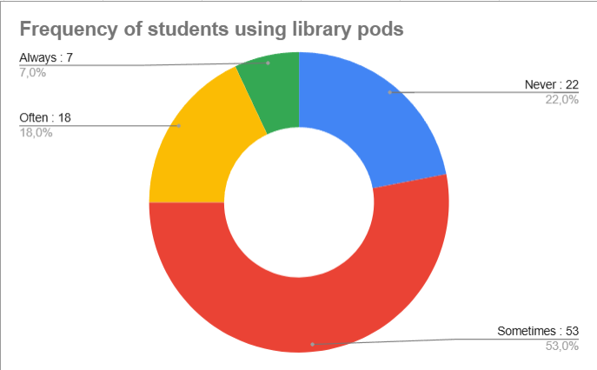
Figure 1. Self-reported frequency of library pod usage
Students generally viewed study pods positively as spaces that support focused academic work. Most respondents agreed that pods improve concentration and productivity compared to open areas (Figure 2). These perceptions align with prior research showing that dedicated learning environments enhance student engagement and satisfaction (Li et al., 2018; Montgomery, 2014; Scoulas & de Groote, 2019).
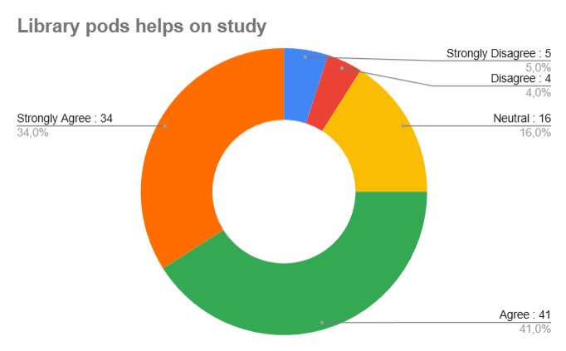
Figure 2. Student perceptions of study pod usefulness for academic activities
However, positive perceptions did not translate into easy access. A substantial proportion of students reported difficulty locating an available pod when needed (Figure 3). This transparency problem reduces efficiency, especially in time-constrained academic schedules where students seek immediate study options.
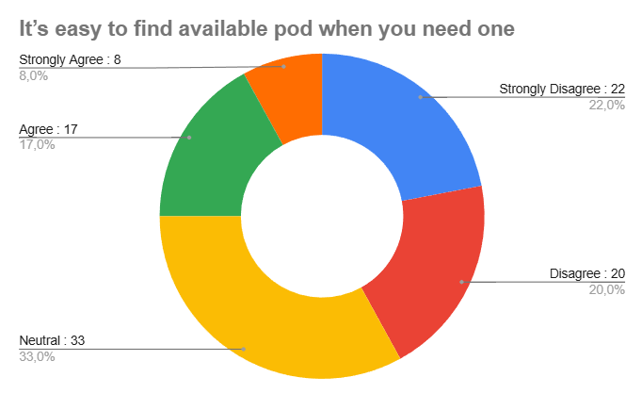
Figure 3. Perceived ease of locating an available study pod
Table 1 summarizes these perceptions. While 75% agreed that pods improve focus and 68% reported higher productivity, 54% found it difficult to locate an available pod, and 72% believed a reservation system would improve fairness and access. These results highlight a clear mismatch between the perceived value of the pods and the current informal allocation process.
Table 1. Summary of Key Student Perceptions Regarding Study Pods (N = 100)

Survey Item | Agree / Strongly Agree (%)
Study pods help improve focus while studying | 75%
Productivity is higher in study pods than in open spaces | 68%
It is not easy to find an available pod when needed | 54%
A reservation system would improve fairness and access | 72%
Open-ended responses provided further insight. Students frequently mentioned limited availability, misuse (e.g., pods occupied without active use or for non-academic purposes), noise, lack of privacy, and unattended belongings (Table 2). While some issues relate to physical infrastructure (e.g., insufficient sockets or poor enclosure), many core complaints, such as uncertainty about availability, ineffective turnover, and misuse, are governance-related and can be addressed through system design. This distinction helped define the scope of the proposed artifact: improving fairness, transparency, and accountability rather than solving all physical limitations.
Table 2. Summary of user-reported issues related to study pod usage

User-Reported Issue / Response Category | Number of Responses
No issues reported | 29
Never used the study pod | 9
Study pods are perceived as too small | 1
Limited pod availability | 27
Misuse of pods (occupied without active use, non-academic use) | 11
Limited electrical sockets | 5
Poor physical condition (e.g., painting, maintenance issues) | 1
Plug-related inconvenience (others using sockets) | 1
Lack of privacy (transparent walls) | 8
Noise disturbance | 10
Absence of door / inadequate enclosure | 14
Uncomfortable seating | 1
Lack of air conditioning | 5
Booking or information validity issues | 1
The integration of governance mechanisms within the reservation system is designed to foster a shift in user behavior from informal occupancy to a culture of accountability. By providing real-time visibility of pod availability and enforcing automated cancellation for "no-shows," the system leverages the concept of transparency to reduce opportunistic behavior. According to institutional governance theory, when rules are embedded directly into the technical infrastructure (governance-by-design), users are more likely to comply with norms as the system provides immediate feedback and consequences (DeLone & McLean, 2003; Hevner et al., 2004). This shift not only optimizes space utilization but also enhances social equity among students, ensuring that learning resources are accessible to those who strictly adhere to the established reservation protocols.
3.2. Stakeholder Insights and Requirement Derivation
Stakeholder interviews complemented the survey by revealing operational challenges from the administrative perspective. Library staff reported frequent no-shows, prolonged occupancy without active use, and misuse that required manual intervention. These issues confirm the problem is systemic, affecting both users and staff efficiency.
No-show behavior was highlighted as particularly disruptive. When users reserve or occupy pods without using them, scarce resources remain blocked, reducing availability for others. This finding is consistent with broader service management literature on no-show behavior (Amberger & Schreyer, 2024; Wang et al., 2020).
Stakeholders also noted that manual monitoring places significant pressure on limited staff, especially during peak hours. This underscores the need for embedded governance mechanisms that reduce reliance on ad hoc supervision.
Combining survey and interview data led to a clear set of requirements. Functional requirements included digital reservation with time-bound bookings, user check-in validation, automated cancellation of unattended reservations, and administrative monitoring. Non-functional requirements emphasized usability, transparency, fairness, and basic data protection. These requirements align with the literature, which stresses that successful digital library systems depend on both technical functionality and perceived service quality, trust, and fairness (Chen & Shen, 2020; Khan et al., 2023; Rivo & Žumer, 2022).
3.3. System Design and Proposed Solution
The proposed system translates these requirements into a governance-oriented reservation artifact. It consists of three main components: a user-facing reservation interface, a centralized rule engine and database, and an administrative monitoring dashboard (Figure 4).
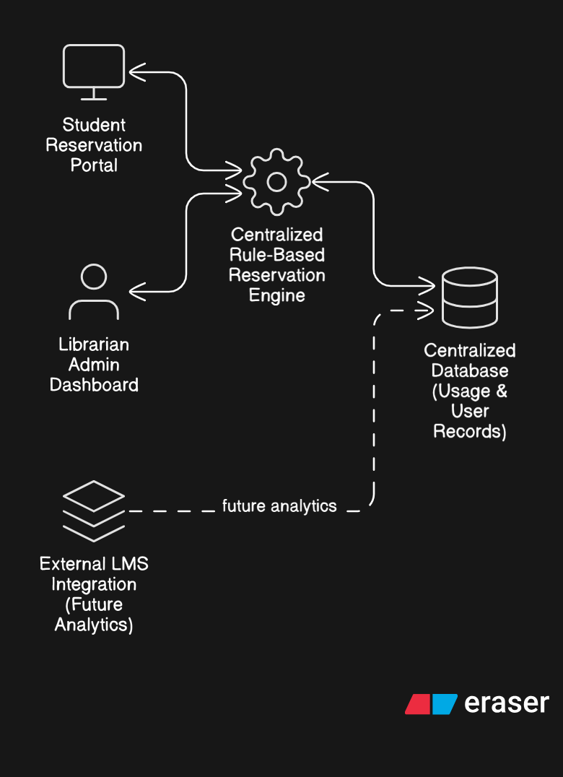
Figure 4. High-level system architecture of the smart library pod reservation system
Source: Author’s elaboration (2026)
The user interface displays real-time pod availability and supports straightforward booking with acknowledgment of the mandatory rule (Figure 5). This design enhances transparency and reduces search time, consistent with findings on digital service interfaces in libraries (Ajab Mohideen et al., 2022; Rivo & Žumer, 2022).
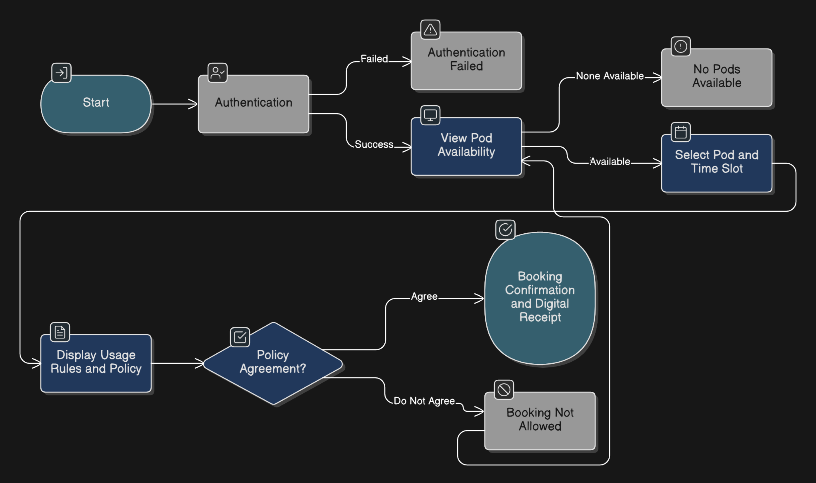
Figure 5. User reservation workflow and booking confirmation process
Source: Author’s elaboration (2026)
A core governance feature is the conditional workflow: bookings require check-in within a defined grace period, with automatic cancellation for no-shows (Figure 6). This mechanism directly addresses no-show behavior and unattended occupancy by transforming reservations into accountable actions.
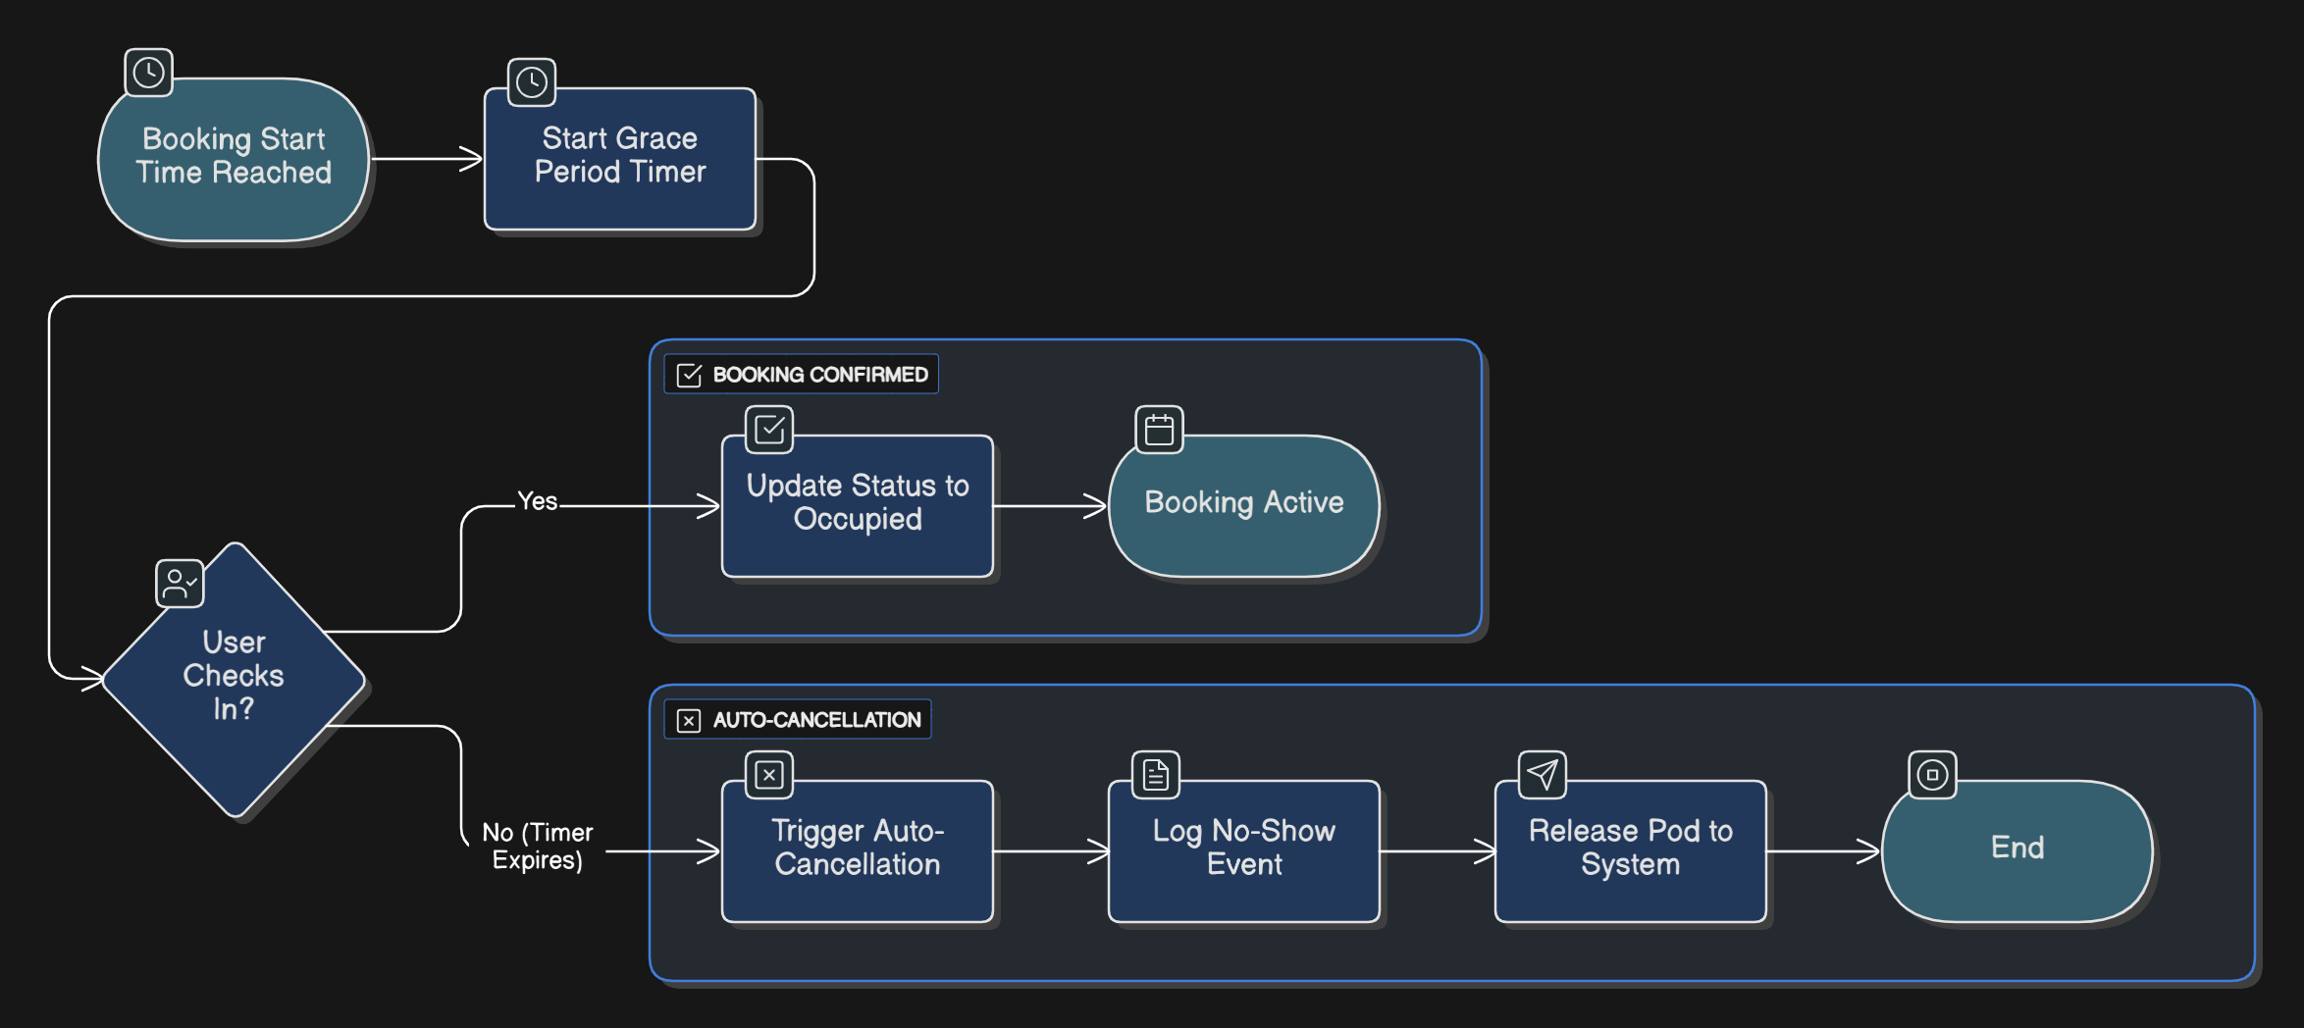
Figure 6. Check-in validation and automated cancellation flow
Source: Author’s elaboration (2026)
The administrative dashboard enables staff to monitor usage patterns, identify repeated non-compliance, and adjust parameters such as grace periods or booking limits (Figure 7). This reduces manual workload while maintaining institutional oversight.
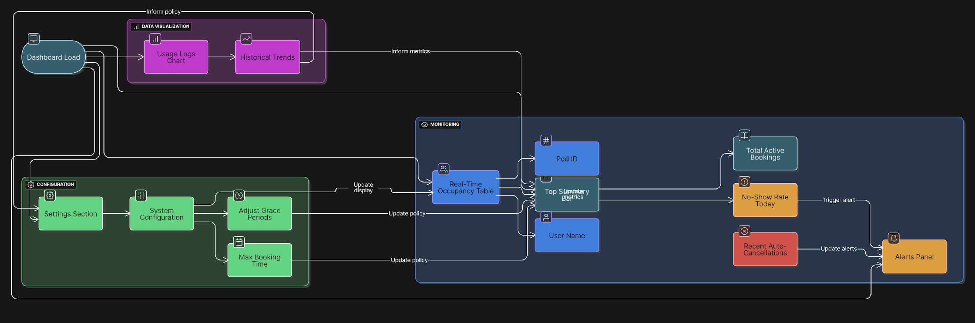
Figure 7. Administrative dashboard and monitoring features
Source: Author’s elaboration (2026)
Each feature maps directly to identified problems: real-time visibility addresses access uncertainty, check-in validation tackles no-shows and misuse, and automated cancellation improves resource turnover. This traceability strengthens the artifact’s practical relevance.
3.4. Evaluation and Discussion
Although the system has not been fully deployed, conceptual evaluation based on user perceptions and stakeholder feedback supports its relevance and feasibility. The design directly responds to the main issues reported: uncertain availability, misuse, unattended occupation, and heavy reliance on manual intervention.
From a system quality perspective, the workflow balances simplicity with accountability, aligning with established models that link usability, information clarity, and user satisfaction to system success (Antonopoulou & Kotsilieris, 2019; Delone & McLean, 2003). Overly complex systems risk low adoption, while overly permissive ones fail to curb misuse; the proposed design aims for a middle ground where convenience and governance reinforce each other.
Unlike previous IoT-based seat reservation systems that focus purely on occupancy detection, this proposed design prioritizes governance as a preventive measure against resource mismanagement. By addressing the socio-technical requirements of shared learning environments, the artifact moves beyond simple automation to ensure sustainable facility management.
The findings also contribute to broader theoretical understanding of technology adoption in shared resource environments. Users are more likely to accept and comply with systems they perceive as fair, transparent, and reliable (Gefen et al., 2003; Venkatesh et al., 2012). By operationalizing fairness through visible availability, time-bound rules, and consistent enforcement, the artifact addresses both behavioral and technical dimensions of adoption.
A key contribution of this study is positioning governance as a core design element rather than an administrative afterthought. While many smart library solutions prioritize automation and convenience (Maepa & Moeti, 2021; Adewojo & Monjolaoluwa, 2025), the present work demonstrates that embedding behavioral control mechanisms at the design stage is essential for addressing socio-technical challenges in shared learning spaces. This approach refines current understandings of “smart” library systems by showing that technological functionality alone is insufficient without integrated accountability.
Beyond immediate library management, the system generates structured, governed usage data that can support future smart campus and learning analytics initiatives (Polat & Eroğlu, 2021; Alotaibi, 2024). Reliable data sources are a prerequisite for meaningful analysis, and the proposed design provides a foundation for such integration without requiring extensive sensor infrastructure.
Overall, the findings demonstrate that a governance-oriented reservation system offers a practical, scalable solution to recurring challenges in study pod management. By integrating usability, transparency, accountability, and administrative oversight, the proposed design addresses the socio-technical nature of shared learning spaces more comprehensively than purely manual or automation-centered alternatives.
4. CONCLUSION
This study applied a Design Science Research approach to address inefficiencies in the management of shared individual study pods in higher education libraries. The findings indicate that students perceive study pods as valuable for enhancing focus and academic productivity. However, their potential remains significantly constrained by limited availability, no-show behavior, misuse, lack of transparency, and reliance on informal manual processes. These results address the research problem directly by demonstrating that the primary limitation lies not in the physical resource itself, but in the absence of structured, enforceable governance mechanisms.
Through systematic requirement elicitation from students and administrative stakeholders, the study developed a governance-oriented smart library pod reservation system as a design artifact. The proposed system integrates real-time availability information, mandatory rule acknowledgment, user check-in validation, automated cancellation of unattended bookings, and administrative monitoring. These features collectively improve transparency, promote fairness in resource allocation, strengthen accountability, and reduce the administrative burden on library staff.
A central contribution of this work is the embedding of behavioral control and governance mechanisms directly into the reservation workflow at the early design stage. Unlike many existing smart library solutions that prioritize automation alone, this approach treats governance as an integral part of the system rather than an external policy, thereby addressing the socio-technical challenges inherent in shared learning spaces.
From a practical perspective, university library administrators and information technology teams in Indonesian higher education institutions, as well as similar resource-constrained contexts, should adopt and implement governance-oriented reservation systems. The purpose of this guidance is to optimize the utilization of limited study pods, enhance equitable access for students seeking focused learning environments, reduce reliance on manual oversight, and support more efficient and sustainable library operations. Such systems will also generate structured usage data that can inform future institutional planning and integration with broader smart campus initiatives.
In conclusion, this study demonstrates that a governance-oriented reservation system offers a practical, scalable, and balanced solution to persistent challenges in managing shared learning spaces. By combining usability with accountability, the proposed design contributes to creating more effective, fair, and technology-supported academic environments.
Practically, library administrators in resource-constrained settings should consider embedding behavioral rules into digital workflows to reduce the administrative burden of manual monitoring. Future implementation of this design could serve as a model for other academic institutions in Indonesia to ensure equitable access to learning facilities through automated governance.
Future research should prioritize longitudinal evaluations of full-scale implementations to measure the long-term impact of governance-oriented designs on user behavior and resource efficiency. While this study establishes the framework for automated accountability, comparative studies across diverse institutional contexts, varying in size, culture, and resource availability, would provide deeper insights into the generalizability of these governance mechanisms (Chen et al., 2022; Natta, 2025). Such research could employ mixed-methods approaches to explore how different 'penalty' or 'nudge' structures affect student satisfaction and perceived fairness over time, ensuring that automated rules do not inadvertently create barriers to accessibility for marginalized student groups (Damgaard & Nielsen, 2018; Mustafa, 2024).
Furthermore, there is significant potential in exploring the integration of pod reservation systems with broader Learning Management Systems (LMS) and campus-wide data ecosystems. By synchronizing reservation data with student academic profiles and engagement metrics, researchers could investigate the correlation between the usage of focused study spaces and specific student learning outcomes (Ismail et al., 2021; Kuderbayeva, 2025). The application of Artificial Intelligence (AI) and predictive modeling could further enhance these systems by forecasting peak demand periods and dynamically adjusting booking policies to optimize space allocation (Kumar et al., 2024; Uche Nweje & Moyosore Taiwo, 2025). Ultimately, moving toward a fully integrated, data-driven smart campus will require a holistic understanding of how physical space utilization interacts with digital learning trajectories.
5. AUTHORS’ NOTE
The authors declare that there is no conflict of interest regarding the publication of this article. The authors confirmed that the paper was free of plagiarism.

6. REFERENCES

Adewojo, A. A., & Monjolaoluwa, O. P. (2025). Smart library environments: IoT and automation for next-generation services. Business Information Review, 42(4), 232-237. https://doi.org/10.1177/02663821251384884
Ajab Mohideen, Z., Sheikh, A., & Kaur, K. (2022). Mobile app in library services. Digital Library Perspectives, 38(3), 283–300. https://doi.org/10.1108/DLP-08-2021-0064
Alotaibi, N. S. (2024). The Impact of AI and LMS Integration on the Future of Higher Education: Opportunities, Challenges, and Strategies for Transformation. Sustainability, 16(23), 10357. https://doi.org/10.3390/su162310357
Amberger, C., & Schreyer, D. (2024). What do we know about no-show behavior? A systematic, interdisciplinary literature review. Journal of Economic Surveys, 38(1), 57–96. https://doi.org/10.1111/joes.12534
Antonopoulou, M., & Kotsilieris, T. (2019). A Literature Review of User Satisfaction Models Towards Information System Success. International Journal of E-Services and Mobile Applications (IJESMA), 11(2), 71–87. https://doi.org/10.4018/IJESMA.2019040105
Arévalo-Cordovilla, F. E., & Peña, M. (2024). Comparative Analysis of Machine Learning Models for Predicting Student Success in Online Programming Courses: A Study Based on LMS Data and External Factors. Mathematics, 12(20). https://doi.org/10.3390/math12203272
Asim, M., & Arif, M. (2026). Internet of Things Adoption and Use in Academic Libraries: A Review and Directions for Future Research. Journal of Information Science, 52(1), 228–243. https://doi.org/10.1177/01655515231188338
Azam, M., & Ahmad, K. (2024). Adoption of Big Data Analytics for Sustainability of Library Services in Academic Libraries of Pakistan. Library Hi Tech, 42(5), 1457–1476. https://doi.org/10.1108/LHT-12-2022-0584
Bogonko, B. M., Nyakweba, I., & Nakhungu, N. (2025). A framework for implementing data governance and artificial intelligence in higher education libraries. Edulib, 15(2), 199–218. https://doi.org/10.17509/edulib.v15i2.87417
Cao, G., Liang, M., & Li, X. (2018). How to make the library smart? The conceptualization of the smart library. The Electronic Library, 36(5), 811–825. https://doi.org/10.1108/EL-11-2017-0248
Chan, H. C. Y., & Chan, L. (2018). Smart library and smart campus. Journal of Service Science and Management, 11(6), 543–564. https://doi.org/10.4236/jssm.2018.116037
Chaudhari, P., Xiao, Y., Cheng, M. M.-C., & Li, T. (2024). Fundamentals, Algorithms, and Technologies of Occupancy Detection for Smart Buildings Using IoT Sensors. Sensors, 24(7), 2123. https://doi.org/10.3390/s24072123
Chen, L., Tong, T. W., Tang, S., & Han, N. (2022). Governance and Design of Digital Platforms: A Review and Future Research Directions on a Meta-Organization. Journal of Management, 48(1), 147–184. https://doi.org/10.1177/01492063211045023
Chen, M., & Shen, C. (2020). The correlation analysis between the service quality of intelligent library and the behavioral intention of users. The Electronic Library, 38(1), 95–112. https://doi.org/10.1108/EL-07-2019-0163

Damgaard, M. T., & Nielsen, H. S. (2018). Nudging in Education. Economics of Education Review, 64, 313–342. https://doi.org/10.1016/j.econedurev.2018.03.008
Delone, W. H., & McLean, E. R. M. (2003). The DeLone and McLean Model of Information Systems Success: A Ten-Year Update. Journal of Management Information Systems, 19(4), 9–30. https://doi.org/10.1080/07421222.2003.11045748
Drechsler, A. (2015). Designing to Inform: Toward Conceptualizing Practitioner Audiences for Socio-Technical Artifacts in Design Science Research in the Information Systems Discipline. I^{n}SITE 2015: Informing Science + IT Education Conferences: USA, 920. https://www.informingscience.org/Publications/2143
Garoufallou, E., & Gaitanou, P. (2021). Big Data: Opportunities and Challenges in Libraries, a Systematic Literature Review. College & Research Libraries, 82(3), 410. https://doi.org/10.5860/crl.82.3.410
Gefen, D., Karahanna, E., & Straub, D. (2003). Trust and TAM in online systems. MIS Quarterly, 27(1), 51–90. https://doi.org/10.2307/30036519
Gregor, S., & Hevner, A. R. (2013). Positioning and presenting design science research. MIS Quarterly, 37(2), 337–355. https://doi.org/10.25300/MISQ/2013/37.2.01
Hevner, A. R., March, S. T., Park, J., & Ram, S. (2004). Design science in information systems research. MIS Quarterly, 28(1), 75–105. https://doi.org/10.2307/25148625
Ismail, S., Hamid, S., Ahmad, M., Alaboudi, A., & Jhanjhi, N. (2021). Exploring Students Engagement Towards the Learning Management System (LMS) Using Learning Analytics. Computer Systems Science and Engineering, 37(1), 73–87. https://doi.org/10.32604/csse.2021.015261
Khan, A. U., Rafi, M., & Zhang, Z. (2023). Determining the impact of technological modernization and management capabilities on user satisfaction and trust in library services. Global Knowledge, Memory and Communication, 72(6-7), 593–611. https://doi.org/10.1108/GKMC-06-2021-0095
Kim, Y., & Yang, E. (2022). Academic library spaces and student activities during the COVID-19 pandemic. The Journal of Academic Librarianship, 48(4), 102529. https://doi.org/10.1016/j.acalib.2022.102529
Kuderbayeva, A. (2025). Hybrid Campuses: Optimization Models of Classroom Occupancy and Timetables Based on Digital Data (LMS, Wi-Fi, Access Control Systems) And Their Relationship with Student Achievement and Well-Being. The American Journal of Applied Sciences, 7(10), 104–112. https://doi.org/10.37547/tajas/Volume07Issue10-12
Kumar, P., Choubey, D., Amosu, O. R., & Ogunsuji, Y. M. (2024). AI-Enhanced Inventory and Demand Forecasting: Using AI to Optimize Inventory Management and Predict Customer Demand. World Journal of Advanced Research and Reviews, 23(1), 1931–1944. https://doi.org/10.30574/wjarr.2024.23.1.2173
Kurka, D. B., & Pitt, J. (2017). Smart-CPR: Self-Organisation and Self-Governance in the Sharing Economy. 2017 IEEE 2nd International Workshops on Foundations and Applications of Self* Systems (FAS*W), 85–90. https://doi.org/10.1109/FAS-W.2017.125

Li, L. H., Wu, F., & Su, B. (2018). Impacts of Library Space on Learning Satisfaction – An Empirical Study of University Library Design in Guangzhou, China. The Journal of Academic Librarianship, 44(6), 724–737. https://doi.org/10.1016/j.acalib.2018.10.003
Lu, J., García-Badell, G., & Rodriguez, J. B. (2025). Digital Heritage from a Socio-Technical Systems Perspective: Integrated Case Analysis and Framework Development. Heritage, 8(9), 348. https://doi.org/10.3390/heritage8090348
Maepa, M. R., & Moeti, M. N. (2021). IoT-Based Smart Library Seat Occupancy and Reservation System Using RFID and FSR Technologies for South African Universities of Technology. Proceedings of the International Conference on Artificial Intelligence and Its Applications, 1–8. https://doi.org/10.1145/3487923.3487933
Maepa, M. R., & Moeti, M. N. (2023). A systematic review on IoT-based smart technologies for seat occupancy and reservation needs in smart libraries at institution of higher learning. In M. K. Habib (Ed.), Internet of things - New insights. IntechOpen. https://doi.org/10.5772/intechopen.113329
Montgomery, S. E. (2014). Library space assessment: User learning behaviors in the library. Journal of Academic Librarianship, 40(1), 70–75. https://doi.org/10.1016/j.acalib.2013.11.003
Mustafa, R. F. (2024). Shove Less, Nudge More: Stakeholders’ Perspective from Writing Classrooms. Higher Education Studies, 14(4), p186. https://doi.org/10.5539/hes.v14n4p186
Natta, P. K. (2025). Scalable Governance Frameworks for AI-Driven Enterprise Automation and Decision-Making. International Journal of Research Publications in Engineering, Technology and Management (IJRPETM), 8(6), 13182–13193. https://doi.org/10.15662/IJRPETM.2025.0806022
Ncube, M. M., & Ngulube, P. (2025). Leveraging Learning Analytics to Personalise Academic Library Services for Enhanced Student Success: A Systematic Review. The Journal of Academic Librarianship, 51(6), 103160. https://doi.org/10.1016/j.acalib.2025.103160
ODonnell, P., & Anderson, L. (2022). The University Library: Places for Possibility. New Review of Academic Librarianship, 28(3), 232–255. https://doi.org/10.1080/13614533.2021.1906718
Peffers, K., Tuunanen, T., Rothenberger, M. A., & Chatterjee, S. (2007). A Design Science Research Methodology for Information Systems Research. Journal of Management Information Systems, 24(3), 45–77. https://doi.org/10.2753/MIS0742-1222240302
Polat, C., & Eroğlu, E. B. (2021). Learning Analytics and an Evaluation Specific to University Libraries. Journal of Balkan Libraries Union, 8(1), 23–32. https://doi.org/10.16918/jblu.937396
Reneilwe Maepa, M., & Nthabiseng Moeti, M. (2024). A Systematic Review on IoT-Based Smart Technologies for Seat Occupancy and Reservation Needs in Smart Libraries at Institution of Higher Learning. In M. K. Habib (Ed.), Internet of Things—New Insights. IntechOpen. https://doi.org/10.5772/intechopen.113329

Rimbeck, M., Stumpf-Wollersheim, J., & Richter, A. (2025). Unfolding IoT Adoption: A Status Quo Bias Perspective. Business & Information Systems Engineering, 67(6), 815–832. https://doi.org/10.1007/s12599-024-00891-6
Rivo, K., & Žumer, M. (2022). Academic Libraries and Use of Mobile Devices: Case Study of Slovenia. The Journal of Academic Librarianship, 48(3), 102507. https://doi.org/10.1016/j.acalib.2022.102507
Rowe, J., Leuzinger, J., Hargis, C., & Harker, K. R. (2021). The impact of library instruction on undergraduate student success: A four-year study. College & Research Libraries, 82(1), 7–28. https://doi.org/10.5860/crl.82.1.7
Scoulas, J. M., & de Groote, S. L. (2019). The library’s impact on university students’ academic success and learning. Evidence Based Library and Information Practice, 14(3), 2–27. https://doi.org/10.18438/eblip29547
Scoulas, J. M., de Groote, S. L., Shotick, K., & Osorio, N. L. (2024). A holistic approach to understanding undergraduates: Campus engagement, library use and psychological factors. Journal of Academic Librarianship, 50(5), 102936. https://doi.org/10.1016/j.acalib.2024.102936
Sedrati, A., Mezrioui, A., & Ouaddah, A. (2022). IoT Governance: A State of the Art and a Comparative Analysis. 2022 13th International Conference on Information and Communication Systems (ICICS), 76–81. https://doi.org/10.1109/ICICS55353.2022.9811219
Shahzad, K., Khan, S. A., & Iqbal, A. (2026). Effects of Big Data Analytics on University Libraries: A Systematic Literature Review of Impact Factor Articles. Journal of Librarianship and Information Science, 58(1), 41–59. https://doi.org/10.1177/09610006241259495
Shahzad, K., Khan, S. A., Iqbal, A., & Javeed, A. M. D. (2024). Identifying university librarians’ readiness to adopt artificial intelligence (AI) for innovative learning experiences and smart library services: An empirical investigation. Global Knowledge, Memory and Communication, 75(1/2), 646–668. https://doi.org/10.1108/GKMC-12-2023-0496
Uche Nweje & Moyosore Taiwo. (2025). Leveraging Artificial Intelligence for Predictive Supply Chain Management, Focus on How AI- Driven Tools Are Revolutionizing Demand Forecasting and Inventory Optimization. International Journal of Science and Research Archive, 14(1), 230–250. https://doi.org/10.30574/ijsra.2025.14.1.0027
V, N. M. A., & R, S. H. (2026). Transforming Libraries: The Emergence of Smart Libraries in the Digital Era. International Journal of Web of Multidisciplinary Studies, 3(2), 287–294. https://doi.org/10.71366/ijwos03022682416
Venkatesh, V., Thong, J. Y. L., & Xu, X. (2012). Consumer acceptance and use of information technology: Extending UTAUT. MIS Quarterly, 36(1), 157–178. https://doi.org/10.2307/41410412
Villarreal, M., Baird, T. D., Tarazaga, P. A., Kniola, D. J., Pingel, T. J., & Sarlo, R. (2025). Shared space and resource use within a building environment: An indoor geography. The Geographical Journal, 191(1), e12604. https://doi.org/10.1111/geoj.12604

Wang, C., Wu, R., Deng, L., Chen, Y., Li, Y., & Wan, Y. (2020). A bibliometric analysis on no-show research: Status, hotspots, trends and outlook. Sustainability, 12(10), 3997. https://doi.org/10.3390/su12103997
Weigand, H., & Johannesson, P. (2023). How to Identify your Design Science Research Artifact. 2023 IEEE 25th Conference on Business Informatics (CBI), 1–10. https://doi.org/10.1109/CBI58679.2023.10187511

