e-ISSN 2549-7529 | p-ISSN 1412-0313
https://ejournal.upi.edu/index.php/gea



PARTICIPATION OF HOUSEWIFE IN IMPROVING THE SUSTAINABILITY OF THE CIPATANI RIVER
(Study in Nangewer Village, Pagerageung District, Tasikmalaya Regency)

Siti Fadjarajani¹, Tineu Indrianeu²
^{1,2}Jurusan Pendidikan Geografi, Universitas Siliwangi
*sitifadjarajani@unsil.ac.id *tineuindrianeu@unsil.ac.id

ABSTRACT
The existence of rivers is very important in the life of the ecosystem on earth, where in the hydrological conditions the river is one of the important places for the flow of water on earth which will be discharged into the sea. However, the current condition of the river is very worrying, because the river is used as a place for waste disposal, both industrial and household waste. In Nagewer Village, Pagerageung District, Tasikmalaya Regency, a group of housewives who are members of the Srikandi Sungai Indonesia (SSI) group took the initiative to improve the sustainability of the river. The group of housewives plays a role in river conservation efforts such as cleaning the river, arranging rivers, and maintaining the quality of river water for the better. So that this research was also carried out to determine the role of housewives in preserving the Cipatani river and to determine the efforts whatever is being done in preserving the Cipatani river. Based on the results of the research, conceptually in an effort to conserve the river by a group of housewives, a group of housewives has made efforts in the form of river conservation, including periodic cleaning of the river, planting plants / trees along the river to reduce soil erosion and sedimentation, organize, and tidy up the river so that become more beautiful.
Keywords: The Role of Housewives, Sustainability, Cipatani River,

INTRODUCTION
River is one of the aquatic ecosystems which is influenced by many factors, both by natural activities and human activities. A river is a naturally occurring network of channels on the surface of the earth, ranging from small in the upstream to large downstream. (Fadjarajani et al., 2018). Rain water that falls to the surface of the earth in the process falls to the surface of the earth, and the water flows in the relief condition of the earth's surface from the high surface of the earth (upstream) to the low surface of the earth (downstream), the water on the surface of the earth is partially accommodated (lakes, swamps, etc.) and some of them are flowed into rivers and will end up in the oceans. In this process, the water undergoes an evaporation process (evaporation) and part of it is on earth and the water condition will continue to do so, this is known as the hydrological cycle.
According to (Syarifuddin, 2000) rivers have several types according to the water, consisting of:
- Permanent river, namely a river whose water discharge is relatively constant throughout the year.
- Periodic rivers are rivers that have a lot of water during the rainy season, while during the dry season the water is low.
- Intermittent river or episodic river, which is a river that flows its water during the rainy season, while in the dry season the water is dry.
- Ephemeral rivers are rivers that have water only during the rainy season.
According to Undang-Undang No. 7 of 2004 concerning Water Resources, Management of Water Resources is the implementation of conservation of water resources, utilization of water resources, and control of the destructive force of water. Therefore the existence of water is very important in a certain quantity, quality and time that can be expected to ensure the sustainability of community life and the environment in a sustainable manner (Norsidi, 2017). So that with this, water resources are a source of very potential needs for the activities of living things to be a process of their life development. Water which is a very important need for living things, lack of water needs will be disrupted by the growth and development process of living things.
The existence of rivers is very important in the life of the ecosystem on earth, where in the hydrological conditions the river is one of the important places for the flow of water on earth which will be discharged into the sea. Rivers are often found in Indonesia and it is not a strange thing, because our people do a lot of activities in the river such as bathing, washing, to support their cooking activities, even the river is something very interesting to be used as a place for children's water to play. Because in the past the quality of river water was still good, the water was still clear, clean and had not been exposed to waste. Over time, the quality and quantity of rivers have changed, the environmental conditions that affect them, such as starting to build factories or home industries where the waste is dumped directly into the river.
Rivers have a very important role in the history of human civilization, where all population activities in the agricultural economic sector are highly dependent on rivers, such as the modification of river ecosystems by the construction of dams and irrigation systems. So that the function of rivers continues to develop and cannot be separated from human life, the variety of activities carried out by humans without rivers until now, such as disposal of household waste, disposal of industrial waste, such things have decreased the quality of river water. The entry of waste into the river will result in changes in the physical, chemical and biological elements of the river. If done continuously, the river will find it difficult to recover and in the end it will experience an imbalance in the natural ecosystem in the river.
Lack of understanding of the character of caring for the environment makes humans meet their needs by making the surrounding environment a satisfying tool. The surrounding nature, as a place for life to take place, actually requires the role of humans to grow in a sustainable manner. Nature and the environment are ultimately beneficial for the benefit of human life (Masruroh, 2018).
In (Murthada, 1995) Scientists like Plato say that in terms of women, in terms of physical and spiritual strength, women are mentally weaker than men, but these differences do not cause any difference in their talents. However, in fact, women have an important influence in life and survival on this earth, because women can be said to be the strongest humans based on the roles and tasks performed by women who are very large and even many, especially women who already have families, her as a wife, teacher, doctor, chef etc.
A group of women who were dominated by housewives in Nangewer Village, Pagerageung District, Tasikmalaya Regency took the initiative to create a community called SSI (Srikandi Sungai Indonesia) which was aimed at preserving the rivers in Pangerageung District, Tasikmalaya Regency, because they saw the concerns of the rivers. many have been polluted by wastes, both industrial waste and household waste. With the existence of problems in the current river conditions and the initiation of the Women's group which is dominated by housewives who care about the sustainability of the river, the problems and objectives of this study are (1) to determine the role of housewives in preserving the Cipatani river (1). 2) to find out what efforts are being made to preserve the Cipatani river.
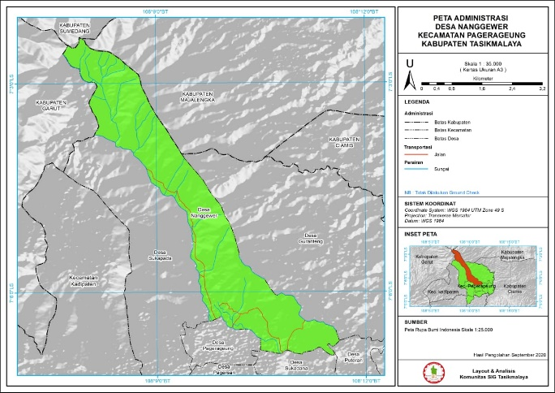
Source: Tasikmalaya SIG Community
Figure 1. Administrative Map

Concept of Role in Social Sciences
In the General Indonesian Dictionary, a role is something that is part of or who holds the main leadership. (Porwadarminto, 1984). Role is a form of behavior expected of a person in certain social situations. When interpreted by role, namely the behavior expected of someone in a certain status, then the role of behavior can be interpreted as the actual behavior of the person who performs that role which is essentially a series of certain behaviors caused by a certain position.
According to (Soerjono, 2013) Role is a dynamic aspect of position (status). If a person exercises rights and obligations according to his position, then it means he is playing a role. The two cannot be separated because one is dependent on the other and vice versa. Every person has various roles that come from the patterns of his life interactions. It also means that the role determines what he does for society and what opportunities the community gives him.
Role is a set of behavior expected by other people towards someone according to their position in a system. The role is influenced by social conditions both from within and from outside and is stable. Role is the form and behavior expected of a person in certain social situations (Soerjono, 2003). So that in the face of a change in both the condition of humans as individual beings and humans as social beings, it is necessary to play a role by humans, so that what is achieved in individuals or groups can be achieved or fulfilled.
Roles can also be defined as a set of behaviors that can be expected to motivate the behavior of a person who occupies a certain social status. (Megawangi, 1999). Role is our existence, role becomes a social description of who we are and who we are. Roles become meaningful when associated with other people, social or political communities.
All activities or activities that are carried out must have a goal to be achieved, this achievement requires a process to be carried out, because each individual has their respective roles, functions and duties. From some of these definitions, it can be concluded that a role is a behavior or action that is expected by each individual or group of people to exert an influence on a group or on the environment.
The Concept of Preserving the River
According to Law no. 23 of 1997 concerning the management of the environment, the environment is a spatial unit with all objects and living things, including humans and their behaviors that carry out their life and welfare of humans and other living creatures. Environmental elements can be divided into three, namely:
- Biotic elements: elements of the living environment consisting of living things, such as humans, animals, plants, and microorganisms.
- Physical (abiotic) elements: environmental elements consisting of inanimate objects such as soil, water, air, climate, and others.
- Socio-cultural elements: namely the social and cultural environment created by humans which is a system of values, ideas, and beliefs in behavior as social beings.
Humans are created as the most perfect creatures of God who have a mind (intelligence) that is able to change any form of life that exists on this earth, from simple life to modern life today. So that what becomes appearance on this earth undergoes a process of change. Humans as the rulers of the environment have a big role in determining environmental sustainability. So that in such conditions the environment has experienced very significant changes, a lot of progress has been achieved by humans, but not a few of these human achievements the environment has suffered damage caused by humans.
According to Sue (2003: 43) in (Tamara, 2016) explains that caring for the environment expresses general attitudes towards environmental quality which are manifested in the willingness to express actions that can improve and maintain environmental quality in any behavior related to the environment. If an attitude of caring for the environment can be expressed in actions, then those who care about the environment will always protect the environment.
The environment acts as a source of geography learning. The environment has a significant relationship with the attitudes and behavior of students even though the relationship is not strong. The environment is not directly related to the attitudes and spatial behavior of students, but through intermediaries, which is influenced by professional competence (Nurlaela, 2016)
Several forms of environmental damage are influenced by humans, including:
a. The occurrence of pollution (air, water, soil, and air / sound pollution) as a result of the existence of an industrial area.
b. The occurrence of flooding, as a result of poor drainage or water disposal systems and errors in protecting watersheds and the impact of forest destruction.
c. The occurrence of landslides, as a direct impact of forest destruction.
Controlling the utilization of water sources: (1) controlling the use of water sources is carried out with the provisions of zone utilization at the water source concerned, (2) controlling the utilization of water sources is carried out through monitoring and supervision based on the provisions on the utilization of the zone at the water source concerned, (3) the ministry or ministries related to the sector of water resources and / or local governments in accordance with their authorities and responsibilities carry out a program to control the use of water sources.

Source: (Kementrian Pekerjaan Umum dan Perumahan Rakyat, 2019)
Figure 2. Upstream-Downstream Planning
Control of land management in the upstream area is carried out in an effort to prevent landslides, reduce the rate of soil erosion, reduce sedimentation rates in water sources and water resource infrastructure, and increase water infiltration into the soil. Land control pays attention to the conservation aspect and maintains its protection function in accordance with the provisions of statutory regulations. In (Kementrian Pekerjaan Umum dan Perumahan Rakyat, 2019) the concept of river management:
1. River Conservation, river protection with troughs, river boundaries, flood exposure lakes, and flood plains. Prevention of river water pollution is carried out in six stages:
a. Determination of the carrying capacity of pollution loads,
b. Identification and investment of sources of waste entering the river,
c. Determination of requirements and procedures for waste water disposal,
d. Prohibition of dumping garbage into rivers,
e. Monitoring water quality in rivers,
f. Monitoring of waste water entering the river
2. River development by utilizing rivers
3. Control of Water Damage

RESEARCH METHODS

The research method is a method used in a study that aims to achieve research objectives. A research method or often referred to as a research methodology is a design or research design. This design contains a formulation of the object or subject to be studied, data collection techniques, data collection and analysis procedures with regard to a particular problem focus. Research methods are the methods used by researchers in designing, implementing, processing data, and drawing conclusions regarding certain research problems (Sukmadinata. N. S., 2008).

This research uses descriptive research method, descriptive research is a research method aimed at describing existing phenomena, which are taking place at this time or in the past. Descriptive research has characteristics (Furchan, 2004). Descriptive research which has the following characteristics:

1. Descriptive research tends to describe a phenomenon as it is by reviewing it regularly, prioritizing objectivity, and being carried out carefully.

2. There is no treatment given or controlled, and there is no test h.

RESULTS AND DISCUSSION
The Role of Housewives in Preserving the Cipatani River
Role is a set of behavior expected by other people towards someone according to their position in a system. The role is influenced by social conditions both from within and from outside and is stable. Role is the form and behavior expected of someone in certain social situations. Achievements in individuals and groups can be achieved or fulfilled.
The role of housewives in Nangewer Village is very meaningful to improve the sustainability of the Cipatani River, in order to improve the efficiency and yield, resource management systems and the environment. The quality of environmental control depends on environmental insight which is influenced by the role of the community in preserving the environment, the level of awareness, and the ability of social institutions and institutions to be able to protect the environment, namely rivers as objects of study, which play an important role in human life.
The non-governmental movement in handling environmental problems is still not strong enough because it has not been fully supported by organizational strength, social institutions, social knowledge, knowledge, and inadequate conditions. For this reason, efforts are still needed to increase awareness of both central and regional government officials, will foster community self-sufficiency in environmental preservation and improvement (Fadjarajani et al., 2018).
The river is an important source of water, so it needs good management. There are many problems that occur in rivers, such as the occurrence of calcification, waste pollution, so that it has an impact on decreasing the quality of river water. The condition of heavily polluted water and occupancy of river land and water sources by residents, problems in physical factors such as reduction of river area as a result of sedimentation and land use change so that problems in rivers are very crucial. In (Kementrian Pekerjaan Umum dan Perumahan Rakyat, 2019) the concept of river management:
1. River Conservation, river protection with troughs, river boundaries, flood exposure lakes, and flood plains. Prevention of river water pollution is carried out in six stages:
a. Determination of the carrying capacity of pollution loads,
b. Identification and investment of sources of waste entering the river,
c. Determination of requirements and procedures for waste water disposal,
d. Prohibition of dumping garbage into rivers,
e. Monitoring water quality in rivers,
f. Monitoring of waste water entering the river
2. River development by utilizing rivers
3. Control of Water Damage
In this case, the role of housewives in Nangewer Village, Pangerageung District, Tasikmalaya Regency took the initiative to make a group called SSI (Srikandi Sungai Indonesia) to try to conserve rivers, because they think that the rivers are now worrying that many are polluted by wastes. , be it household waste or industrial waste.
The role of housewives in Nangewer Village, Pagerageung Subdistrict, Tasikmalaya Regency, has made a major contribution to efforts to preserve the Cipatani river, so that the Cipatani river will return clean, beautiful, and have a positive impact on the environment and surrounding communities. The efforts made by a group of housewives are cleaning around the Cipatani river, picking up trash from the river, making improvements to the river to make it look organized, neat and beautiful.
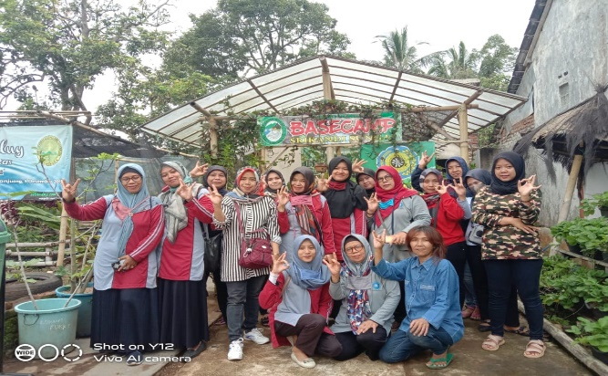 Source: Research Documentation Results
Figure 3.The Group of Housewives who are members of the SSI Group (Srikandi Sungai Indonesia)
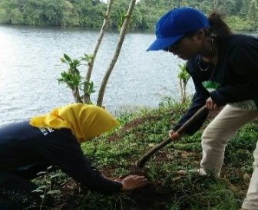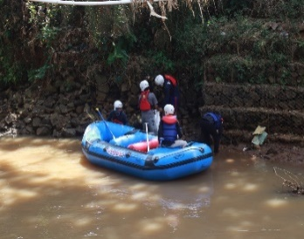
Source: Research Documentation Results
Figure 4. Cleaning activities around the riverbanks and planting plants around the river and cleaning the river from rubbish

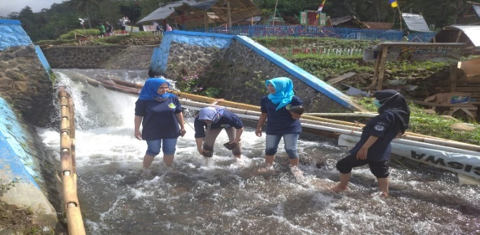 Source: Research Documentation Results
Figure 5. Activities to Arrange River Rocks and Clean Up Garbage

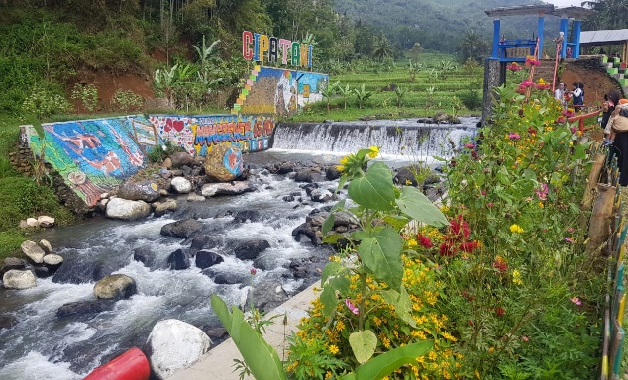 Source: Research Documentation Results
Figure 6. The condition of the river is clean, neat, and beautiful and the water is clear and is not exposed to waste

To increase the conservation results of the Cipatani river in Nagewer Village, Pageurageung District, Tasikmalaya Regency, SSI (Srikandi Sungai Indonesia) optimizes the areas around the river so that environmental damage does not occur due to soil erosion, planting is carried out along the banks of the Cipatani river. With this optimization Srikandi Sungai Indonesia (SSI) collaborates with related agencies such as the Perhutani Office for plant nurseries and with Siliwangi University with the Community Service Program in tree planting from upstream to downstream of rivers.
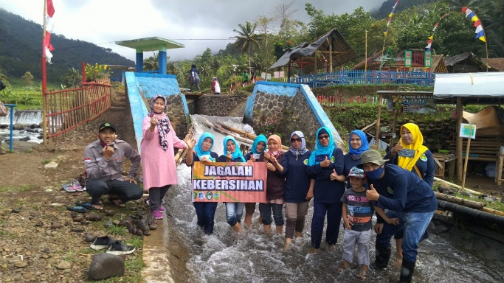
Source: Research Documentation Results
Figure 7. Collaboration with Siliwangi University in Community Service Programs

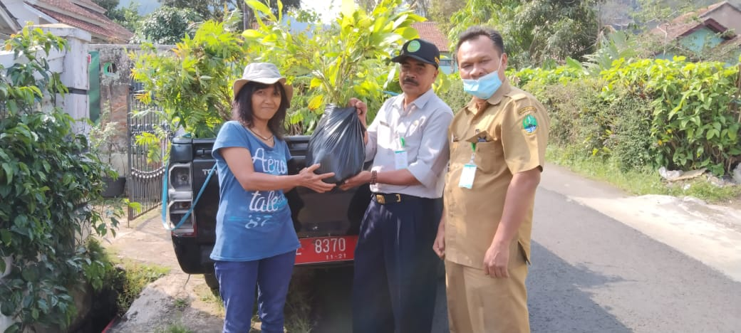
Source: SSI Documentation (Srikandi Sungai Indonesia)
Figure 8. Plant Seed Assistance Activities from the Dinas Perhutani

Efforts Made by Housewives in Improving the Conservation of the Cipatani River

Land management control in the upstream area is carried out in an effort to prevent landslides, reduce the rate of soil erosion, reduce sedimentation rates in water sources, and increase water infiltration into the soil. Land control pays attention to conservation aspects and maintains a protective function in accordance with the provisions of laws and regulations (Kementrian Pekerjaan Umum dan Perumahan Rakyat, 2019) river management conception:
1. River Conservation, river protection with troughs, river boundaries, flood exposure lakes, and flood plains. Prevention of river water pollution is carried out in six stages:
a. Determination of the carrying capacity of pollution loads,
b. Identification and investment of sources of waste entering the river,
c. Determination of requirements and procedures for waste water disposal,
d. Prohibition of dumping garbage into rivers,
e. Monitoring water quality in rivers,
f. Monitoring of waste water entering the river
2. River development by utilizing rivers
3. Control of Water Damage

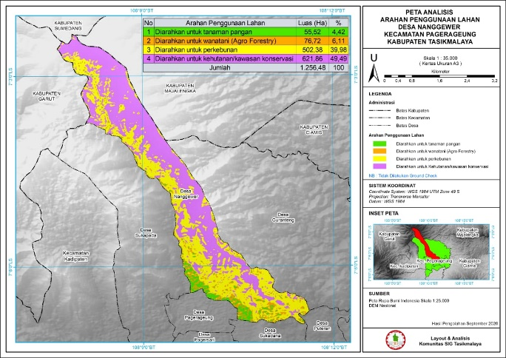
Source: Tasikmalaya SIG Community
Figure 9. Map of Soil Types in Nangewer Village
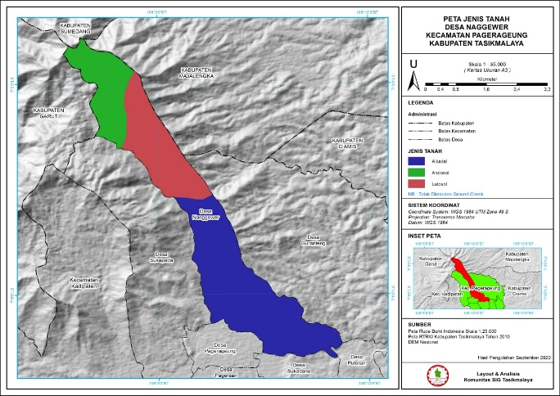
Source: Tasikmalaya SIG Community
Figure 10. Map of Analysis of Land Use Direction in Nangewer Village

Based on the condition of the soil type map and analysis map of the directions for use in Nangewer Village, the group of housewives initiated in the Srikandi Sungai Indonesia group optimizes the process of planting trees / plants in river conservation activities to minimize what is the impact of damage from the river other than exposure to the river. by waste, namely the process of sedimentation in rivers. So the form of efforts to preserve the river is the process of planting plants / trees along the riverbanks from upstream to downstream. In addition, posters were made to prohibit littering, conduct plant nurseries, and conduct regular river cleaning.
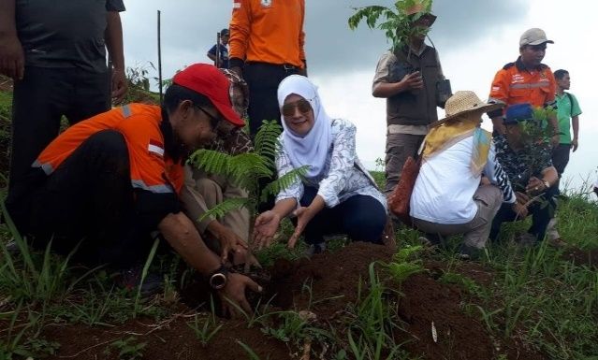
Source: Research Documentation Results
Figure 11. Tree Planting Around the Riverbanks
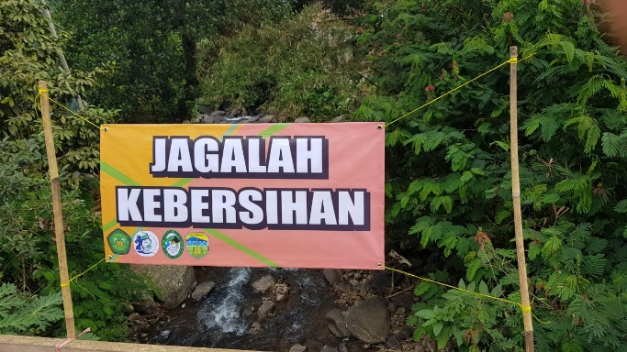
Source: Research Documentation Results
Figure 12. Posters Around the River

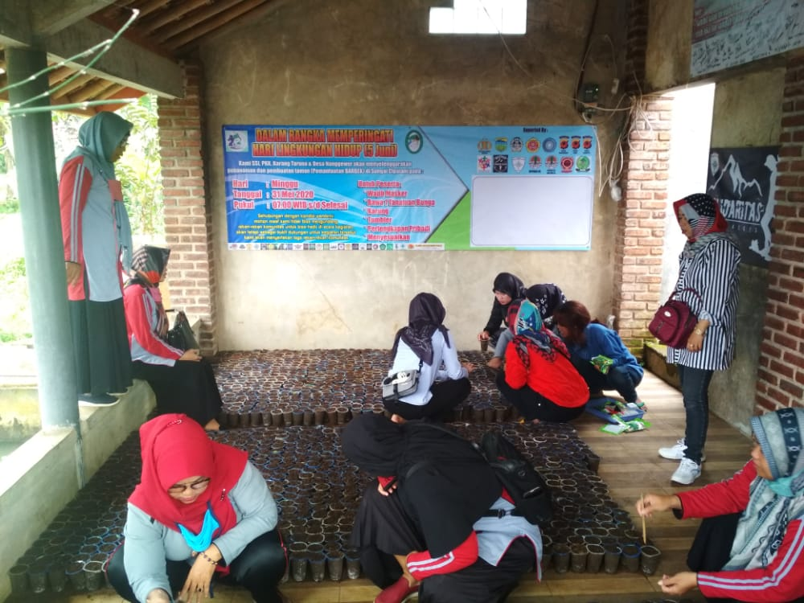
Source: Field Documentation Results
Figure 13. Process of Plant Nursery for Planting Around the River

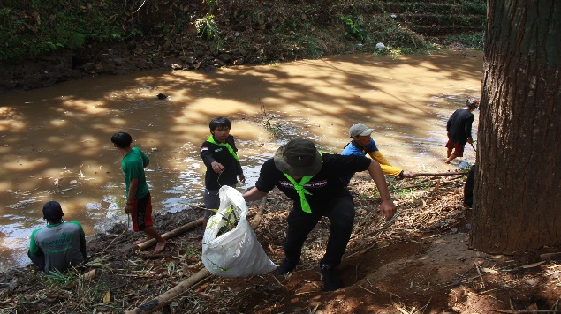
Source: Research Documentation Results
Figure 14. River Cleaning Periodically assisted by Student Volunteers

CONCLUSION
Based on the research results that have been explained regarding the role of housewives in improving the sustainability of the Cipatani river (Study in Nangewer Village, Pagerageung District, Tasikalaya Regency). The role carried out by housewives has a very big role in improving the sustainability of the Cipatani river so that with the initiation a non-governmental group was formed, namely the name Srikandi Sungai Indonesia (SSI), the role played by this group of housewives is to carry out activities in cleaning the river regularly, make improvements to the river to make it more orderly, tidy, and beautiful. In this role, efforts are made to improve the sustainability of the river, namely by planting poho / plants along the riverbanks from upstream to downstream, cleaning the river from garbage or waste dumped into the river, conducting plant nurseries.

REFERENCES

Fadjarajani, S., Singkawijaya, E. B., & Indriane, T. (2018). Peran Serta Masyarakat Dalam Menjaga Kelestarian Sungai Cimulu Di Kota Tasikmalaya. Prosiding Seminar Nasional Geografi UMS IX 2018. Restorasi Sungai : Tantangan Dan Solusi Pembangunan Berkelanjutan, 2000, 248–254.
Furchan, A. (2004). Pengantar Penelitian Dalam Pendidikan. Pustaka Pelajar Offset.
Kementrian Pekerjaan Umum dan Perumahan Rakyat. (2019). Modul perlindungan dan pelestarian sumber air.
Masruroh, M. (2018). Membentuk Karakter Peduli Lingkungan Dengan Pendidikan. Jurnal Geografi Gea, 18(2), 130. https://doi.org/10.17509/gea.v18i2.13461
Megawangi, R. (1999). Membiarkan Berbeda? Sudut Pandang Terbaru Tentang Relasi Gender. Mizan.
Murthada, M. (1995). Hak-Hak Wanita Dalam Islam. Lentera.
Norsidi, N. (2017). Pelestarian Daerah Aliran Sungai Berbasis Kearifan Lokal Lubuk Larangan Desa Lubuk Beringin Kecamatan Bathin Iii Ulu. Sosial Horizon: Jurnal Pendidikan Sosial, 3(2), 274–285. http://lppm.ikippgriptk.ac.id/index.php/sosial/article/view/370
Nurlaela, A. (2016). Peranan Lingkungan Sebagai Sumber Pembelajaran Geografi Dalam Menumbuhkan Sikap Dan Perilaku Keruangan Peserta Didik. Jurnal Geografi Gea, 14(1), 40–48. https://doi.org/10.17509/gea.v14i1.3361
Porwadarminto, W. J. . (1984). Kamus Umum Bahasa Indonesia. PN Balai Pustaka.
Soerjono, S. (2003). Sosiologi: Suatu Pengantar. Raja Grafindo Persada.
Soerjono, S. (2013). Sosiologi Suatu Pengantar. PT. Raja Grafindo Persada.
Sukmadinata. N. S. (2008). Metode Penelitian Pendidikan. Remaja Rosdakarya.
Syarifuddin, dkk. (2000). Sains Geografi. Bumi Aksara.
Tamara, R. M. (2016). Peranan Lingkungan Sosial Terhadap Pembentukan Sikap Peduli Lingkungan Peserta Didik Di Sma Negeri Kabupaten Cianjur. Jurnal Geografi Gea, 16(1), 44. https://doi.org/10.17509/gea.v16i1.3467

