Acquiring Scientific Process and Innovative Thinking Skills for Secondary School Sixth Grade Students through Digital Activities: An Action Research

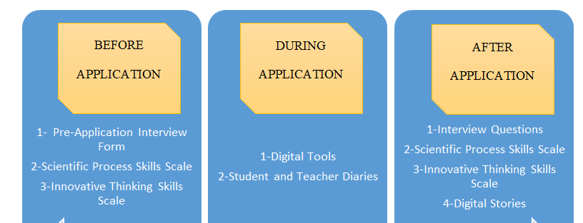

FINDINGS-DISCUSSION-CONCLUSION

