SUBMISSION PREPARATION CHECKLIST
Please write a checklist (√) for this requirement and submit this file with the manuscript to Editor
Yes? (√) | Points to be fulfilled for Initial Review
√ | Manuscripts submitted for publication in JSL should be between 4,000 and 10,000 WORDS and typed in double spacing, including tables, figures, and references.
√ | The ABSTRACT should maintain a maximum of 250 WORDS.
√ | If you are from the university (Staff of Students), the affiliation must contain Department, Faculty, University, City, Country.
√ | State within 100 words regarding your CLEAR NOVELTY and your research contribution to the latest development of technology-integrated science learning, media, assessment, or curriculum.
√ | Please add rigorous literature reviews in the introduction
√ | The manuscript submission contains at least ONE FIGURE representing the flow or mechanism of the research
√ | Reformat Tables, Figures following the example in JSL Example
√ | All Figures and Tables caption must be cited in Text
√ | Provide minimum 25 references and written carefully without an error. Follow APA 6 rev for the reference style. Here is the guideline: https://apastyle.apa.org/style-grammar-guidelines/tables-figures/tables, https://oldi.lipi.go.id/public/APA-References.pdf
√ | All citations must be referenced
√ | All references must be cited in text
√ | Use Mendeley or Endnote to format the citations and references or see the example https://youtu.be/AlYndOezang
√ | The number must be set as international standard 0.1, not the Indonesian style number 0,1
√ | Provide more International Journals as references instead of books
√ | DISCUSSION PART must be SEPARATED from Conclusion. The manuscript Must Contain the CONCLUSION part.
√ | The author is REQUESTED to recommend 5 (FIVE) international peer reviewers during the submission: 1. Reviewer Names, 2. Institutions, Countries, 3. Emails, 4. Reasons. The suggested reviewer must be outside your institution. The author confirms that there is no conflict of interest regarding recommending reviewers. JSL has the authority to decide the reviewers from or outside recommended reviewers.

The Development Of Foodivity Interactive As An Interactive Multimedia To Improve Students’ Understanding On Food Nutrition Topic

Sulistinayah Suwaka Putri^{1*}, Ari Widodo¹, Yaya Wihardi²
¹Department of International Program on Science Education, Faculty of Mathematics and Science Education, Universitas Pendidikan Indonesia, Bandung, Indonesia
² Department of Computer Education, Faculty of Mathematics and Science Education, Universitas Pendidikan Indonesia, Bandung, Indonesia

*Corresponding Author. sulistinayahsp@upi.edu

NOVELTY
Foodivity interactive was developed as an interactive multimedia on of food nutrition topic. The application built is a composite of several applications, taking their strengths and weaknesses into consideration. It can significantly improve students' understanding when used the foodivity interactive application. This is seen in the expert judgment and student responses were give good result.

ABSTRACT
The pandemic of COVID-19 has affected the education sector. All school access is restricted, transforming education into distance learning. This encourages educators to explore alternative methods for improving students' understanding. Interactive multimedia is a method of learning media that can be used to promote efficiency, motivation, and student understanding of subjects. This research aims to measure the students' understanding of nutrition by developing foodivity interactive as interactive multimedia. A pre-experimental one-group pretest-post-test design was adopted. In developing multimedia using the instructional design process ADDIE (Analysis, Design, Develop, Implement, and Evaluate). The research subject was 53 junior high school students in West Java, more precisely in two locations, Sukabumi and Kuningan. The instrument consisted of an expert judgment rubric, a student questionnaire, and a multiple-choice objective test with pretest and posttest. Expert judgment using the V Aiken index shows an average validation of 0.8125, indicating that the media is valid. Students responded positively to the questionnaire by a percentage of 93.01 percent. Based on the analysis, the N-gain value on students' understanding is 0.35. This indicates there was an increase in students achieving in the moderate improvement category between the pre- and post-tests. The hypothesis test establishes that hypothesis H1 is acceptable, showing a significant difference between pre- and post-tests occurred. These results indicate that using Foodivity Interactive as an Interactive Multimedia can enable students ’ understanding of nutrition topics.

Keywords
Foodivity Interactive, Multimedia Interactive, Students understanding, Food Nutrition Topic

1.Introduction
Due to the COVID-19 pandemic, many schools and colleges are closed. According to UNESCO data, nearly 160 countries have implemented national closures, affecting more than half of the world's student population (Abidah et al., 2020). With the restrictions on interaction, the Indonesian Ministry of Education also issued a policy, which is by closing schools. so that during the outbreak, the majority of students go to school by distance learning. Technology is used to deliver all subjects to students. Educators are required to explore and apply various theories, approaches, and principles of learning design to create an innovative learning environment for their students (Bhavya et al., 2021). In line with the rapid development of science and technology in the early 21st century which demands an increase in the quality of superior human resources. The learning model uses media such as smartphones, desktop PCs, laptops, or other devices connected to the internet. Smartphones, on the other hand, are preferred by consumers over other devices because they are easier to carry and offer lower prices than others (Sahlström et al., 2019).
Educators are directly or indirectly required to follow these developments by innovating and being creative in modifying learning. However, in reality on the online learning system, there are certain challenges faced. When doing online learning activities at home, students still lack the desire and encouragement to take the initiative to learn on their own (Godwin, 2012). Therefore, the problems surrounding distance learning during the Covid-19 pandemic must be addressed immediately so that learning outcomes can be maximized and significantly impact student behavior (Churiyah et al., 2020).
The low level of understanding and student learning outcomes is one of the reasons for the need for updates in learning strategies and methods of delivering material (transfer of knowledge) to students (Huryah et al., 2017). One of the factors that determine the quality of educational outcomes is the approach used by teachers in the learning process. The accuracy in using the learning approach taken by the teacher not only arouses students' motivation, interest and learning achievement but also increases students' understanding of the material provided by the teacher.
Apparently, behind the problems and complaints, many lessons can be learned in Indonesia. In this case, students and teachers will be better prepared to interact with new technologies so that online learning can be improved (Putri et al., 2020). In this era of increasingly sophisticated technological disruption, students and teachers are expected to be equally skilled in learning technology. There are various kinds of skills of students and instructors in using learning technology. A good lesson is a lesson that the learner has learned, and the multimedia material presented is a method of obtaining answers to the questions posed. It is essential to enhance enjoyment, creativity, willingness, and motivation in the learning process by utilizing digital media (Zheng et al., 2018). So one of the efforts to improve the understanding of science material, especially in biology is to use interactive multimedia.
Interactive multimedia will present nutrition topics in junior high schools related to health issues. Learning by utilizing interactive multimedia in learning, especially science learning, is expected to be an alternative to improve student learning outcomes. Nutrition material in schools rarely gets the attention it deserves. Because on Nasional Curriculum, the chapter focuses more on the digestive system (Roswati et al., 2019). While nutrition is an essential component of human existence, it is also necessary for health and well-being during various stages of life. To ensure that students are healthy, they must first have a basic awareness of nutrition and must be given a balanced diet with a strong basic understanding. This conception is essential for proper development into adulthood and well into the later stages of life (Perera et al., 2015).
Interactive multimedia can be further developed to transfer knowledge to students, which is an effective way to focus students' attention during the learning process, concretize information, and is an endless learning tool. Therefore, this study aims to develop interactive multimedia foodivity as interactive multimedia to increase students' understanding of food nutrition in junior high schools.

2. Method
The method used in this research is pre-experimental method. There is no control group or comparison groups in pre-experimental method (Dawson, 2007). Pre-experiments can be a cost-effective technique to see if a possible answer is worth investigating further. This research has used pretest and posttest design. The research design utilized in this study is one groups pretest and posttest, which is a research design that includes a pretest before treatment and a posttest after treatment.
The method to assess in this research by developing the multimedia. The development model used to develop interactive multimedia products is the ADDIE model. ADDIE Model is an instructional design process. This model consists of five stages, which is Analyse, design, develop, implement and evaluate. This design want to know the student understanding or test hypotheses about the presence or absence of the effect of the action after implement the application. After the multimedia is validated by material experts and multimedia experts, the multimedia is ready to be implemented into the learning process. It is expected that after using the interactive multimedia learning multimedia the learning outcomes obtained by students increase and the multimedia can be said to be effective. Then it will distribute the question pretest and postest, questionnaires and review from experts regarding multimedia content.
This research to obtain data using the instrument to measure the appropriateness of interactive media and how their designs will affect the student’s understanding of Food nutrition topics.
Table 1 The Indicator and Aspect for Expert Judgement
Indicator | Aspect
Content Quality | Accuracy, balanced presentation of ideas, appropriate level of detail, and reusability in contexts
Learning Goal Alignment | Alignment among learning goals, activities, assessments, and learner characteristics
Feedback and Adaptation | Adaptive content or feedback driven by differential learner input or learner modeling
Motivation | Ability to motivate and interest an identified population of learners
Presentation Design | Design of visual and auditory information for enhanced learning and efficient mental processing
Interaction Usability | Ease of navigation, predictability of the user interface, and quality of the interface help features
Accessibility | Design of controls and presentation formats to accommodate disabled and mobile learners
Standards Compliance | Adherence to international standards and operability on commonly used technical platforms
(Source: Nesbit et al., 2009)
Table 2 The category and statement of students questionnaire
Category | Statement
Mobile Interface | The interactive media design "Foodivity Interactive" used is attractive.
Mobile Interface | The shape, model and size font of media used are simple and easy to read.
Mobile Interface | The use of interactive media “Foodivity Interactive” is very easy.
Material content | The video on the interactive media "Foodivity Interactive" supports understanding the nutritional material.
Material content | Animations in this interactive media easy to understand nutrition material.
Material content | Games in this interactive media help to understand nutrition material.
Material content | The content of the material in this interactive media is related to everyday life.
Improve Understanding | The material presented of interactive media is easy to understand.
Improve Understanding | Presentation of material in this media helps in answering questions
Motivation | The existence of interactive media can provide motivation to learn nutrition material

Table 3 Blue Print of Cognitive Test Item
Concept | Cognitive Process Dimension and Number of Test Item |  |  |  |  | Total
Concept | C1 | C2 | C3 | C4 | C5 | Total
Nutrition | 1 | 2 | 14 | - | 17 | 4
Diet Balance | - | 7 | 16 | - | 9 | 3
Carbohydrate | - | - | 20 | 8 | - | 2
Fat | - | 5 | 10 | 13 | - | 3
Protein | - | 4 | 19 | - | - | 2
Vitamin | 3 | - | - | 11 | 18 | 3
Food Testing | - | 6 | 12 | 15 | - | 3
Total | 2 | 5 | 6 | 4 | 3 | 20

Based on Table 1 The instruments will be used on the rubric for expert judgment. The rubric was adopted from LORI (Learning Object Review Instrument). The questionnaire used a Likert scale with a scale of up to 5 for students can be shown in Table 2 The questionnaire aims to see students' impression of using interactive foodivity as interactive multimedia. And also this research instrument for test item question in the form of an objective test used the form of multiple choice with a total of 20 questions. The question is only used to measure the cognitive domain using Bloom's taxonomy measurement indicators C1 to C5. Based on Table 3, the test items are grouped into several concepts according to the cognitive level adopted based on the revised bloom taxonomy. The concept consists of Nutrition, diet balance, carbohydrates, fat, protein, vitamins, and food testing.
A trial was conducted on students who had learned about food nutrition before the real data collection began. Instrument testing was carried out to establish the instrument's validity and reliability in retrieving the relevant data. The results of the validity of each item can be determined through the validity interpretation. By looking at the correlation coefficient we can determine the category of validity.
Table 4 Validity Result
Question Number | Validity Score | Interpretation | Validity Criteria | Decision
1 | 0.350 | Valid | Low | Directly used
2 | 0.566 | Valid | Enough | Directly used
3 | 0.471 | Valid | Enough | Directly used
4 | 0.545 | Valid | Enough | Directly used
5 | 0.500 | Valid | Enough | Directly used
6 | 0.391 | Valid | Low | Directly used
7 | 0.332 | Valid | Low | Directly used
8 | 0.367 | Valid | Low | Directly used
9 | 0.373 | Valid | Low | Directly used
10 | 0.363 | Valid | Low | Directly used
11 | 0.315 | Valid | Low | Directly used
12 | 0.308 | Valid | Low | Directly used
13 | 0.305 | Valid | Low | Directly used
14 | 0.370 | Valid | Low | Directly used
15 | 0.463 | Valid | Enough | Directly used
16 | 0,328 | Valid | Low | Directly used
17 | 0.428 | Valid | Enough | Directly used
18 | 0.336 | Valid | Low | Directly used
19 | 0.357 | Valid | Low | Directly used
20 | 0.313 | Valid | Low | Directly used

Based on table 4 stated the results of the validity of 20 multiple choice questions, it turns out that all of them can be said to be valid and the questions can be used. However, some questions still need to be improved by revising the questions. The instrument reliability test in this study was carried out with the help of the SPSS version 23 application. The results of the reliability of test item instrument can be seen in the table 5:
Table 5 Reliability Statistic Result
Cronbach's Alpha | N of Items
0.70 | 20

Based on the results of data analysis using SPSS 23, that the instrument was obtained with Cronbach's Alpha coefficient, it is known that r count = 0.70, so the instrument is said to be reliable in the high category and can be used for data collection. This instrument can be used several times to measure the same object at different times and will produce the same data.

3. Result and Discussion

The development of this research resulted in the application of Foodivity Intractive as Interactive multimedia in increasing students' understanding. This product can be accessed via android based application and HTML5. Explanation of the results of each stage of development, as follows:

3.1 The Development of Interactive Multimedia
In the results, describe the research findings on data collection and analysis procedures. The development of this application uses the ADDIE as instructional design, which is analysis, design, development, implementation, and evaluation.
- Analysis Stage
At this stage, the researcher analyzes the interactive media applications the existing and have been implemented for students at school. The analysis is carried out in the form of gathering the strengths and weaknesses of each existing application. The use of instructional media can not only raise students' interest and motivation, but it can also make data presentation more appealing and reliable, help data interpretation, summarize information, and improve students' knowledge (Priyanto, 2009). Many interactive media models are used for learning purposes, including tutorials, drills, and practice, simulations, instructional games, inquiry, and information. Most of the interactive media on nutrition topics already exist in the form of information and tutorials. Only a few interactive media in the form of instructional games and simulations. Based on each of the weaknesses and strength of the analyzed application, it can be seen in general in Table 6.
Table 6 Strength and Weaknesses of Existing Interactive Media
No | Weaknesses | Strengthness
1 | The text is too long which makes it difficult for the reader to understand | Content material about nutrition has complete consists of guidelines for balanced nutrition, energy requirement, facts about nutrition.
2 | Quiz questions are still too easy and not very deep | The placement of each composition is neat
3 | There are symbols or images that are less HD and unclear so that it makes the reader confused and difficult to read | There is a glossary about the scientific vocabulary
4 | There are still features that are not running | The language is relatively easy to understand
5 | There are only one or two hierarchies in the media | There are simulations and mini games so that users do not get bored

The weaknesses of existing applications include application design images that are not clear and not HD images. Besides that the font selection and font size must be adjusted. The parts of the interactive multimedia layout have a harmonious color composition, clarity, and contrast, interactive multimedia has become an excellent media. A visually appealing display with clear and bright pictures might help students focus on learning to grasp topics (Puspitasari et al., 2019). This was consistent with the belief that the essential aspect of creating visual design goods was the use of color. Maharani & Asyhari (2020) said, multimedia presentations increase students' interest in a subject and improve students' comprehension, excitement, and satisfaction.
According to the Bennett & Brennan (1996), self-evaluation is emphasized on assessment. The media maintains a record of their chosen response, and thorough feedback is provided on each topic following the quiz's completion. The quiz requires students to self-assess and holds them accountable for their own learning. This is contrary to the existing media that has already. Thus, if it is just a single quiz will be insufficient to assess students' understanding. Besides that, to better understand the phenomenon of Interactive Multimedia, Novianto et al., (2018) discovered that Interactive Multimedia is a multimedia equipped with a controller and may be managed by the user, which gives the user the power to determine exactly what subsequent processing steps should be used.
There are several weaknesses that researchers must reduce by considering the strengths of each application. According to Ahmizar (2008), the more senses involved in the learning process, the more successful the learning process will be. Explicitly, this idea implies the utilization of many human senses. Definitely, by analyzing the strengths and weaknesses, researchers can develop better interactive media applications.
- Design Stage
The second stage of the development of the ADDIE model is the design stage. In making the design, flowcharts and storyboards produce a visual representation of the media to be created. The design is essential before writing code because media takes a lot of time to create information, links, and organizing content to create visual appeal and testing media in its appearance and features.
In designing this interactive foodivity application, the design structure used is a composite structure, which is a free navigation structure. The advantage of this navigation structure is that an application is able to provide better linkage of information.
- Development
This development stage is the design stage of media development after making flowcharts and storyboards. At the foodivity interactive development stage, construct 2 software is used because various kinds of behavior have been provided, which can be applied to objects in the media that we create and do not need to understand programming languages. However, they still require knowledge of programming algorithms.
When developing the media, Inserting objects that will be included in the application, adding action, giving button effects, making navigation, adding games, inserting music and video, creating animation, and showing pop up are all part of the application development process. This is in line with Munir (2020), who stated that multimedia is utilized with supporting features, such as buttons, to make it easier for students to select which section to study for themselves to encourage students to learn independently.

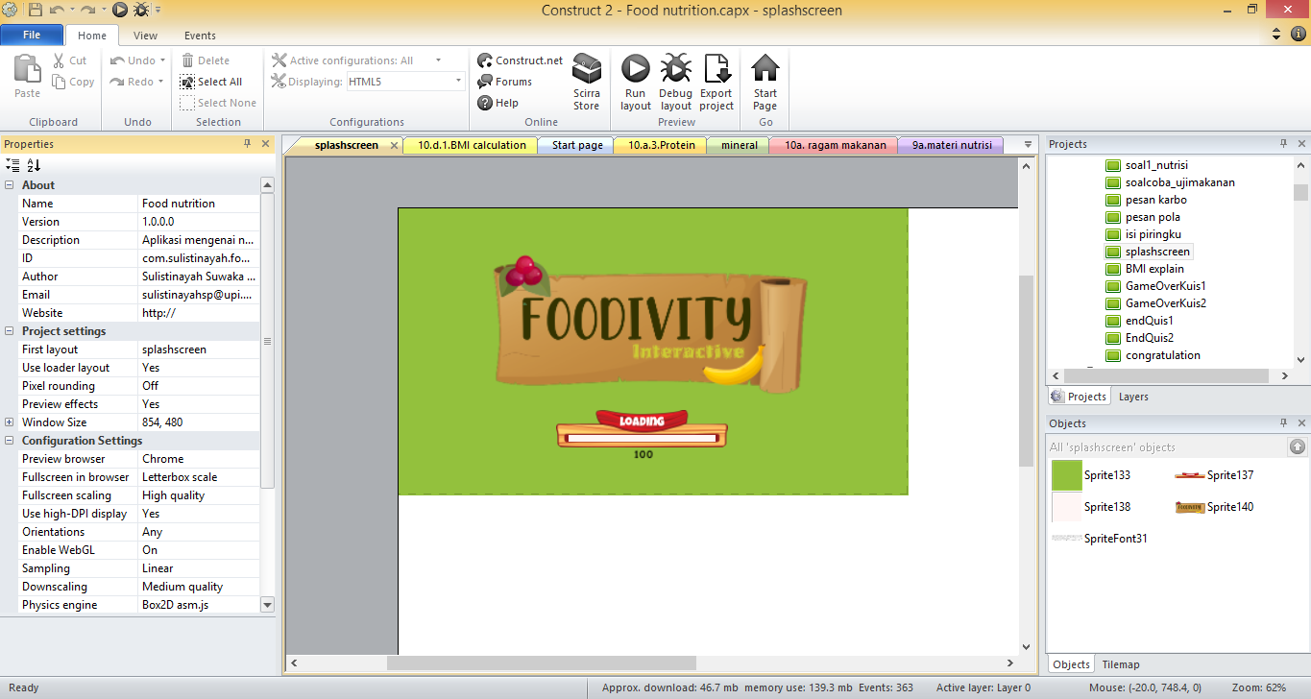
Figure 1 Splashscreen view
In Construct 2, when we first open construct 2 we will find the Start Page page. The start page is a main page or page where the page will appear when we open the construct 2. On this page, there are commands for creating and opening projects. The next thing to do is change the project name, description and windows size. This is shown in Figure 1 on the left of the screen. Next, we put the objects that are needed. These objects do not require placement in the layout because they are hidden and can automatically be used later. Now all layouts in our project can used mouse and keyboard input.
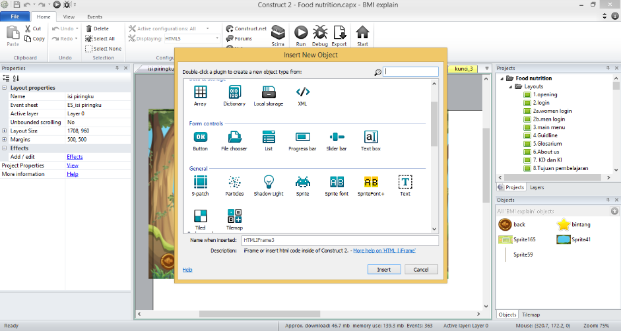
Figure 2 Plugin object
For all of these objects, we will use sprite objects. Sprite objects are objects that only display textures or images that can be moved, rotated, or resized. We can see the sprite button in Figure 2. All objects such as text, videos, images etc., can be accessed on that page.
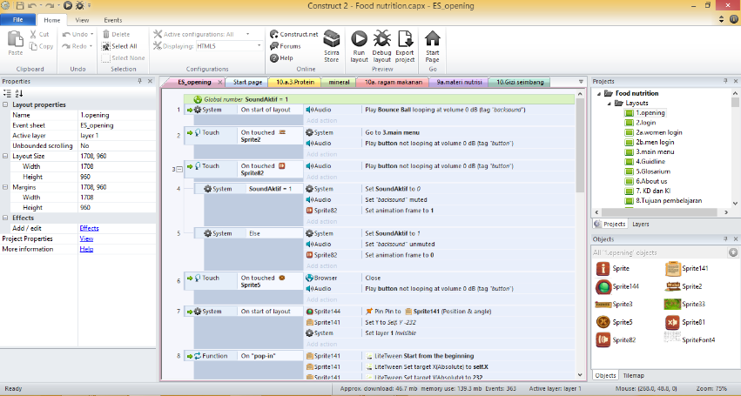
Figure 3 Evensheet view
Furthermore, the Event consists of conditions, which test or test whether a criterion is met. If all conditions are met, the action event will be executed. Once the action is executed, all of the sub-events will be executed, which can test other conditions, then run another action, and also another sub-event, and so on. Using such a system, allows us to create functional or sophisticated capabilities for media and apps. We can see an example of an evensheet from Figure 3 which contains conditions and functions so that they can run according to the command. The event sheet is the place where we create simple code to run the objects we have created in the layout.
The material presented is as easy as possible for users to understand so that they can learn independently (Wiana et al., 2018). Because interactive multimedia is designed for self-learning, the user maintains complete control throughout its application. Interactive multimedia built employing the drill and practice method is meant to teach users new skills or to reinforce their understanding of a concept. This quiz must be done quickly because there is a countdown time. The system in working on this quiz is a knockout system. if we answer the question with the wrong answer, we will be game over and repeat it. It is required that users study the material seriously. Additionally, this quiz gives a number of questions that are often displayed randomly, ensuring that each time it is used, the questions displayed will always be unique, or at least in unique combinations. Because Pujawan (2018) study indicates that drill and practice is essentially a learning strategy that aims to provide a more concrete learning experience through the provision of exercise questions aimed at assessing students' performance skills and understanding as measured by they complete the learning questions provided. This is also supported by Eksa (2020) who said Quizzes are the most important aspect of mobile application since they can assist students understand more about the topics.
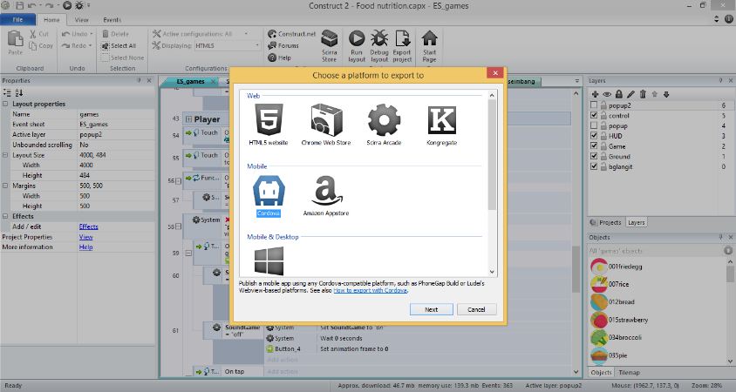
Figure 4 Export Project View
Construct 2 saves every project as a file with the extension .capx. The application will be exported into HTML 5 and Android applications if it is felt that the application has been completed. There are many more Android users than IOS users among the youth population. The HTML5 Export project to let bring the game to many platforms.
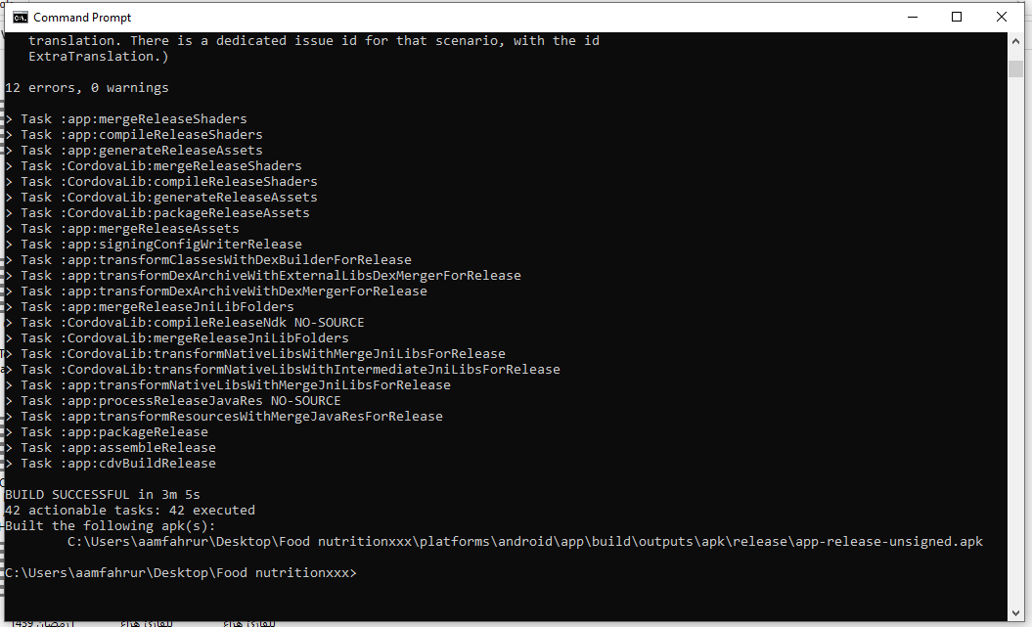
Figure 5 Export the android based application
When exporting via Apk, we have the option to wait for the game to compile while exporting. These programs will be installed next with other programs that must be installed. It can be shown in Figure 4. As the compilation process for the game is finished, the game has been successfully built into a android based application file. To return to the first, to build the second platform to HTML5 by click export and then selecting HTML5 as the export destination. Wait for the program to finish then launch it via the web by open the index format.
- Implementation Stage
Foodivity Interactive as an interactive media is implemented in several schools in West Java. The data collection process involved 53 students at 8th grade junior high school. The process of collecting data online through the WhatsApp’s group is due to pandemic conditions that do not allow face-to-face meetings. This research targets 8th grade students who have not studied the digestive system chapter and only focus on nutrition topic. The function of this research is to implement the Foodivity interactive application as an interactive media learning.
- Evaluation Stage
At this stage, the researcher evaluates interactive media products. The first evaluation was performed by material and media experts to determine the product's validity. After the evaluation, the researcher revised till the product was declared valid by media and material experts. The next stage is for the researcher to evaluate the confined interactive learning media products in schools. After utilizing the foodivity interactive application, students were invited to complete a student response form.

3.2 The Experts’ Judgment media
Three experts and one practitioner validated this application. Expert validation is an expert of material content in science and an expert of media. The practitioners consist of one science teacher. The purpose of this validation is regarding the weakness of the media and learning materials. The data were analyzed and used to revise the material in the learning media to improve the quality of learning media that will be used in research. The scale used from 1 to 5 has categories and definitions for each indicator. Thus, the expert can choose the most suitable point based on media conditions and perspectives. The results of four experts, media background, and teachers were selected to assess based on the indicator criteria as tabled in Table 7:
Table 7 Recapitulation of Expert Judgement
Indicator | Judges Rating |  |  |  | V |  | Result
Indicator | Expert 1  (Science) | Expert 2  (Science) | Expert 3(Media) | Expert 4  (Teacher) |  |  | Result
Content Quality | 4 | 5 | 4 | 4 | 0.8125 |  | Valid
Learning Goal Alignment | 5 | 4 | 5 | 4 | 0.875 |  | Valid
Feedback and Adaptation | 4 | 5 | 4 | 4 | 0.8125 |  | Valid
Motivation | 4 | 5 | 4 | 4 | 0.8125 |  | Valid
Presentation and Design | 4 | 5 | 5 | 3 | 0.8125 |  | Valid
Interaction Usability | 4 | 5 | 5 | 3 | 0.8125 |  | Valid
Accesbility | 4 | 5 | 4 | 4 | 0.8125 |  | Valid
Standard Compliance | 3 | 5 | 3 | 5 | 0.75 |  | Valid
Average V index |  |  |  |  | 0.8125 | Valid

Based on Table 7. the expert recapitulation results can determine whether or not an application is feasible. Learning media before being widely used need to be evaluated and validated first, both in terms of material content, educative aspects, and technical aspects of media, so that when used media meet the requirements as a good educational media. This is important to note and do so that what is conveyed to students is correct and good. the average value given by the expert is 3 to 5 on a scale of 5. The aspects assessed are Content Quality, Learning Goal Alignment, Feedback and Adaptation, Motivation, Presentation and Design, Interaction Usability, Accessibility and Standard Compliance. The expert judgment according to Bolger & Wright (1992) is an important input both for decision support. If the judgment obtained from the experts is poor in some respects, then the results of any decision support system will also be flawed. Ideally we want to know whether the judgment is correct or valid. To assess validity, it is necessary to have objective external criteria.
3.3 Students Response
Data on student responses to interactive media were obtained from the results of the questionnaire. The scale used consists of 5 scales, including strongly disagree, disagree, neutral, agree, strongly agree. A score of 5 with strong agree, while a score of 1 has a strongly disagree meaning. By using these 5 scales to find out in the context of respondents' impressions and judged by students of the response item (Joshi et al., 2015). These aspects are in the form of the mobile interface, content material, improve understanding, and motivation.

Figure 6 Students Questionnaire Result
Students give a positive response to the interactive foodivity application. Because students who responded strongly agreed reached 70.75%. In addition, 22.26% gave an agreed response and the rest only a few percent stated that the response was less agree or negative. However, those who gave disagreed opinions did not exceed 5%. Suppose it is translated into graphic form.
Based on Figure 6 it can be seen that the percentage is high in each aspect. On the aspect of motivation has the highest percentage, which is 77.37%. This shows that the interactive foodivity application can motivate almost all students. This is also supported by the absence of students who gave a response that did not agree on the motivational aspect. This motivation can be the initial foundation in students' interest in studying the material to understand the topic given. Then in the second position, there is an aspect of improving understanding which reaches 74.53% of students strongly agree. This certainly has a positive impact on interactive media. This shows that the purpose of using interactive media is to increase understanding in understanding material. According to Primamukti & MuhFarozin's (2018) research on using interactive multimedia on learning interest, there is a significant difference in students' learning interest when they are taught with interactive multimedia.
Then there is the mobile interface aspect. This aspect focuses more on the design and appearance of an application such as video, audio, text, and animation that can support understanding concepts in learning materials. In addition, the display can mean quite attractive, clear, and easy to read text, images, and other media accessible, and the last aspect is material content, as many as 68.39 strongly agree, and 25.47 choose to agree. The content material relates to the materials presented in the application. Videos or other elements such as simulations can be used to explain the content so that students can understand the content independently.
Hadibin et al. (2012) discovered that learning through the use of interactive multimedia-based learning media increases students' attention and responsiveness to the subject matter. This corresponds to the author's development findings. This is consistent with the findings of studies Wang (2008) conducted research that resulted in the development of multimedia-enabled learning programs. The findings indicate that the produced programs are effective in terms of student learning outcomes and recommend that instructors consider incorporating them into their student learning. According to Lee & Tseng (2008) when compared to traditional learning, using digital content instruments resulted in substantial variations in student accomplishment.

3.4 Students’ Understanding Skills
Students' cognitive abilities were analyzed through an objective test consisting of 20 questions. The question aims to analyze students' understanding of the topic of nutrition. The questions are categorized into taxonomy blooms, which are C1 (remembering), C2 (Understanding), C3 (Applying), C4 (Analyzing), and C5 (Evaluating). The questions that will be tested on students are in the form of pre-test and post-test. Before being tested, this test was tested, and the results were processed using SPSS Version 23 to see the validity and reliability results.
Table 8 Students Understanding Result
Component | Pretest |  | Post Test
Descriptive Test Analysis
N | 53 |  | 53
Average Score | 46.23 |  | 66.04
Standard Deviation | 16.696 |  | 12.262
Highest Score | 80 |  | 90
Lowest Score | 15 |  | 40
N- Gain | 0.35
Score Percentage (%) | 35.49
Normality Test
Signification (Sig α = 0.05) |  | 0.200 |  | 0.066
Information |  | Normality Distribute (Sig. > 0.05)
Hypotesis Test (Paired Sample T-Test)
Signification (Sig < 0.05) |  | 0.000
Information |  | H₀ is Rejected
Conclusion |  | There is Significant Difference
From the table, it can be seen that the number of students for pretest and postest is 53 students. The results of the score between the pre-test and post-test showed an increase after the application of interactive media. The mean score of the pretest was 46.23, and the mean score of the posttest was 66.04. The posttest value is higher than the pretest value. It means the mean score of the pretest indicates that the students have less prior knowledge about the material. Although some students had difficulty in answering the questions, there were students who got high scores from the pretest. It can be shown that students with high pretest scores have good prior knowledge about the material.
The test can be said to be normality if the data has met the minimum threshold of normality. Meanwhile, if the data does not meet the normality limit, it cannot be said to be normal. When referring to the assumption of normality, it literally states that the sample is drawn from a normally distributed population. Kolmogorov Smirnov is used when the sample is less than 100. Meanwhile, Shapiro Wilk can be used when the sample is less than 50 (Joshi et al., 2015). This can be seen the level of significance from two test instruments more than 0.05 (0.200 for pretest and 0.066 for posttest). It may be determined that the data examined using Kolmogorov-Smirnova is regularly distributed, with a 0.05 significance level.
As shown in the table, the significance value for normality on each is greater than 0.05 (sig. > 0.05). As a result, the data appears to be distributed normally. It suggests that parametric analysis can be used to analyze the data. Because the data were analyzed using parametric analysis, the data will be assessed using a paired sample t-test. Paired T-Test is a parametric test and the test used to compare the difference between two means of two paired samples with the assumption that the data is normally distributed (Potochnik et al., 2018). If the significance value of 2 tailed is less than 0.05 (sig. (2 tailed) < 0.05), it can be said that there is a significant difference. The requirement of this test is that the data can be normally distributed (Mishra et al., 2019). The Paired Samples Test table is the main table of the output that shows the results of the tests carried out. This can be seen from the significance value (2-tailed) from the table 4.8 can be seen that, from pretest (M= 46.23 , SD= 16.69 ) to postest (M= 66.04, SD= 12.26 ), t (52)= -11.666 , p< 0.05 (two tailed). The mean increase in students understanding was 19.81 ranging from 23.21 to 16.40. These results show the significance value of Sig. (2-tailed) is 0.000, it means the significance value for the simple test pair is less than 0.05 (.000 < 0.05). So that the results of the initial test and the final test experienced a significant change. Based on descriptive statistics, the initial test and the final test proved to be higher in the final test. It can be said that there is a significant difference in students' understanding on nutrition topic by using Foodivity Interactive as an interactive media. After that, a normalized gain test was carried out to analyze the level of increase in cognitive abilities. The N-Gain value is 0.35 which is categorized as a medium increase. If the score is 0.30 <g≤0.70, it is categorized as a moderate improvement (Hake, 1999). It means there is a moderate increase from pretest to posttest, and the score percentage is 35.49%.
Data were also analyzed using a normalized gain test based on Hake's Rule. This test is used to analyze the level of improvement in students' understanding. To analyze the overall results of student understanding, each aspect of understanding is based on the bloom taxonomy, especially in C1 (Remembering), C2 (Understanding), C3 (Applying), C4 (Analyzing), and C5 (Evaluating) is also analyzed. Table 9 shows the average pretest and posttest scores of each aspect of understanding depicted through the table:
Table 9 The Result of N-Gain Score
Cognitive Aspects | Average Score of Pre-Test | Average Score of Post-Test | N-Gain Score | Category
C1 (Remembering) | 37.74 | 66.04 | 0.45 | Medium
C2 (Understanding) | 49.43 | 66.42 | 0.34 | Medium
C3 (Applying) | 41.51 | 63.52 | 0.38 | Medium
C4 (Analyzing) | 48.58 | 69.81 | 0.41 | Medium
C5 (Evaluating) | 52.83 | 64.41 | 0.27 | Low

Based on Table 9, almost all aspects show the category of medium improvement. The results of the increase in the medium and low categories indicate that more effort is needed in increasing understanding. The results of the students' average pretest in each aspect varied. The results of the pretest show that the C1 (remembering) aspect has the lowest average score compared to other aspects. This can happen due to several factors, one of which is remembering. Some students do not know the material and the topics given have never been given before. However, at C5 (evaluating) the average score obtained has the highest score. This shows that some students already understand the concept of the material. After that the average pretest and posttest scores were compared. The N-gain of each aspect can be seen in the table. in the aspect of C5 (evaluating) has the lowest improvement category. This is because in bloom taxonomy C5 is a high level or including high order thinking. In addition, students are required to be able to judge from an event or activity. So students need deep understanding. Hoque (2016) said that teachers and students must comprehend the cognitive domain's hierarchy of processes and abilities in order to grasp prerequisite skills for learning as well as how these skills must be modified to master more sophisticated aspects of discipline-specific concept inventories. In teaching or learning new content, the development of learning skills should never be taken for granted.
While the C1-C4 aspects have a medium improvement category. when comparing the pretest and posttest, the C1 (remembering) aspect has the highest N-gain score among other aspects. this is because C1 is the most basic level in the taxonomy bloom. C1 is also low order thinking, so it is often categorized as an easy item question and only requires the ability to remember without understanding the material.
In aspects C2, C3 and C4 have almost the same N-gain scores. The C4 aspect also has a fairly high N-gain, so it can be said that the use of interactive media can affect the level of students' understanding of the material. However, the level of N-Gain scores in students' overall understanding has a medium category, meaning that efforts are still needed to improve students' understanding in order to get a high category.

4. Conclusion
Based on the research, this research was conducted using a pre-experimental method and using the ADDIE learning design (Analysis, Design, Develop, Implement and Evaluate). This research was conducted in public schools in West Java, in two locations, which is Sukabumi and Kuningan Junior High School in grade 8th. In the results of this research is the development of Foodivity Interactive which is used to assess students' understanding. The findings of this study indicate that students' understanding increases as a result of using Foodivity Interactive as an interactive multimedia on food nutrition topics. The development of Foodivity Interactive as Interactive Multimedia has been carried out using software construct 2. ADDIE instructional design is used in developing Foodivity Interactive and exported as HTML 5 and Android-based applications.
The expert assessment of interactive foodivity based on the results of index V which was carried out using a Likert scale. The mean value found for index V is 0.8125. This shows that the media is valid and can be used as a learning medium. The data questionnaire data is used to determine the results of student responses. 70.07 percent of students strongly agree, while 22.26 percent agree. Based on these findings, it can be concluded that more than half of the students stated positive results for the application.
So, it can be concluded that Developing Foodivity Interactive multimedia can help students have a better knowledge about nutrition topics. This can be proven by the results of the N-gain which shows a moderate increase between the pre and post-treatment tests. The hypothesis test stated that hypothesis H1 was accepted, which indicated that there was a significant difference between pre-test and post-test.

Acknowledgment
The author sincerely thanks to Prof. Dr. Phil. Ari Widodo, M.Ed. and Mr. Yaya Wihardi, M.Kom. who have guided and motivated the author in the process of completing the research paper. Beside that, Author also acknowledge to Universitas Pendidikan Indonesia, especially the International Program on Science Education Department for giving the chance to do this research.

References
Abidah, A., Hidaayatullaah, H. N., Simamora, R. M., Fehabutar, D., & Mutakinati, L. (2020). The Impact of Covid-19 to Indonesian Education and Its Relation to the Philosophy of “Merdeka Belajar.” Studies in Philosophy of Science and Education, 1(1), 38–49. https://doi.org/10.46627/sipose.v1i1.9
Bennett, S. J., & Brennan, M. J. (1996). Interactive multimedia learning in physics. Australasian Journal of Educational Technology, 12(1). https://doi.org/10.14742/ajet.2031
Bhavya, B., Gautam, G., & Sumedha, M. (2021). Impact of Covid-19 Pandemic on Education System. EPRA International Journal of Environmental Economics, Commerce and Educational Management, June, 6–8. https://doi.org/10.36713/epra6363
Churiyah, M., Sholikhan, S., Filianti, F., & Sakdiyyah, D. A. (2020). Indonesia Education Readiness Conducting Distance Learning in Covid-19 Pandemic Situation. International Journal of Multicultural and Multireligious Understanding, 7(6), 491. https://doi.org/10.18415/ijmmu.v7i6.1833
Dawson, T. E. (2007). A Primer on Experimental and Quasi-Experimental Design A Primer on Experimental and Quasi-Experimental Design. Southwest Educational Research Association, January 1997, 1–15. https://eric.ed.gov/?id=ED406440
Godwin, J. R. (2012). Emerging technologies: Challenging hegemonies in online learning. Language, Learning and Technology, 16(2), 4–13.
Hadibin, M. M., Purnama, B. E., & Kristianto, G. (2012). Pembangunan Media Pembelajaran Teknik Komputer Jaringan Kelas X Semster Ganjil Pada Sekolah Menengah [Development of Learning Media for Computer Network Engineering for Class X Odd Semesters in Middle School]. Indonesian Journal on Networking and Security (IJNS), 9330(1), 1–6.
Hake, R. R. (1999). Analyzing Change/Gain Scores. American Educational Research Association, 1(1), 16–22. https://doi.org/10.24036/ekj.v1.i1.a10
Huryah, F., Sumarmin, R., & Effendi, J. (2017). Analisis Capaian Literasi Sains Biologi Siswa Sma Kelas X Sekota Padang [Analysis of Biological Science Literacy Achievements for Class X Senior High School Students in Padang]. Jurnal Eksakta Pendidikan (Jep), 1(2), 72. https://doi.org/10.24036/jep.v1i2.70
Joshi, A., Kale, S., Chandel, S., & Pal, D. (2015). Likert Scale: Explored and Explained. British Journal of Applied Science & Technology, 7(4), 396–403. https://doi.org/10.9734/bjast/2015/14975
Lee, S. H., & Tseng, H. C. (2008). Investigation of Technology Integrated Instruction in Art Education: A Case Study of Exploring Learning Achievement. In Journal of Educational Multimedia and Hypermedia (Vol. 17, Issue 3, pp. 337–361). http://www.editlib.org/p/23648
Maharani, P., & Asyhari, A. (2020). Construct 2 Interactive Multimedia for Temperature and Heat Topic: A Multimedia Development for Senior High School Learning. Indonesian Journal of Science, 03(November), 336–346. https://doi.org/10.24042/ijsme.v4i1.8673
Mishra, P., Pandey, C. M., Singh, U., Gupta, A., Sahu, C., & Keshri, A. (2019). Descriptive statistics and normality tests for statistical data. Annals of Cardiac Anaesthesia, 22(1), 67–72. https://doi.org/10.4103/aca.ACA_157_18
Munir. (2020). Multimedia Konsep & Aplikasi Dalam Pendidikan [Multimedia Concepts & Applications in Education]. In Antimicrobial agents and chemotherapy (Vol. 58, Issue 12).
Nesbit, J., Belfer, K., & Leacock, T. (2009). Learning Object Review Instriment (LORI) User Manual Version 2.0. 11. https://www.academia.edu/7927907/Learning_Object_Review_Instrument_LORI_
Novianto, L. A., Degeng, I. N. S., & Wedi, A. (2018). Pengembangan Multimedia Interaktif Mata Pelajaran IPA Pokok Bahasan Sistem Peredaran Darah Manusia Untuk Kelas VIII SMP Wahid Hasyim Malang [Development of Interactive Multimedia for Natural Science Subjects Subject of the Human Circulatory System for Class VIII SMP Wahid Hasyim Malang]. Jurnal Kurikulum Teknologi Pendidikan (JKTP) Universitas Negeri Malang, 1(3), 257–263. http://journal2.um.ac.id/index.php/jktp/article/view/5770
Perera, T., Frei, S., Frei, B., Wong, S. S., & Bobe, G. (2015). Improving Nutrition Education in U.S. Elementary Schools: Challenges and Opportunities. Journal of Education and Practice, 6(30), 41–50. www.iiste.org
Potochnik, A., Colombo, M., & Wright, C. (2018). Statistics and Probability. Recipes for Science, Table 2, 167–206. https://doi.org/10.4324/9781315686875-6
Priyanto, D. (2009). Pengembangan Multimedia Pembelajaran Berbasis Komputer [Development of Computer-Based Learning Multimedia]. 14(1), 1–13.
Pujawan, K. A. H. (2018). the Development of Interactive Multimedia With Drill and Practice Model on Multimedia Ii (Two Dimention Animation) Course in Politeknik Ganesha Guru. Journal of Education Research and Evaluation, 2(1), 22–27. https://doi.org/10.23887/jere.v2i1.13142
Puspitasari, D. N., Indriyanti, D. R., & WH, N. (2019). Development of Interactive Multimedia for Human Reproduction System in Junior High School. Journal of Biology Education, 8(2), 238–245. https://doi.org/10.15294/jbe.v8i2.28016
Putri, R. S., Purwanto, A., Pramono, R., Asbari, M., Wijayanti, L. M., & Hyun, C. C. (2020). Impact of the COVID-19 pandemic on online home learning: An explorative study of primary schools in Indonesia. International Journal of Advanced Science and Technology, 29(5), 4809–4818.
Roswati, N., Rustaman, N. Y., & Nugraha, I. (2019). The Development of Science Comic in Human Digestive System Topic for Junior High School Students. Journal of Science Learning, 3(1), 12–18. https://doi.org/10.17509/jsl.v3i1.18120
Sahlström, F., Tanner, M., & Valasmo, V. (2019). Connected youth, connected classrooms. Smartphone use and student and teacher participation during plenary teaching. Learning, Culture and Social Interaction, 21(January), 311–331. https://doi.org/10.1016/j.lcsi.2019.03.008
Wang, L. (2008). Developing and Evaluating an Interactive Multimedia Instructional Tool: Learning Outcomes and User Experiences of Optometry Students. In Journal of Educational Multimedia and Hypermedia (Vol. 17, Issue 1, pp. 43–57). http://www.editlib.org/p/22939
Wiana, W., Syaom Barliana, M., & Riyanto, A. A. (2018). The effectiveness of using interactive multimedia based on motion graphic in concept mastering enhancement and fashion designing skill in digital format. International Journal of Emerging Technologies in Learning, 13(2), 4–20. https://doi.org/10.3991/ijet.v13i02.7830
Zheng, L., Li, X., & Chen, F. (2018). Effects of a mobile self-regulated learning approach on students’ learning achievements and self-regulated learning skills. Innovations in Education and Teaching International, 55(6), 616–624. https://doi.org/10.1080/14703297.2016.1259080

Highlights
- Developing Interactive Multimedia has been carried out well
- Experts Judgment have assessed the Application, and the results are valid
- Students give positive responses to Foodivity Interactive
- Students’ Understanding were categorized as medium improvement

