Examining the Use and Effects of Kahoot, Quizlet, and Google Forms in Online Teaching
ABSTRACT
This study aims to examine the effects of using Kahoot, Quizlet and Google Forms as a gamification and formative assessment tool in the Chemistry II course conducted through synchronous online instruction during the COVID-19 period. The study was conducted based on a triangulation design, one of the mixed research designs in which quantitative and qualitative data collection tools and analyses are used together. A Solutions Achievement Test (SAT) and Chemical Kinetics Achievement Test (CKAT) were used as quantitative data collection tools in the study. The results of the analysis of the data in the SAT and CKAT revealed a significant difference in favour of the posttest. The Student Opinion Questionnaire (SOQ), which was created by utilising Conversational Interviews (CI) held with students throughout the implementation, was used as a qualitative data collection tool. Following the qualitative data analysis, it was determined that the students did not participate in online classes due to the accessibility of the course video recordings, the absence of a compulsory attendance rule, and restricted access to the internet and technology. The use of Kahoot, Quizlet and Google Forms in online classes and in students’ free time outside class had positive effects, namely enjoyable and productive lessons, contribution to professional teaching skills, reinforcement of learned knowledge, and students’ awareness of their own learning levels through the feedback they received in a stress-free competitive environment. In addition, qualitative data were obtained to the effect that these applications were more effective in verbal subjects.
Key words: Gamification, formative assessment, online teaching, science education

1. Introduction
Among the main goals of education is the high motivation of students in order for them to achieve meaningful learning (Curto Prieto, Orcos Palma, Blázquez Tobías & Molina Leon, 2019). It is not always possible to hold students’ motivation, interest and participation in lessons together, and a negative/unfavourable atmosphere in the classroom environment and students’ low grades in tests and exams negatively affect their motivation and learning products (Liu, Bridgeman & Adler, 2012). Student motivation affects students’ achievement, retention of learning, and interaction in the learning environment (Şahin, Karadağ, Bozkurt, Doğan, Kılınç, Uğur et al., 2017). In the 21st century, it has become necessary for many teachers to support education by integrating competitive games that will encourage learning in the classroom (Dellos, 2015). Nowadays, innovations and developments in information and communication technologies support learning with new opportunities, both in schools and outside school, with new learning and teaching models (Correia & Santos, 2017). Internet access and technological development are important for meeting students’ needs and providing more opportunities for students in student education in different geographical areas through distance education (Moore, Dickson-Deane & Galyen, 2011; Hartnett, George & Dron, 2011). Online learning, in which different devices with internet access are used synchronously or asynchronously (Dhawan, 2020), is regarded as a subcategory of distance education (Hartnett, George & Dron, 2011). In online distance education, students’ aims and learning preferences can be very different, and especially for this reason, in order to draw their attention, meet their learning needs, and ensure motivation, it is very important to use appropriate motivating strategies in online learning platforms (Bovermann & Bastiaens, 2020), and applications aimed at tests and exams used for assessment of students (Antonaci, Klemke & Specht, 2019). Although developments and innovations in technology offer teachers different opportunities in online learning environments, some teachers who are accustomed to the traditional face-to-face learning environment may have difficulty in using these new technological developments effectively (Kamble, Gauba, Desai & Golhar, 2021). Moreover, although developing technology may increase the interaction options of individuals who participate in online learning environments (Dickey, 2003), it may also prevent individuals from interacting with each other (Yıldız, 2020). Therefore, it is very important for students in online learning environments to see themselves as part of a community (Yıldız, 2020). The use of online surveys, exams and tests are effective in eliminating the monotony of online lessons, enabling students to recall their prior knowledge, and making students aware of their own learning level by giving them feedback (Curto Prieto, Orcos Palma, Blázquez Tobías & Molina Leon, 2019).
Due to health measures and quarantine practices in many countries during the COVID-19 pandemic, universities and educational institutions that provided face-to-face education switched to online education practices. Providing students with good quality education in online education practices depends on the quality of the online learning environment, internet access, active and effective participation and interaction of students and teachers, the knowledge and ability to use the online learning environment correctly and effectively, and teachers’ and students’ knowledge about information and communication technologies (Kamble, Gauba, Desai & Golhar, 2021).
The student assessment process is important for maintaining a good quality education. Teachers have important duties in formative assessment activities in the classroom, yet many teachers cannot use formative assessment effectively in their lessons (Aydeniz & Pabuççu, 2011; Black & William, 1998; Black, Harrison, Lee, Marshall & William, 2004). Formative assessment activities are performed in different ways, such as pencil-and-paper and online applications (Quizizz, Kahoot, Quizlet, etc.) (Ismail, Ahmad, Mohammad, Fakri, Nor & Pa, 2019). In the assessment process, gamification contributes to more effective assessment by enabling students to access information sources and to receive feedback as soon as they demonstrate what they have learned. Furthermore, data obtained through gamification about students’ learning levels give insight to education administrators and policymakers as to what revisions should be made in the field of education (Menezes & De Bortolli, 2016). Many educational researchers and teachers state that the use of gamification is important for drawing students’ attention and supporting different types of learning inside or outside the classroom (Menezes & De Bortolli, 2016; Prensky, 2001), and that its use in formative assessment is important for contributing to student achievement and motivation (Zainuddin, Shujahat, Haruna & Chu, 2020; Göksün & Gürsoy, 2019; Ismail et al., 2019; Zhang & Fang, 2019). Gamification is a persuasive technology that attempts to influence individuals’ behaviour by activating individual motives (Blohm & Leimeister, 2013) through the use of game design elements in different environments such as health, culture, education and marketing (Antonaci, Klemke & Specht, 2019; Alsancak-Sırakaya, 2017; Deterding, Dixon, Khaled & Nacke, 2011; Huang & Soman, 2013; Seaborn & Fels, 2015). Gamification aims to create change in an observable behaviour or to reinforce that behaviour. In order to decide whether gamification is beneficial, it is important that the targeted behaviour should be observable or recordable, or that it is transformed into that form (Tunga & İnceoğlu, 2016). The term gamification was first discussed by Nick Pelling in 2002, began to appear in documents in 2008, and started to become popular in the second half of 2010. However, the use of gamification in education dates back to ancient times. Gamification in the field of education is not only concerned with adding games to the knowledge and skill dimension that is intended to be acquired, but also facilitates student learning in the teaching process. Rather than confining the gamification to a certain pattern, it will be more beneficial to further enrich it with the experiences gained (Karataş, 2014; Sezgin, Bozkurt, Yılmaz & Van Der Linden, 2018). In gamification, the game elements are handled in two ways: self-elements and social elements. Self-elements may be scores, achievement badges, levels, or just time constraints. These elements enable students to focus on competing with themselves and recognising their own achievements. As for social elements, these are concerned with interactive competition or cooperation, such as leaderboards. These elements bring students into a community with other students, and their progress/successes are announced (Huang & Soman, 2013).
Unlike traditional classroom activities, Kahoot is a game-based learning platform used in formative assessment to determine the student’s level of knowledge. Kahoot is the first student response system (SRS) to provide game experience by using game design principles based on intrinsic motivation theory (Wang & Tahir, 2020). As an interactive response system (IRS), which is named learning-centred, interactive education technology (Sun & Chen, 2016), applications such as Kahoot and Quizlet are used as gamification tools in formative assessment (Çetin & Solmaz, 2020).
Quizlet is an application created in the form of learning cards with alternatives in the form of “study” and “games” in the virtual environment in education, and which allows students to repeat the topic or answer questions inside or outside the classroom. Quizlet is also frequently used as a learning tool in foreign language teaching (Dizon, 2016; Montaner-Villalba, 2019; Sarıgül, 2021; Wright, 2016).
1. 1 Aim of the Study
The aim of this study is to examine the effect of using Google Forms and as gamification tools, Kahoot and Quizlet, in formative assessment in online teaching of the Chemistry II course during the COVID 19 pandemic in science teacher education. In line with the aim of the study, answers to the following research questions were sought:
1-What is the effect of using the Kahoot and Quizlet formative assessment platforms on the student achievement scores in the online Chemistry II course?
2-What are students’ views on the use of Kahoot, Quizlet, and Google Forms during the online Chemistry II course and their extracurricular time?
1.2 Importance of the Study
For student achievement, motivation (Curto Prieto, Orcos Palma, Blázquez Tobías & Molina Leon, 2019), learning with fun, repeating what they have learnt, solving plenty of questions, making assessments that will motivate students (Antonaci, Klemke & Specht, 2019), absence of anxiety about obtaining low grades from tests (Liu, Bridgeman & Adler, 2012), and active student participation in the learning environment (Dickey, 2003) are effective. Moreover, the fact that students have an idea about their learning levels by receiving feedback as soon as they demonstrate what they have learnt (Menezes, De Bortolli, 2016) is also effective for student achievement. Performing formative assessment through gamification in the teaching process makes most of the above-mentioned possible.
One of the indicators of a student’s achievement is his/her ability to use the knowledge he/she has learned in answering the questions he/she encounters. Just as an athlete becomes successful with constant practice, the achievement of a student in science and mathematics courses depends on using the knowledge he/she has learned in order to answer many and various types of questions and on obtaining quick feedback on whether his/her answers to questions are right or wrong. Here, the importance of formative assessment emerges. However, most students do not like exams because they experience test anxiety and fear of receiving low grades. In this study, the use of Web 2.0 gamification tools in formative assessment, the quick feedback received by the students as to whether the questions they answered were right or wrong, and the fact that the exams were in the form of stress-free games had an impact on students’ achievement and on their development of a positive attitude towards the course. This study is also important in terms of enabling future pre-service science teachers to gain professional experience of how to perform effective formative assessment. We can say that this study will contribute to the studies of educational researchers who wish to investigate the effects of using Web 2.0 gamification tools in the formative assessment process.
1.3 Implementation Process
The study was conducted in the form of synchronous online lessons (spring semester, 2020-2021) over a period of 11 weeks. The implementation process is given in Table 1.

Table 1.
Quantitative and qualitative data collection process of study
Quantitative data collection process of study* | Single-Group Pretest-Posttest Pre-experimental Design
Quantitative data collection process of study* | Topic | Group | Pretest/  Time | Treatment/ Time | Posttest/  Time
Quantitative data collection process of study* | Solutions | A | O1  Week 1 | X  Weeks 1, 2, 3, 4 and 5 | O1  Week 6
Quantitative data collection process of study* | Chemical Kinetics | A | O2  Week 6 | X  Weeks 7, 8, 9 and 10 | O2  Week 11
O1: SAT, O2: CKAT, X: Use of the Kahoot and Quizlet Web 2.0 gamification tools in formative assessment in online education, CI: Conversational interviews, SOQ: Student Opinion Questionnaire
*The quantitative data collection process of the study was adapted from McMillan & Schumacher (2006).
Qualitative data collection process of study | CI held with students during the 11 weeks
Qualitative data collection process of study | Student opinion questionnaire given in 11th week

2. Method
In order to provide a more comprehensive approach to the study, a triangulation design, one of the mixed methods research designs in which quantitative and qualitative data are handled together, was used (Table 1).
The quantitative part of this study was conducted according to a one-group pretest-posttest pre-experimental design. In this study, the same implementations were carried out in two different subjects (solutions and chemical kinetics) in order to increase the internal validity. Obtaining similar results from the same implementations in two different subjects supports the internal validity of the study. In the qualitative part of the study, in order to gain insight into the effects of the implementation, the conversational interviews held with the students during the implementation were examined by taking notes, and using these notes, following the implementation process, the data were obtained through Padlet and Google Forms by creating a Student Opinion Questionnaire (SOQ) consisting of 11 open-ended items.
2.1 Study Participants
This study was conducted with 32 volunteer participant students studying in the first grade of the science education department. In all, 25-30 students participated in the synchronous online classes. In order to analyse the changes in the scores of the same students who participated in the Solutions Achievement Test and Chemical Kinetics Achievement Test pretest and posttest, the students were asked to indicate their names and surnames or their school numbers in the tests. Accordingly, the students wrote their names and surnames or their school numbers on the SAT and CKAT.
2.2 Quantitative Data Collection Tools and Analysis
In the study, SAT and CKAT were used to determine the students’ academic achievement in the subjects of solutions and chemical kinetics. The data of the tests administered as a pretest and posttest were obtained through Google Forms. KR-20 reliability coefficients were calculated for the tests and item analysis was performed.
2.2.1 Solutions and Chemical Kinetics Achievement Tests
In this study, the SAT consisting of 32 multiple choice questions and CKAT consisting of 20 questions were prepared by three domain experts following examination of chemistry textbooks. The item difficulty index and item discrimination index of the SAT and CKAT were calculated using the data obtained from 164 students studying in the science education department. Questions with an item discrimination index of 0.3 or below were excluded from the test. Regarding the tests used in the study, the KR-20 reliability coefficient of the SAT, which consists of 28 questions, was calculated as 0.92, while the KR-20 reliability coefficient of the CKAT consisting of 17 questions was calculated as 0.89. The solutions and chemical kinetics topics are given in Appendix 1.
2.3 Qualitative Data (Cl, SOQ) Collection Tools and Analysis
This study was conducted by the lecturer and the researcher in recorded online classes over a period of 11 weeks. The researcher attended the classes as a participant observer for 10 weeks. In the online lessons, spontaneous and naturally developing conversational interviews (Patton, 2002; Yıldırım & Şimşek, 2011) took place between the lecturer and the students about the applications. After the lesson was over, the researcher and the lecturer watched the recordings of the lessons and transcribed verbatim the students’ opinions about the applications. Using these records, the researcher and lecturer prepared a Student Opinion Questionnaire (SOQ) consisting of 11 open-ended questions. The SOQ data were collected in the 11th week, which was the final week of the implementation, using Padlet, defined as a virtual application of the noticeboard/wall, which is one of the means of in-class interaction and communication (Weller, 2013), and Google Forms (Google, 2022), which enables the preparation and answering of questions in different forms in the online environment, and the presentation of the results in the form of graphs and tables.
In this study, in the analysis of the qualitative data, sentences and words/synonyms of words, taken directly from the students’ statements in the CI and in the SOQ, were used in order to ensure validity by verbatim (objective) representation of the reality of the data (Creswell & Plano-Clark, 2007; Yıldırım & Şimşek, 2011).
Student opinions obtained from the conversational interviews were explained with descriptive analysis, which is used for the description and interpretation of data obtained in qualitative research, and in which opinions are quoted verbatim (Robson & McCartan, 2016).
The opinions of 27 students who filled out the student opinion questionnaire were transcribed verbatim using Microsoft Word, and coding was done separately by the lecturer and the researcher on condition of using the same sentences or words/synonyms of words used by the students. Inter-rater agreement was calculated using the formula ∆ = C/ ( C+ ∂).100 (∆: reliability coefficient, C: Number of agreements, ∂: Number of disagreements) (Miles & Huberman, 1994; Baltacı, 2017). The reliability coefficient was calculated as 87%. The Microsoft Word document, which was created by transcribing the opinions of 27 students, was transferred to the MAXQDA Plus 2022 program, and by utilising the codes, the coders created the themes and sub-themes using thematic coding (Robson & McCartan, 2016).
2.4 Role of the Researcher
This study was conducted by two researchers who are experts in the field of science education. One of the researchers delivered the course and the other researcher took part in all lectures as an observer. The data collection tools were created by the two researchers and they were used after obtaining the opinions of two researchers who are experts in their field and making the necessary revisions.
3. Findings
3.1 Findings Obtained from the Quantitative Data
3.1.1 Analysis Findings of Solutions and Chemical Kinetics Achievement Tests
As can be seen in Table 2, 27 students participated in the pretest and 15 students participated in the posttest. The reason why a low number of students participated in the pretest and posttest was determined following examination of the notes obtained from the CI. It can be seen that the students’ mean score, which was 34.37 in the pretest, increased to 56.13 following the implementation.
Table 2. Descriptive analysis results of SAT pretest and posttest

 | N | sd | Min | Max | 
Pretest | 27 | 14.18 | 10.71 | 60.69 | 34.37
Posttest | 15 | 16.04 | 35.70 | 96.39 | 56.13

The Wilcoxon signed-rank test was used to determine whether there was a significant difference between the scores of the same students who participated in the pretest and posttest of the SAT. According to the test results (Table 3), it was observed that there was a significant (p < .05) difference between the students’ scores before and after the implementation. In addition, it can be said that the effect size (r = .73) was large (0.1 = small, 0.3 = moderate, 0.5 = large).

Table 3. Wilcoxon Signed-Rank Test Results of SAT

 | N | Sum of Ranks | Mean Ranks | z | p | r
Negative Ranks | 1 | 10 | 10 | -2.843 | .004 | .73
Positive Ranks | 14 | 110 | 7.86 | -2.843 | .004 | .73
Ties | 0 |  |  | -2.843 | .004 | .73

When Table 4 is examined, it can be seen that the students’ mean CKAT pretest score increased from 39.26 to 64.09 following the implementation.
Table 4. Descriptive analysis results of CKAT pretest and posttest

 | N | sd | Min | Max
Pretest | 31 | 16.45 | 11.76 | 76.44 | 39.26
Posttest | 20 | 21.91 | 23.52 | 99.96 | 64.09

The Wilcoxon signed-rank test was used to see if there was a significant difference between the scores of the same students who participated in the pretest and posttest of the CKAT. According to the test results, it was observed that there was a significant (p < .05) difference between the students’ scores before and after the implementation. It can also be seen that the effect size (r=.80) was large (Table 5).

Table 5. Wilcoxon Signed-Rank Test Results of CKAT

 | N | Sum of Ranks | Mean Ranks | z | p | r
Negative Ranks | 1 | 1 | 1.00 | -3.581 | .000 | 0.80
Positive Ranks | 16 | 152.00 | 9.50 | -3.581 | .000 | 0.80
Ties | 3 |  |  | -3.581 | .000 | 0.80

3.2 Findings Obtained from the Qualitative Data
3.2.1 Conversational Interviews (CI)
Among the factors affecting students’ achievement and their attitudes towards the course can be listed students’ participation/lack of participation in the lessons and the extent of their participation in the practices during the process of the course, using/not using the applications/materials, the duration of the lesson, and the performance of the teacher. The data obtained in the CI and directly quoted from the students’ statements are given in Figure 1.
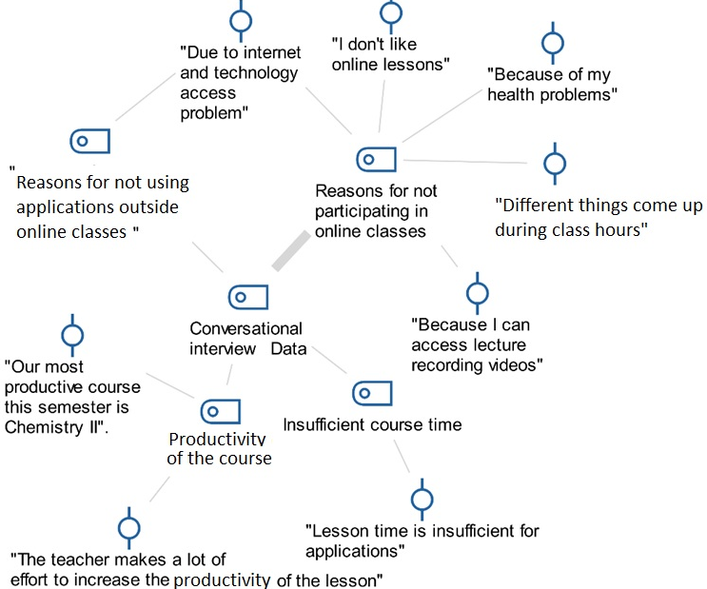
Figure 1. Descriptive analysis of CI data
3.2.2 Findings Obtained from the Student Opinion Questionnaire (SOQ)
Out of the 44 students enrolled in the online Chemistry II course, 27 expressed their opinions by filling in the SOQ. In this section, the qualitative data, which are summarised as themes and sub-themes in Figure 2a and Figure 2b, are examined in detail with themes and sub-themes .
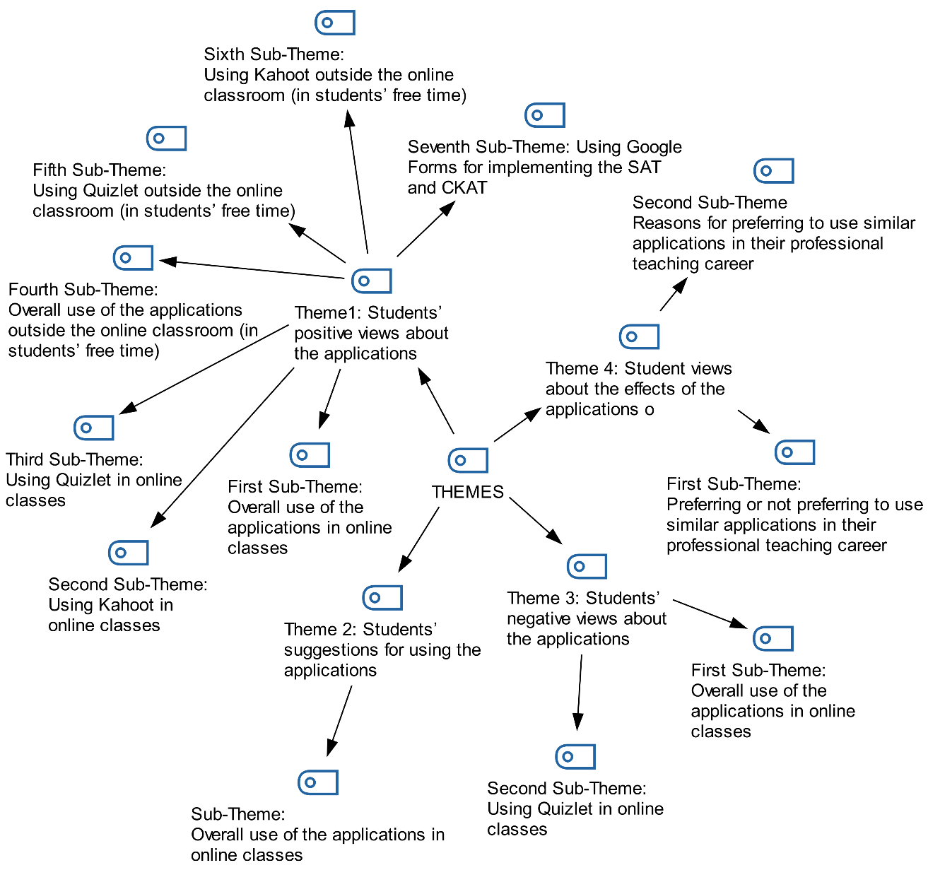
Figure 2. Themes and Sub-Themes created after examination of SOQ
Theme 1: Students’ positive views about the applications
Regarding Theme 1, which was created following the examination of the SOQ, the students’ positive views about the overall use of the applications and the use of the Kahoot and Quizlet applications in online classes were examined (Figure 3).
When Figure 3. is examined, the opinion most expressed by the pre-service teachers is; is the view that these practices contribute to the teaching profession skills (“we intend to use these practices that contribute to our professional skills in our future professional life”, ∑f=21). In addition, the other most repeated opinions; fun code (∑f= 29,“apps were great fun”), high quality questions (∑f=18, “questions were great and good quality”), effective/efficient lessons (∑f=16, “classes were very productive”) , stress-free exam (∑f= 15, “we solved the questions in the exams without getting stressed”), recognizing the deficiencies ( ∑f= 8, “we noticed our learning level, our deficiencies”).

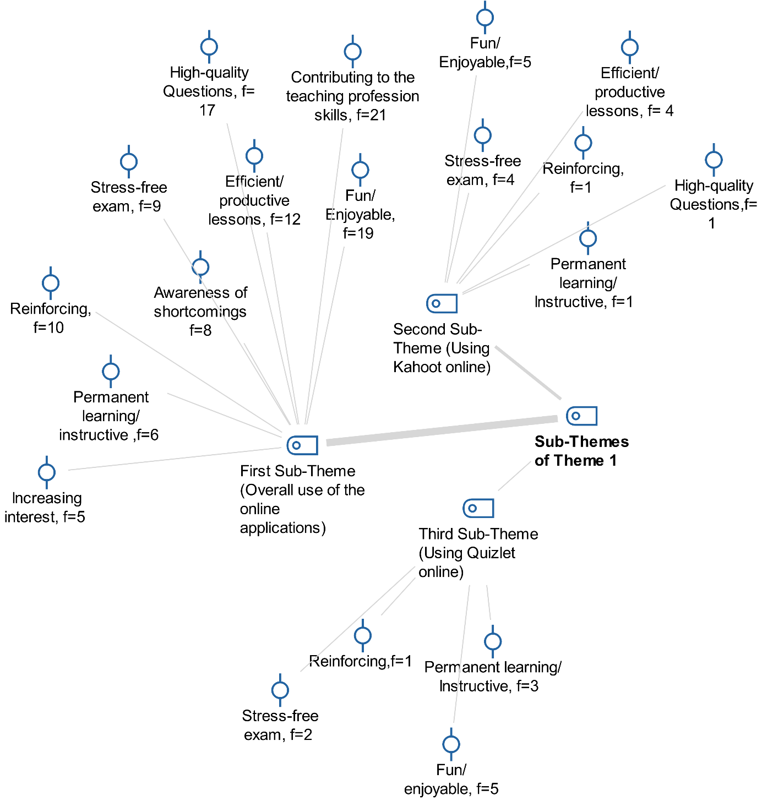
Figure 3. Findings for first, second and third sub-themes of Theme 1
When we examine Figure 4, we can see that the students mostly reported positive opinions (∑f=11) about the use of Quizlet outside class (5th Sub-Theme) , and that in second place, they reported positive opinions (∑f=10) about using Google Forms outside class (7 th Sub-Theme). Students’ opinions were determined to the effect that the cards in the Quizlet application were instructive and contributed to the reinforcement of knowledge by enabling repetition of the information learned. Among the positive opinions they expressed about taking exams with the Google Forms application, the opinion about stress-free exams draws attention.

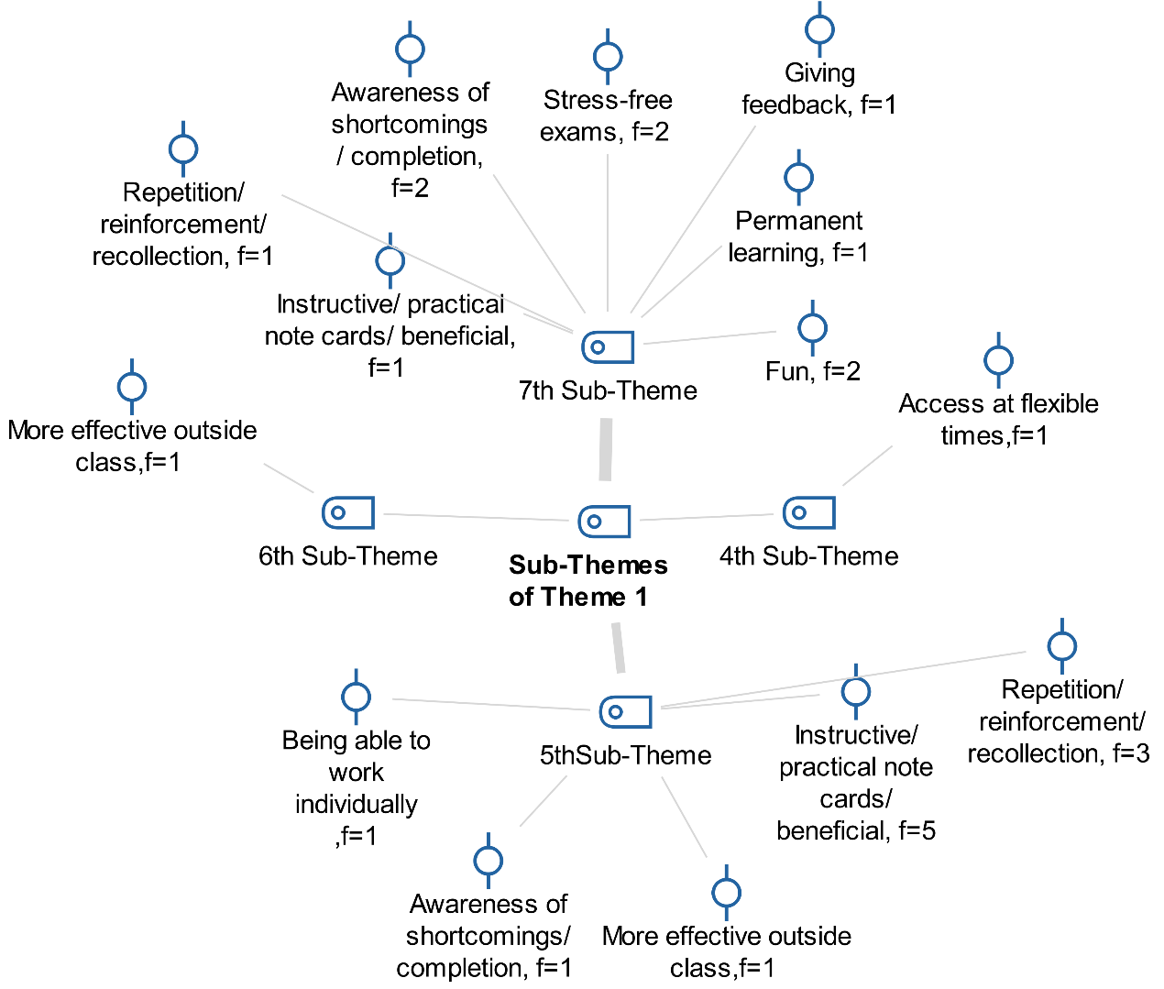

Figure 4. Findings for fourth, fifth, sixth and seventh sub-themes of Theme 1

4th Sub-Theme of Theme 1: Overall use of the applications outside the online classroom
5th Sub-Theme of Theme 1: Using Quizlet outside the online classroom
6th Sub-Theme of Theme 1: Using Kahoot outside the online classroom
7th Sub-Theme of Theme 1: Using Google Forms for implementing the SAT and CKAT

Theme 2: Students’ suggestions for using the applications
Examination of Figure 5 shows that students stated that it would be better to use applications like Kahoot and Quizlet for verbal subjects (f=10). It can also be seen that there were suggestions to the effect that teachers should answer the questions in class (f=2) and that the number and type of questions should be increased (f=2).
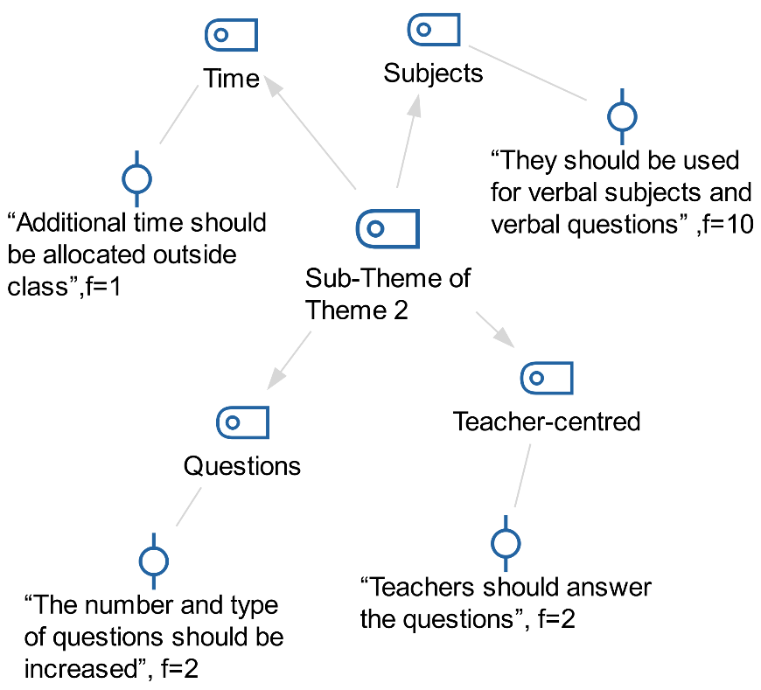
Figure 5. Findings regarding sub-theme of Theme 2
Theme 3: Students’ negative views about the applications
In Figure 6, students' negative views about the problems and practices they encountered during the application are included. The main ones are; students' internet and technology access problems (f=10) and some students' dissatisfaction with technology-oriented learning environments (∑f= 6).
In Figure 6, students' negative views about the problems and practices they encountered during the application are included. The main ones are; students' internet and technology access problems (f=10) and some students' dissatisfaction with technology-oriented learning environments (∑f= 6).
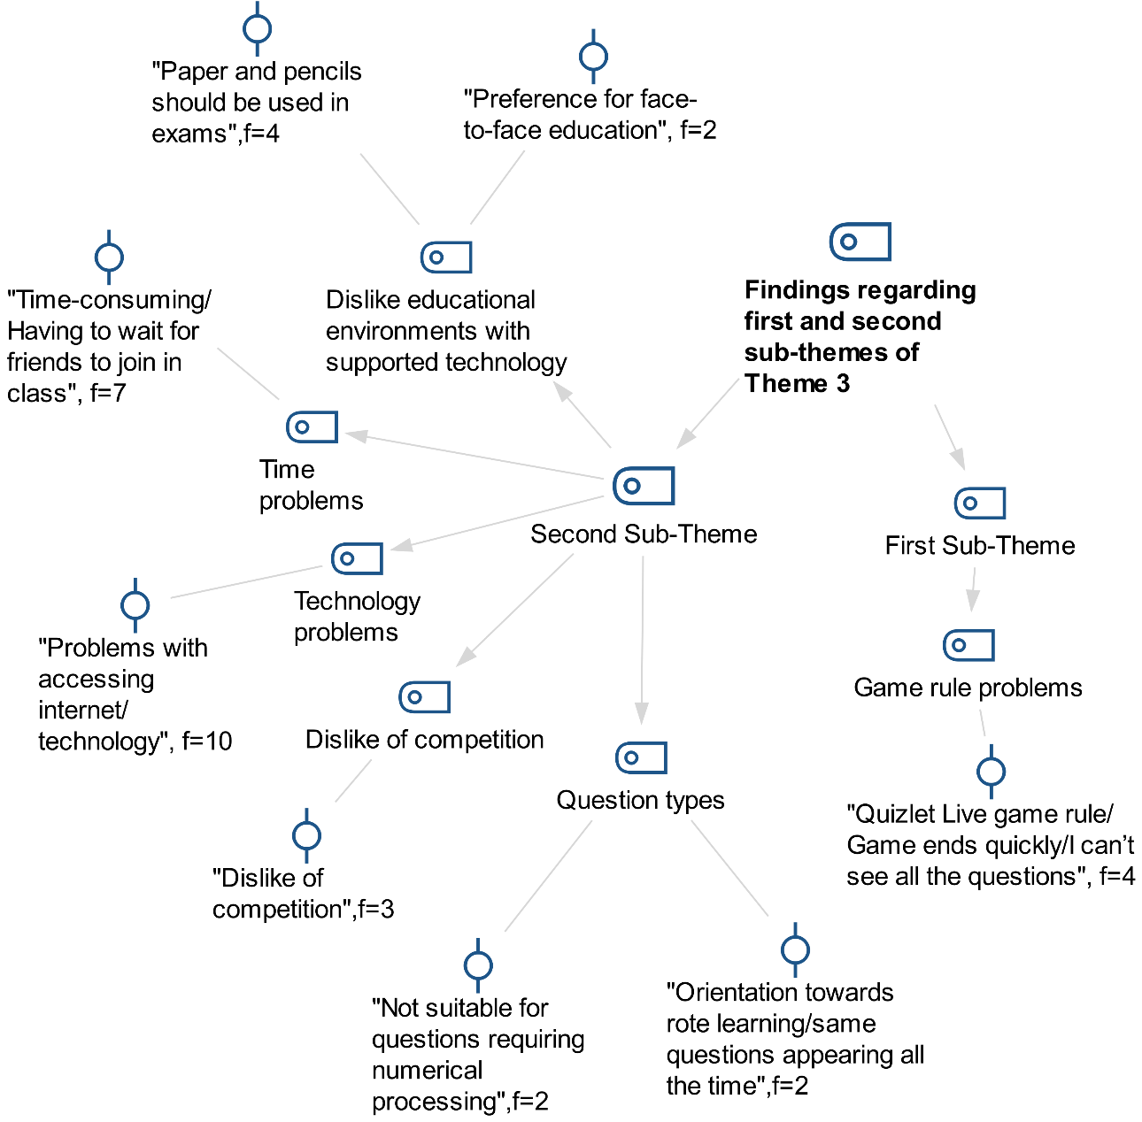
Figure 6. Findings regarding first and second sub-themes of Theme 3

Theme 4: Students’ views on the effects of the applications on their professional teaching skills
Theme 4, which was created as a result of the examination of the SOQ, was examined under two sub-themes. The first sub-theme is concerned with whether students would prefer to use similar applications in their professional teaching careers. Out of the 22 students who expressed their opinions on this sub-theme, 21 stated that they would prefer to use similar applications in their professional teaching careers, while 1 student stated that they would not prefer to use similar applications because they did not find it right that technology should dominate the learning environment. Within the scope of the second sub-theme, in which the reasons why students would prefer to use similar applications in their professional teaching careers were examined, students stated that they would prefer these applications because they enable learning with fun, they ensure students’ active participation in the learning environment, they enable permanent learning, and they allow students to have an idea about their own level (Figure 7). Considering the qualitative findings, it can be seen that students’ positive opinions about the use of these applications in online classes and outside class (Figure 3) and the reasons for preferring these applications in their professional teaching careers are similar (Figure 7).

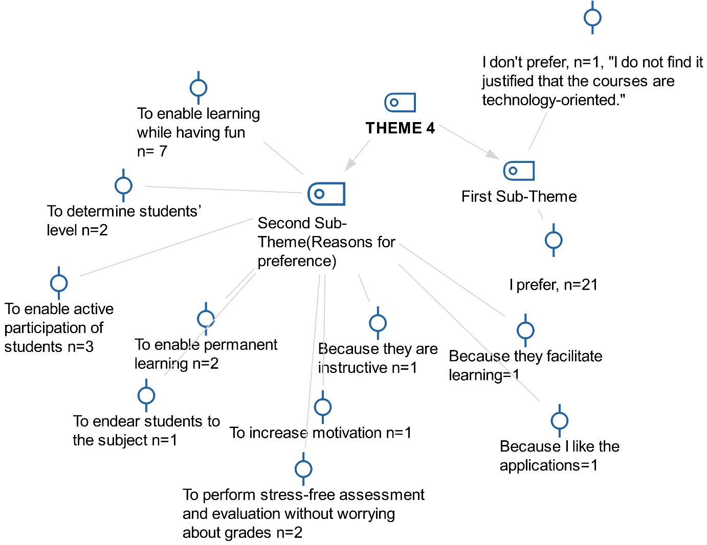
Figure 7. Findings regarding first and second sub-themes of Theme 4

4. Discussion
Students’ low scores in tests or exams are among the factors causing a decrease in motivation and achievement in the subject (Liu, Bridgeman & Adler, 2012). The fact that the learning environment motivates the student (Curto Prieto, Orcos Palma, Blázquez Tobías & Molina Leon, 2019), and that there are good quality formative assessments that give students feedback about their levels are among the factors that positively affect student achievement (Sadler, 1998). In this study, too, it was determined that the use of gamification tools, namely Kahoot and Quizlet, and the use of Google Forms in formative assessment in the online learning process had a positive effect on student achievement (Table 3 and Table 5). In this study, it can be seen that the qualitative data of the study support and account for the quantitative results of the study. Thus: The students’ opinions obtained from the SOQ are that the implementations made the students aware of their shortcomings, the lessons were enjoyably spent, a stress-free exam and competitive environment were created, the implementations facilitated the reinforcement and recollection of the learned information, the student felt the need to come to the lesson prepared, and active participation in the lesson and in-class interaction increased (Figure 2 and 3). These data explain the reason for the increase in student achievement. When the literature is examined, similar results can be seen. Among these, Arif, Zubir, Mohammad and Yunus (2019) stated that university students expressed positive opinions about the use of Kahoot as a formative assessment tool in foreign language teaching. In the study by Yılmaz and Yılmaz (2019), preservice teachers expressed the view that the use of Kahoot as a gamification and formative assessment tool was fun, motivating for the subject, and useful for reinforcing the learned information. Ismail and Mohammad (2017) stated that the use of Kahoot in formative assessment in medical education assisted the teacher with its instant feedback feature while giving the student an idea about what he/she had learnt and needed to learn, and that it was an application that motivated students to study. Kalleny (2020) stated that the use of Kahoot as a formative assessment tool in the histology and cell biology laboratory during the COVID-19 pandemic had a positive effect on students’ achievement and on their interest and motivation for the course. Author (2018) stated that using the Kahoot application in the face-to-face General Chemistry course contributed positively to the students’ achievement. Nadeem and Falig (2020) reported that the use of Kahoot in foreign language teaching with adults contributed to the development of students’ self-regulation skills by improving effective feedback, the classroom environment, and students’ metacognitive characteristics. Bratel, Kostiuk, Bratel and Okhrimenko (2021) stated in their study that foreign language teachers in Ukraine mostly used Kahoot, Google Forms and Quizlet in online education during the COVID-19 pandemic. Besides the studies that reported positive results on the use of Kahoot, Kapsalis, Galani and Tzafea (2020) stated that no statistically significant difference was determined between the control group using paper and pencils and the experimental group using the Kahoot application for formative assessment in foreign language teaching with adults. Again, in the literature review, studies can be found showing that the use of Quizlet in formative assessment is preferred in foreign language education. The reason for this may be the cards in the Quizlet application containing information in the form of definitions/terms. Platzer (2020) stated that Quizlet was effective for learning vocabulary in foreign language learning. In their study conducted with adults, Göksün and Gürsoy (2019) stated that in the comparison of the two experimental groups, in which Kahoot and Quiziz applications were used in formative evaluation, and the control group, in which a traditional method was used, there was a difference in favour of the experimental group in which Kahoot was used, whereas there was no significant difference between the experimental group in which Quiziz was used and the control group in terms of academic achievement. Setiawan and Wiedarti (2020) reported that the use of Quizlet in vocabulary teaching in a foreign language class with tenth grade students had a significant effect on students’ motivation. In the study conducted by Çetin and Solmaz (2020), social studies teacher candidates stated that Kahoot was effective in drawing attention, remembering what was learnt, and enabling performance evaluation, while Quizlet was effective in drawing attention, presenting information, and remembering information. Curto Prieto, Orcos Palma, Blázquez Tobías and Molina Leon (2019) analysed the opinions of 12-16 year-old secondary school students about the use of Kahoot in mathematics and science classes, and stated that most of the students reported that the use of Kahoot in the lessons made positive contributions to their cognitive and affective domains. Among these, they stated that the use of Kahoot contributed to self-evaluation, that learning was effective, and that learning was fun. In this study conducted with preservice science teachers, it can also be seen that the use of applications like Kahoot and Quizlet in the learning process contributed to their professional teaching skills and that they would choose similar applications in their future teaching careers (Figure 3).
5. Conclusion
Although there are studies discussing students’ views on the use of applications such as Kahoot and Quizlet in the teaching process, not very many studies can be found that examine the effects of similar applications on professional teaching skills. In order to make formative assessment more effective at all levels of education and in courses in different fields, more effective practices can be developed to increase the quality of education by examining different results obtained in terms of teachers, students and the learning environment by using different game-based applications such as Kahoot, Quizlet, etc. Within the framework of the obtained results, contemporary education methods for the 21st century can be developed in face-to-face or online courses.

Appendices
 | Subject 1: Solutions | Subject 2: Chemical Kinetics
1 | Dissolution, melting, homogeneous mixture, heterogeneous mixture | What is chemical kinetics?  Collision theory
2 | Solubility, factors affecting solubility | Activated complex, forward and reverse activation energy
3 | Saturated, unsaturated and supersaturated solutions | Endothermic and exothermic reactions
4 | Solubility, dissolution rate | Enthalpy change
5 | Electrolyte solution | Reaction rate
6 | Solubility of solids in liquids (crystals, molecular, ionic and metallic crystals) | Factors affecting the reaction rate (structure of the substance, concentration, surface area, temperature, catalyst)
7 | Solute-solvent interaction (endothermic, exothermic dissolution), Le Chatelier’s principle | Reaction rate-determining step
8 | Hydration energy | Order of reaction
9 | Solubility, solubility of solids, liquids and gases
10 | Fractional crystallisation
11 | Solution preparation, molar concentration, molality
12 | Colligative properties (freezing point depression, boiling point elevation)
13 | Osmosis
14 | Azeotropic mixtures, deviation from ideal solution
15 | Osmotic pressure
16 | Raoult’s Law, mole fraction, vapour pressure

Appendix 1. Solutions and chemical kinetics topics

Tools Used During Implementation Process
Kahoot Tests and Quizlet Sets
The lecturer and the researcher, who is a domain expert, prepared the Kahoot tests by preparing the verbal questions and questions requiring problem solving related to the course topics, and adapting them to the Kahoot format. The prepared tests were used in the lessons, and access links were also given to the students to answer the questions in their free time outside the online classroom.
Kahoot Tests Prepared for Solutions and Chemical Kinetics Topics
With the aim of using them in formative assessment in the study, a test named “Solutions/Solubility-I-2021” consisting of 20 verbal questions and a test named “Solutions/Solubility-II-2021” with 10 numerical questions requiring problem solving were prepared using the Kahoot application. For the subject of chemical kinetics, a test named “Chemical Kinetics I” consisting of 24 verbal questions and a test named “Chemical Kinetics II” with 10 numerical questions requiring problem solving were prepared using Kahoot.
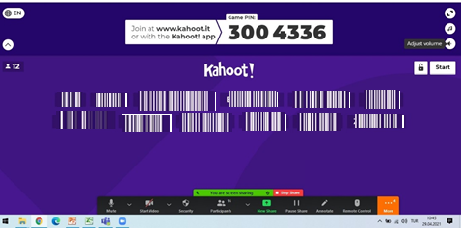
Appendix 2. Screenshot of student logging into Kahoot in lesson conducted with online education
Students logged into the Kahoot application using their own names in the online lessons conducted synchronously (Appendix 2).
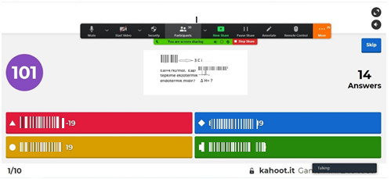
Appendix 3. Screenshot of question answered by student on Kahoot
In Kahoot, in addition to verbal questions, question types that require operations were also included (Appendix 3). In these types of questions, students were given more time to answer the questions.
Quizlet Sets Prepared for Solutions and Chemical Kinetics Topics
In the study, for the subject of solutions, a “Solutions/Solubility” study set consisting of 37 terms/definitions, and a “Solutions-Solubility-problems” study set consisting of 12 terms/definitions that require numerical operations on the subject of solutions were prepared. For the subject of chemical kinetics, a “Chemical Kinetics I” set containing 10 definitions/terms, and a “Chemical Kinetics II” set consisting of 7 terms/definitions that require numerical operations were prepared. These sets prepared in Quizlet were used for formative assessment as a gamification tool in the classroom. In addition, after becoming a member of the Quizlet class, the students used these sets individually whenever they wanted.
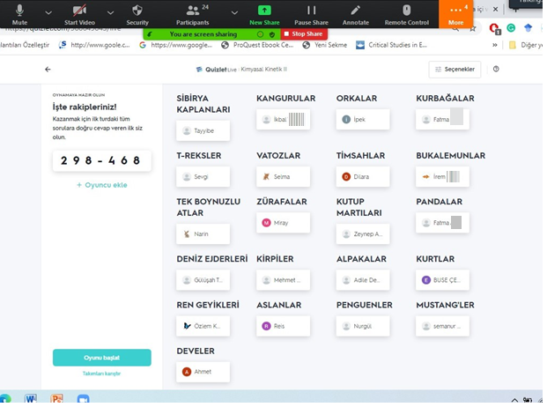
Appendix 4. Screenshot of student participating in a game individually with Quizlet Live in distance education
Students logging into the Quizlet Live application were given nicknames by the system, and student participation was thus ensured (Appendix 4).
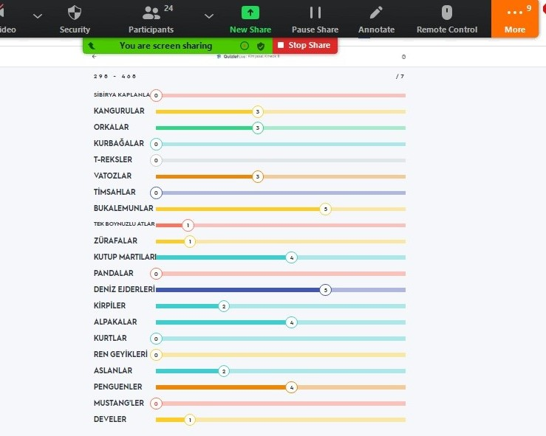
Appendix 5. Screenshot of game progress with Quizlet Live in lesson in online education
In Quizlet Live, the students’ progress and the scores they received (Appendix 5) were shared with the students, ensuring that they were informed about their progress.
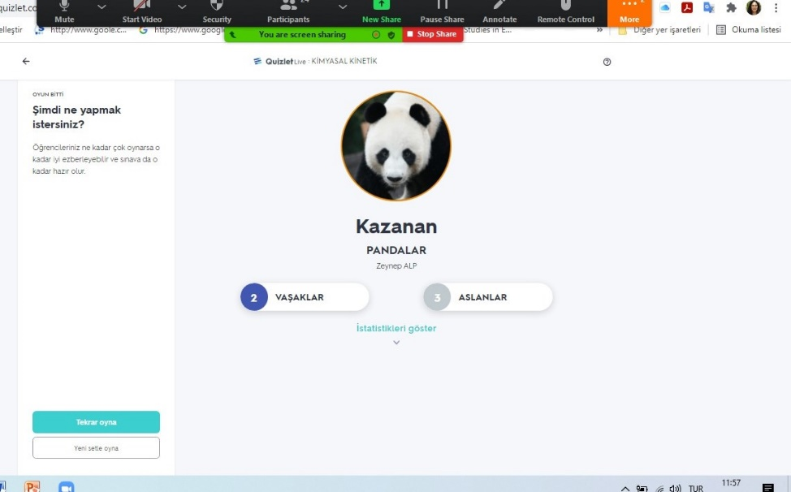
Appendix 6. Screenshot of game result with Quizlet Live in lesson in online education
The results of the students who ranked the highest at the end of Quizlet Live (Appendix 6) were shared with the students.
Questions in the Student Opinion Questionnaire (SOQ)
1- How many courses did you take this semester? If you were to rank the courses you took in terms of productivity, in which place would the Chemistry II course appear? Why?
2- How often were you able participate in the online Chemistry II lessons (You can answer as all of them, most of them, a few of them, etc.)? What are your reasons for not participating in classes?
3- How often did you use the Kahoot and Quizlet applications outside the online course (You can answer frequently, sometimes, all the time, or not at all)? What are your reasons for not using them?
4- What are your views and suggestions about taking the Solutions Achievement Test (SAT) and Chemical Kinetics Achievement Test (CKAT) using Google Forms?
5- What are your views on using the Kahoot application in online lessons and in your extracurricular time?
6- What are your views on using the Quizlet application in online lessons and in your extracurricular time?
7- What has been the effect of these applications on your professional teaching skills?
8- Would you choose to use similar applications in your teaching career? Why?
9- What are your views on the use of these applications for different types of questions that require verbal and numerical processing in the chemistry course?
10- What are your views on the exams you have entered in your education life so far and the exams you have taken via Kahoot, Quizlet and Google Forms?
11- What are your different views and suggestions that you wish to express about the implementations made within the scope of this course?
FUNDING INFORMATIONT
This research did not receive any specific grant from funding agencies in the public, commer-cial, or not
for-profit sectors.
CONFLICTS OF INTEREST
There are no conflicts of interest to declare.
DATA AVAILABILITY STATEMENT
All data generated or analysed during this study is included in this published paper. All data is publicly
available and cited.
ETHICS STATEMENT
* E- 762 441 75-752.01.01-18610 numbered ethics approval was obtained from the chairmanship of the social and human sciences ethics committee in the session numbered 2021/46, dated 12/03/2021.
REFERENCES
Alsancak-Sırakaya, D.(2017). Oyunlaştırılmış tersyüz sınıf modeline yönelik öğrenci görüşleri. Ondokuz Mayıs Üniversitesi Eğitim Fakültesi Dergisi, 36(1), 114-132.
Antonaci, A., Klemke, R., & Specht, M. (2019). The effects of gamification in online learning environments: A systematic literature review. Informatics ,6(3),32. https://doi.org/10.3390/informatics6030032
Arif, F. K. M., Zubir, N. Z., Mohamad, M., & Yunus, M. M. (2019). Benefits and challenges of using game-based formative assessment among undergraduate students. Humanities & Social Sciences Reviews, 7(4), 203-213.
Aydeniz, M., & Pabuccu, A. (2011). Understanding the impact of formative assessment strategies on first year university students’ conceptual understanding of chemical concepts. Necatibey Eğitim Fakültesi Elektronik Fen ve Matematik Eğitimi Dergisi, 5(2), 18-41.
Baltacı, A. (2017). Nitel veri analizinde Miles-Huberman modeli. Ahi Evran Üniversitesi Sosyal Bilimler Enstitüsü Dergisi, 3(1), 1-14.
Bellera, C. A., Julien, M., & Hanley, J. A. (2010). Normal approximations to the distributions of the Wilcoxon statistics: accurate to what N? Graphical insights. Journal of Statistics Education, 18(2).
Bovermann, K., & Bastiaens, T. J. (2020). Towards a motivational design? Connecting gamification user types and online learning activities. Research and Practice in Technology Enhanced Learning, 15(1), 1-18.
Blohm, I., & Leimeister, J. M. (2013). Design of IT-Based Enhancing Services for Motivational Support and Behavioral Change. Business & Information Systems Engineering, 5, 275-278. http://dx.doi.org/10.1007/s12599-013-0273-5
Black, P., Harrison, C., Lee, C., Marshall, B., & Wiliam, D. (2004). Working inside the black box: Assessment for learning in the classroom. Phi delta kappan, 86(1), 8-21.
Black, P., & Wiliam, D. (1998). Assessment and classroom learning. Assessment in Education: principles, policy & practice, 5(1), 7-74.
Bratel, O., Kostiuk, M., Bratel, S., & Okhrimenko, I. (2021). Student-centered online assesment in foreign language classes. Linguistics and Culture Review, 5(S3), 926-941.
Büyüköztürk, Ş. (2010). Sosyal bilimler için veri analizi el kitabi. Pegem Akademi. Ankara.
Creswell, J. W., & Clark, V. L. P. (2007). Designing and conducting mixed methods research. Sage publications.
Correia, M., & Santos, R. (2017, November). Game-based learning: The use of Kahoot in teacher education. In 2017 International Symposium on Computers in Education (SIIE) (pp. 1-4). IEEE.
Curto Prieto, M., Orcos Palma, L., Blázquez Tobías, P. J., & León, F. J. M. (2019). Student assessment of the use of Kahoot in the learning process of science and mathematics. Education Sciences, 9(1), 55.
Çetin, E., & Solmaz, E. (2020). Gamifying the 9 Events of Instruction with Different Interactive Response Systems: The Views of Social Sciences Teacher Candidates. Malaysian Online Journal of Educational Technology, 8(2), 1-15.
Dhawan, S. (2020). Online learning: A panacea in the time of COVID-19 crisis. Journal of educational technology systems, 49(1), 5-22
Dickey, M. D. (2003). 3D virtual worlds: an emerging technology for traditional and distance learning. Proceedings of Ohio Learning Network. OH: Columbus.
Dellos, R. (2015). Kahoot! A digital game resource for learning. International Journal of Instructional technology and distance learning, 12(4), 49-52.
Deterding, S., Dixon, D., Khaled, R., & Nacke, L. (2011, September). From game design elements to gamefulness: defining" gamification". In Proceedings of the 15th international academic MindTrek conference: Envisioning future media environments (pp. 9-15).
Dizon, G. (2016). Quizlet in the EFL classroom: Enhancing academic vocabulary acquisition of Japanese university students. Teaching English with Technology, 16(2), 40-56.
Google (2022). Online: http:// https://www.google.com/forms/about/ [accessed 06 May 2022].
Göksün, D. O., & Gürsoy, G. (2019). Comparing success and engagement in gamified learning experiences via Kahoot and Quizizz. Computers & Education, 135, 15–29. https://doi.org/10.1016/j.compedu.2019.02.015.
Hartnett, M., St George, A., & Dron, J. (2011). Examining motivation in online distance learning environments: Complex, multifaceted, and situation-dependent. International Review of Research in Open and Distributed Learning, 12(6), 20-38.
Huang, W. H. Y., & Soman, D. (2013). Gamification of education. Report Series: Behavioural Economics in Action, 29.
Ismail, M. A. A., Ahmad, A., Mohammad, J. A. M., Fakri, N. M. R. M., Nor, M. Z. M., & Pa, M. N. M. (2019). Using kahoot! As a formative assessment tool in medical education: A phenomenological study. BMC Medical Education, 19(1), 230. https://doi.org/10.1186/s12909-019-1658-z
Ismail MA-A, Mohammad JA-M (2017). Kahoot: a promising tool for formative assessment in medical education. Education in Medicine Journal. 19–26. https://doi.org/ 10.21315/eimj2017.9.2.2
Kalleny, N. K. (2020). Advantages of Kahoot! Game-based formative assessments along with methods of its use and application during the COVID-19 pandemic in various live learning sessions. Journal of Microscopy and Ultrastructure, 8(4), 175.
Kamble, A., Gauba, R., Desai, S., & Golhar, D. (2021). Learners’ perception of the transition to instructor-led online learning environments: Facilitators and barriers during the COVID-19 pandemic. International Review of Research in Open and Distributed Learning, 22(1), 199-215.
Kapsalis, G. D., Galani, A., & Tzafea, O. (2020). Kahoot! As a Formative Assessment Tool in Foreign Language Learning: A Case Study in Greek as an L2. Theory and Practice in Language Studies, 10(11), 1343-1350.
Karataş, E. (2014). Eğitimde Oyunlaştirma: Araştirma Eğilimleri. Ahi Evran Üniversitesi Kırşehir Eğitim Fakültesi Dergisi, 15(2), 315-333.
Liu, O. L., Bridgeman, B., & Adler, R. M. (2012). Measuring learning outcomes in higher education: Motivation matters. Educational Researcher, 41(9), 352-362.
McMillan, J. H., & Schumacher, S. (2006). Research in Education: Evidence-Based Inquiry, MyEducationLab Series. Pearson.
Miles, M, B., & Huberman, A. M. (1994). Qualitative data analysis: An expanded Sourcebook. (2nd ed). Thousand Oaks, CA: Sage
Moore, J. L., Dickson-Deane, C., & Galyen, K. (2011). e-Learning, online learning, and distance learning environments: Are they the same? The Internet and higher education, 14(2), 129-135.
Montaner-Villalba, S. (2019). The use of Quizlet to enhance vocabulary in the English language classroom. CALL and complexity–short papers from EUROCALL, 304-309.
Nadeem, N. H., & Al Falig, H. A. (2020). Kahoot! quizzes: a formative assessment tool to promote students’ self-regulated learning skills. Journal of Applied Linguistics and Language Research, 7(4), 1-20.
Prensky, M. (2001). Digital Natives, Digital Immigrants Part 1. On the Horizon, 9, 1-6. http://dx.doi.org/10.1108/10748120110424816
Menezes, C. C. N., & De Bortolli, R. (2016). Potential of Gamification as Assessment Tool. Creative Education, 7, 561-566. ). http://dx.doi.org/10.4236/ce.2016.74058
Platzer, H. (2020). The Role of Quizlet in Vocabulary Acquisition. Electronic Journal of Foreign Language Teaching, 17(2).
Robson, C., & McCartan, K. (2016). Real world research: a resource for users of social research methods in applied settings. Wiley.
Sarıgül, K. (2021). Yabancı Dil Olarak Türkçe Öğretiminde Çevrim İçi Süreç Değerlendirme Araçları. Karamanoğlu Mehmetbey Üniversitesi Edebiyat Fakültesi Dergisi, 4(2021 Yunus Emre ve Türkçe Yılı Yabancı Dil Olarak Türkçe Öğretimi Özel Sayısı), 56-80.
Author. (2018).
Sadler, D. R. (1998). Formative assessment: Revisiting the territory. Assessment in education: principles, policy & practice, 5(1), 77-84
Seaborn, K., & Fels, D. I. (2015). Gamification in theory and action: A survey. International Journal of human-computer studies, 74, 14-31.
Setiawan, M. R., & Wiedarti, P. (2020). The effectiveness of Quizlet application towards students’ motivation in learning vocabulary. Studies in English Language and Education, 7(1), 83-95.
Sezgin, S., Bozkurt, A., Yılmaz, E. A., & Van der linden, N. (2018). Oyunlaştırma, eğitim ve kuramsal yaklaşımlar: Öğrenme süreçlerinde motivasyon, adanmışlık ve sürdürebilirlik. Mehmet Akif Ersoy Üniversitesi Eğitim Fakültesi Dergisi, (45), 169-189.
Sun, J. C. Y., & Chen, A. Y. Z. (2016). Effects of integrating dynamic concept maps with Interactive Response System on elementary school students’ motivation and learning outcome: The case of anti-phishing education. Computers & Education, 102, 117-127. https://doi.org/10.1016/j.compedu.2016.08.002
Şahin, Y. L., Karadağ, N., Bozkurt, A., Doğan, E., Kılınç, H., Uğur, S., ... & Güler, C. (2017). Uzaktan eğitimde oyunlaştırma kullanımı: oyunlaştırılmış web tabanlı bir alıştırma uygulaması. Turkish Online Journal of Qualitative Inquiry (TOJQI), 8(4), 372-395.
Tunga, Y., & İnceoğlu, M. M. (2016, Nisan). Oyunlaştırma tasarımı. 3rd. International Conference on New Trends in Education (3. Uluslararası Eğitimde Yeni Yönelimler Konferans), (s.267-279).
Wang, A. I., & Tahir, R. (2020). The effect of using Kahoot! for learning–A literature review. Computers & Education, 149, 103818.
Weller, A. (2013). The use of Web 2.0 technology for pre-service teacher learning in science education. Research in Teacher Education, 3(2), 40-46.
Wright, B.A. (2016). Transforming vocabulary learning with Quizlet. In P. Clements, A. Krause, & H. Brown (Eds.), Transformation in language education. Tokyo: JALT.
Yıldız, E. (2020). Çevrimiçi öğrenme ortamlarında uzaktan eğitim öğrencilerinin topluluk hissine etki eden faktörlerin incelenmesi. Egitimde Nitel Araştırmalar Dergisi – Journal of Qualitative Research in Education, 8(1), 180-205. doi:10.14689/issn.2148-2624.1.8c.1s
Yılmaz, R., & Karaoglan Yilmaz, F. G. (2019). Bir oyunlaştırma ve biçimlendirici değerlendirme aracı olarak kahoot kullanımına yönelik öğretmen adaylarının görüşlerinin incelenmesi. Presented at II. Uluslararası Eğitimde ve Kültürde Akademik Çalışmalar Sempozyumu’nda (II. International Symposium of Academic Studies on Education and Culture) I-SASEC, (12-14 September) (331-337 ss). Denizli/Turkey
Zainuddin, Z., Shujahat, M., Haruna, H., & Chu, S. K. W. (2020). The role of gamified e-quizzes on student learning and engagement: An interactive gamification solution for a formative assessment system. Computers & Education, 145, 103729.
Zhang H., Fang L. (2019) Project-Based Learning for Statistical Literacy: A Gamification Approach. In: Väljataga T., Laanpere M. (eds) Digital Turn in Schools—Research, Policy, Practice. Lecture Notes in Educational Technology. Springer, Singapore. https://doi.org/10.1007/978-981-13-7361-9_1

