**Paper Circuit Project-based STEAM Learning to Enhance Student Understanding and Creativity**

Arnie Novianti Zulkarnain, Eka Cahya Prima, Nanang Winarno

*Corresponding Author. [arnienovianti@upi.edu](mailto:arnienovianti@upi.edu)

**NOVELTY**

The novelty in this research is students’ understanding was assessed using an objective test of cognitive levels C1 (remembering), C2 (understanding), C3 (applying) and 25 multiple-choice questions based on the Bloom Classification (Anderson & Krathwohl, 2001). For measuring the enhancing students' creativity, the project was assessed using the instrument for creative product analysis matrix (CPAM) indicator and the results were also assessed by teacher and then it was seen whether students could increase their creativity or not.

# ABSTRACT

Students believed physics is one of the most difficult sciences in education and their interest in learning physics was lacking. Therefore, this study aims to enhance students' understanding and creativity in the STEAM learning system in electricity topic by creating a project (Paper Circuit) using the students' creativity at the junior high school level. Quantitative research with a pre-experimental design used as method for this study. The population is 8th grade and 9th grade (50 students adapted to the curriculum used in the school) in one of Junior Secondary School that is located in Bandung and Cimahi, Indonesia. The data is obtained through results from the pretest-posttest results standing from average of pre-test score was 57.04 and the post-test score was 76.64. The nonparametric test was tested using the Willcoxon test, for measureing student understanding. The results from e Willcoxon is .000 which the results show sig. <0.05, which means there is a significant difference pre-test and post-test. Students’ creativity is obtained from Creativity Product Analysis Matrix (CPAM) and the result for project 1 as 73.71% which is categorized enough and project 2 as 83.13% which is categorized as good. Based on the result, Paper Circuit STEAM project-based learning can enhance student understanding and creativity STEAM project-based learning can be used as alternative teaching strategies in Junior Secondary School.

***Keywords***

Electiricty, STEAM Project-based Learning, Students Creativity, Students Understanding

# 1. INTRODUCTION

One of the STEM subjects that causes students difficulty understanding and confusion is electricity. Students believed physics is one of the most difficult sciences in education, which contributed to their lack of enthusiasm and disinterest in learning (Yasin et al., 2018). This was also justified after the researchers conducted interviews with one of the schools in Bandung, grade 8th junior high school students, and grade 9th junior high school students in Cimahi. 37 of 45 students said that physics lessons were very difficult to understand and their interest in learning physics was lacking. In the interviews in grade 9 junior high school, they did not do electricity experiment, there was no clear reason why their teacher did not do an experiment on electricity, even though electricity is a challenge, according to Mulhall et al., (2001) in Journal (Yasin et al., 2018), since it contains exceedingly abstract and sophisticated concepts and is entirely dependent on models, analogies, and metaphors. Cao & Brizuela, (2016) also stated that it is difficult for students to explain the role of the electric field in the interaction of the various elements of a circuit. There was also an alternative concept about electric current in the electric circuit that the students generated (Yasin et al., 2018). Anwari et al., (2015) stated that a STEM educational approach to learning about magnetism, electricity, and electrical energy can stimulate students' interest in science, provide deep and meaningful learning, and improve students' thinking and hands-on skills.

In Indonesia there are still many the learning-teaching process is often teacher-centered. In fact, student learns better when they engage in meaningful learning activities. The learning teaching process itself still occurs in the form of direct transfer of knowledge from teacher to students. In fact, student learns better when they engage in meaningful learning activities. Project-based STEM learning is one of the alternative teaching strategies to encourage students to engage in meaningful learning (Hanif et al., 2019). STEM learning in many schools is heavily focused on science and mathematics while ignoring the critical role of engineering and technology (Christine & McDonald, 2016). In recent years, STEM becomes a trending pedagogic topic in every education sector in many countries. In the United States, STEM has become a national priority and the National Science Foundation has followed suit at all levels of secondary education (Sanders, 2009; Wannapiroon & Pimdee, 2022), to instill critical thinking skills in students so they have the potential to develop students become creative- thinking problem solvers who will ultimately thrive in the workforce (Wannapiroon & Pimdee, 2022; White, 2014). In general, the implementation STEM into learning can enhance students improve their 21st-century skills (Farwati et al., 2021; Permanasari, 2016). However, in Indonesia over the last six years, STEM implementation has primarily involved high school students, reaching 42%. Thus, strong encouragement is required to pique the interest of other education unit-level teachers in innovating by incorporating STEM into classroom learning (Farwati et al., 2021). Today, art has added an "A", and STEAM education now helps students better understand their world through a diversity of knowledge and perspectives, which is conducive to cultivating their innovative abilities (Connor et al., 2015; Miller & Knezek, 2013).

Therefore, the researchers assume that Paper Circuit Project-based STEAM Learning will be proposed to solve students' problems understanding and creativity in electrical concepts and applications. Project-based STEM learning is a project-based methodology in which Science, Technology, Engineering, and Mathematics (STEM) are integrated into curriculum design. STEM project-based learning is distinguished by its design approach and multidisciplinary training. Project-based STEM learning design approach begins with creating a well-defined result by defining the purpose and organizing the project's summative evaluation. Students will next be assigned an in which they must present their thoughts for solving a complicated problem in a novel way. Project-based STEM learning has the potential to boost creativity since students will build or enhance their product ideas. One crucial talent that students should cultivate is creativity (Dawes & Wegerif, 2004; Hanif et al., 2019). Creativity refers to the creation of a novel and appropriate response, product, or solution to an open-ended task (Amabile, 2012). If creativity is related to study and technology, it will result in high-quality work. STEM project-based learning has been used to assess students' creativity in areas such as adventure, curiosity, imagination, and challenge (Hanif et al., 2019).

STEAM education is a learning management extension of STEM education, designed to integrate four subjects: science, technology, engineering, and mathematics. The STEAM model of learning management encourages student innovation and design thinking, providing possible solutions. Real problems due to the engineering design process. Below are process-based teaching and learning models for structural design: (1) Problem identification (2) Finding relevant information (3) Solution design (4) Planning and development (5) Testing and evaluation and design improvement (6) Presentation. Art integration under the STEAM concept is an innovative way to enable students to work through creative processes, experiential learning, real-world work practice, problem-solving, analysis, synthesis, evaluation, and creative skill development. Focused on design, resulting in improved cognitive skills, a better understanding of what is being taught, and the development of creative thinking (Wittayakhom & Piriyasurawong, 2020). Ogunleye, (2018) has stated that the key to STEAM education is the word, ‘integration’. Bazler & Sickle, (2017) stated that adding art to STEM increases students’ systematic thinking skills, creativity development, and student motivation enhancement.

Creativity is defined as novelty or originality; thus, it must generate something new and distinct Something cannot be deemed innovative If inappropriate or unimaginative. As a result, teachers must be capable of cultivating pupils' creativity. According to Davies et al., (2013) in Journal (Aguilera & Ortiz-Revilla, 2021) if a teacher's teaching and instructional conduct promote the development of a student's creative potential, it must adhere to the following criteria: (1) grant freedom of use and displacement between spaces; (2) set aside sufficient time and avoid rushing into the development of the activities; (3) layout and incorporate a broad range of educational resources; (4) design novel and stimulating tasks; (5) focus learning from a perspective of play, minimizing pressures and permitting a structured yet flexible and self- directed learning experience; (6) promote cooperative work, dialogue, and respect; and (7) rely on the participation of external bodies and experts unconnected with the school (museums, research centers, etc.). The most significant part that has been addressed is how a teacher can enhance and provide action to students so that they may have many creative ideas and new inventions in developing STEAM learning projects.

Many researches conducted about project based STEAM learning, according to Taylor, (2016) in this paper outline reasons why integrating the arts with science, technology, engineering and mathematics is not just another curriculum fad but an important response to the pressing need to prepare young people with higher-order abilities to deal positively and productively with 21st century. Moreover, according to Purnamasari et al., (2020) has found that digital literacy for children based on steam in family education also plays an important role for the success of the program. In addition, according to Wandari et al., (2018) already describe that students’ concept mastery and creativity in the implementation of project-based STEAM Learning in light and optic lesson is categorized as good. Furthermore, according to Sigit et al., (2022) the research results indicate that the Project based STEAM learning model improves students’ mastery of ecological concepts. The research has a limitation related to the assessment of students’ attitudes. According to journal Rahmawati et al., (2021) describe project-based STEAM learning can train students critical thinking skills in science learning through electrical bell project.

Existing research in project-based learning has often focused on generic project implementations, neglecting the nuanced interplay between artistic expression, scientific principles, and interdisciplinary collaboration that characterizes STEAM education. Similarly, studies on STEAM education tend to lack in-depth investigation into specific projects, hindering a comprehensive understanding of their impact on student engagement, creativity, and cognitive development. Various research studies from Weibert et al., (2016) have investigated the implementation project-based STEAM learning using paper circuit in elementary school and secondary school, then to measure the increase in creativity it was not explained in more detail what indicators were used, and to measure students' understanding of electricity topic was not explained in more detail In addition, Lindberg et al., (2020) research on improving student's creativity by using STEAM Project Based Learning toward paper circuit project with ethnographic method in High School. Furthermore, the research utilizing STEAM Project-Based Learning on student concept mastery and creativity skills through paper circuit project also have been conducted by Lee & Recker, (2018). However, in this research, the participant are middle school students, and using pre-experimental research. The study aims to investigate how this hands-on, multidisciplinary approach enhances students' creativity and comprehension of electricity concepts. However, in previous research to measure the increase in creativity it was not explained in more detail what indicators were used

Therefore, the novelty in this research is students’ understanding was assessed using an objective test of cognitive levels C1 (remembering), C2 (understanding), C3 (applying) and 25 multiple-choice questions based on the Bloom Classification (Anderson & Krathwohl, 2001). For measuring the enhancing students' creativity, the project was assessed using the instrument for creative product analysis matrix (CPAM) indicator and the results were also assessed by teacher and then it was seen whether students could increase their creativity or not. More information, this research endeavor seeks to bridge this gap and unravel uncharted dimensions by examining how the synergy between the Paper Circuit Project, project-based learning, and STEAM education can redefine educational experiences.

The research problem would be state as:

* + 1. How does the implementation of Paper Circuit after STEAM Learning in Classroom?
    2. How does the improvement of Students’ understanding after implementing STEAM Learning in electricity topic?
    3. How does the improvement of Students’ Creativity after implementing STEAM Learning in electricity topic?

# 2. METHOD

1. **Research Method**

Quantitative Method used as the method of this research. Quantitative research rigorously tests objective theories by analyzing the relationship between variables (Creswell & Creswell, 2018). Pre-experimental Design and Pre-test Post-test is chosen as the experimental research methods. In pre-experimental designs, the researcher studies a one group and implements an intervention during the experiment. This design does not have a control group to compare with the experimental group (Creswell & Creswell, 2018). The pre-experimental design was used to discover the effect of STEAM Learning approach implemented by the researcher to students’ STEAM Understanding and Creativity. Therefore, the researcher will know whether any change occurred due to the implementation of STEAM Learning approach in learning electricity. Students’ understanding was assessed using an objective test of cognitive levels C1 (remembering), C2 (understanding), C3 (applying) and 25 multiple-choice questions based on the Bloom Classification (Anderson & Krathwohl, 2001). All test assignments were analyzed by experts as part of the assessment and tested to the students. Test task results are used, modified, or deleted after the evaluation process. The objective test analyzed using SPSS. The reliability score is 0.60 which is moderate reliability. Reliability is the constancy of stating that reliability refers to an understanding that the instruments used in research to obtain information used can be trusted as a data collection tool and are able to reveal actual information in the field (Riskawati, 2018). The design of this research was One-Group Pretest Posttest Design. A pretest was used to measure some understanding of participants in an experiment before receiving treatment. A posttest was used to measure some understanding of participants in an experiment after receiving treatment.

**Table 1.** Pre-Experimental Research Design

|  |  |  |
| --- | --- | --- |
| Pre-test | Implementation | Post-test |
| Students’ Understanding – Pretest | Experiment Paper Circuit Project –  implementation of STEAM learning | Students’ Understanding – Posttest |

1. **Participants**

In this research, sample is 8th grade and 9th grade student (adapted to the curriculum used in the school) and will be one class (50 students) as a sample of this research that will be implementing Project Base Learning through Paper Circuit Experiment. Location that will be conducted at one of school in Bandung and Cimahi. The characteristic of the chosen school is they conduct Merdeka curriculum and Cambridge curriculum.

1. **Research Instrument**

Research instrument is required to collect the data. There are several types of research instrument used in this research. Those instruments are described as follow: The pretest was given before conducting the treatment to know STEAM understanding in basic Electricity subject of students. Worksheet was used to measure the creativity implementation of STEAM learning in the class. The worksheet contains the steps taken by students which will be assessed whether students can make their own projects or not. In the implementation, students create Paper Circuit Project, in this observation Project Based Learning used to test students’ STEAM Understanding and Creativity. Post-test was given after the implementation conducting the treatment to know enhance STEAM understanding in basic Electricity subject of students. In Table 2. shown the STEAM lesson plan

**Table 2.** STEAM Lesson Plan

|  |  |  |  |
| --- | --- | --- | --- |
| **Meeting** | **Activity** | **Science**  **Concept** | **Developed STEM** |
| **Meeting 1st**  **Meeting 2nd** | STEAM understanding and creativity Pre-test  Create Circuits Diagrams by using Paper Circuit (LED, Battery and Cooper tape) | * Electric Current * Resistance * Ohms’ Law * Potential Difference   - Series and parallel circuit | **Science**  Students learn the basic principles of electricity such as electric current, voltage, resistance, and power.  **Technology**  Students use technology in this project, including the use of batteries, wires, and light sources such as LEDs.  **Engineering**  Students learn the basic principles of electrical engineering and build more complex circuits. They will also apply engineering principles to solve problems in their project.  **Art**  Students use art elements in this project, such as paper, scissors, and other decorative materials to make their circuits look attractive and eye-catching.  **Mathematics**  Students are able to apply Ohm’s Law students will learn basic math in relation to electrical principles, such as calculating voltage, current, resistance, and power. |
| **Meeting 3rd**  **Meeting 4th** | * Experimental : Series and parallel construction with Paper Circuits * Combined series and parallel construction * Making variation Paper Circuits Project. * Create a Circuit and Art   Design (drawing)  Modifying the Circuit   * STEAM Understanding   Post- test | Electric Current: - Series and parallel circuit   * Potential Difference * Resistance * Ohms’ Law * Potential Difference * Electric Current * Resistance * Ohms’ Law * Potential Difference | **Science**  Students learn how simple circuits work and how different materials affect the flow of electricity.  Students are able to recall the principle of series and parallel circuit.  **Technology**  Students use design software to plan and design their circuits.  **Engineering**  Students apply engineering principles to design and build circuits with the appropriate resistance. They will also troubleshoot and modify their circuits to achieve the desired results.  **Mathematics**  Students measure and record data to test their circuits. |

For creativity used creativity product analysis matrix (CPAM) that was developed by Besemer & Treffinger, (1981). The data gathered from students' creativity is based on a creative product created by students as part of a STEAM project-based learning activity. For each criteria of creativity, students' inventiveness is graded on a scale of 1 to 3. The criterion employed is valuable, helpful, well-crafted, expressive, unique, and new. In Table 3 shown the creativity product analysis matrix indicator.

**Table 3**. Instrument for creative product analysis matrix (CPAM)

|  |  |  |  |  |
| --- | --- | --- | --- | --- |
| **Creative Dimension** | **Criterion** | **Score** | | |
| **1 2 3** | | |
| **Novelty:** | Germinal | **Lower** | **Medium** | **Higher** |
| The product is inspiring other with the creation | The product is inspiring others to try something new | The product is inspiring others to try something new by directly give ideas to develop more product design |
|  | Original | Students mostly use the previous finding as their product idea | Students use the previous finding as their idea, but they make a modification of the product | The product idea comes from their own understanding |
| **Resolution:** | Valuable | The product is not compatible with the purpose and not relates to the concept | The product is compatible with the purpose and not relates to the concept | The product is compatible with the purpose and relates to the concept |
|  | Useful | The product can be used once | The product can be used continuously with a certain requirement | The product can be used continuously without any requirement |
| **Elaboration:** | Well Crafted | The product is done well | The product is done well with the goodlooking design | Students take an effort to give interesting product design by using some material |
|  | Expressive | The product is presented with lacking body language and need to control speaking tone, not understandable | The product is presented with lacking body language and need to control speaking tone, not understandable | The product is presented in a communicative way (using effective body language and clear voice) and understandable manner |

(Hanif et al., 2019)

1. **Data Analysis**

Using SPSS software, the outcomes of the pretest and posttest in one class. Data analysis is broken down into numerous assessments to determine the understanding and creativity in electrical and circuit subject. When assessing the data, the following statistical test was run:

1. Pre-requisite test

Perquisite test are needed to determine which data will be processed into further tests.

Prerequisite test includes normality test and homogeneity test.

* 1. Normality test

The normality test is carried out in order to test the distribution of data on a group or variable that is normally distributed or not. In this study, the result of the pretest and posttest of the control class and the experimental class were tested using the Kolmogorov-Smirnov test. The following is Kolmogorov-Smirnov formula:

D+ = , 1 ≤ *i* ≤ *n* ;

D- = , 1 ≤ *i* ≤ *n* ;

D = max (D+, D-);

D = D $\left(\sqrt{n}+0.12+0.11/\sqrt{n}\right)$

Where,

*zi* = cumulative probability of s.n.d

*Di =* Difference between observed and expected values

D = Kolmogorov–Smirnov test statistic

n = population

(Yazici & Yolacan, 2007)

If the data is normally distributed, the analysis can be continued to the parametric test, but if data is not normally distributed, the data analysis is continued to the nonparametric test. The criteria for testing the Normality test using the SPSS program are as follows:

* + - If the significance value is < 0.05, then the data is not normal
    - If the significance value is > 0.05, then the data is normal
  1. Homogeneity test

Homogeneity test was carried out to find out whether samples from the control class and experimental class came from uniform populations or not. The test used in study is the Levene test because the data is in the form of a scale. The criteria for testing the Homogeneity test using the SPSS program are as follows:

* + - If the significance value is >0.05, then the data is not homogeneous
    - If the significance value is < 0.05, then the data is homogeneous

1. **Hypothesis**

H.0 there is no significant difference of students’ understanding and creativity between before implementation and after implementation electricity material and made paper circuit project in STEAM learning.

Ha. there is significant difference of student’s understanding and creativity between before implementation and after implementation electricity material and made paper circuit project in STEAM learning.

Hypothesis will be measure with Willcoxon test. Willcoxon test using the SPSS program are as follows:

* If the significance value is < 0.05, then the data is significant difference between pretest and posttets
* If the significance value is > 0.05, then the data is not significant difference between pretest and posttets

# 3. RESULT AND DISCUSSION

1. **Implementation of Paper Circuit after STEAM Learning in Classroom**

To investigate the implementation of the project in this lesson, students will explore the basics of electricity through hands-on STEAM activities. Students will work in teams to design, build and test circuits, and investigate the properties of different materials to understand how they affect the flow of electricity. They will also learn about the history and importance of electricity in our daily lives, and the role of electrical engineers in developing new technologies. Table 4 shows the learning activity plan.

**Table 4.** STEAM Learning Lesson Plan

| **Meeting** | **Activity** | **Science**  **Concept** | **Implemen-tation** | **Developed STEAM** |
| --- | --- | --- | --- | --- |
| **Meeting 1st**  **Meeting 2nd** | STEAM understanding and creativity Pre-test  Create Circuits Diagrams by using Paper Circuit (LED, Battery and Cooper tape) | * Electric Current * Resistance * Ohms’ Law * Potential Difference * Series and parallel circuit | 100%  100% | **Science**  Students learn the basic principles of electricity such as electric current, voltage, resistance, and power.  **Technology**  Students use technology in this project, including the use of batteries, wires, and light sources such as LEDs.  **Engineering**  Students learn the basic principles of electrical engineering and build more complex circuits. They will also apply engineering principles to solve problems in their project.  **Art**  Students use art elements in this project, such as paper, scissors, and other decorative materials to make their circuits look attractive and eye-catching.  **Mathematics**  Students are able to apply Ohm’s Law students will learn basic math in relation to electrical principles, such as calculating voltage, current, resistance, and power. |
| **Meeting 3rd** | * Experimental : Series and parallel construction with Paper Circuits * Combined series and parallel construction * Making variation Paper Circuits Project. * Create a Circuit and Art   Design (drawing)  Modifying the Circuit | Electric Current: - Series and parallel circuit   * Potential Difference * Resistance * Ohms’ Law * Potential Difference | 100% |
| **Meeting 4th** | * STEAM Understanding Post- test | * Electric Current * Resistance * Ohms’ Law   Potential Difference | 100 % | **Science**  Students learn how simple ircuits work and how different materials affect the flow of electricity.  Students are able to recall the principle of series and parallel circuit.  **Technology**  Students use design software to plan and design their circuits.  **Engineering**  Students apply engineering principles to design and build circuits with the appropriate resistance. They will also troubleshoot and modify their circuits to achieve the desired results.  **Mathematics**  Students measure and record data to test their circuits. |

In meeting 1, Before the lesson starts students fill out the pretest that has been provided within 30 minutes. This is done to determine students' understanding of electricity before being given the actual material. The 30 questions are in the form of multiple choice which includes Science, Technology, Engineering, Mathematics and Creativity. After completing the pre-test, students are given material about electricity (Electric Current, Resistance, Ohms’ Law, Potential Difference)

In meeting 2, before students do experiments, students are first given material about electricity (continuing material from meeting 1), after the teacher delivers the material it is continued by students doing experiments. In groups, students can arrange projects very well and then draw Art on paper very creatively with the combination of LED, Copper tape, and Art that they make. In this project all of the students made a series circuit and used 1 LED, but the art they made in the paper was very diverse. No obstacles were found, the projects made by students were all successful. Students can also describe the circuit they made.

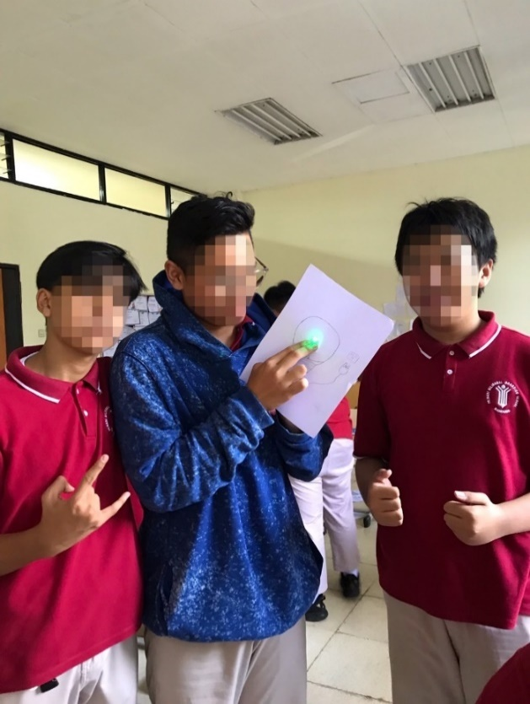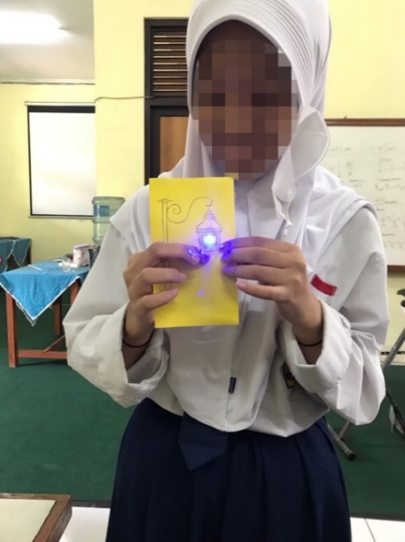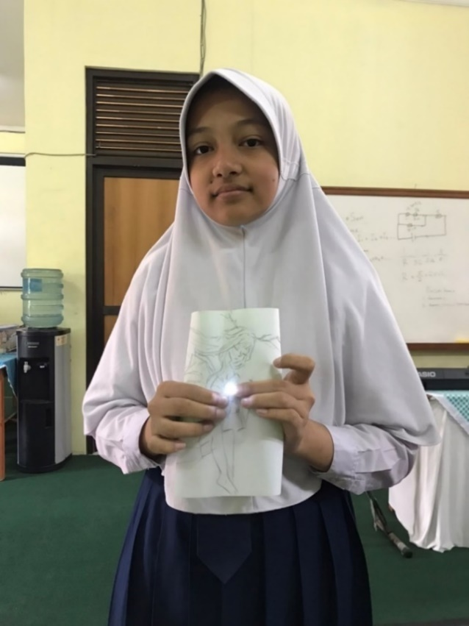

**Figure 1.** Student’s Paper Circuit Project (Series Circuit)

In meeting 3, the treatment given to students was the same as in meeting 2, but at this meeting, students were required to make a different project than before, to see if there was an increase in the creativity of these students. Students draw art that requires them to use more than 1 LED light. After they do the project, continue to fill in the worksheet that has been provided. At this meeting, several obstacles were found in the making of the project. After the students assembled the paper circuit, a group experienced that the LED lights did not light up at all, the result in Figure 4.2

|  |  |
| --- | --- |
| **Figure 2.** The Art | **Figure 3.** The circuit (Series) |

After making the project above students fill out the worksheet that has been provided and the following is an explanation from students after working on a paper circuit project.

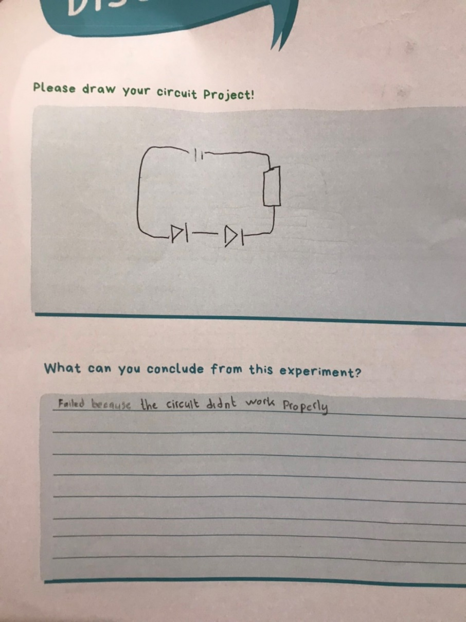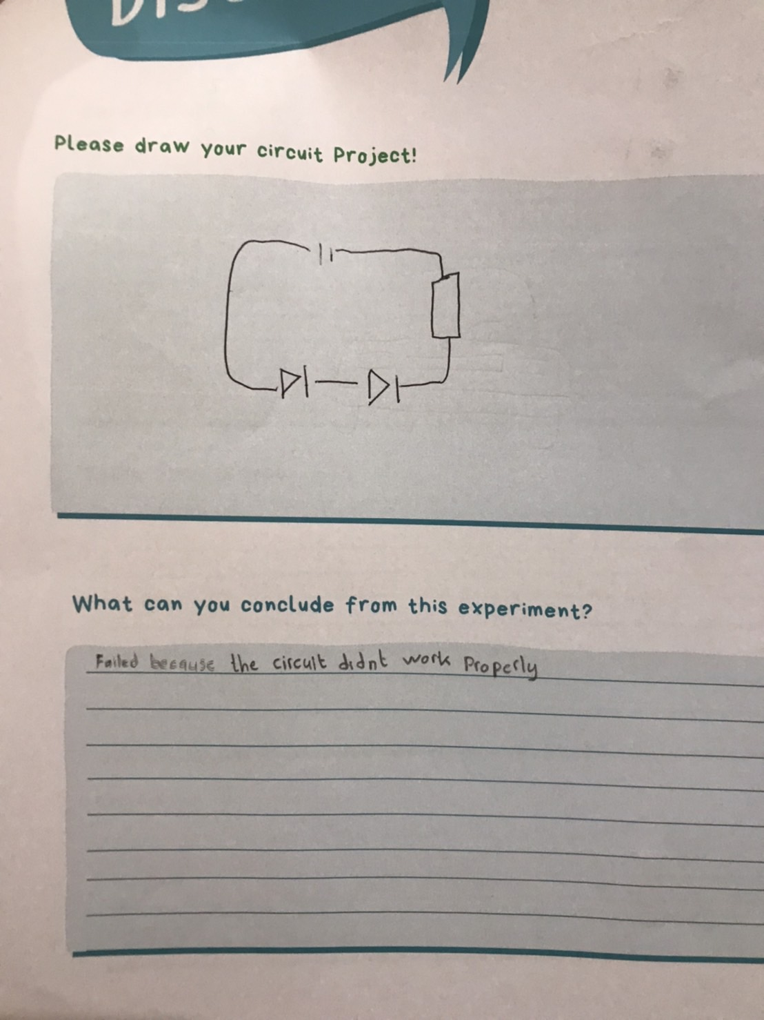

**Figure 4** the student’s answer in worksheet after made Car Paper Circuit

From Figure 4, the average student answered that because the circuit they made was not optimal (there was damage), the copper tape didn't stick too much to the paper so the current from the battery couldn't flow optimally and the LED lights couldn't turn on. Cases like this are experienced by students who string electricity in series.

Students who string electricity in parallel also have problems, namely the LEDs cannot all light up (only 1 or 2 LEDs can light up). They are also required to find out the problem. From the worksheet, it is answered why the project that was carried out was successful or did not go well. For the group that made the circuit in series, this has been answered, because the series circuit is one branch, so if one lamp is damaged, all of them will turn off. Unlike the parallel circuit, there are students who make a traffic light project, they use 3 LEDs and one 3V battery and only 2 LEDs are lit, this proves that the electric power from the battery is not strong enough to turn on 3 LEDs, only able to turn on 2 LEDs.

|  |  |
| --- | --- |
| **Figure 5** The Art (Traffic Light)    **Figure 7** The Art (Birthday Cake) | **Figure 6** The circuit of Traffic Light (Parallel)    **Figure 8** The circuit of Birthday Cake (Parallel) |

After making the project above students fill out the worksheet that has been provided and the following is an explanation from students after working on a paper circuit project.

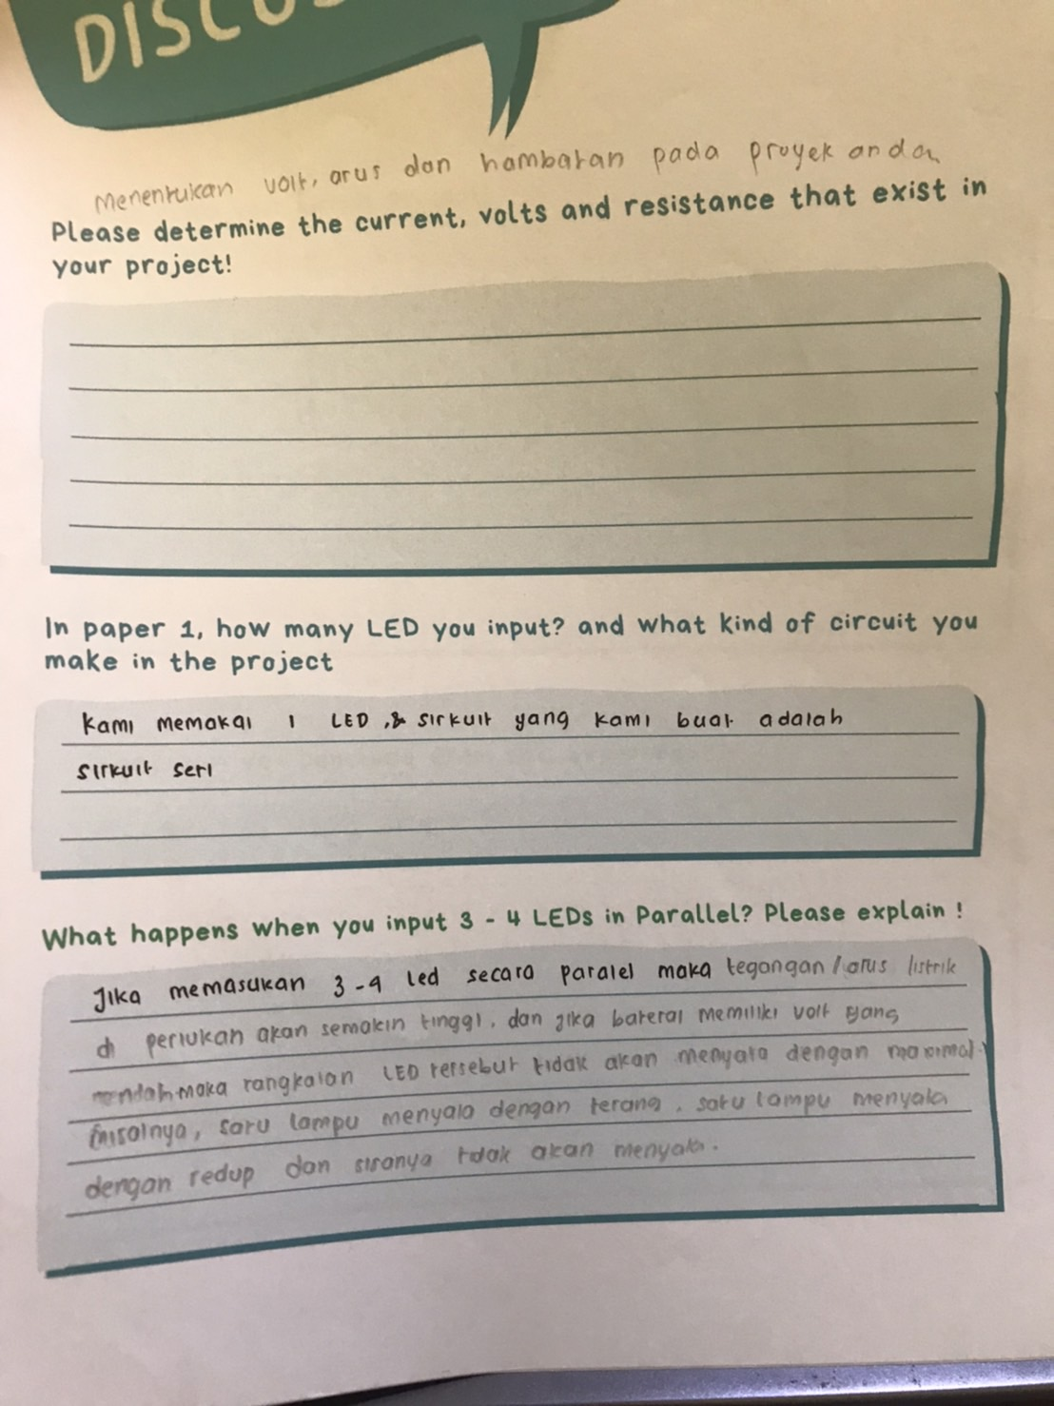

*If you insert 3-4 LEDs in parallel, the required voltage will be higher and if the battery has a low voltage, the LED circuit will not light up optimally. For example, one light is on brightly, one light is on dimly and the rest are off*

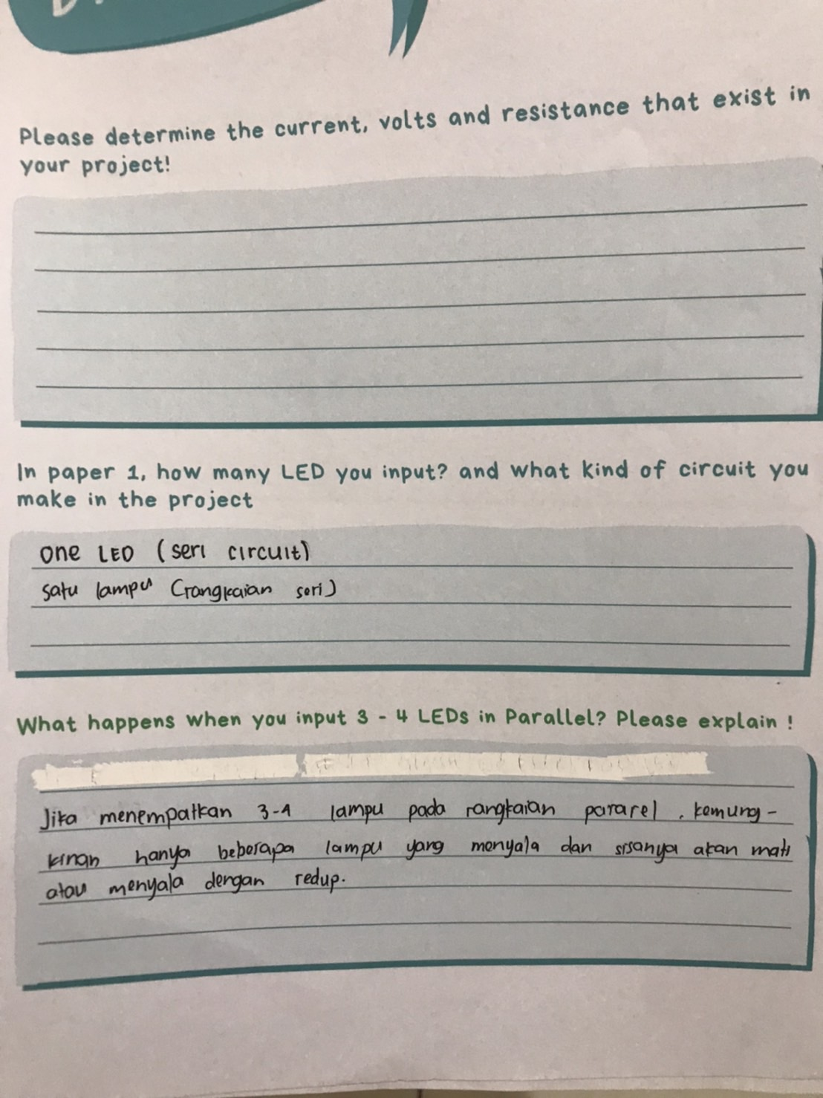

*if placing 3-4 lights in a parallel circuit, chances are only a few lights will be lit and the rest will be off or dim*

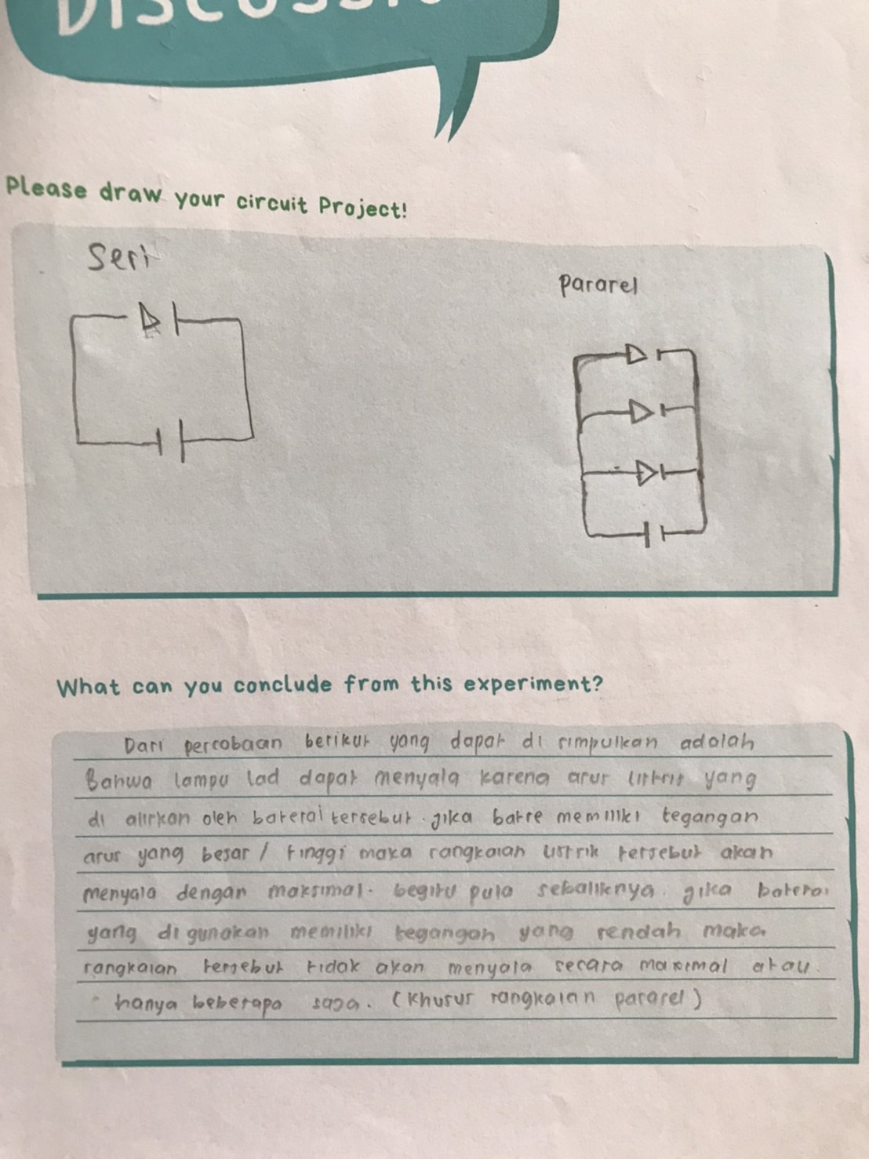

*From the experiment, it can be concluded that LEDs can light up because of the electric current from the battery. If the battery has a large voltage then the electrical circuit will run with the maximum turning on the LED and vice versa if the battery used has a low voltage, the circuit will not turn on the LED optimally*

**Figure 9** student’s answer from their worksheet

Paper Circuit includes PBL in STEM Learning. PBL is based on constructivist concepts, learning through real, specific contexts and involving the students in their own learning (Kokotsaki et al., 2016). Alternative methods enhance student engagement in actual problem solving, which allows for the application of multidisciplinary concepts and processes and increases knowledge generalization and enthusiasm toward these fields (Asghar et al., 2012). Furthermore, PBL can improve student understanding and creativity while creating a project. It can be seen from the results of the project and the answers they gave in the student worksheets. From the answers above, they are already beginning to understand why the student's LEDs cannot turn on or not all the LEDs can light up from here. The testers think that the students already understand more about electricity and can make projects well and creatively. On the other hand, other students who make parallel circuit projects using 2 LEDs can run well, the lights can glow brightly. It looks like Figure 10 students who make parallel circuits using 2 LEDs

|  |  |
| --- | --- |
| **Figure 10** Make a Cat | **Figure 11** Parallel Circuit from a Cat |

In meeting 4, students are given the last material about electricity and the conclusions of all of meetings starting from meeting 1 to the last meeting (meeting 4). After being given this treatment, students are required to complete the Post-test to find out whether there is an enhancement in students' understanding of electricity. 30 Post-test questions must be done in 30 minutes and are presented in the form of a G-form so that students can simply fill them out from their respective devices.

1. **Improvement of Students’ understanding of Electricity after STEAM Learning**

To measure students' understanding of electricity, the researcher conducted a pre-test post-test on the sample (students). Students work on 25 questions about electricity in 30 minutes. The pre-test is given at the first meeting before students receive treatment material from the researcher and the Post-test is given at the last meeting (meeting 4) after being given material about electricity by a researcher.

Using SPSS software, the outcomes of the pretest and posttest in the control class and experimental class will be examined. Data analysis is broken down into numerous assessments to determine the understanding. To see the effect of Paper Circuit Project-based STEAM Learning to Enhance Student Understanding concepts were pre-test and post-test with the aim of seeing students' initial abilities, students' final abilities and improvements the student. By calculating the normalized gains, we gain a deeper understanding of the student's concepts.

Data normality was checked as a basis for choosing an appropriate statistical method and the result of normality test using SPSS. There are two types of calculations: Kolmogorov-Smirnov and Safiro-Wilk. The first type is used when there is a large amount of data (>50) and the second type is used for small data. As sees from Table 5, the score distribution of pretest and posttest displays a not normal distribution (sig.<0.05).

Homogeneity test was carried out to find out whether samples from one class came from uniform populations or not. The test used in study is the Levene test. The score is .490, which is the data is not homogeneous because the significance value is >0.05. If the significance value is < 0.05, then the data is homogeneous.

In this research, the score of sig. in pretest and posttest are not normal (sig.<0.05) then, the data analysis is continued to the nonparametric test (R. R. Hake, 1999). The nonparametric test was tested using the Willcoxon test. The results from the Willcoxon is .000. The basis for the decision of the Willcoxon test, if the value of asymp. sig> 0.05 then there is no difference but if the asymp. sig value <0.05, then there is a significant difference. From the data that has been obtained and tested using SPSS the results show sig. <0.05, which means there is a significant difference between the pre-test and post-test result. Statistical data and the result of students’ improvement understanding score in electricity are shown in Table 5.

**Table 5**

Descriptive statistical data of students’ improvement understanding score in electricity

| Statistics | Value | |
| --- | --- | --- |
|  | Pretest | Posttest |
| Mean | 57.04 | 76.64 |
| Variance | 160.529 | 190.276 |
| Minimum | 20.00 | 36.00 |
| Maximum | 88.00 | 100.00 |
| Standard deviation | 12.67 | 13.79 |
| Median | 60.00 | 76.00 |
| Normality Test (Kolmogorov-Smirnov - Sig.) | .000 (not normal) | .039 (not normal) |
| N-Gain | 0.43 | (medium) |
| Homogeneity (Levene test Sig.) | .490 | (not homogeneous) |
| Willcoxon test (Asymp. Sig.) | .000 | (significant  difference) |

Table 4.2 shows that there is a difference between pretest to posttest results and the value of N-gain values ​​demonstrate the effect of Paper Circuit Project-based STEAM Learning to Enhance Student Understanding concepts. Students' average improvement gain score in conceptual understanding was 19,60, increasing from 57.04 to 76.64. Based on the calculation the N-Gain is 0.43 which is categorized as medium (Meltzer, 2002).

**Table 6**

Recapitulation of Students’ Understanding Objective Test Item in Each Cognitive Level



As presented in Table 6, the data indicates achieved at every level of cognition. Notable improvements from pre-test to post-test were observed in all cognitive levels: C1 showed a gain of 19.5, C2 showed a gain of 15 and C3 demonstrated a gain of 26. The questions on the test items are mostly on the C2 indicator, the N-gain is in the low category, this shows that the difference between the pre-test and the post-test is small, not too significant, it is possible that many students can really answer the questions about the C2 indicator before implementation so that after carrying out the implementation post-test on C2 it did not increase significantly. However, a significant difference can be observed in C3. The test item in C3 only 2 questions, and this is perhaps what distinguishes a very significant increase between C1 and C2. On the other hand, it can also be concluded from the Gain that has been obtained that there has been a significant increase in students' understanding after implementing Project-based STEAM Leaning in class.

This result is supported by previous findings by (Wandari et al., 2018) STEAM-Based Learning can improves students’ understanding and previous findings by (D. H. Kim et al., 2014) that is STEAM education has been proven to benefit academic achievement. This type of learning experience can open up exciting possibilities for students (Wandari et al., 2018).

Another research by (Henriksen, 2014) resulted that STEAM education has been found to have a significant impact on academic achievement, basic scientific process skills, and the affective domain. The integration of science, technology, engineering, arts, and mathematics in education has proven to be effective in enhancing learning outcomes and promoting a holistic approach to education. Students who are exposed to STEAM education are better equipped with the skills they need to succeed in the modern world and are more likely to become successful and productive members of society. S. W. Kim et al., (2012) also stated in their research that the implementation of the STEAM Teaching Model results in enhanced student understanding of STEAM-related activities.

The previous research about Using Brain-Based Learning to Promote Students’ Concept Mastery in Learning Electric Circuit from Sani et al., (2019) stated that Brain Based Learning can be one of the alternative teaching approaches that can improve students’ understanding in learning the electric circuit. Therefore, in this study the researcher uses another way by using a paper circuit project-based STEAM learning as a media to increase students' understanding. STEAM education used in this study is project-based learning and technology in the context of creativity and design (Aguilera & Ortiz-Revilla, 2021; Ozkan & Topsakal, 2019).

The increase occurred because during the pre-test there was no material given, after that the teacher gave material in 4 meetings. After being given material and doing a project (implementation). In implementation, student did the discussion because when students made a project has a problem. After implementation the teacher give suggestion for the student and in the last meeting after implementation student are given a post-test to see if there is an increase in students' understanding in STEAM learning

1. **Improvement of Students’ creativity of Electricity after STEAM Learning**

To find out the increase in student creativity in STEAM learning, students make 2 paper circuit projects. In making this project the students were divided into 8 groups, each group consisting of 6-7 students. The project was made at the 2nd meeting and 3rd meeting. At the 2nd meeting, students could make projects well without encountering problems, the LEDs could light up properly. All students make a series of circuits, but the Art they make for each group is different.

**Table 7.** The Integration of STEAM in making paper circuit project

|  |  |  |  |  |
| --- | --- | --- | --- | --- |
| **Science (S)** | **Technology (T)** | **Engineering (E)** | **Art (A)** | **Mathematic (M)** |
| Current flow from the battery to LED.  The principle of series and parallel circuit. | Use technology in this project, including the use of batteries, wires, and light sources such as LEDs. | Basic principles of electrical engineering and build more complex circuits. | Art elements in this project, such as paper, scissors, and other decorative materials to make their circuits look attractive and eye-catching. | Apply Ohm’s Law students will learn basic math in relation to electrical principles, such as calculating voltage, current, resistance, and power. |

After making the project in 2nd meeting. The project 1 was assessed based on the CPAM indicators. Table 8 there are results from student projects.

|  |  |  |  |  |  |  |  |  |  |  |  |  |  |  |
| --- | --- | --- | --- | --- | --- | --- | --- | --- | --- | --- | --- | --- | --- | --- |
| **Table 8**  5 Creative product analysis matrix (CPAM) rubric - Project 1 | | | | | | | | | | | | | | |
| **Creative Product Criteria** | **Criterion** | **Group 1** | | | **Group 2** | | | **Group 3** | | | **Group 4** | | |
| 1 | 2 | 3 | 1 | 2 | 3 | 1 | 2 | 3 | 1 | 2 | 3 |
| Novelty | Germinal | v |  |  | v |  |  | v |  |  | v |  |  |
|  | Original | v |  |  | v |  |  | v |  |  | v |  |  |
| Resolution | Valuable |  |  | v |  |  | v |  |  | v |  |  | v |
|  | Useful |  | v |  | v |  |  | v |  |  | v |  |  |
| Elaboration | Well Crafted | v |  |  | v |  |  |  | v |  | v |  |  |
|  | Expressive | v |  |  | v |  |  |  | v |  |  | v |  |
|  |  | **Group 5** | | | **Group 6** | | | **Group 7** | | | **Group 8** | | |
|  |  | 1 | 2 | 3 | 1 | 2 | 3 | 1 | 2 | 3 | 1 | 2 | 3 |
| Novelty | Germinal | v |  |  | v |  |  | v |  |  | v |  |  |
|  | Original | v |  |  | v |  |  | v |  |  | v |  |  |
| Resolution | Valuable |  |  | v |  |  | v |  |  | v |  |  | v |
|  | Useful | v |  |  | v |  |  | v |  |  | v |  |  |
| Elaboration | Well Crafted |  | v |  | v |  |  |  | v |  |  | v |  |
|  | Expressive |  | v |  | v |  |  |  | v |  |  | v |  |

The result shows were obtained based on the creativity rubric. Creativity of students is measured based on students' product which is making paper circuit project (Hanif et al., 2019). 8 Groups’ creativity is assessed by using the Creative Product Analysis Matrix (CPAM) adapted from (Besemer & Treffinger, 1981) shown in Table 8. Germinal and Original Criteria were chosen as the dimensions of novelty. The germination criteria are defined as products that are likely to offer additional creative product offerings in the future, while the unique criteria are how rare and rare a product with the same product idea bundled together is indicates similar experience. For the dimension of resolution, a useful and Valuable criterion was chosen. Criteria of value relate to how others judge a product to be of value because it satisfies an economic, physical, social, or psychological need; useful criteria are: It has to do with how clear and practical the product is. And the last, well-crafted and expressive criteria were selected for the elaboration dimension. Well-crafted criteria are related to how the product looks and has been edited or revised with the care that the ideas originate from, while strong criteria relate to how communicative the product is. Defines what should be presented in an intelligible way (Hanif et al., 2019).

All criteria for each creativity aspect are used to assess student project outcomes after conducting STEAM project-based learning. The recapitulation project 1 of students’ creativity for each group is presented in Table 9

**Table 9**

Students creativity result for each group

|  |  |  |  |  |
| --- | --- | --- | --- | --- |
| **Group** | **Creativity Dimension (Project 1)** | | | **Average** |
| **Novelty** | **Resolution** | **Elaboration** |
| 1 | 70 % | 78 % | 75 % | 74.33 % |
| 2 | 68 % | 60 % | 50 % | 59.33 % |
| 3 | 70 % | 75 % | 80 % | 73.33 % |
| 4 | 75 % | 78 % | 80 % | 77 % |
| 5 | 70 % | 78 % | 83 % | 76 % |
| 6 | 70 % | 78 % | 78 % | 75.33 % |
| 7 | 75 % | 80 % | 80 % | 78.33 % |
| 8 | 75 % | 75 % | 80 % | 76 % |

Based on Table 9, the creativity performance of each group is different. Group 1 scored 74.33%, group 2 scored 59.33 %, group 3 73.33%, group 4 scored 77%, group 5 scored 76 %, group 6 scored 75.33 %, group 7 scored 78.33%, and group 8 scored 76 %. Based on the result, there is distant gap in creativity between group 2 with another group, because group 2 has the lowest percentage of creativity and 2 groups that get the same average results, namely group 5 and group 8 get an average of 76 %.

Group 2 has the lowest percentage of creativity which is 59.33% categorized as low creativity (Hanif et al., 2019). This is due to group 2 only making the circuit (series circuit), not drawing the Art like the other groups. Group 2 only used 1 LED and 1 resistor of 1 Ohm size. After testing, the LED does not turn on. As a result, group 2 did not take any effort to improve the quality of the product. In contrast to group 7 which got the highest score of 78.33%. Even though group 7 only used 1 LED which was made in series, the art made by this group is very good so this group can improve the quality of the product. The product of group 2 and group 7 shown in Figure 12 and Figure 13

|  |  |
| --- | --- |
| **Figure 12** Result of group 2 project | **Figure 13** Result of group 7 project |

From the figure 12 and 13 can compare the results of group 2 with group 7 and can conclude why group 2 got the lowest score. However, from Table 8 the recapitulation of students' creativity in this study can be seen in Table 10

**Table 10.** Students’ creativity result

|  |  |  |  |  |
| --- | --- | --- | --- | --- |
| **Creativity Dimension** | | | **Average** | **Category** |
| **Novelty** | **Resolution** | **Elaboration** |
| 71.63 % | 75.25 % | 74.25 % | 73.71 % | Enough |

Base on Table 10 novelty scored 71.63%, Resolution scored 75.25%, and Elaboration 74.25%. From the results the average score for each dimension of creativity after conducting STEAM project-based learning 73.71% which categorized as enough based on (Purwanto, 2009). Students who made the Project 1 of Paper Circuit through STEAM project-based learning has enough creativity.

At the 3rd meeting, the students made a different circuit and draw art that were different from the previous project and required more than 1 LED. Project 2 was assessed based on the CPAM indicators. In Table 11 there are results from student projects.

|  |  |  |  |  |  |  |  |  |  |  |  |  |  |  |
| --- | --- | --- | --- | --- | --- | --- | --- | --- | --- | --- | --- | --- | --- | --- |
| **Table 11.**  5 Creative product analysis matrix (CPAM) rubric - Project 2 | | | | | | | | | | | | | | |
| **Creative Product Criteria** | **Criterion** | **Group 1** | | | **Group 2** | | | **Group 3** | | | **Group 4** | | |
| 1 | 2 | 3 | 1 | 2 | 3 | 1 | 2 | 3 | 1 | 2 | 3 |
| Novelty | Germinal |  | v |  |  | v |  |  |  | v | v |  |  |
|  | Original |  | v |  |  | v |  |  | v |  |  | v |  |
| Resolution | Valuable |  |  | v |  |  | v |  |  | v |  |  | v |
|  | Useful | v |  |  | v |  |  |  | v |  |  | v |  |
| Elaboration | Well Crafted |  | v |  |  | v |  |  | v |  |  | v |  |
|  | Expressive |  | v |  |  | v |  |  | v |  |  | v |  |
|  |  | **Group 5** | | | **Group 6** | | | **Group 7** | | | **Group 8** | | |
|  |  | 1 | 2 | 3 | 1 | 2 | 3 | 1 | 2 | 3 | 1 | 2 | 3 |
| Novelty | Germinal | v |  |  |  | v |  |  | v |  |  | v |  |
|  | Original | v |  |  |  |  | v |  |  | v |  | v |  |
| Resolution | Valuable |  |  | v |  |  | v |  |  | v |  |  | v |
|  | Useful |  | v |  |  | v |  |  | v |  |  | v |  |
| Elaboration | Well Crafted |  |  | v |  | v |  |  |  | v |  | v |  |
|  | Expressive |  | v |  |  | v |  |  | v |  |  | v |  |

All criteria for each creativity aspect are used to assess student project outcomes after conducting STEAM project-based learning. The recapitulation project 2 of students’ creativity for each group is presented in Table 12.

**Table 12.** Students creativity result for each group

| **Group** | **Creativity Dimension (Project 2)** | | | **Average** |
| --- | --- | --- | --- | --- |
| **Novelty** | **Resolution** | **Elaboration** |
| 1 | 78 % | 79 % | 83 % | 80 % |
| 2 | 80 % | 75 % | 83 % | 79.33 % |
| 3 | 80 % | 83 % | 80 % | 81 % |
| 4 | 83 % | 85 % | 90 % | 86 % |
| 5 | 78 % | 85 % | 85 % | 82.67 % |
| 6 | 80 % | 85 % | 80 % | 81.67 % |
| 7 | 80 % | 93 % | 90 % | 87.67 % |
| 8 | 85 % | 85 % | 90 % | 86.67 % |

Based on Table 12, the creativity performance of each group is different. Group 1 scored 80 %, group 2 scored 79.33 %, group 3 scored 81 %, group 4 scored 86 %, group 5 scored 82.67 %, group 6 scored 81.67 %, group 7 scored 87.67 %, and group 8 scored 86.67 %. Based on the result, there is no distant gap in creativity results. Even though group 2 again has quite a gap with group 7. However, from Project 1, group 2 experienced an increase in creativity. Group 2 added Art to their project, even though they only used 1 LED and 1 Battery, whereas the other groups used more than 1 LED, but it cannot be denied that the Art they made was quite creative. The results of the progress of group 2 and several other groups in the figure 14 – figure 19.

|  |  |
| --- | --- |
| **Figure 14** Group 2 - Project 1 | **Figure 15** Group 2 - Project 2 (Lamp) |
| **Figure 16** Group 4 – Project 1 (MONAS) | **Figure 17** Group 4 – Project 2 (Traffic Light) |
| **Figure 18** Group 7 – Project 1 (Tinkerbelle) | **Figure 19** Group 7 – Project 2 (Birthday Cake) |

From the figure 14 - figure 19 can see the results of project 1 and project 2. However, from Table 11 the recapitulation of students' creativity in this study can be seen in Table 13.

**Table 13.** Students’ creativity result

|  |  |  |  |  |
| --- | --- | --- | --- | --- |
| **Creativity Dimension** | | | **Average** | **Category** |
| **Novelty** | **Resolution** | **Elaboration** |
| 80.50 % | 83.75 % | 85.13 % | 83.13 % | Good |

Base on Table 13 novelty scored 80.50%, Resolution scored 83.75%, and Elaboration 85.13%. From the results the average score for each dimension of creativity after conducting STEAM project-based learning 83.13% which categorized as good based on (Purwanto, 2009). Students who made the Project 2 of Paper Circuit through STEAM project-based learning has good creativity.

During the implementation phase, students conduct experiments to create the products they have designed. Furthermore, the experimental product is subjected to actual tests to ensure that the product they make can work properly. Munandar, (1999) stated that creative thinking skills can be developed through experiments and discussions activity between students (Hanif et al., 2019).

After creating the project, students must fill out the worksheet that has been provided. They also had to fill in a number of questions related to their own project. From their answers, there are constraints on what they make. For example, in Figure 19, group 7 made a parallel circuit using 3 lights, but it turned out that 1 light was on 1 dim and the other one couldn't light up, it doesn't mean their product failed, from their worksheet answer is, because the voltage on the battery is weak so it can't turn on 3 LEDs at once.

Group 2 who made a series circuit using 1 LED and 1 resistor in Project 1 stated that their project failed and could not work properly shown in Figure 14. Their reason is that there are obstacles in the circuit they made with copper tape, the voltage is not great plus there is a resistor so that the electric current from the battery is unable to turn on the lights. Another reason why group 2 didn't draw the art, they said, was because they were busy repairing and finding solutions for how the LEDs should light up, so they didn't think about drawing the art. But in project 2, group 2 was able to create a project that was different from before, even though they still used 1 LED they managed to make the project more creative by designing Art on paper, so their project was more interesting than before shown in Figure 15.

In this case, the student's creativity plays an important role in developing effective solutions for repairing the student's product. Therefore, students should be able to create two different projects than before. from here it can be seen whether students an Improvement their creativity in the STEAM project-based learning in electricity or not. The recapitulation of students’ creativity for each project shown in Figure 20.

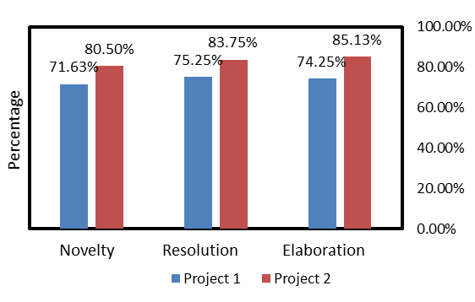

**Figure 20.** Students’ creativity result from Project 1 until Project 2

The Figure 20 shows an enhancement from Project 1 to project 2 in each creativity dimension. Novelty in Project 1 shows a score of 71.63% while Project 2 shows a score of 80.50%. Resolution on Project 1 showed a score of 75.25% while project 2 scored 83.75%, and the last elaboration on project 1 showed a score of 74.25% while Project 2 showed a score of 85.13%.

From Table 11 and Table 12, it can be seen that the average of project 1 and project 2 has also increased, Table 10 shows project 1 getting an average of 73.71% which is categorized as enough, then in Table 13 project 2 gets an average of 83.13%. which is categorized as good. This shows an increase of 9.42%.

These results are supported by research conducted by (D. H. Kim et al., 2014) that showed a significant improvement in students' creativity by using STEAM-based Learning. (S. W. Kim et al., 2012) research found that STEAM leads to processes that result in creativity, innovation, and continued growth and exploration of the world. Another study, conducted by (Lee & Recker, 2018) making a project with paper circuit can help students develop productive thinking skills related to various important computational concepts.

This increase occurred after students were given more suggestion by the teacher, then students tried to make new innovations that were more interesting than the projects they had previously designed. Previous research The Effect of STEAM-based Learning on Students’ Concept Mastery and Creativity in Learning Light and Optics from (Wandari et al., 2018) made a telescope and us CPSS to measure creativity in physics lessons (Light and Optics), in this research students who implemented STEAM project-based learning in the concept of light and optics have good creativity in the dimensions of novelty, resolution, and elaboration and synthesis. The difference is in this study after the students finish their project, the researcher gives a score with CPSS rubric to the project done by the student and find the average of the score, not made something significantly different. Based on research on STEAM education from the BERA Research Commissions (Colucci-Gray et al., 2017) which discussed examples of school science projects that successfully integrated art. However, it was noted that none of these projects were physics-based (Boyle, 2021). Therefore, this study used Art to increase student creativity. Some scholars use the term “Arts” as a synonym for project-based learning, technology-based learning, or design-based learning (Perignat & Katz-Buonincontro, 2019) and in this research STEAM education used is project-based learning and technology in the context of creativity and design (Aguilera & Ortiz-Revilla, 2021; Ozkan & Topsakal, 2019). STEAM education places a strong emphasis on the context in which the Engineering and Art process is developed, while STEM education tends to center more on the final products created by students (Aguilera & Ortiz-Revilla, 2021).

**4. CONCLUSION**

The findings of the study indicate that the implementation of STEAM Learning has proven to be immensely successful, with each meeting yielding a 100% success rate. Notably, Table 5 show Students' average improvement gain score in conceptual understanding was 19.60, increasing from 57.04 to 76.64. Based on the calculation the N-Gain is 0.43 which is categorized as medium (Meltzer, 2002). The score of sig. in pretest and posttest is not normal (sig.<0.05) then, the data analysis is continued to the nonparametric test. The nonparametric test was tested using the Willcoxon test, the results from the Willcoxon is.000. which the results show sig. <0.05, which means there is a significant difference between the pre-test and post-test result. This result suggests indicating that the STEAM Learning treatment is crucial in enhancing students' understanding of electricity.

For creativity, there was also an increase from each dimension of creativity. Table 4.7 shows project 1 getting an average of 73.71% which is categorized as enough, then in Table 4.10 project 2 gets an average of 83.13%. which is categorized as good. This shows an increase of 9.42%. It can be concluded Paper Circuit Project-based STEAM Learning can Enhance Student Understanding and Creativity in Electricity.

Same as Hypothesis Ha. there is significant difference of student’s understanding and creativity between before implementation and after implementation electricity material and made paper circuit project in STEAM learning. Overall, the study's outcomes demonstrate the effectiveness of STEAM Learning in improving students' comprehension and support its integration into the educational curriculum

**5. ACKNOWLEDGMENT**

The authors acknowledge principals one of Secondary School in Bandung and Cimahi who are already allowed to conduct research about STEAM project-based learning.

**REFERENCES**

Aguilera, D., & Ortiz-Revilla, J. (2021). Stem vs. Steam education and student creativity: A systematic literature review. *Education Sciences*, *11*(7). https://doi.org/10.3390/educsci11070331

Amabile, T. M. (2012). Componential Theory of Creativity. *Harvard Business School*, 1–10.

Anderson, L. W., & Krathwohl, D. R. (Eds. . (2001). *A Taxonomy for Learning, Teaching, and Assessing*. Addison Wesley Longman, Inc.

Anwari, I., Yamada, S., Unno, M., Saito, T., Suwarma, I. R., Mutakinati, L., & Kumano, Y. (2015). Implementation of authentic learning and assessment through stem education approach to improve students’ metacognitive skills. *K-12 STEM Education*, *1(3)*, 123–136.

Asghar, A., Ellington, R., Rice, E., Johnson, F., & Prime, G. . (2012). Supporting STEM Education in Secondary Science Contexts. *Interdiscip. J. Probl.-Based Learn*.

Bazler, J., & Sickle, M. V. (2017). Cases on STEAM education in practice. *IGI Global*. https://doi.org/10.4018/978-1-5225-2334-5

Besemer, S. P., & Treffinger, D. J. (1981). Analysis of Creative Products: Review and Synthesis. *The Journal of Creative Behavior*, *15*(3), 158–178. https://doi.org/10.1002/j.2162-6057.1981.tb00287.x

Boyle, J. (2021). Oceans of Inspiration: A Marine Based STEAM Project. *European Journal of STEM Education*, *6*(1), 15. https://doi.org/10.20897/ejsteme/11356

Cao, Y., & Brizuela, B. M. (2016). High school students’ representations and understandings of electric fields. *Physical Review Physics Education Research*.

Christine, V., & McDonald. (2016). STEM Education: A review of the contribution of the disciplines of science, technology, engineering and mathematics. *Science Education International*, *27*(4), 530–569.

Colucci-Gray, L., Trowsdale, J., Cooke, C. F., Davies, R., Burnard, P., & Gray, D. S. (2017). Reviewing the potential and challenges of developing STEAM education through creative pedagogies for 21st learning. *How Can School Curricula Be Broadened Towards a More Responsive, Dynamic, and Inclusive Form of Education?*, 1–105.

Connor, A. M., Karmokar, S., & Whittington, C. (2015). From STEM to STEAM: Strategies for enhancing engineering & technology education. *International Journal of Engineering Pedagogy*, *5(2)*, 37 – 47. https://doi.org/doi: 10.3991/ijep.v5i2.4458

Creswell, J. W., & Creswell, J. D. (2018). Research Design, Qualitative, Quantitative, and Mixed Methods Approachs, Second Edition. In *Sage Publications*. Sage Publications.

Davies, D., Jindal-Snape, D., Collier, C., Digby, R., Hay, P., & Howe, A. (2013). Creative learning environments in education-A systematic literature review. *Thinking Skills and Creativity*, *8*(1), 80–91. https://doi.org/10.1016/j.tsc.2012.07.004

Dawes, L., & Wegerif, R. (2004). *Thinking and learning with ICT: Raising achievement in primary classrooms*.

Farwati, R., Metafisika, K., Sari, I., Sitinjak, D., Solikha, D. F., & Putra, E. E. (2021). STEM Education Dukung Merdeka Belajar (dilengkapi dengan Perangkat Pembelajaran Berbasis STEM). *DOTPLUS*. https://books.google.co.id/books?id=TeIhEAAAQBAJ&hl=id&sitesec=reviews

Hanif, S., Wijaya, A. F. C., & Winarno, N. (2019). Enhancing Students’ Creativity through STEM Project-Based Learning. *Journal of Science Learning*, *2*(2), 50. https://doi.org/10.17509/jsl.v2i2.13271

Henriksen, D. (2014). Full STEAM Ahead: Creativity in Excellent STEM Teaching Practices. *STEAM Journal*, *1*(2), 1–9. https://doi.org/10.5642/steam.20140102.15

Kim, D. H., Ko, D. G., Han, M. J., & Hong, S. H. (2014). The Effects of science lessons applying STEAM education program on the creativity and interest levels of elementary students. *Journal of the Korean Association for Science Education*, *34 (1)*, 43–54.

Kim, S. W., Chung, Y. L., Woo, A. J., & Lee, H. J. (2012). Development of a theoretical model for STEAM education. *Journal of the Korean Association for Science Education*, *32*(2), 388–401.

Kokotsaki, D., Menzies, V., & Wiggins, A. (2016). Project-based learning: A review of the literature. *Improving Schools*, *19*(3), 267–277. https://doi.org/10.1177/1365480216659733

Lee, V. R., & Recker, M. (2018). Paper Circuits: A Tangible, Low Threshold, Low Cost Entry to Computational Thinking. *TechTrends*, *62*(2), 197–203. https://doi.org/10.1007/s11528-017-0248-3

Lindberg, L., Fields, D. A., & Kafai, Y. B. (2020). STEAM Maker Education: Conceal/Reveal of Personal, Artistic and Computational Dimensions in High School Student Projects. *Frontiers in Education*, *5*(May), 1–16. https://doi.org/10.3389/feduc.2020.00051

Meltzer, D. E. (2002). The relationship between mathematics preparation and conceptual learning gains in physics: A possible “hidden variable” in diagnostic pretest scores. *American Journal of Physics*, *70*(12), 1259–1268. https://doi.org/10.1119/1.1514215

Miller, J., & Knezek, G. (2013). STEAM for student engagement. *Proceedings of the SITE 2013*, 25–29.

Mulhall, P., McKittrick, B., & Gunstone, R. (2001). A Perspective on the Resolution of Confusions in the Teaching of Electricity. *Research in Science Education*.

Munandar, U. S. C. (1999). *Mengembangkan Bakat dan Kreativitas Anak Sekolah*. Gramedia Widiasarana Indonesia.

Ogunleye, J. (2018). *Creativity and innovation in STEM Education*. https://tinyurl.com/4ce4af7xOrnstein

Ozkan, G., & Topsakal, U. . (2019). Exploring the effectiveness of STEAM design processes on middle school students’ creativity. *Int. J. Technol. Des. Educ*.

Perignat, E., & Katz-Buonincontro, J. (2019). STEAM in practice and research: An integrative literature review. *Thinking Skills and Creativity*, *31*, 31–43. https://doi.org/10.1016/j.tsc.2018.10.002

Permanasari, A. (2016). STEM Education: inovasi dalam pembelajaran sains. *Seminar Nasional Pendidikan Sains VI*.

Purnamasari, I., Khasanah, I., & Wahyuni, S. (2020). Digital literacy for children based on steam in family education. *Journal of Physics: Conference Series*, *1464*(1). https://doi.org/10.1088/1742-6596/1464/1/012032

Purwanto, M. N. (2009). *Prinsip-prinsip dan Teknik Evaluasi Pengajaran*. Remaja Rosdakarya.

Rahmawati, Y., Adriyawati, Utomo, E., & Mardiah, A. (2021). The integration of STEAM-project-based learning to train students critical thinking skills in science learning through electrical bell project. *Journal of Physics: Conference Series*, *2098*(1). https://doi.org/10.1088/1742-6596/2098/1/012040

Riskawati. (2018). Uji Validitas dan Reliabilitas. *Jurnal Tarbiyah: Jurnal Ilmiah Kependidikan*, *7*(1), 1–10.

Sanders, M. (2009). STEM, STEM education, STEMmania. *The Technology Teacher*, 20–26.

Sani, A., Rochintaniawati, D., & Winarno, N. (2019). Using Brain-Based Learning to Promote Students’ Concept Mastery in Learning Electric Circuit. *Journal of Science Learning*, *2*(2), 42. https://doi.org/10.17509/jsl.v2i2.13262

Sigit, D. V., Ristanto, R. H., & Mufida, S. N. (2022). Integration of Project-Based E-Learning with STEAM: An Innovative Solution to Learn Ecological Concept. *International Journal of Instruction*, *15*(3), 23–40. https://doi.org/10.29333/iji.2022.1532a

Taylor, C. P. (2016). Why is a STEAM Curriculum Perspective Crucial to the 21st Century ? *14th Annual Conference of the Australian Council for Educational Research*, *August*, 89–93. https://link-springer-com.ezproxy1.library.usyd.edu.au/content/pdf/10.1007%2F978-94-007-2150-0_212.pdf

Wandari, G. A., Wijaya, A. F. C., & Agustin, R. R. (2018). The Effect of STEAM-based Learning on Students’ Concept Mastery and Creativity in Learning Light And Optics. *Journal of Science Learning*, *2*(1), 26. https://doi.org/10.17509/jsl.v2i1.12878

Wannapiroon, N., & Pimdee, P. (2022). Thai undergraduate science, technology, engineering, arts, and math (STEAM) creative thinking and innovation skill development: a conceptual model using a digital virtual classroom learning environment. *Education and Information Technologies*, *27*(4), 5689–5716. https://doi.org/10.1007/s10639-021-10849-w

Weibert, A., Aal, K., Wulf, V., & Masrhall, A. (2016). *Facilitating STEAM Learning among Children with Paper Circuit Activities*. McGraw-Hill.

White, D. W. (2014). What Is STEM education and why is it important? *Florida Association of Teacher Educators Journal*, 1–9.

Wittayakhom, N., & Piriyasurawong, P. (2020). Learning Management STEAM Model on Massive Open Online Courses Using Augmented Reality to Enhance Creativity and Innovation. *Higher Education Studies*, *10*(4), 44. https://doi.org/10.5539/hes.v10n4p44

Yasin, A. I., Prima, E. C., & Sholihin, H. (2018). Learning Electricity using Arduino-Android based Game to Improve STEM Literacy. *Journal of Science Learning*, *1*(3), 77. https://doi.org/10.17509/jsl.v1i3.11789

Yazici, B., & Yolacan, S. (2007). A comparison of various tests of normality. *Journal of Statistical Computation and Simulation*, *77*(2), 175–183. https://doi.org/10.1080/10629360600678310