SUBMISSION PREPARATION CHECKLIST
Please write a checklist (√) for this requirement and submit this file with the manuscript to Editor
Yes? (√) | Points to be fulfilled for Initial Review
√ | Manuscripts submitted for publication in JSL should be between 4,000 and 10,000 WORDS and typed in double spacing, including tables, figures, and references.
√ | The ABSTRACT should maintain a maximum of 250 WORDS.
√ | If you are from the university (Staff of Students), the affiliation must contain Department, Faculty, University, City, Country.
√ | State within 100 words regarding your CLEAR NOVELTY and your research contribution to the latest development of technology-integrated science learning, media, assessment, or curriculum.
√ | Please add rigorous literature reviews in the introduction
√ | The manuscript submission contains at least ONE FIGURE representing the flow or mechanism of the research
√ | Reformat Tables, Figures following the example in JSL Example
√ | All Figures and Tables caption must be cited in Text
√ | Provide minimum 25 references and written carefully without an error. Follow APA 6 rev for the reference style. Here is the guideline: https://apastyle.apa.org/style-grammar-guidelines/tables-figures/tables, https://oldi.lipi.go.id/public/APA-References.pdf
√ | All citations must be referenced
√ | All references must be cited in text
√ | Use Mendeley or Endnote to format the citations and references or see the example https://youtu.be/AlYndOezang
√ | The number must be set as international standard 0.1, not the Indonesian style number 0,1
√ | Provide more International Journals as references instead of books
√ | DISCUSSION PART must be SEPARATED from Conclusion. The manuscript Must Contain the CONCLUSION part.
√ | The author is REQUESTED to recommend 5 (FIVE) international peer reviewers during the submission: 1. Reviewer Names, 2. Institutions, Countries, 3. Emails, 4. Reasons. The suggested reviewer must be outside your institution. The author confirms that there is no conflict of interest regarding recommending reviewers. JSL has the authority to decide the reviewers from or outside recommended reviewers.

Feasibility of Class XII Enzyme and Cell Metabolism Material Booklet Media Based on Acute Toxicity Test of Zuriat Fruit Seed Extract

Ariesta Albriyanti¹, Ruqiah Ganda Putri Panjaitan^{1*}, Hayatul Fajri¹
¹Department of Biology Education, Faculty of Teacher Training and Education, Tanjungpura University, Pontianak, Indonesia
*Corresponding author: ruqiah.gpp@fkip.untan.ac.id

NOVELTY
This research is a test of the validity of the booklet media on enzymes and cell metabolism based on an acute toxicity test of zuriat seed extract which has never been carried out before. This research uses research and development methods (Sugiyono, 2017) as well as validation analysis using Content Validity Ratio and Content Validity Index (Lawshe, 1975). The results of this research provide information regarding the validity of booklet media that teachers can use as learning media in teaching and learning activities. This article is useful for teachers because it introduces booklet media based on the acute toxicity test of zuriat seed extract which can help students improve their understanding of concepts regarding enzymes and cell metabolism.

ABSTRACT
Learning media is a tool that makes it easier for educators to convey material to students effectively and efficiently in order to improve the quality of learning. Booklets are a medium that can make it easier for students to learn, they are small and attractive, practical, simple and easy to carry anywhere. This research aims to determine the suitability of booklet media for enzyme material and cell metabolism based on the acute toxicity test of zuriat seed extract. The stages of this research are determining potential and problems, collecting information, designing booklets, validating booklets, revising booklets, and making booklets. The initial stage of making the booklet is to carry out an acute toxicity test of zuriat seed extract and design the contents of the booklet. The suitability of the booklet is seen from the assessment carried out by 5 validators. The research instrument uses a validation sheet. The aspects assessed include aspects of format, content and language. The results of the research show that the value for the format aspect is 1, the value for the content aspect is 1, and the value for the language aspect is 1. The results of the validation show the CVI value is 1. It can be concluded that the class XII booklet on enzymes and cell metabolism is based on the acute toxicity test zuriat seed extract as a learning medium can be declared feasible.
Keywords: aspects, booklet, indicators, learning media, validation

1. Introduction
The learning process is an interaction between teachers and students in transferring and interpreting the experience and knowledge they have (Pane & Dasopang, 2017; Octiana et al., 2020). The biology learning transfer process runs optimally if it is supported by appropriate learning media and learning approaches (Octiana et al., 2020). An educator is required to be able to master methods and choose appropriate learning media, in order to support a quality learning process (Istiqlal, 2018; Shidiq & Faikhamta, 2020).
Learning media are tools that can help the teaching and learning process and function to clarify the meaning of the message conveyed so that learning goals can be achieved better and more perfectly (Kustandi & Sutjipto, 2013; Babincakova & Bernard, 2020). Learning media makes it easier for educators to convey material to students effectively and efficiently to improve the quality of learning (Hanum et al., 2017; Panjaitan et al., 2021). To achieve quality learning, the choice of learning media must be planned and determined carefully, and learning media can even be designed according to needs to solve learning problems (Panjaitan et al., 2021; Ramadhani et al., 2021).
According to Arsyad (2015) Learning media can be grouped into four groups, namely: media resulting from print technology, media resulting from audio-visual technology, media resulting from computer-based technology, media resulting from a combination of print and computer media. Print media is one of the commonly found learning media. Print media is visual media that is produced through a printing or offset process. According to Putri & Lasari (2023) The use of print media in the learning process can increase students' understanding and interest aimed at teachers and students in order to: (1) teachers have strategies and can also make the learning process enjoyable; (2) can provide motivation to students; (3) students receive varied material; (4) using media can also increase students' understanding; and (5) media as an alternative in learning activities.
Booklets are learning media in the form of prints or small books measuring 14.8 x 21 cm (A5) which contain specific information and are equipped with text, images, photos and color elements (Susilawati & Marlina, 2015). The advantage of booklet media is that it makes it easier for students to learn, because through this media students do not need to take notes on the material that has been presented by the teacher, its appearance is small and attractive, making booklets a practical, simple and easy medium to carry anywhere so they can be studied well at home or at school (Octiana et al., 2020). Several studies show that learning through the use of booklets can increase knowledge (Fitriani & Krisnawati, 2019; Yuliana, et al., 2019), improve learning outcomes (Mahendrani & Sudarmin, 2015; Yuliana, et al., 2019), foster student activity (Mahendrani & Sudarmin, 2015; Pralisaputri, et al., 2016), and increase communication effectiveness (Hapsari, 2013; Rehusisma, et al., 2017).
Based on the results of interviews with SMA Negeri 2 Mempawah, SMA Negeri 1 Sepauk, and SMA Karya Sekadau, these three schools still need effective and innovative learning media on class XII enzymes and cell metabolism because students do not understand and have difficulty remembering terms of science and cycles, and difficulty understanding the material. Nazarni (2020) who think that biology subjects, especially enzymes and cell metabolism, are difficult to understand. To be able to work on biology questions, it takes a long time because students have to read, understand and take notes carefully. Muspikawijaya et al. (2017) stated that students' low mastery of enzymes and cell metabolism is thought to be because students experience learning difficulties. Learning difficulties experienced by students have an impact on their ability to understand the material or concepts being taught.
Based on the description above, research was carried out which aimed to determine the feasibility of a booklet on enzymes and cell metabolism based on the acute toxicity test of zuriat fruit seed extract to increase the understanding of concepts for class XII students.

2. Method
Research into the feasibility of booklet media uses the Research and Development research and development method (Sugiyono, 2017) with the stages, namely potential and problems, information gathering, product design, design validation, design revision, and product creation (Figure 1). The information gathering stage carried out an acute toxicity test of zuriat fruit seed extract. From the information obtained, product design was carried out by determining the title of the booklet, analysis of competency standards (basic competencies, achievement indicators, and learning objectives), preparation of booklet components, editing process, and preparation of evaluation questions. Next, the design validation stage was carried out to determine the suitability of the booklet media. The validation of the booklet media was assessed by five validators based on their expertise in the field of biology and learning, using a validation sheet. The booklet media validation sheet consists of three aspects, namely format aspects, content aspects and language aspects.
Media validation data will be analyzed using the Content Validity Ratio (CVR) (Lawshe, 1975) with the following formula:
$$CVR=\frac{Ne-\frac{N}{2}}{\frac{N}{2}}$$
Information:
Ne : Number of validators who agree on the validity of the media (considered agreeing if the score for each aspect is 3 – 4. If < 3 then they are considered disagreeing)
N : The total number of validators or expert team
Provisions regarding the CVR index according to Lawshe (1975) are as follows:
1. When the number of respondents who agree or strongly agree is less than ½ of the total respondents, the CVR value = -
2. When the number of respondents who agree or strongly agree is ½ of the total respondents, the CVR value = 0
3. When all respondents agree or strongly agree, the CVR value = 1
4. When the number of respondents who agree or strongly agree is more than ¹/₂ of the total respondents, the CVR value = 1
After calculating the CVR value for each criterion, the CVI (Content Validity Index) value or the overall average CVR value is calculated. The CVI formula includes the following:
$$CVI=\frac{\sum{CVR}}{\sum{n}}$$
Information:
ƩCVR : total CVR value
Ʃn : number of items in all aspects
The criteria used in CVI are:
- If the CVI value is ≥ 0.99, the booklet media can be said to be valid
- If the CVI value is ≤ 0.99, the booklet media can be said to be invalid
If the media is said to be "valid" then the media is suitable for use, and if the media is said to be "invalid" then the media is not suitable for use.
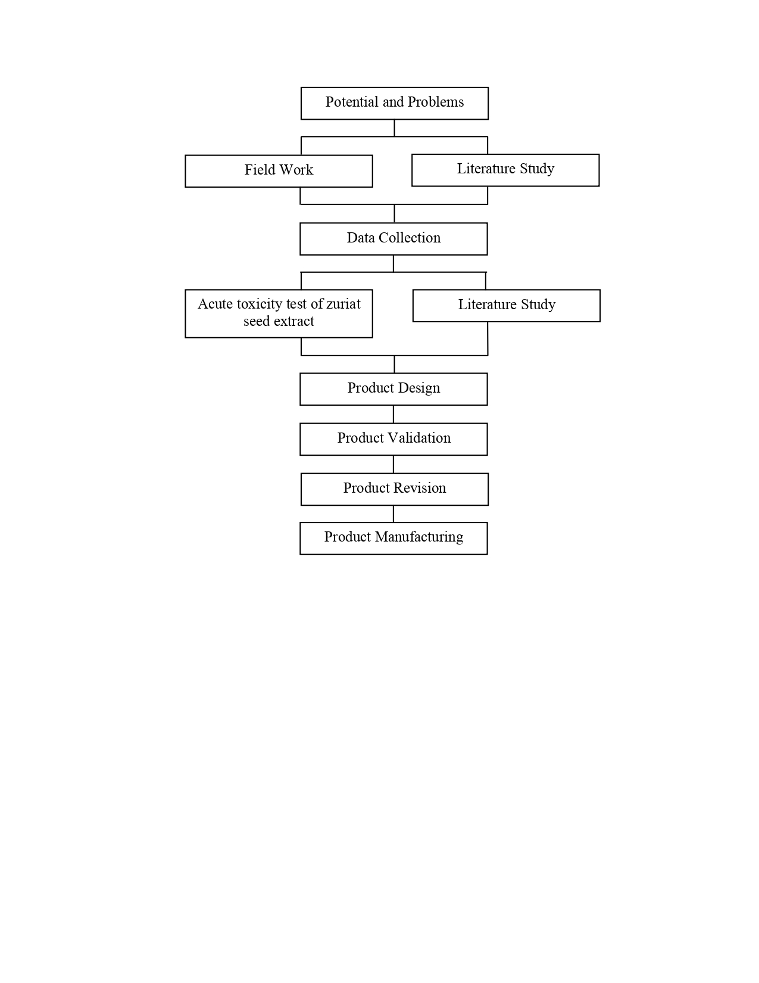
Figure 1 Research method scheme

3. Result and Discussion
Booklet media validation was carried out by five validators. The assessment of booklet media consists of four aspects, namely, format, content and language. Data from the validity analysis are presented in Table 1.
Table 1 Results of booklet media validity analysis
Aspect | Indicators | Validator |  |  |  |  | CVR | Information
Aspect | Indicators | 1 | 2 | 3 | 4 | 5 | CVR | Information
Format | 1. The attractiveness of the booklet cover design | 4 | 4 | 4 | 4 | 4 | 1 | Valid
Format | 2. Completeness of the booklet presentation | 4 | 4 | 4 | 4 | 4 | 1 | Valid
Format | 3. Clarity of images in booklet media | 3 | 4 | 3 | 3 | 4 | 1 | Valid
Format | 4. Suitability of booklet size | 4 | 4 | 4 | 3 | 4 | 1 | Valid
Format | 5. Clarity of letters in booklet media | 4 | 4 | 4 | 4 | 4 | 1 | Valid
Content | 1. Suitability of material with basic competencies, achievement indicators and learning objectives | 3 | 4 | 4 | 4 | 4 | 1 | Valid
Content | 2. Information on research results presented is in the form of toxicity of zuriat fruit seed extract | 3 | 4 | 4 | 4 | 4 | 1 | Valid
Content | 3. The presentation of material does not violate applicable laws | 4 | 4 | 4 | 4 | 4 | 1 | Valid
Content | 4. The information in the material is self contained | 3 | 3 | 3 | 4 | 3 | 1 | Valid
Language | 1. The language used in the booklet is correct | 3 | 3 | 4 | 4 | 3 | 1 | Valid
The value of CVI |  |  |  |  |  |  | 1 | Valid
Information:
- If the CVI value is ≥ 0.99, the booklet media is said to be valid
- If the CVI value is ≤ 0.99, the booklet media is said to be invalid
(Lawshe,1975)
The booklet media displays material on enzymes and cell metabolism in a concise and interesting manner, consisting of enzyme sub-material, understanding of acute toxicity tests, acute toxicity test methods, research results of acute toxicity tests, pictures of zuriat plants, taxonomic classification of zuriat plants, and descriptions of zuriat plants. Furthermore, the booklet media is also equipped with competency standards, evaluation questions, answer keys and a glossary. Booklets are learning teaching materials that are included in printed media, also called small books which contain information on a certain topic (Mahendrani & Sudarmin, 2015). The small shape makes the booklet easy to carry anywhere and the illustrations make it easy for students to use it during the learning process (Pralisaputri et al. 2016). Apart from that, users can view the contents at their leisure, information can be shared with family and friends, easy to create, reproduce and repair and easy to adjust, reduces the need to take notes, can be made simply at relatively low cost, is durable, has a wider capacity, and can be directed at certain segments (Hapsari, 2013).
Making this booklet learning media aims to make it easier for teachers to convey the content of the material and make it easier for students to receive the material presented by the teacher, especially regarding enzymes and cell metabolism. This booklet learning media has a concept that is simple, clear and easy to understand, and there are pictures supporting the material, attractive designs, colors that will increase students' interest.
Media suitability testing is the initial stage to determine its suitability for learning and the expected competencies. To determine the suitability of the booklet media, it is first validated by five validators. Booklet media consists of 10 indicators with 3 aspects, namely, format, content and language, including the following:

3.1 Format Aspect
Assessment of the first indicator, namely the attractiveness of the cover design of the booklet, obtained a CVR value of 1 in the valid category. This is in line with the statement of Muktaf (2016) It is believed that a book cover design must have distinctive characteristics that other cover designs do not have, by highlighting a certain theme and displaying images that match the content. Booklet media has three criteria, namely the booklet cover design uses more than three colors so it is varied, contains information, namely the title of the booklet, the name of the institution, the name of the booklet author, class and semester, and there are supporting images (Figure 2). As stated by Muswita et al. (2020) that the harmony of the combination of colors, letters and cover images can provide an overview of the content so that it can attract readers' interest.
Assessment of the second indicator, namely the completeness of the booklet presentation, obtained a CVR value of 1 in the valid category. This is in line with Daryanto's (2014) statement that the complete content of a teaching medium must be fully discussed through presentations, so that students feel they understand a particular field of study, so that it can increase students' motivation and enthusiasm in developing abilities and interacting directly with the environment. The booklet media has eleven criteria, namely a front cover, foreword, table of contents, competency standards, a description of the contents consisting of material on enzymes and cell metabolism, brief information about the zuriat plant, and the stages and results of the acute toxicity test of zuriat fruit seed extract, evaluation questions. , answer key, bibliography, glossary, index, and back cover.
Assessing the third indicator, namely the clarity of the images in the booklet media, a CVR value of 1 was obtained in the valid category. This is in line with Habibati's (2017) statement that clarity in image displays aims to ensure that learning material is conveyed effectively and efficiently. Students like interesting reading with a little description and lots of pictures or colors, so that it can help students absorb and understand the content of the material. Booklet media has three criteria, namely clear and colorful image display, the image displayed is appropriate to the material presented, and there is information explaining the image (Figure 3). According to Asyhar (2011) learning media must be good, clear and neat in presenting writing and images so that their function is maximum in learning.
Assessment of the fourth indicator, namely the suitability of the booklet size, obtained a CVR value of 1 in the valid category. This is in line with the statement by Susilana & Riyana (2018) that the booklet is in the form of a small book with dimensions of 14.8 x 21 cm (A5) and Dewi et al. (2020) that the number of booklet pages consists of 32 to 96 pages and the maximum is 100 pages. Booklet media has three criteria, namely booklets using A5 size paper (14.8 x 21 cm), portrait orientation and bound in book form, and booklet pages numbering less than 100.
Assessing the fifth indicator, namely the clarity of the booklet letters, obtained a CVR value of 1 in the valid category. This is in line with the statement of Panjaitan & Tenriawaru (2022), Rahma (2019), and Valentino (2019) that the suitability of the use of letters affects the readability of the media so that the media is easy for readers to read. The booklet has five criteria, namely selecting letters that are attractive, easy to read, the title uses the Book Antiqua font with a font size of 20, the subtitle uses the Book Antiqua font with a font size of 14, and the contents use the Book Antiqua font with a font size of 12.
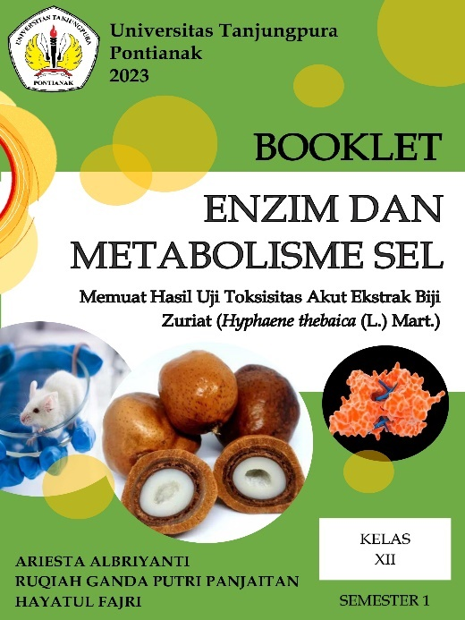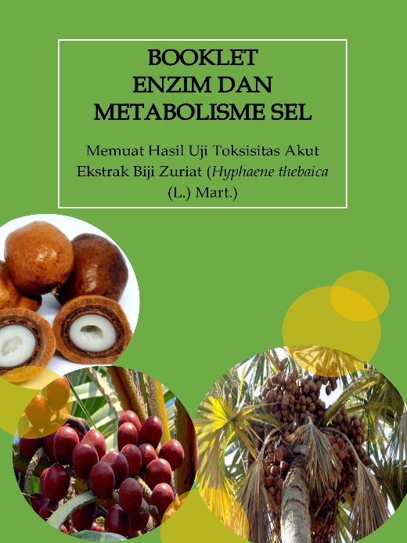
(a) Front cover (b) Back cover
Figure 2 Presentation of (a) front cover and (b) back cover on booklet media in Bahasa

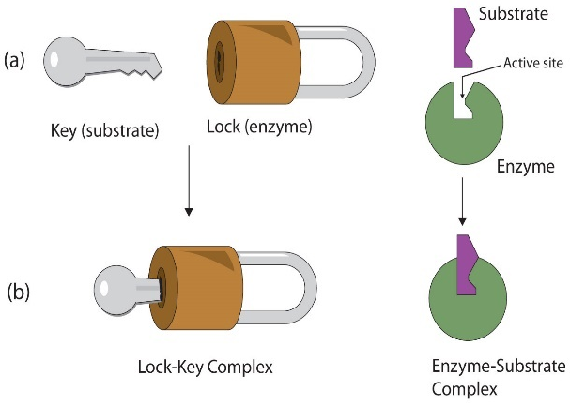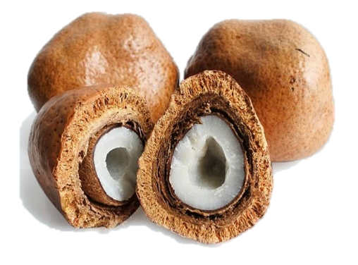
(a) Illustration of the lock and key theory (b) Zuriat fruit
Figure 3 Presentation of images (a) illustration of lock theory with key and (b) image of zuriat fruit on booklet media

3.2 Content Aspect
Assessment of the first indicator, namely the suitability of the material with basic competencies, achievement indicators and learning objectives, obtained a CVR value of 1 in the valid category. This is in line with the statement by Babincakova & Bernard (2020) and Susilana & Riyana (2018) that competency achievement indicators are formulated based on basic competencies and learning objectives are formulated based on competency achievement indicators. Booklet media has three criteria, namely the material in the booklet is in accordance with basic competencies, achievement indicators and learning objectives. The booklet is arranged according to achievement indicators and learning objectives so that students after completing the booklet can understand the material on enzymes and cell metabolism according to basic competency 3.2. Achievement indicators and learning objectives are then described in a description of the material which is equipped with examples and pictures to clarify the concept of enzymes and cell metabolism (Figure 4).
Assessment of the second indicator, namely information on research results presented in the form of toxicity of zuriat seed extract, obtained a CVR value of 1 in the valid category. This is in line with the statement of Djannah et al. (2020) and Wulandari et al. (2020) that the completeness of the information that has been presented can support the explanation of concepts so that they become clearer, so that the material can be conveyed well. Booklet media has three criteria, namely the information presented is useful, in the form of new knowledge, and presented in sentences that are easy to understand. Addition of information on the results of toxicity tests on zuriat seed extract as a way to introduce natural potential to students so they can find out the potential that exists around them.
Assessing the third indicator, namely that the material presented does not violate applicable legislation, a CVR value of 1 is obtained in the valid category. This is in line with Kallang's (2017) statement that education must be based on certain foundations or principles, because education is the main pillar in the development of humans or national society. Booklet media has three criteria, namely the material or content in the booklet does not give rise to ethnic, religious, racial and inter-group (SARA) problems, the material or content does not contain pornography, the material or content in the booklet does not present anything that discriminates, biases and discredits other types of media, male or female (gender), region or region, profession, etc. (Figure 5). All aspects of education in the booklet media are in accordance with the legal basis and applicable legislation, so that it does not cause SARA problems, pornography and discrimination, in accordance with Law No. 20 of 2003 concerning the National Education System Article 4 paragraph 2 which reads "Education is carried out democratically and fairly and is not discriminatory by upholding human rights, religious values, cultural values and national pluralism".
Assessment of the fourth indicator, namely the information in the material is self-contained, obtained a CVR value of 1 in the valid category. This is in line with Djono's (2023) statement that teaching materials must be self-contained (complete and coherent material) because they present complete learning material to provide opportunities for students to learn. Booklet media has three criteria, namely presenting information in the form of enzymes and cell metabolism, in accordance with achievement indicators and learning objectives, and in accordance with the material presented. Self-contained aims to present complete enzyme and cell metabolism material, so that students can study the complete description of enzyme and cell metabolism material.
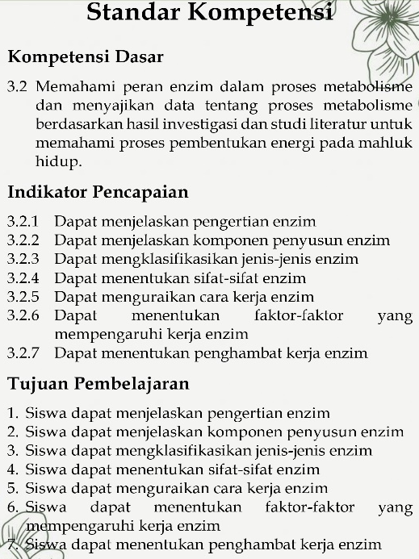
Figure 4 Presentation of competency standards in booklet media

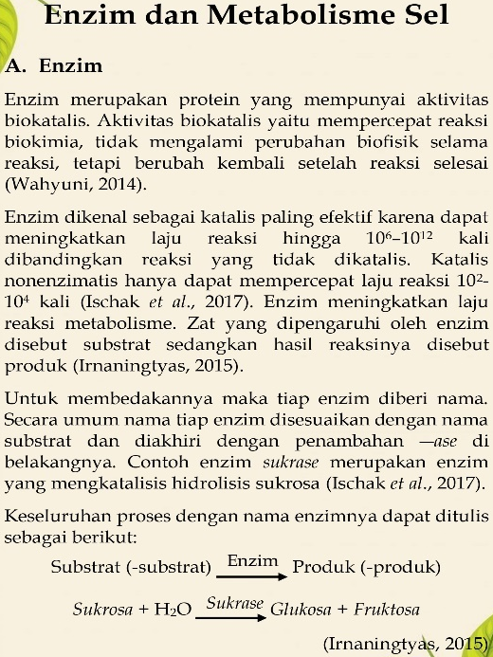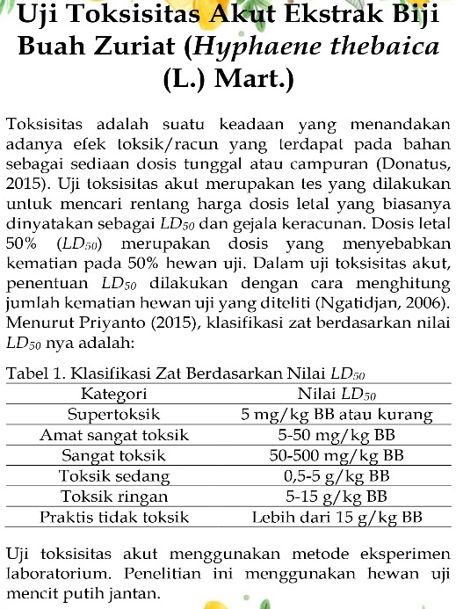
(a) Learning materials (b) Research results
Figure 5 Presentation of learning materials and (b) research results in booklet media

3.3 Language Aspects
The assessment of the first indicator, namely the language used in the booklet, was correct, a CVR value of 1 was obtained in the valid category. This is in line with the statement of Panjaitan et al. (2021), Panjaitan et al. (2022), and Harahap et al. (2020) that a good booklet must meet the rules of Enhanced Spelling, have letters that are easy to read, not create duplicate information, and overall be easy for students to understand. Booklet media has five criteria, namely in accordance with the KBBI (Big Indonesian Dictionary), using effective sentences, the spelling used refers to the provisions of Enhanced Spelling (EYD), the language used is clear and easy to understand, and does not give rise to multiple interpretations (Figure 5) .
The average total validation (CVI) results of the enzyme booklet media and cell metabolism were obtained with a value of 1 in the valid category. Based on the validation results, with the criteria used referring to Lawshe (1975), the total validation average was declared valid so that by presenting information on research results on the toxicity test of zuriat seed extract it was suitable to be used as a learning medium for class XII enzymes and cell metabolism material.

4. Conclusions
The class XII enzyme and cell metabolism material booklet based on the acute toxicity test of zuriat seed extract received a score for the format aspect, namely 1, the value for the content aspect is 1, the value for the language aspect is 1, and the CVI value is 1, so that the booklet can be declared suitable as a learning medium.

References
Arsyad, A. (2015). Media pembelajaran. Jakarta: PT. Raja Grafindo Persada.
Asyhar. (2011). Kreatif mengembangkan media pembelajaran. Jakarta: Gaung Persada.
Babincakova, M., & Bernard, P. (2020). Online experimentation during covid-19 secondary school closures: teaching methods and student perceptions. Journal of Chemical Education, 97(9), 325-3300.
Daryanto, D. (2014). Pendekatan pembelajaran saintifik kurikulum 2013. Yogyakarta: Gava Media.
Djannah, S. N., Sulistyawati., Sukesi, T. W., Mulasari, S. A., & Tentama, F. (2020). Audiovisual media to improve sexual-reproduction health knowledge among adolescent. International Journal of Evaluation and Research in Education, 9(1), 138-143.
Djono. (2023). Persepsi guru terhadap bahan ajar sejarah sekolah menengah atas. DWIJA CENDEKIA: Jurnal Riset Pedagogik, 7(1), 59-69.
Dewi, B., Hamidah, A., & Sukmono, T. (2020). Pengembangan booklet keanekaragaman kupu-kupu di Kabupaten Kerinci dan sekitarnya sebagai sumber belajar pada materi animalia kelas X SMA. BIODIK: Jurnal Ilmiah Pendidikan Biologi, 6(04), 492-506.
Fadli, R., Sartono, N., & Suryanda, A. (2017). Pengembangan kamus berbasis sistem operasi telepon pintar pada materi biologi SMA kelas XI. Jurnal Pendidikan Matematika dan IPA, 8(2), 10–17.
Fitriani, L. & Krisnawati, Y. (2019). Pengembangan media booklet berbasis keanekaragaman jenis jamur makroskopis. Bioedusains: Jurnal Pendidikan Biologi dan Sains, 2(2), 143– 151.
Habibati. (2017). Strategi embelajaran. Banda Aceh: Syiah Kuala Universitas Press.
Hanum, L., Ismayani, A., & Rahmi, R. (2017). Pengembangan media pembelajaran buletin pada materi hukum-hukum dasar kimia kelas X SMA/MA di Banda Aceh. JIPI (Jurnal IPA dan Pembelajaran IPA), 1(1), 42-48.
Hapsari, C. M. (2013). Efektivitas komunikasi media booklet “anak alami” sebagai media penyampai pesan gentle birthing service. Jurnal E-Komunikasi, 1(3), 264–275.
Harahap, I. A., Helendra., Farma, S. A., & Syamsurizal. (2020). Validity of the human respiratory system booklets as learning suplement for student class VIII junior high school. Bioeducation Journal, 4(2), 103-110.
Istiqlal, A. (2018). Manfaat media pembelajaran dalam proses belajar dan mengajar mahasiswa di perguruan tinggi. Jurnal Kepemimpinan dan Pengurusan Sekolah, 3(2), 139–144.
Kallang, A. (2017). Hubungan pendidikan dan hukum dalam mensejahterakan manusia. Ekspose, 16(2), 502-412.
Kustandi, C., & Sutjipto, B. (2013). Media pembelajaran: manual dan digital. Bogor: Ghalia Indonesia.
Lawshe, C. H. (1975). A Quantitative approach to content validity. Personnel Psychology, 28(4), 563-575.
Mahendrani, K., & Sudarmin. (2015). Pengembangan booklet etnosains fotografi tema ekosistem untuk meningkatkan hasil belajar pada siswa SMP. Unnes Science Education Journal, 4(2), 865–872.
Muktaf, Z. M. (2016). Proses kreatif desain sampul buku dalam membangun brand positioning. Seminar Nasional 2016 Fakultas Ilmu Sosial dan Ilmu Politik. Universitas Muhammadiyah Ponorogo, Jawa Timur.
Muspikawijaya., Iswari, S. R., & Marianti, A. (2017). Analisis kesulitan peserta didik SMA/MA Kabupaten Luwu Timur dalam memahami konsep pada materi metabolisme sel. Journal of Innovative Science Education, 6(2), 252-263.
Muswita., Yelianti, U., Intan, A., & Kusuma, L. (2020). Pengembangan booklet tumbuhan paku di Taman Hutan Raya Sultan Thaha Syaifuddin sebagai bahan pengayaan mata kuliah taksonomi tumbuhan. Biodik: Jurnal Ilmiah Pendidikan Biologi, 6(1), 58–75.
Nazarni. (2020). Upaya meningkatkan hasil belajar siswa kelas XII IPA-4 materi enzim dan metabolisme sel pelajaran biologi melalui model pembelajaran talking stik pada SMA Negeri 1 Sigli Kabupaten Pidie. Serambi Akademica: Jurnal Pendidikan, Sains, dan Humaniora, 8(8), 1406-1417.
Nuraini., & Waluyo, E. (2021). Pengembangan desain instruksional model project based learning terintegrasi keterampilan proses sains untuk meningkatkan literasi sains. JIPI (Jurnal IPA dan Pembelajaran IPA), 5(1), 101-111.
Octiana, N., Darussyamsu, R., Yogica, R., & Syamsurizal. (2020). Validitas booklet pada materi pola pewarisan sifat pada hukum mendel sebagai suplemen pembelajaran genetika di SMA. Atrium Pendidikan Biologi: Jurnal Pendidikan Biologi, 5(3), 1-6.
Pane, A., & Dasopang, M. D. (2017). Belajar dan pembelajaran. Fitrah: Jurnal Kajian Ilmu-Ilmu Keislaman, 3(2), 333-352.
Panjaitan, R. G. P., Titin., & Wahyuni, E. S. (2021). Kelayakan booklet inventarisasi tumbuhan berkhasiat obat sebagai media pembelajaran. Jurnal Pendidikan Sains Indonesia, 9(1), 11-21.
Panjaitan, R. G. P., & Tenriawaru, A. B. (2022). Kelayakan media booklet sawi dayak (Elephantopus mollis Kunth) pada pembelajaran biologi mahasiswa. Jurnal Pendidikan Sains Indonesia, 10(4), 740-751.
Panjaitan, R. G. P., Titin., & Wahyuni, E. S. (2022). Kelayakan media pembelajaran booklet buah Hyphaene thebaeca (L.) Mart. Jurnal Pendidikan Sains Indonesia, 10(1), 125-137.
Pralisaputri, K. R., Soegiyanto, H., & Muryani, C. (2016). Pengembangan media booklet berbasis sets pada materi pokok mitigasi dan adaptasi bencana alam untuk kelas X SMA. Jurnal GeoEco, 2(2), 147-154.
Putri, A. D., & Lasari, Y. L. (2023). Analisis media pembelajaran berupa media cetak terhadap minat belajar siswa pada pembelajaran IPS. JUARA SD: Jurnal Pendidikan dan Pembelajaran Sekolah Dasar, 2(2), 214-220.
Rahma, F. I. (2019). Media pembelajaran (kajian terhadap langkah-langkah pemilihan media dan implementasinya dalam pembelajaran bagi anak SD. Pancawahana: Jurnal Studi Islam, 14(2), 87-99.
Ramadhani, A. R. D., Asri, M. T., & Purnama, E. R. (2021). Profil dan validitas secara teoritis booklet materi sel untuk meningkatkan pemahaman konsep peserta didik kelas XI SMA. BioEdu, 10(2), 275-282.
Rehusisma, L. A., Indriwati, S. E., & Suarsini, E. (2017). Pengembangan media pembelajaran booklet dan video sebagai penguatan karakter hidup bersih dan sehat. Jurnal Pendidikan: Teori, Penelitian, dan Pengembangan, 2(9), 1238–1243.
Shidiq, G. A., & Faikhamta, C. (2020). Exploring the relationship of teachers’ attitudes, perceptions, and knowledge towards integrated STEM. Elementary Education Online, 19(4), 2514–2531.
Sugiyono. (2017). Metode penelitian dan pengembangan. Bandung: Alfabeta.
Susilana, R., & Riyana, C. (2018). Media pembelajaran: hakikat, pengembangan, pemanfaatan, dan penilaian. Bandung: CV Wacana Prima.
Susilawati, N., & Marlina, R. (2015). Kelayakan media booklet etnobotani di Desa Arus Deras pada subkonsep manfaat keanekaragaman hayati SMA. Jurnal Pendidikan dan Pembelajaran, 5(1), 1-13.
Valentino, D. E. (2019). Pengantar tipografi. TEMATIK: Jurnal Teknologi Informasi dan Komunikasi, 6(2), 152-173.
Wulandari, Y., Ruhiat, Y., & Nulhakim, L. (2020). Pengembangan media video berbasis powtoon pada mata pelajaran IPA di kelas V. Jurnal Pendidikan Sains Indonesia, 8(2), 269-279.
Yuliana., Muldayanti, N. D., & Kahar, A. P. (2019). Studi komparasi media pembelajaran booklet berbasis sikap konservasi dan media gambar terhadap hasil belajar pada materi keanekaragaman hayati di SMA/MA Kecamatan Rasau Jaya. Jurnal Bioeducation, 6(2), 50–54.

Article reviewer recommendations:
- Name : Anita Raharjeng
Institution, Country : UIN Raden Fatah Palembang, Indonesia
Email : anitaraharjeng_uin@radenfatah.ac.id
Reason : Because it fits the field of study
- Name : Ilmi Zajuli Ichsan
Institution, Country : Pendidikan Guru Sekolah Dasar, Fakultas Keguruan dan Ilmu Pendidikan, Universitas Mohammad Husni Thamrin, Indonesia
Email : ilmizajuli95@gmail.com
Reason : Because it fits the field of study
- Name : Galih Albarra Shidiq
Institution, Country : Department of Science Education, Faculty of Education, Kasetsart University, Bangkok, Thailand, Indonesia
Email : galihalbarra1@gmail.com
Reason : Because it fits the field of study
- Name : Much. Fuad Saifuddin
Institution, Country : Pendidikan Biologi Universitas Ahmad Dahlan, Indonesia
Email : fuad.saifuddin@pbio.uad.ac.id
Reason : Because it fits the field of study
- Name : Fitmawati
Institution, Country : Biologi-FMIPA, Universitas Riau, Indonesia
Email : fitmawati2008@yahoo.com
Reason : Because it fits the field of study

