Validity and Reliability Test (Supporting Table 1,2,3,4 & 5)
(Self-directed Learning) Validity and Reliability Test

- Validity
CORRELATIONS
/VARIABLES=Soal_1 Soal_2 Soal_3 Soal_4 Soal_5 Soal_6 Soal_7 Soal_8 Soal_9 Soal_10 Soal_11 Soal_12 Soal_13 Soal_14 Soal_15 Total
/PRINT=TWOTAIL NOSIG
/MISSING=PAIRWISE.
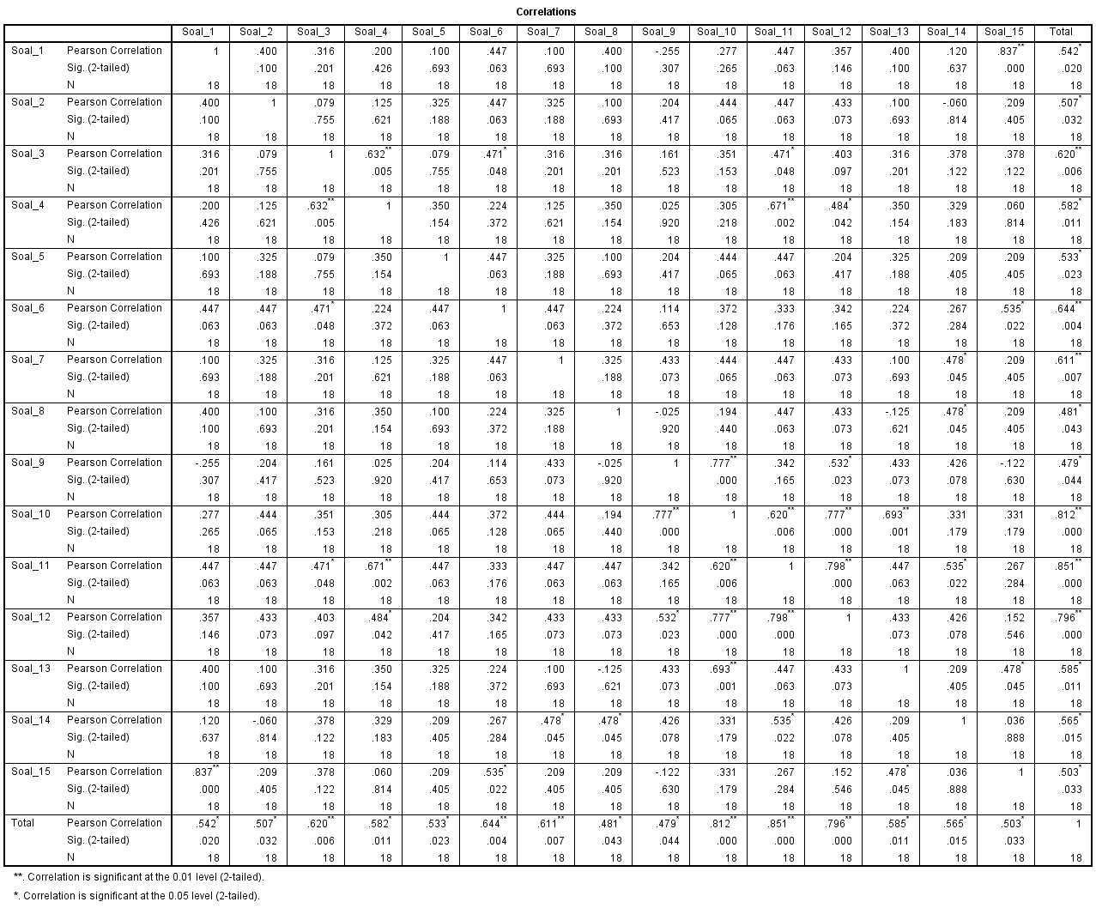
To find out the question item is valid by looking at the corrected item total correlation value. If the question item has r count greater than r table, it is said to be VALID. The amount of r table for question items 18 respondents, the amount of df = N-2, namely df = 18-2 = 16 which is 0.4683. So, valid question items have a calculated r value greater than 0.4683.
From the results of the SPSS output, the validity of the above questions to measure student SRL on 15 question items is declared VALID. Because 15 question items have a calculated r value greater than 0.4683.

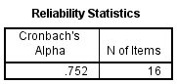
While a question item is said to be reliable if it provides a Cronch alpha value of more than 0.70.
From the results of SPSS output, the validity consisting of 15 question items to measure students' SRL is declared RELIABLE because the resulting Cronch alpha value is 0.752.

So, 15 question items are appropriate to be used as instruments in research.

