Computer Assisted Teaching in Scince Education: A Bibliometric Overview
ABSTRACT
The aim of this study is to examine the studies on computer assisted teaching in science teaching in terms of different variables with bibliometric analysis. Scopus database was used to collect the data. The phrase “science education and computer assisted teaching” was written in Scopus on 11_07_2023 and a total of 1232 publications were found. Since not all of the data is related to computer-assisted teaching in science education, the Scopusta Social Science section was selected and filtered, and a total of 454 publications were subjected to bibliometric analysis. VOSviewer program was used for bibliometric analysis. As a result of the research, the most studies on computer-assisted teaching in science education were done in 2010, the most articles were preferred as document type, the most frequently used keyword was computer-assisted instruction, the country with the most publications was United Stataes, and the most cited publication was Leidner,d.e ; Jarvenpaa s.l. (1993) and the most frequently used term is student.
Key words: Computer assisted teaching, Bibliyometrik Analiz, VOSviewer Scopus

1. INTRODUCTİON
In today's information age, the increase in the knowledge produced day by day and the number of students per teacher have caused many problems in the education process. However, the inclusion of new technologies, which have an important place in the development of quality in education, has become mandatory (General, 1998; Akçay et al., 2005). New technologies have added computers to the education process as an effective communication and individual teaching tool. With the involvement of the computer in this process, the term "Computer Assisted Instruction" has emerged (Guven & Sülün, 2012). Computer-assisted instruction (CAI), in which students interact with programmed learning materials using computers; In other words, it is a form of teaching in which students learn through computer programs, monitor their learning and evaluate themselves (Senemoğlu, 2001; Bayturan, 2011). In another definition, the CAI method is the use of computer technology and related hardware and software in educational activities in various dimensions in line with certain goals (Delikara, 2022).
Most educators say that computer technology helps teachers to provide students with effective and efficient opportunities to learn the products and processes of science (Weller, 1996). Computer-assisted instruction actively involves individuals in learning and helps students learn at their own pace. It also offers students the opportunity to learn through simulations, without destroying themselves and the laboratory, and by eliminating complex problems that are too costly or impossible (Chambers & Sprecher, 1980). At the same time, most educators see student practice in teaching with computers as an important element in developing psychomotor and cognitive skills (Holman, 2000).
Science is a natural science. Understanding and interpreting the environment in which people live is the essence of knowledge and skills that trigger the idea of seeking regularity in this complex environment (Hançer et al., 2003). Many subjects in science courses have a complex, abstract and dynamic structure. Difficulties are encountered in obtaining and transferring information by students on such subjects. In order for individuals to appeal to most sense organs, various materials such as pictures, sounds, graphics, animations must be used individually or together. This situation is very important in terms of conveying the subjects in an understandable way (Kahyaoğlu, 2011; Ergüzeloğlu & Kaplan, 2021). Computer-assisted teaching is of great importance at this point. What is intended to be taught in science education may not always be learned by experience. However, thanks to computer-assisted teaching, existing situations can be shown to individuals and they can be involved in the event as if they had experienced it (Kurt, 2006; Okur & İnal, 2010).
Bibliometric analysis is an approach that uses quantitative methods to monitor, measure, monitor and analyze scientific literature (Roemer & Borchardt, 2015). Bibliometric research is based on analyzing certain features of publications or documents and obtaining data related to the scientific side of communication (Al & Coştur, 2007; Yılmaz, 2017). In the literature, there are bibliometric researches (Zeren & Kaya, 2020), which is a method that is used in many areas in many areas. When the relevant literature is examined, when the bibliometric studies in the field of science education are examined, some of these studies are as follows; Yurdakul and Bozdoğan (2022) examined the bibliometric analysis of science education articles in the WoS database in their study. Özkaya (2019) examined the bibliometric analysis of scientific research published on STEM education in his study. Effendi et al., (2021) carried out a bibliometric analysis of scientific literacy studies in the field of science education. Maryanti et al., (2022) aimed to find sustainable development goals in science education from bibliometric analysis in their study. Chiu et al., (2022) conducted a bibliometric analysis of the roles, applications and research designs of robots in journal publications in science education from 1996 to 2020. When the literature is examined, no research has been found that provides bibliometric analysis of research tendencies in documents related to computer assisted teaching in science education. For this reason, this study is very important for a researcher who wants to do computer-assisted teaching in the field of science education to have knowledge about research. In addition, it is very important to follow the technology of the age in science education, because the education to be given to the students should be in accordance with the characteristics of the age. For this reason, the advantages of computer-assisted work in science education should be extensively researched, developments in this field should be followed by considering the importance of these benefits, and deficiencies should be eliminated as much as possible (Yumuşak & Aycan, 2002). This study provides an overview and an effective understanding of the current state of the literature on computer-assisted teaching in science education. The aim of this study is to examine the studies on computer-assisted teaching in science teaching in terms of different variables with bibliometric analysis. In line with the purpose of the research, answers to the following questions were sought.

- What is the distribution of research on computer assisted- teaching in science education according to document type and years?
- What is the distribution of research on computer assisted teaching in science education according to the preferred keywords?
- What is the distribution of research on computer assisted- teaching in science education by country?
- What is the distribution of research on computer assisted teaching in science education according to the authors?
- What is the distribution of researches on computer assisted teaching in science education according to terms?

2. METHOD
In this study, bibliometric analysis method was used to examine the studies published on computer assisted teaching in science education between 1973-2023. With bibliometric analysis research, which is a method used to determine the extent to which scientific communication tools are used, publications or documents are examined in terms of certain characteristics and findings related to scientific communication are obtained. Thanks to the bibliometric study; It is possible to statistically analyze data such as subject, author, cited author, cited sources, and to reveal the general structure of a particular field thanks to the statistical results obtained (Bozkurt & Çetin, 2016). Especially in recent years, bibliometric analysis has become an important part of research evaluation method and is widely used in scientific and applied fields (Tekin, Öztürk & Bahar,2021). Bibliometric analysis was preferred in this study as the relationships between authors, journals, countries and institutions are determined by visualizing thanks to bibliometric analysis (Van Eck & Waltman, 2010). In addition, the fact that the temporal and holistic plane, which is difficult to understand due to the ever-increasing development of the literature on computer-assisted teaching in science education, will be summarized in an understandable way under one title, which is another reason why bibliometric analysis is preferred in this study.In order to understand the literature on computer assisted teaching in science education in detail, publications in the Scopus database were examined in this study. The following steps were followed during data collection and analysis (Figure 1)

Figure 1 Data collection and analysis steps

3. FİNDİNGS AND DİSCUSSİON
3.1. Distribution of Documents by Types and Years
As a result of the analysis made within the scope of the research, the distribution of documents related to computer assisted learning in science education is shown in Graph 1. According to the graph, 378 of the documents were articles (72.2%), 75 of them were Conference Paper (16.5%), 34 of them were Review (7.5%), 8 of them were Conference Review (1.8%), 6 of them Book Chapter (1.3%), 2 of them are of book (0.4%) and 1 of them are of note (2%). Bozdoğan (2019) states in his study that articles are the most preferred publication type because they provide concrete data in determining the productivity and academic activities of scientists (Bozdoğan, 2019; cited by Yurdakul & Bozdoğan, 2022). The data of scientific studies on computer-assisted learning in science education by years are given in Graph 2.When Graph 2 is examined, it is seen that the highest number of studies on computer assisted learning in science education was done in 2010 with 33 studies. It is seen that there is a continuous fluctuation in the number of studies between 1973 and 2023. In addition, the decrease in the number of studies from 2018 to 2022 is remarkable. It can be said that the decrease in the number of studies conducted in these years is due to the pandemic. As a matter of fact, the COVID-19 epidemic, which started in December 2020 and the first death worldwide was on January 11, 2020, was declared as a global epidemic (pandemic) by the World Health Organization (WHO) on March 11, 2020 (Karataş, 2020). When we look at the literature, there are similar studies supporting this finding. For example; Otluoğlu et al., (2021), stated in their study that conducting research and publishing during the pandemic period became difficult for academic mothers, and that the increase in inequalities in housework and child care caused academic inefficiency by inhibiting the productivity of academic mothers. In his research, Erkal (2021) examined the effect of academics' absence from the workplace during the Covid 19 epidemic in terms of emotional exhaustion, decline in success and depersonalization, and stated that academics were emotionally exhausted when faced with the problem of not being able to go to work in this period.
Since the study data were obtained in July 2023, the available data are limited to July 2023. The fact that 2023 has not been completed can be seen as a reason for the low number of studies in that year.

Graph1 Distribution of Documents by Types of publication

Graph2 Distribution of documents by year of publication

3.2. Keyword analysis: Core content of a research
In order to determine the top 10 most used keywords out of 454 publications obtained in the search, at least 11 or more keywords were included in the analysis. The 10 most used keywords out of 1066 keywords were reached (Table 1). The most used keywords are “computer-assisted instruction” followed by “e-learning”, “education - computer assisted”. The preferred keywords give important ideas about the content of the research, the sample level and the computer-assisted teaching method used in the research. Looking at the results of the systematic search conducted in the past years, it has been seen that the software used among the keywords is less included. This situation can be interpreted as less space is given to the software/technology used in the researches conducted in the past years (Aldemir & Tatar, 2014; Battal & Caliskan, 2021).
For keyword analysis, 1066 keywords were included in the sample visualizations created with VOSviewer (Figure 2).
Tablo 1 Most common keywords for computer assisted instruction in science education
Keyword | Occurrences | Total Link Strength
computer-assisted instruction | 26 | 16
e-learning | 24 | 10
education - computer assisted | 19 | 0
education | 18 | 6
dental education | 17 | 10
educational technology | 15 | 11
technology | 14 | 3
medical education | 13 | 7
blended learning | 11 | 3
curriculum | 11 | 6

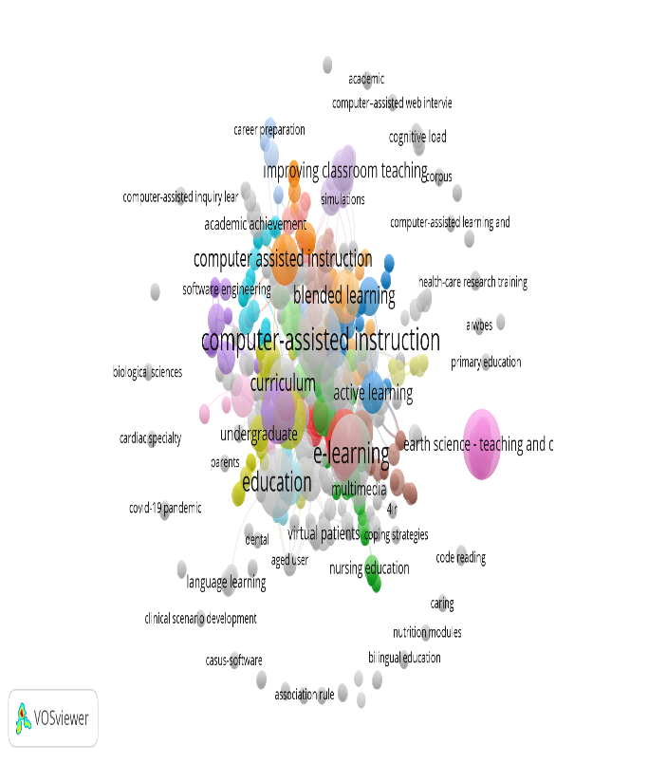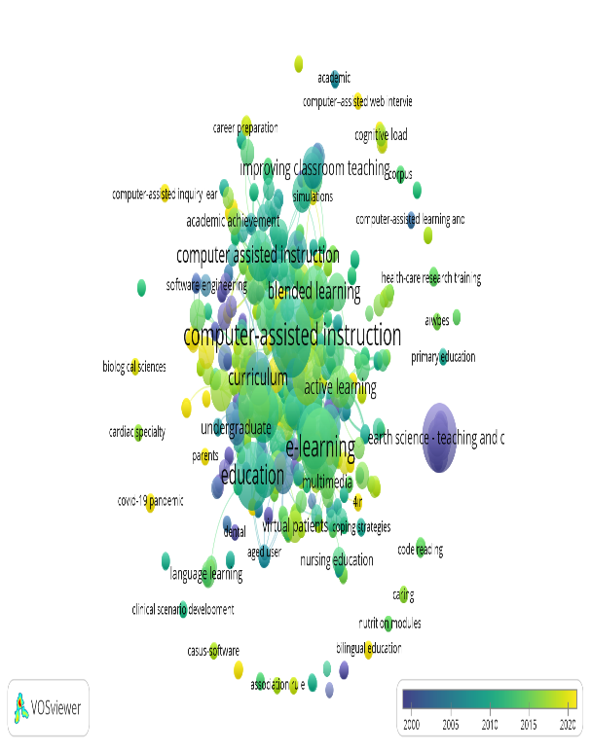
A B
Figure 2 Keyword map and temporal trend of computer assisted instruction in science education
When the visual relationship network map in Figure 2 (A) is examined, a total of 1066 keywords were used in studies on computer-assisted teaching in science education, and there are 74 interrelated clusters and 3739 links within these keywords. The size of the circle shows the excess usage of the keywords, the colors of the circles show which keywords are used together, and the lines between the circles show the relationship between the keywords (Bulut and Demirel Province, 2022). The first 3 words that stand out on the visual map; The computer-assisted instruction is designated as education - computer assisted, e-learning. According to Figure 2 (B), it is understood that there are more relatively new study subjects as it goes from blue to yellow. Accordingly, it can be said that stem, human computer interaction, biological sciences, covid 19 pandemic have been used in recent years.

3.3. Spatial distribution: Top broadcasting countries
According to the findings, 78 countries have published documents on computer assisted teaching in science education. Keywords used at least 7 times or more were included in the analysis to determine the 10 countries with the most publications out of 454 publications obtained as a result of the search from the Scopus database, and 10 countries were reached.. (Table 2).
Table 2 Countries with the most publications on computer-assisted teaching in science education
Country | Documents | Citations
united states | 161 | 2891
united kingdom | 50 | 857
australia | 31 | 700
canada | 29 | 881
turkey | 20 | 489
germany | 17 | 578
taiwan | 17 | 424
china | 14 | 75
netherlands | 9 | 324
spain | 8 | 128

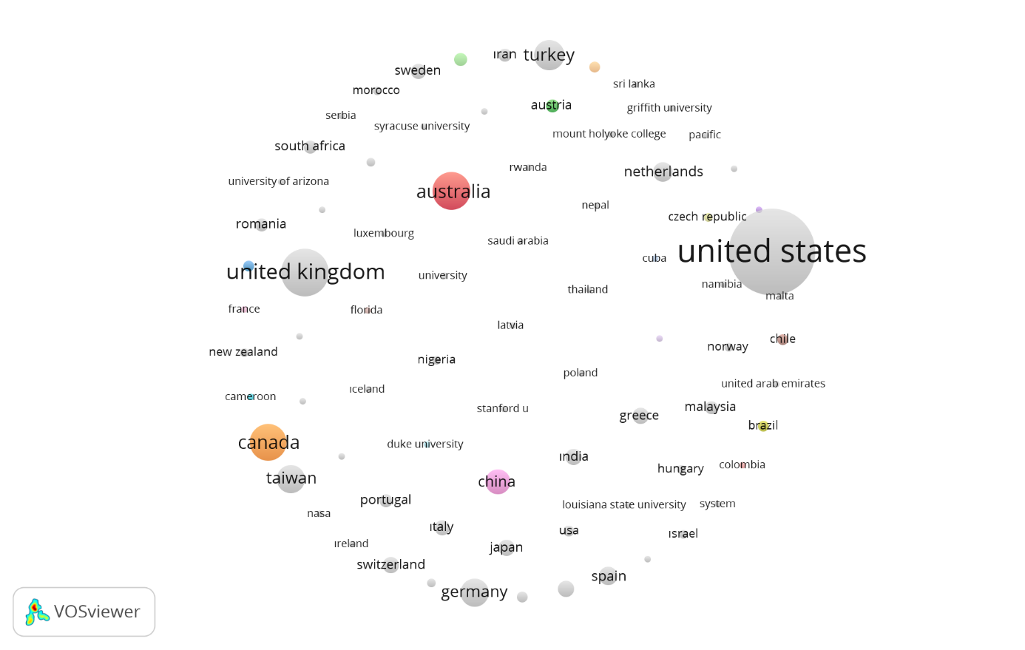
Figure 3 The Nexus of Citation among the Countries
Looking at the image in Figure 3, it is seen that no country is connected with each other. It is seen that the countries with the most publications on computer assisted teaching in science education are "United States", "United Kingdom", "Australia" and "Canada", respectively. This shows that the USA is the leader in computer assisted teaching in science education compared to other countries. Many similar studies support this situation (Demir & Selvi, 2018; Demir & Çelik,2020; Gapsalamov et al.,2020; Yurdakul & Bozdoğan, 2022).
78 countries were included in the sample visualizations created with VOSviewer for country analysis (Figure 3).
3.4. Author Citiation analysis: Most Cited documents and number of citations
Among the 454 publications obtained in the search, the top 10 documents with the highest number of citations from 441 authors are seen (Table 3).
Table 3 Most cited documents for computer assisted instruction in science education
Document | Documents | Citations
leidner ; jarvenpaa s.l. (1993) | 1 | 192
harder b.n.(2010) | 1 | 177
woltering v.; herrler a.; spitzer k.; spreckelsen c.(2009) | 1 | 167
moraros j.; ıslam a.; yu s.; banow r.; schindelka b.(2015) | 1 | 166
raggi v.l.; chronis a.m.(2006) | 1 | 161
shih m.; feng j.; tsai c.-c.(2008) | 1 | 155
fidan m.; tuncel m.(2019) | 1 | 152
zary n.; johnson g.; boberg j.; fors u.g.h.(2006) | 1 | 135
cook d.a.; levinson a.j.; garside s.(2010) | 1 | 132
çepni s.; taş e.; köse s. (2006) | 1 | 121

The most cited documents are leidner and jarvenpaa s.l. (1993), with 192 citations; with 177 citations Harder b.n.(2010), 167 citations woltering v.; herrler a.; spitzer k.; spreckelsen c. (2009), with 166 citations, moraros j.; islam a.; yu p.; banow r.; schindelka b. (2015). Leidner d.e.;jarvenpaa s.l. (1993), which has the most citations with 177 citations; , in their study titled “The information age confronts education: Case studies on electronic classrooms”, examined the use and results of computer-based instructional technology in the context of postgraduate business education and compared the use of computer-based instructional methods to traditional methods and computer-based methods that do not require the practical use of students. indicated that it offered an advantage. The fact that this research was conducted many years ago can also be considered as an indication that it has more citations. Here also ; It is also noteworthy that the work of Fidan m.;tuncel m.(2019) is among the documents with the highest number of citations, with 152 citations. Although the study was conducted in 2019, it can be thought that this highly cited study is due to its high quality.

3.5. Term analysis of computer assisted instruction in science education: Most used terms
In order to determine the top 10 most used terms out of 10881 terms obtained in the search, at least 62 and more used terms were included in the analysis. 16 terms met the relevant threshold. A fitness score was calculated for each of the 16 terms. Accordingly, the most relevant terms were selected. For this, 60% of the most relevant terms were selected and 10 terms were reached.
Table 4 Most common terms for computer assisted instruction in science education
Term | Occurrences | Relevance Score
student | 315 | 26.157
study | 242 | 14.275
education | 225 | 0.9829
learning | 194 | 0.7876
science | 190 | 0.7622
computer | 188 | 0.7343
course | 160 | 0.9839
technology | 154 | 0.5416
teaching | 151 | 0.6323
instruction | 117 | 0.532

When the results of the analysis were examined, the most used term was “student”. It was concluded that terms such as “study”, “education”, “learning”, “science” are used more frequently than other terms. The reason for this situation can be considered as the fact that the studies in science education are mostly experimental studies and students are preferred as the sample group. When the literature is examined, there are similar studies supporting this situation (Sözbilir et al., 2015; Özcan & Çalışkan, 2020; Kara, 2021). As a matter of fact, in support of this finding, Lin, Lin, Potvin & Tsai (2018) examined the research trends in science education with content analysis in their study named "Research trends in science education from 2013 to 2017: A systematic content analysis of publications in selected journals". They stated that subjects such as learning, education program, educational technologies are the subjects that they focus more on.

4. CONCLUSİON
The aim of this study is to examine the studies on computer assisted teaching in science teaching in terms of different variables with bibliometric analysis. When the literature is examined, no research has been found that provides bibliometric analysis of research trends in documents related to computer-assisted teaching in science teaching. Therefore, it can be said that this study is the first study in this field. This creates a unique field for new studies on the subject. This study provides an overview and an effective understanding of the current state of the literature on computer-assisted teaching in science education. It also provides interesting information on the development of the area. I believe that the results of this study are important for the future development of computer assisted instruction in science education. Although the research is a study on computer-assisted teaching in particular, it is generally related to science education as a research area. Therefore, it gives an idea about how the subject can be handled in related disciplines. The prominent results of the research are as follows: 72.2% of 454 publications on computer-assisted teaching in science education are articles, The most studies were done in 2010, The most frequently used keywords were determined as computer-assisted education, education - computer-assisted, e-learning. The countries that published the most on the subject were the United States, England and Australia, respectively. The most cited document is Leidner d.e. Jarvenpaa s.l. (1993) with 192 citations. The most used term on the subject was “student”.
With this research, an idea can be obtained about how and which studies can be done in other areas. From this point of view, science education research will fill the gaps in the literature and provide the opportunity to closely follow new trends. In addition, considering the macro data presented in this study, more detailed bibliometric studies can be conducted in different fields of education. Bibliometric studies are important for researchers to follow closely the studies and developments in that field. The research will also include a method applicable to different fields of science. For this reason, it gives direction to new researches about the method to be followed and it can be recommended to conduct bibliometric research in another diciplines

REFERENCES
Akçay, S., Aydoğdu, M., Şensoy, Ö. & Yıldırım, H.İ. (2005). Fen eğitiminde ilköğretim 6. sınıflarda çiçekli bitkiler konusunun öğretiminde bilgisayar destekli öğretimin öğrenci başarısına etkisi. Kastamonu Eğitim Dergisi, 13(1),103-116.
Al, U., Coştur, R. (2007). Türk Psikoloji Dergisi’nin Bibliyometrik Profili. Türk Kütüphaneciliği, 21(2), 142-163.
Aldemir, R., ve Tatar, E. (2014). Teknoloji destekli matematik eğitimi hakkında yayınlanan makalelerin incelenmesi. Bartın Üniversitesi Eğitim Fakültesi Dergisi, 3(1), 298–319.
https://doi.org/10.14686/BUEFAD.201416219
Artsın, M. (2020). Bir metin madenciliği uygulaması: vosvıewer. Eskişehir Teknik Üniversitesi Bilim ve Teknoloji Dergisi B-Teorik Bilimler, 8(2), 344-354.
Battal, A., & Çalışkan, A. (2021). Bilgisayar destekli matematik eğitimi alanında 2015-2019 yılları arasında yapılan araştırmaların incelenmesi. OPUS International Journal of Society Researches, 18(40), 2258-2287. https://doi.org/10.26466/opus.837465
Bayturan, S. (2011). Ortaöğretim matematik eğitiminde bilgisayar destekli öğretimin, öğrencilerin başarıları, tutumları ve bilgisayar öz-yeterlik algıları üzerindeki etkisi. (Yayımlanmamış doktora tezi). Dokuz Eylül Üniversitesi, İzmir.
Bozkurt, Ö. Ç., ve Çetin, A. (2016). Girişimcilik ve Kalkınma Dergisi’nin Bibliyometrik Analizi. Girişimcilik ve Kalkınma Dergisi, 11(2), 229- 263.
Bulut, Z., & Demirel İli, N. (2022). Türkiye ve Dünyadaki “Hüzün Turizmi” Çalışmalarının Bibliyometrik Analizi. Turizm ve İşletme Bilimleri Dergisi, 2(1), 67-88.
Chambers, J. A., & Sprecher, J. W. (1980). Computer assisted instruction: Current trends and critical issues. Communications of the ACM, 23(6), 332-342. https://doi.org/10.1145/358876.358881
Chiu, M. C., Hwang, G. J., & Tu, Y. F. (2022). Roles, applications, and research designs of robots in science education: a systematic review and bibliometric analysis of journal publications from 1996 to 2020. Interactive Learning Environments, 1-26. https://doi.org/10.1080/10494820.2022.2129392
Delikara, Ö. Ü. A. (2022). Müzik eğitiminde bilgisayar destekli öğretim yöntemi. Müzik Eğitiminde Öğretim Yaklaşım ve Yöntemleri, 243
Demir, E., & Çelik, M. (2020). Fen bilimleri öğretim programları alanındaki bilimsel çalışmaların bibliyometrik profili. Turkiye Kimya Dernegi Dergisi Kısım C: Kimya Egitimi, 5(2), 131-182.
https://doi.org/10.37995/jotcsc.765220
Demir, H., Selvi, S. (2018). Sağlık Alanında Kaynak Bağımlılığı Yaklaşımı ile İlgili Bilimsel Yayınların Bibliyometrik Analizi. 17. Uluslararası Katılımlı İşletmecilik Kongresi, İzmir, 2018.
Effendi, D. N., Anggraini, W., Jatmiko, A., Rahmayanti, H., Ichsan, I. Z., & Rahman, M. M. (2021, February). Bibliometric analysis of scientific literacy using VOS viewer: Analysis of science education. In Journal of Physics: Conference Series (Vol. 1796, No. 1, p. 012096). IOP Publishing. https://doi.org/1088/1742-6596/1796/1/012096
Ekinci, G., & Özsaatci, F. G. B. (2023). Yapay Zekâ ve Pazarlama Alanındaki Yayınların Bibliyometrik Analizi. Sosyoekonomi, 31(56), 369-388. https://doi.org/10.17233/sosyoekonomi.2023.02.17
Ergüzeloğlu, U. A., & Kaplan, B. (2021). Mekanik enerji ve uygulamaları: kinetik ve potansiyel enerji için deney tasarlama ve bilgisayar destekli öğretim. Dünya Multidisipliner Araştırmalar Dergisi, 4(1-2), 55-74.
Erkal, E. A. (2021). Pandemi sürecinde akademisyenlerin tükenmişlik algısının belirlenmesi: Ağrı İbrahim Çeçen Üniversitesi örneği. Uluslararası Ekonomi Siyaset İnsan ve Toplum Bilimleri Dergisi, 4(4), 207-220.
Gapsalamov, A., Bochkareva, T., Vasilev, V., Akhmetshin, E., & Anisimova, T. (2020). Comparative analysis of education quality and the level of competitiveness of leader countries under digitalization conditions. Journal of Social Studies Education Research, 11(2), 133-150.
Genel, T. (1998), Ortaöğretimde İkinci Dereceden Fonksiyonların Grafiği Konusunun Öğretiminde Bilgisayar Desteğinin Rolü. (Yayınlanmamış Yüksek Lisans Tezi). Hacettepe Üniversitesi, Ankara.
Güven, G., & Sülün, Y. (2012). Bilgisayar destekli öğretimin 8. sınıf fen ve teknoloji dersindeki akademik başarıya ve öğrencilerin derse karşı tutumlarına etkisi. Journal of Turkish Science Education, 9(1), 68-79.
Hançer, A. H., Şensoy, Ö., & Yıldırım, H. İ. (2003). İlköğretimde çağdaş fen bilgisi öğretiminin önemi ve nasil olmasi gerektiği üzerine bir değerlendirme. Pamukkale Üniversitesi Eğitim Fakültesi Dergisi, 13(13), 80-88.
Holman, L. (2000). A comparison of computer-assisted instruction and classroom bibliographic instruction. Reference & User Services Quarterly, 53-60.
Işın, A. (2022). The investigation of studies concerning to corporate social responsibility practices in restaurants through bibliometric analysis: A Research on Scopus Journals. İşletme Araştırmaları Dergisi, 14(1), 1063-1076. https://doi.org/10.20491/isarder.2022.1427
Kahyaoğlu, M. (2011). İlköğretim öğretmenlerinin fen ve teknoloji dersinde yeni teknolojileri kullanmaya yönelik görüşleri. Eğitim Bilimleri Araştırmaları Dergisi, 1(1), 79-96.
Kara, N. (2021). A systematic review of the use of serious games in science education. Contemporary Educational Technology, 13(2), ep295. https://doi.org/10.30935/cedtech/9608
Karataş, Z. (2020). COVID-19 pandemisi sürecinin LGS ve YKS sınavına hazırlık sürecinde olan çocuk ve ergenlerin psikolojilerine yansımalarının incelenmesi. Pandemi döneminde çocuk ve ergen psikolojisi, 1, 54-74.
Kurt, A. Ġ. (2006). Anlamlı öğrenme yaklaşımına dayalı bilgisayar destekli 7. sınıf fen bilgisi dersi için hazırlanan bir ders yazılımının öğrencilerin akademik başarılarına ve kalıcılığa etkisi. (Yüksek Lisans Tezi). Çukurova Üniversitesi, Adana.
Leidner, D. E., & Jarvenpaa, S. L. (1993). The information age confronts education: Case studies on electronic classrooms. Information systems research, 4(1), 24-54. https://doi.org/10.1287/isre.4.1.24
Lin, T. J., Lin, T. C., Potvin, P. ve Tsai, C. C. (2018). Research trends in science education from 2013 to 2017: A systematic content analysis of publications in selected journals. International Journal of Science Education, 41(3), 367-387. https://doi.org/10.1080/09500693.2018.1550274
Martín-Martín, A., Orduna-Malea, E., Thelwall, M., & López-Cózar, E. D. (2018). Google Scholar, Web of Science, and Scopus: A systematic comparison of citations in 252 subject categories. Journal of informetrics, 12(4), 1160-1177. https://doi.org/10.1016/j.joi.2018.09.002
Maryanti, R., Rahayu, N. I., Muktiarni, M., Al Husaeni, D. F., Hufad, A. C. H. M. A. D., Sunardi, S., & Nandiyanto, A. B. D. (2022). Sustainable development goals (SDGs) in science education: Definition, literature review, and bibliometric analysis. Journal of Engineering Science and Technology, 17, 161-181.
Otluoğlu, K. Ö. Ç., Yılmaz, B. K., & Dalkılıç, O. S. (2021). Covid-19 döneminde akademisyen annelerin iş-yaşam deneyimlerini anlamak: Nitel bir araştırma. KADEM Kadın Araştırmaları Dergisi, 7(1), 13-52. https://doi.org/10.21798/kadem.2021.50
Özcan, C., & Çalışkan, İ. (2020). Fen eğitimi alanındaki araştırmaların konu ve yöntem açısından incelenmesi. Ege Eğitim Dergisi, 21(1), 101-111. https://doi.org/10.12984/egeefd.673437
Özkaya, A. (2019). STEM eğitimi alanında yapılan yayınların bibliyometrik analizi. Bartın University Journal of Faculty of Education, 8(2), 590-628. https://doi.org/10.14686/buefad.450825
Roemer, R. C., & Borchardt, R. (2015). Meaningful metrics: A 21st century librarian’s guide to bibliometrics, altmetrics, and research impact. Association of College and Research Libraries.
Senemoğlu, N. (2001). Gelişim Öğrenme ve Öğretim, Gazi Kitabevi.
Sözbilir, M., Gül, Ş., Okçu, B., Kızılaslan, A., Zorluoğlu, S. L., & Atilla, G. (2015). Görme yetersizliği olan öğrencilere yönelik fen eğitimi araştırmalarında eğilimler. Abant İzzet Baysal Üniversitesi Eğitim Fakültesi Dergisi, 15 (1), 856-991. https://doi.org/10.17240/aibuefd.2015.15.1-5000128604
Tekin, M., Öztürk, D., & Bahar, İ. (2021). Tersine lojistiğin bibliyometrik analizi. Aksaray Üniversitesi İktisadi ve İdari Bilimler Fakültesi Dergisi, 13(3), 87-100. https://doi.org/10.52791/aksarayiibd.899935
Van Eck, N., & Waltman, L. (2010). Software survey: VOSviewer, a computer program for bibliometric mapping. Scientometrics, 84 (2), 523-538. https://doi.org/10.1007/s11192-009-0146-3
Weller, H. G. (1996). Assessing the impact of computer-based learning in science. Journal of Research on Computing in Education, 28(4), 461-485. https://doi.org/10.1080/08886504.1996.10782178
Yılmaz, G. (2017). Restoranlarda bahşiş ile ilgili yayınlanan makalelerin bibliyometrik analizi. Seyahat ve Otel İşletmeciliği Dergisi, 14(2), 65-79. https://doi.org/10.24010/soid.335082
Yumuşak, A., & Aycan, Ş. (2002). Fen bilgisi eğitiminde bilgisayar destekli çalışmanın faydaları; demirci (manisa)’de bir örnek. Benefits, (16), 197-204.
Yurdakul, M., & Bozdoğan, A. E. (2022). Web of Science Veri Tabanına Dayalı Bibliyometrik Değerlendirme: Fen Eğitimi Üzerine Yapılan Makaleler. Türkiye Bilimsel Araştırmalar Dergisi, 7(1), 72-92.
Zeren, D., & Kaya,N. (2020). Dijital pazarlama: Ulusal yazının bibliyometrik analizi. Çağ Üniversitesi Sosyal Bilimler Dergisi, 17(1), 35-52.

