The Development of Digital Comic as a Learning Media to Facilitate Students Understanding and Awareness in Drugs Topic

**NOVELTY**

The development of the digital comics produced by the researcher on the topic of drugs topic is a movement that is expected to facilitate students understanding and awareness by providing a simple and colorful visualization of material that is difficult to visualized.

# ABSTRACT

The human mindset greatly affects the progress of science and technology. Drugs are one of the examples that resulted from human complex thought. The lack of understanding can plunge students into psychotropic drugs that are harmful to their health. Studying sciences with only using text book will not be imprinted in student memories. So, using a media can help teacher to improve student understanding. This study was aimed to facilitate students understanding and awareness in drugs topic. The ADDIE model is used to developed the media. The resulted media is judge by Expert which consists of Lecturer and Teacher that proceeded using Index Aiken. While the students respond are gathered using a questionnaire consists of 20 statements and used a Likert scale. The result shows that the Lecturers judgment rater agreement index has a V = 0.9625, that indicates a high score for the media. While the teacher’s judgment has a V = 0.7875, that indicates an average score for the media. While the students respond shows 56.67% students strongly agree that the comic can facilitate them to understand and be more aware with drugs. From the results, it shows that lecturer and teacher agree that digital comic can be used as a learning media that facilitate students understanding and awareness. And the students are facilitated to learn drugs topic.

***Keywords***

Digital Comic, Drugs Topic, Learning Media, Students Understanding, Students Awareness

# 1. Introduction

Drugs are one of the examples that resulted from human complex thought. Drugs are usually known as medicine that is given by the doctor when someone is sick, but as the era develops, many individuals got stressed and burdened by lots of problems, with the escape thought that might linger in their minds, new drugs are born. Initially, drugs are any substances that are taken into the human body that has a function to modify or affects the chemical reactions in the body.

Drugs itself it’s not dangerous if it used in the right amount that the body needs. But nowadays, there are many modifications in the use of drugs itself. Drugs are usually used by humans and animals (S.E. Jorgensen, 2000). Each drug has its own function, whether it’s used as a painkiller or a treatment. The often-used type is cough medicine, the cough medicine gives a high and sleepy feeling even when used with the doctor's recipe. When individuals drink too many drugs outside written by the doctor, it will cause a high feeling. The high feeling is what the drug user looking for. Drugs give a pleased euphoria when dopamine is released, drinking the drugs it will block the receptor to absorb the dopamine back. This is a simple drug that can be found in any drugstore.

Parents and doctors often initially miss the misuse of these drugs due to shared misunderstandings about their potential for causing harm(Levine, 2007). In Indonesia, the analysis of national examination results shows that students have a lack of understanding of drug materials in junior high school (JHS). The lack of understanding can plunge students into psychotropic drugs that are harmful to their health (Ayu Kartina, 2019). As what happens in the US specifically in Fresno, where there are a lot of teenagers who fall into psychotropic drugs simply just because they want temporary happiness and not considering the danger and the after effect in the future, which can actually kill themselves or even someone else. One of the psychotropic drugs used is fentanyl-type anesthetic which is made in tablet form. Also, there are a lot of death cases caused by the drugs like Methamphetamine, Doxylamine, and Alcohol that consume by the teenager with the youngest age at 18 years old (Mims, 2022). As previously described, there are a lot of reasons why Addictive substances or Drugs are very important to be taught especially to students in their teenage age.

As technology becomes more and more developed these days, it also greatly affects the progress of education. Many new ways of teaching and studying were created. A lot of teachers develop either a program or teaching technique to help students in studying. Not only developed countries are trying to advance their education, but also many developing countries are competing to improve the quality of their education. One of them is Indonesia. Right now, Indonesia is trying to develop the quality of its education by creating a lot of national programs and different kinds of curriculum. However, the quality of education will not improve only by making lots of programs and creating a new curriculum because if the school, teacher, and student are not ready to be implied with the new program, the program will be useless. In the learning process, not only students and teachers play a role but there are also other components that are as important as the involvement of teachers and students, namely the objectives of the learning, the methods used, the materials provided, learning tools such as the media used, and evaluation. (Riyana & Pd, n.d.) .

When Indonesia wants to advance its education sector, of course there are some problems that must be faced. Indonesia is currently one of the countries that has a low quality of education. There are several factors that make Indonesia a little behind, especially in the education sector, like the lack of funds available for education, the quality of education is still poor, this happens because of the lack of expertise of a teacher in delivering material to students, the high cost of education in Indonesia which makes many people ended up not going to school, lack of teaching materials so that teachers have limitations in providing materials, there are no adequate facilities, and minorities for groups of people with disabilities in getting education.

In Indonesia, most schools still use conventional media as a learning media such as blackboards, learning books and others. However, since the pandemic, many teachers have started using website as a learning medium. But sometimes the use of media is not very effective in learning because not all studying websites have an interactive appearance especially for students. As the result of the development in technology, there is also a development in teaching media which is a visual media. Visual media is a teaching aids that used in learning process that can be enjoyed through the five senses. Visual media either an images or parables, play an important role in the learning process. Visual media can help to improve the understanding and help to strengthen the student memories. Visual can also foster student interest and provide a relationship between the content of the subject and the real phenomena in the environment (Sholihah Mar’atus et al., 2019).

Comic is one of the examples of the development of visual media that can be use in teaching learning process. There is a comic which can be called as an educational comic. Educational comic is a subset of comics whose purpose is not to storytelling or entertaining but to transfer an information or communicate concepts. Reading a comic requires not only the text but also interpretation an image as the reader must negotiate two systems of codes which sometimes function independently, and at other times interact (McNicol, 2017). Some of researchers have strongly argued against the use of comic as an educational media, but nowadays many teachers, librarians, and educational researchers design learning activities in efforts to take advantage of comics’ educational strengths. In 1992 after Art Spiegelman’s comic book *Maus* won a Pulitzer Prize in Nazi Holocaust, educational comic become more and more popular. The example happens in 2001 at University of Minnesota physics professor James Kakalios, in his introduction of physics course “Everything I Needed to Know About Physics I Learned from Reading Comic Books”, gave an example of basic principles of physics, chemistry, and biology using a concepts and characters from the comic books (Vassilikopoulou et al., 2011).

Studying sciences with only using text book will not be imprinted in student memories. So, using a media can help teacher to improve student understanding. Other than media that used, there are an additional factor as gender and prior knowledge. As in some studies reported that female experience greater learning benefits from animated resources, while some other studies stated that animated resources are more beneficial for males (Heo & Toomey, 2020).

Therefore, the purpose of this study is to analyze the Development of Digital Comic as A Media to Improve Students' Understanding and Awareness in Drugs Topic.

# 2. Method

The method that is used in this research is Developmental Research. Stated by Seels & Richey (1994) in Richey & Klein (2005) that the methodical study of designing, developing, and evaluating instructional programs, procedures, and the outcome must meet the internal consistency and effectiveness. Developmental research is not research that aim to create new theory, but it’s focusing on producing or developing a product. The developmental research is a method that used to developed and evaluate a educational product. Is also an effort to create a product that is suitable and effective to be used by school in teaching and learning processes (Gravemeijer, 1998).

In this research, the researcher use the ADDIE model as the media development stage. The ADDIE model is a model that consists of 5 steps. Analysis, Design, Development, Implementation, and Evaluation. An instructional design model's goal is to ".. provide both an appropriate endpoint and the correct path to lead you there.." or to "..enhance students ensure that they are teaching the necessary information in an optimum way." Addie's model is one of the instructional design models. It is used to develop the curriculum in various fields (Cheung, 2016). The ADDIE instructional design is a very well-known approach that is often used to develop instructional courses and training programs. This help educators to clearly define the stages in effective implementation of the instruction (Peterson, 2003).

Figure 1. ADDIE model

evaluation

analysis

design

development

implementation

Using ADDIE model in the teaching learning process improve a lot of aspects such as the performance of the teachers in the class, and also how students engaged in the learning activities. Using ADDIE model prove that the model can help the quality of teaching learning in the secondary school (Handrianto et al., 2021).

1. Analysis

In the analysis phase, the creators will consider the main target of the audience. Analyses needed must be conducted to determine the needs of the audience (in here is the students’) by determining between what students’ need to know and what the students already know at the conclusion of the course or the materials given (Peterson, 2003).

1. Design

In this phase, there are several key facets. Mainly is where the creator is conducting the research and planning throughout this phase. The planning includes:

1. Identifications of objectives
2. Determining how the objectives will met
3. The instructional strategies that will employed to achieve the objectives
4. The media and methods that will be most effective in the delivering of the objectives. And during the design stage, the creator must consider the data and information from the previous stage. (Peterson, 2003).
5. Development

Designers should now develop a product for the delivery of the information during the development phase by simply referring to the results of the previous two phases. During this phase of transition, the creator's job changes from one of research and planning to one of producing. Drafting, manufacturing, and evaluation are the three areas that are prioritized in the development phase. Designers in this stage develop or select materials and media as well as conduct formative evaluations (Peterson, 2003).

1. Implementation

Creators must play a more active than passive role throughout the implementation phase. With the advent of this phase, the creator's or instructor's job becomes more important. The product must continue to be evaluated, redesigned, and improved by creators in order to be delivered efficiently (Peterson, 2003).

1. Evaluation

The evaluation phase, which includes multiple dimensions, is a crucial part of the ADDIE process. The evaluation phase can take the form of formative evaluations during the development stage, evolving student and teacher support during the implementation phase, and a summative evaluation for instructional improvement at the conclusion of the implementation of a course or program. The designer must decide whether the problem has been solved (important to training programs), if the objectives have been accomplished, the impact of the product or course, and the changes that must be made for the program or course to be delivered in the future during the assessment phase (Peterson, 2003).

# 3. Result and Discussion

The research process was done by spreading the digital comic to the targeted students which is a junior high school student who currently studying in 7th and 8th grades. While for the expert, it’s done by giving them the comic to be judged. The results from the expert and student judgment will be carried out in the 5 stages of the ADDIE Model, and will be discussed based on the research question.

**3.1 Characteristic development of each comic stage**

3.1.1 Analysis stage

The first stage of the ADDIE Model is the analysis stage. This stage explained what should be done before making or deciding the media that will be used. This stage consists of the analysis of the reason for choosing the specific topic which is drugs, the urge to spread it on the internet and media social, the used of the digital comic, the application needed to develop the digital comic (Software use), and lastly the hardware used for developing the digital comic was all done by doing a literature review and study field. All the analyses chosen in this stage will be described below:

3.1.1.1 The characteristic of the boys and girls and the curriculum used

The boys and the girls in this school are active and have a high curiosity during the teaching and learning process. The girls are a bit more active than the boy, and it’s probably because the amount of the girl’s student is doubled the boy’s student number. During library time, boys are more interested in reading colors and animated books such as comic or colored reading books. While the girls mostly talk to each other and stay with their phones. But somehow during the teaching and learning process, the girl’s student will be more active and curious.

The curriculum that uses in X junior high school is a national and international curriculum. It uses a Merdeka curriculum and a Cambridge curriculum. The science subject is using a Cambridge curriculum where the topic of the drug didn’t explain in a deep way but stopped until the antibiotics and how does it work in human body. In another school that still use a Kurtilas or *Kurikulum 2013* are having a deep material in the drugs topic.

3.1.1.2 Analysis of the reason for choosing the drugs topic

In this stage, the researcher starts to do short research about the cases related to drugs and teenagers. Suddenly the news about the ‘walking dead’ boomed. Walking dead is a phenomenon that suddenly happen in the United States of America (USA). The sudden viral news shows that a lot of people walking like a zombie in the streets. This phenomenon specifically take place in Kensington Avenue near Delaware river is a famous place where an open market for drugs transaction occurs. Along the streets there are a lot of people fainted and day dreaming they are a drugs addicts, because of that the place known as a walking dead area. Before the news of walking dead appeared and booming, there are a case related to drugs that happen in United States of America (USA) specifically happen in an area called Fresno. In Fresno, the youngest age that died from overdose is 18 years old. Both the walking dead phenomenon in Philadelphia and the sudden death in Fresno is a famous phenomenon caused by the drugs. The type for both phenomenon is different; the walking dead phenomenon is caused by a drug called *tranq* while the sudden death phenomenon caused by a drug called *fentanyl*.

*Fentanyl* usually use to treat pain, mostly use to treat cancer patient or other clinical condition that noncancer related like postoperative pain. The death caused by *fentanyl* found in early 1980s, over time more and more people took *fentanyl* (Han et al., 2019)*.* In other hand, *Tranq* or known as a *Xylazine* is a drug that usually use for animals and not for humans. *Xylazine* is a veterinary drug that used as a sedative, analgesic, and muscle relaxant for cow and horse (Ruiz-Colón et al., 2014). Both type of drugs gives a terrible effect on human body. *Fentanyl* gives an effect 50 – 100 times stronger than morphine and 30 – 50 times stronger than heroine. While *Xylazine* because it wasn’t made for human it gave such an effect, *xylazine* when use in long term will caused a tissue body died which make the user doesn’t feel any pain even when the skin is blisters and open wounds.

From both of the famous cases, there are a lot of teenagers that happened to use drugs as their final decisions for feeling happy. In other words, drugs is the easiest way for someone who wanted a happiness even though it’s only a temporary happiness. This decision was made maybe because they didn’t know the side effect that given by the specific drugs that uses, or what can drugs do to their body in short or long term. Drugs itself have a lot of impact to human body, not only giving the euphoria but also damage some part of the body when used in the certain amount.

Social implication is also one of the reasons of choosing drugs topic. With the increased number of the drugs users, it results a various social problem like crimes and violence. It also can be seen through the increased number of the public service and social service also the healthcare. The reason of someone get into drugs is also something that can be prevent, such as a family issues, no one to talk to, or lack of empathy. Because of this reason the researcher would like to increase the understanding and awareness that can be instilled in children.

3.1.1.3 Analysis of the urge to spread it on social media and internet

The use of internet is like a daily staple food. Internet is very close to us and always there wherever we are. The use of internet doesn’t mean surfing around the internet for finding something through website. Nowadays there are a lot of things that can be done using internet, and one of it is using a social media. Social media is a thing that can be use when there’s an internet.

According to the American Academy of Pediatrics, 22% of teenagers log in into their favorite social media 10 times perday. Also 75% of teenagers own their own cell phone, from 75% of teenagers that got their own cell phone 54% of them use it for texting and 24% other use it for sending an instant messaging (O’Keeffe et al., 2011). From all the data, it shows how someone stay in their phone every day and how many times they exchange information through the texting and messaging app. Using this information, it helps to analys how people actually read and got some information through the social media on their phone.

Base on some research also shows that using internet and through social media, it helps to improve their health. It’s because through the internet, people can easily get an information. But because of the convenience provided by the internet, children who are teenagers do not know whether the information obtained is valid or not. That’s why the usage of internet must be monitored by adult whether to receive an information or to share any information.

During the observation in specific targeted school, researcher find out that most of the students have and use their own gadget either it is a phone, tablet, or a laptop. The students usually looking for an information on internet during teaching and learning process. That shows how often students stays on their gadget to open internet and scrolling around.

3.1.1.4 Analysis of the use of digital comic

During the observation in the specific school, the researcher finds out that most of the student spend time with their gadget. Only few of them seen in the library during the break time, even when the students have a library time, they prefer to do other activities like talking with each other, playing their phone, rather than sit and stay in the library for reading a book.

As the observation shows how often students stay with their phone and scrolling though social media and internet, researcher found out that digital comic might be one of the best ways to increase students’ interest in reading. Because digital comic is a comic that can be view everywhere and every time through their mobile phone. Comic itself has a unique characteristic which there isn’t lot of words contain instead it following by many colors and pictures, so studying doesn’t feel like a burden at all.

3.1.1.5 Analysis of the software use

The software use is an Ibis PaintX offered by ibis inc. an application that specifically made for an artist to draw anime and manga art. Ibis PaintX itself is an application that offered a lot of features that is very useful and easy to use even for the beginner. It have some features unlocked only for the premium user, and also other features that can be use by the free user.

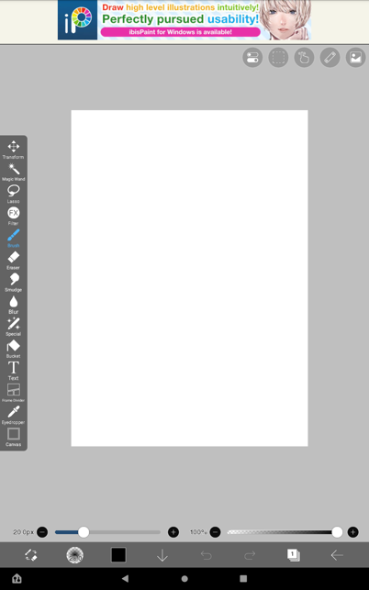

Figure 3.1. Ibis PaintX main drawing screen display

3.1.1.6 Analysis of the Hardware Use

The hardware use in this comic development is an Amazon Fire Tablet 10 with a drawing pencil for tablet. In this case, the tablet is the easiest and effective hardware that can be used to draw a whole comic. The comic itself has a hundred untitled canvas consist of the raw drawing and the result drawing, and sometimes this what caused the application to stop running, because it’s heavy.

|  |  |
| --- | --- |
| Memory | |
| Card slot | microSDXC (dedicated slot) |
| Internal | 32Gb 3Gb RAM, 64Gb 3 Gb RAM eMMc 5.1 |
| Platform | |
| OS | Android 9.0 (Pie),] Fire.OS 7 |
| Chipset | Mediatek MT8183 Helio P60T (12 nm) |
| CPU | Octa-core (4x2.0 GHz Cortex-A73 & 4x2.0 GHz Cortex-A53) |
| GPU | Mali G-72 |

Table 3.1 AmazonFire HD 10 (2021 11th Generation) Specification

3.1.2 Design Stage

In this stage, the researcher focusing on how the comic will turn out by creating a flowchart and storyline. Both of the flowchart and storyline are necessary to create a clear vision of how the comic will be constructed.

3.1.2.1 Flowchart

Flowchart is a visual representation used to document the step-by-step sequences of operations or processes (Chapin, 2003). In this research, researcher use flowchart as a visualization of the comic strip outline. The flowchart can be seen in the appendix (Appendix 1).

3.1.2.2 Storyline

Storyline was made after the flowchart finished. The storyline developed based on the information represented in the flowchart. The storyline helps bring the flowchart to life by describing the actions or decisions taken at each stage and the outcomes or results achieved. Through the storyline, the reader can follow each progression of the scenes and understand the purpose of each scene.

Generally, flowchart and storyline complement each other, when the flowchart offers a visual representation of how the operations of the comic, the storyline provides the context and narrative along with the indicators so the process can be more understandable and relatable. The storylines can be seen in Appendix 2.

3.1.3 Development Stage

In this stage, the researcher starts to develop the instrument using the chosen application. The first thing to do is that the researcher starts to develop the characteristic of each character. The development of the character starts by drawing it on paper as the main reference, then scanning it using any scan application. Then, used the ibis Paint X application to start making all the drawings digital. All the explanation of this stage will be described below:

3.1.3.1 Raw Sketch

This stage was the beginning of all of the designs made before the instrument was finished. The raw sketch is the rough draft with minimal details, it is the initial stage of the drawing process before getting into the digital process. The raw sketch here was focusing on the composition, proportion, and overall art structure.

The raw sketch helps the creator to experiment with the comic composition and proportion or even the art style. This process helps the creator to do an adjustment to the comic so the instrument results have a clear direction and foundation. An example of the raw sketch shows in Figure 3.2;

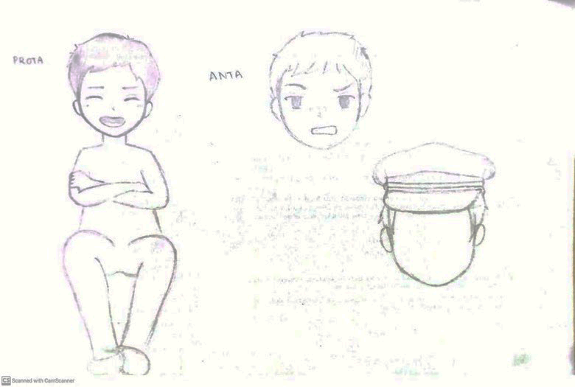

Figure 3.2 Raw sketch of the comic

3.1.3.2 Soft Sketch Digital

Soft sketch digital is the process where the raw materials are moved into the digital by scanning all the raw sketches. The raw pictur become the reference for future design so that the art style can be constant. The soft sketch is the process where the raw sketch is moved into digital but with no details yet such as the colors, background effect, bubble chat box, facial expression, and emotions.

Soft sketch digital here is referred to as a preliminary or rough version of a design, idea, or concept that can be easily modified and adjusted. The researcher called this step a soft sketch digital because the raw sketch is changed into the form of digital already. In this step, as shown in Figure 3.3, the figure of each character is already shown but other element such as panels and chat box is not shown yet.

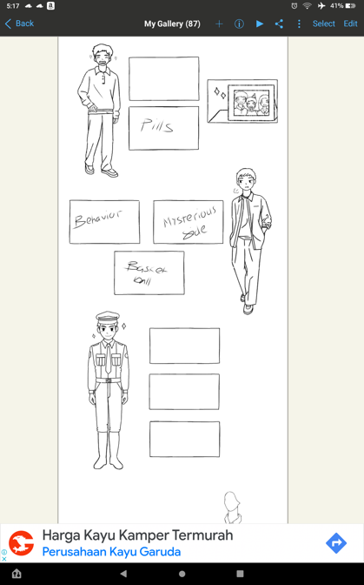

Figure 3.3 Soft sketch of the comic

3.1.3.3 Digital step and fixed sketch

Digital steps are a step where the creator starts to change everything and do anything digitally. No more using the raw sketch as the reference to do the next drawing to make it precise and constant, by using a copy-paste features that are provided in the application.

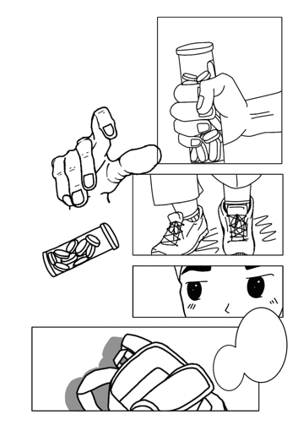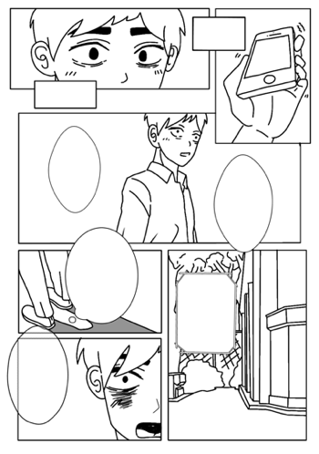

Figure 3.4 Digital step and the fixed sketch

During this process, all the structures are already structured and in position with balanced composition from the creator's perspective. But in this process, the creator didn’t put any background effect or any emotional effect yet. That’s why from the picture shown above, the emotion only can be seen from the expression given by the character.

3.1.3.4 Final Result

The final result (Figure 4.5) here refers to the complete version of the comic itself including all the background and emotional effect, coloring, and shading, also the complete bubble text and materials that need to be delivered in the comic itself.

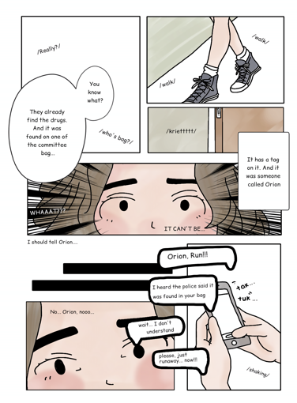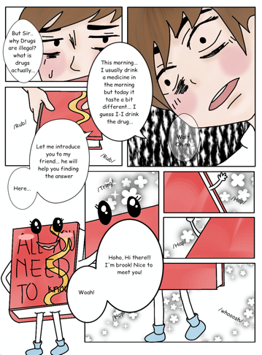

Figure 3.5 The final result of the coloring and background of emotional effect

The final result also shows the finalization of the cover and the closing of the comic. That includes the title of the comic, the creator’s name, and also the word that can describe the whole point of the comic. The complete final comic is shown in the Appendix 3.

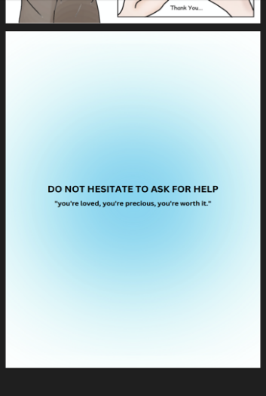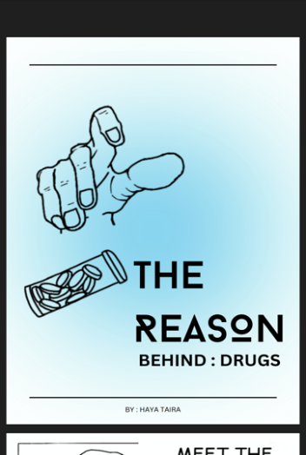

Figure 3.6 The final design of the cover and the closure page of the comic

3.1.4 Implementation Stage

The implementation stage refers to a process where the researcher starts to spread the comic to the experts. here expert judgment is divided into two types, the lecturers as the expert judgment and the teachers as the expert judgment. Along with the distribution of the comic, the researcher also shares the questionnaire that contains 4 (four) indicators with 20 (twenty) questions. The aspect is also divided into 4 (four) aspects which are the Science aspect, Art aspect, Linguistic aspect, and Awareness aspect. After all the expert judgment answers are collected, the researcher can start to spread the comic to the students. Along with the comic, the student also has a questionnaire that consists of 4 aspects and 20 statements that need to be done after reading the comic.

3.1.5 Evaluation stage

During this stage, the researcher will start collecting all the expert judgment and student judgments to improve the comic for the next research by analyzing all the answers that had been given by all the experts and students.

**3.2 Expert Judgment**

Expert judgment is divided into two categories. The first category consists of the judgment from the lecturers and the second category consist of the judgment from the teachers. An expert judgment is involved to validate the instrument to improve the quality either from the content aspect or the drawing aspect and even the language aspect. Expert judgment plays a crucial role in order to developing and evaluating the instrument. The need for 2 (two) types of experts which consist of a lecturer and a teacher is that the lecturer is responsible for the content or materials because they have a wide knowledge and know exactly what needs Junior High School (JHS) needs to learn. While the teacher is responsible in the class. The teacher is involved directly in the teaching and learning process, which make the teacher knows more about what student are interested in during the studying and learning process. Here, the lecturer and teacher using the same rubric of questionnaire. The researcher also provides a suggestion column which can be filled with a short text that can help the researcher to see the difference in lecture and teacher perspectives.

All the data obtained proceed using the index Aiken. Based on the index Aiken scoring, the range score of Aiken is between 0 – 1. The V index calculation allowed to categorize an item or device according to its index value. If the index resulted around 0.4 or below, it will be considered to have a low validity, while an index between 0.4 – 0.8 indicates to have a moderate validity, and if the index resulted above 0.8 it indicates as a high validity or very valid. The closer the index Aiken resulted to 1, the better the item is because it will be more relevant (M Priatna, 2008; Retnawati, 2016). The Expert judgment are targeted to be filled by 3 (Three) Lecturer and 2 (Two) Teachers (Table 3.2) shown and described below;

|  |  |  |
| --- | --- | --- |
| No. | Occupation | Expert Field |
| 1. | Lecturer | Computer Science |
| 2. | Lecturer | Biotechnology (Biology) |
| 3. | Lecturer | Biology |
| 4. | Teacher | JHS Teacher |
| 5. | Teacher | English Teacher |

Table 3.2 Lecturer and Teacher Occupation and Expert Fields

3.2.1 Lecturer Expert Judgement

As what have been described previously, the lecturers become one of the experts to validate the instrument using a questionnaire containing 20 questions. The result of the V from all questions are shown in Figure 4.7;

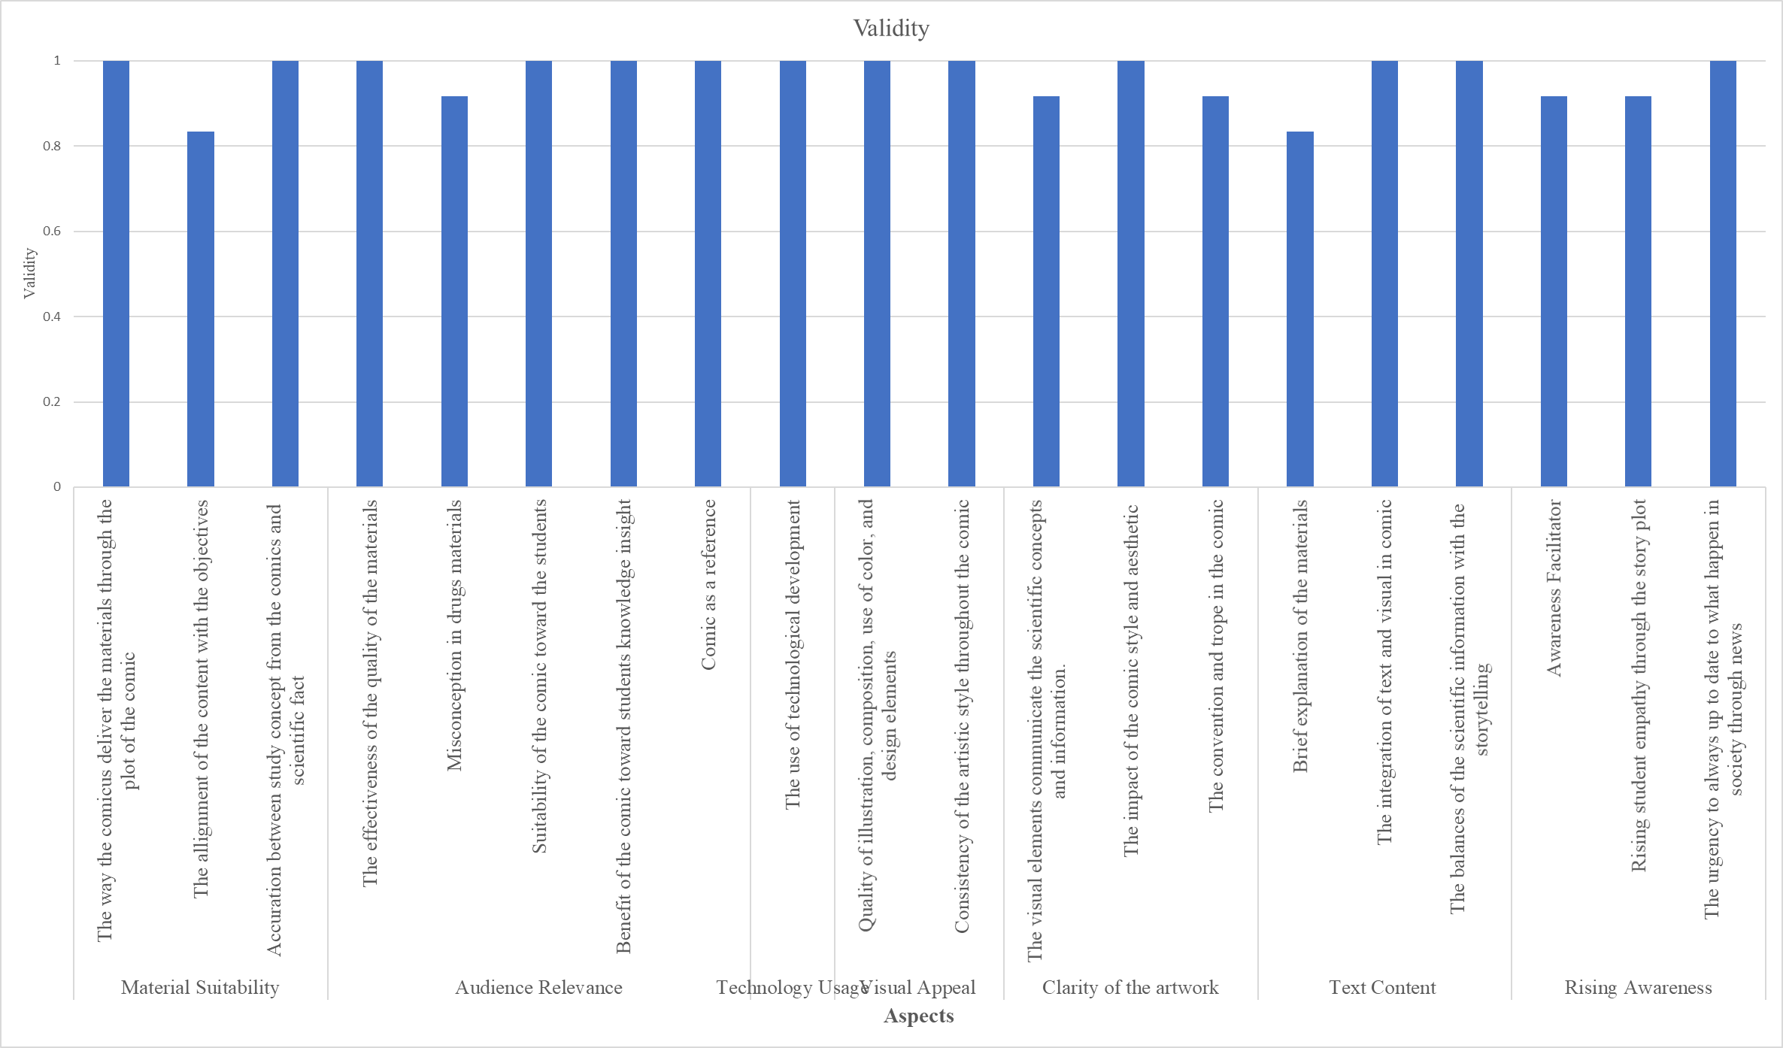

Figure 3.7 V Result from All Statement from the Lecturer as the Expert Judgement

All the data obtained will proceeded by using an index Aiken. Expert validation is a process where a qualified and knowledgeable person or a group assesses the accuracy, credibility, and quality of information or materials, produce by some other person or system.

3.2.1.1 Expert Judgment by Lecturer in Science Aspect

The science aspect contains 3 main indicators which are material suitability, audience relevance, and technology usage. Each indicator contains a specific statement with a 1-5 range score where 1 is the lowest score and 5 is the highest score. Material suitability contains 3 (three) statements, audience relevance contains 5 (five) statements, and technology usage contains of 1 (one) statement. The result of the science aspect validity is shown in the Figure 3.8;

Figure 3.8 Science Aspect from Lecturer Validity as the Expert Judgment

As shown on the Figure 3.8, the result of the science aspect from all the lecturers has an average of 0.97 with most statement answer by the lecturer is 5 (five). As stated, before in index Aiken, the score that above 0.8 can be indicates as a ‘high validity’. As the example can be taken from the material suitability aspect in the ‘materials through the plot’ statement, the index of the validity is 1 which mean ‘very valid’. This result can be stated as ‘very valid’ because it has an index Aiken value of 1, but it also can be considered as ‘very valid’ due to the media ability to communicate and deliver the materials and create a useful tool that aid students in better understanding the information as what stated by Darnawati (2019) in Husna & Fajar (2022).

The second statement of the rubric ‘The alignment of the content with the objectives’ has a result 0.83 of the index Aiken, this shows that the result is ‘very valid’ as the result is still above 0.8 of the index Aiken. Means that the content that delivered was aligned with the objectives, this statement is supported by (Porter et al., 2007) an aligned instructional guidance system resulting in alignment with the classroom instruction will produce a better result on an aligned student achievement test. In other words, if the instruction is aligned with the objectives or the targets that have been made before, it will ensure a clear and focused direction of the learning process. It also helps to avoid unnecessary or redundant content.

The third statement of the rubric ‘Accuration between study concept and scientific fact’ means that what the students need to learn is aligned with the fact that happen in real life. In here, the index Aiken value is high where it can be considered as a ‘high validity’ or a ‘very valid’ content. This statement is supported by what was stated by Narut & Ntelok (2020) in Husna & Fajar (2022) that science courses particularly concepts with a lot of visual appeals and real-world (real life) applicability, the use of the learning media can be beneficial in helping teachers delivered the materials so it will be more comprehensible. Also, the contextual approach highlights the connection between the subject matter under study and real-life condition that students can directly observe and analyze make it easier to understand (Husna & Fajar, 2022).

Going into the second aspect which the audience relevance, 4 (four) out of 5 (five) statements has a 1 (one) index Aiken, which make it considered as a ‘high validity’ or having a ‘very valid’ content. The first, third, fourth, and the fifth statement is connected to each other. All four statement have a very valid index Aiken which make it have a very high validity content. This statement can be supported by what stated in (Husna & Fajar, 2022), Based on the learning styles, certain students mentioned that reading effectively helped them grasp lessons more easily, while others found that it simple to comprehend the subject matter if they had a good understanding. For the other students, demonstration made the subject matter easier to understand, whereas others found pictures and animations particularly helpful in remembering and understanding the lessons. These statements can be concluded that students have a diverse learning preference. That’s why, it is essential to choose science learning materials that can accommodate these individuals need. Therefore, specific media might help some student understanding but not being a helpful source for others. The effectiveness of the media can happen when the learning media can accommodate and facilitate students’ curiosity and understanding.

For the ‘misconception in drugs topic’ statement, it has a 0.92 index Aiken result. It shows that the content has a ‘high validity’ which means there are not lots of misconceptions in the media produced. The complete rubric or the blueprint of the rubric can be seen in the appendix (Appendix 4).

The last statement of the last aspect in the science field is ‘The use of technology development’ shows that the creator uses technology development to provide the media to the students. It shows that the statement has a ‘high validity’ of index Aiken, which means the creator takes advantage of the technological developments. As stated by Indonesian Internet Service Providers Association (APJII) (2020) (Kaloeti et al., 2021) that the use of the Internet in school and online learning requires that children are connected to the digital world. During the same period, a significant portion of internet users in Indonesia accessed online media for educational and school-related purposes.

Figure 3.9 Art Aspect from Lecturer Validity as the Expert Judgement

From the art aspect, there are 2 (two) important aspect which is the visual appeal and clarity of the artwork. Both of the aspects are related to each other. As the result shown in Figure 4.9 that 3 (three) of 2 (two) statement has a 1 index Aiken which makes it a ‘very valid’ content while the other 2 (two) have a 0.92 index Aiken, which makes it also still have a ‘very valid’ or a ‘high validity’ content. The visual appeal and the clarity of the artwork is a very crucial element when using a digital comic as a media to communicate science materials because a visual appeal in the comic can capture the attention of the audience and make it more enjoyable and engaging in learning. It also helps to explore the science materials further. People also tend to remember visual information better than text information. Using a drawing can help the reader to imagine and retain the science content for a more extended period, as the combination of images and text reinforces memory.

The clarity of the artwork in the digital comic spark interest in science among readers who may not typically engage with scientific materials. It can also present science material in a creative way and approachable manner to engage more audience. ‘The visual elements communicate the scientific concept and information’ means each element in the comic can deliver the meaning behind it. Is aligned with the statement ‘Artistry in science involves the ability to perceive patterns, connect various elements, and synthesize diverse information to create a coherent and meaningful understanding’(Eisner & Powell, 2002). When making media or communicating through a design visual, the creator needs to consider to whom the media targeted (Rodríguez Estrada & Davis, 2015).

Figure 3.10 Linguistic Aspect from Lecturer Validity as the Expert Judgement

Shown on Figure 4.10 that the text content contain of 3 (three) statement that 2 (two) out of 3 (three) statements have a 1 index Aiken which considered as a ‘high validity’ in other word it can called as a ‘very valid’ content. The statement of ‘Brief explanation of the materials’ have a 0.83 index Aiken which can still be considered as a ‘very valid’ content. Comic combine both textual information and visual imagery to convey a story message. Through the visual, the reader can get the emotion that been deliver by the character of the comic. Visuals in a comic can complement the text by providing additional details and context, with this combination the reader can get more helpful message and concept with the better understanding. The comic excels at creating context and storytelling. The comic can be said successful when the comic itself can creates a powerful and effective tool for communicating and delivering the materials that can be easily understand by the reader targeted.

Figure 3.11 Awareness Aspect from Lecturer Validity as the Expert Judgement

As shown on the Figure 3.11 all of the statement has an index Aiken above 0.8 which make it as a ‘very valid’ or a ‘high validity’ content. The relation between the use of digital comic as a learning media with the awareness is that the creator wants to help students to have a better understanding about the specific drugs and aware that it might be happen in their surroundings. By using the digital comic, it can enhance awareness of educational content by making it more accessible to diverse audience. With a visualization inside, it allows students to grasp and understand the content more effectively.

From all of the lecturer judgement as an expert’s judgement, the result or the V from all the expert can be conclude as ‘high validity’ or can be considered a very valid content. Some suggestions come from the expert such as;

*“The media is very good and suitable for comic fans. It can be an alternative learning media. The Illustrations of how the drugs works can be further detailed”.*

From the lecturer perspective, the comic is already good and can be used to gain student interest in learning drugs topic. There also some other revision that needs to be done from lecturer perspective such as;

*“Comics are still dominantly used to improve students' understanding, while students' attitudes and awareness and students' literacy are not yet clearly presented. According to official sources, it's a good idea to ensure that comics contain indicators of students’ attitudes, awareness, and literacy. The explanation of material in comics should be accompanied by official sources”.*

From the lecturer perspective, the comic still needs a revision in the materials regarding to increased student awareness, and to be adding more information from the official sources.

3.2.2 Teachers’ expert judgement

The rubric that shared to the teachers is also the same. The teachers that involved in this judgement is 2 teachers consist of the English teacher and a science JHS teacher. The different perspective can be obtained by involving the teachers in this research. Lecturer is someone that have a focused on studying specific fields that makes them as a content validator, while teachers is someone that knows the situation in the real class and how junior high school students characteristic. The category of the teacher judgement are divided into 3 (three) parts, which; The Validity of all aspect, that shown on the Figure 3.12.

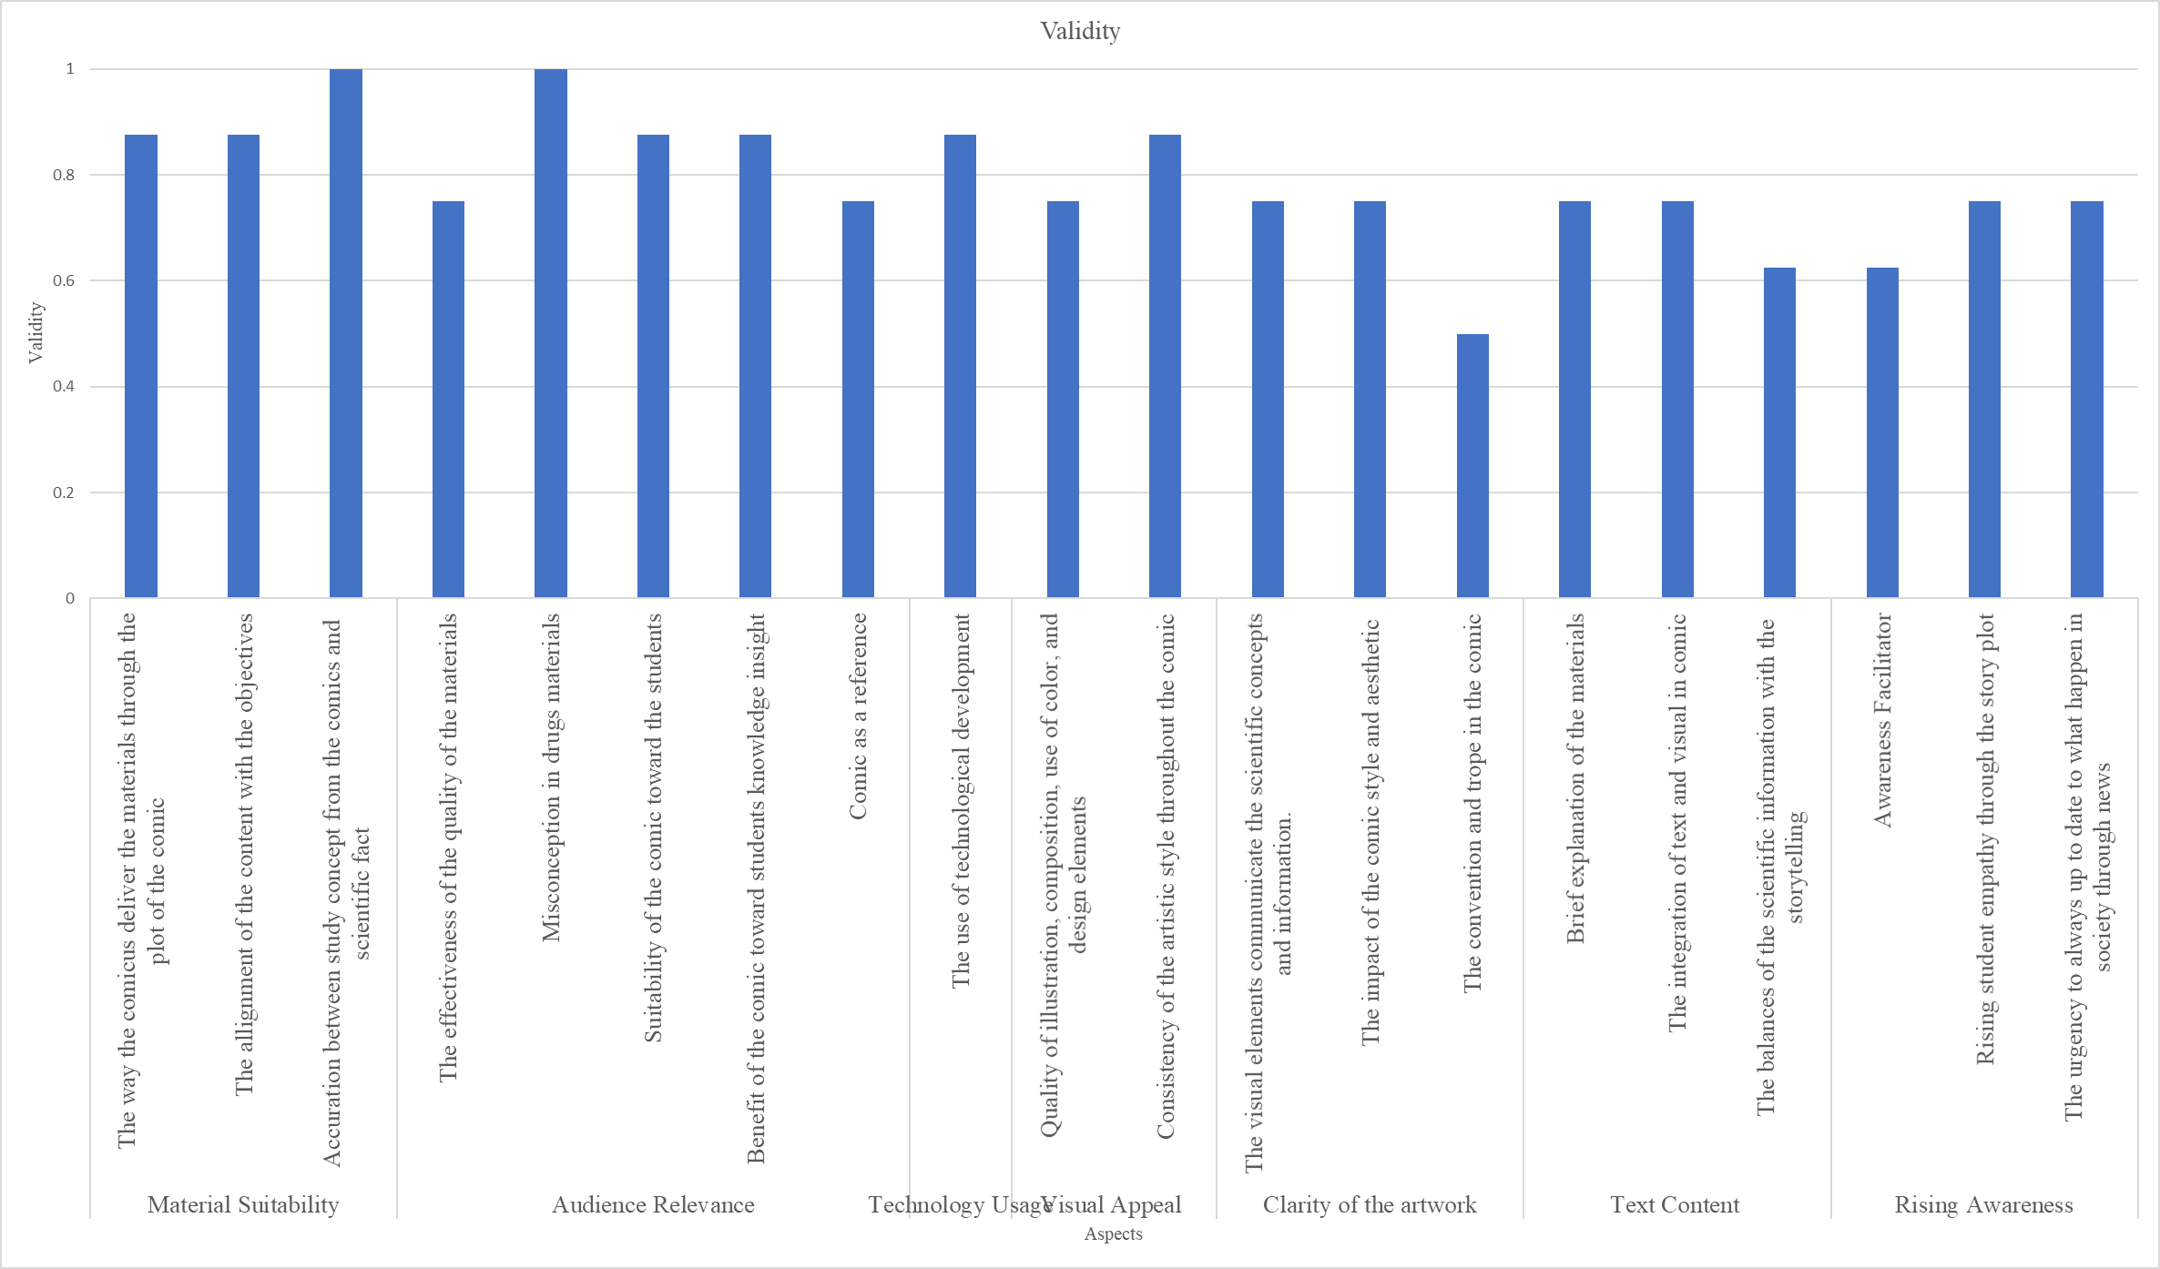

Figure 3.12 V Result from All Statement from the Teacher as the Expert Judgement

As what have been stated previously, all the data obtained proceed by using an index Aiken. Based on the index Aiken scoring, the range score of Aiken is between 0 – 1. The V index calculation allowed to categorize an item or device according to its index value. If the index resulted around 0.4 or below, it will be considered to have a low validity, while an index between 0.4 – 0.8 indicates to have a moderate validity, and if the index resulted above 0.8 it indicates as a high validity or very valid (Retnawati, 2016). That resulted, the closer the result of the index Aiken to 1 it can be considered as a ‘very valid’ content.

Figure 3.13 Science Aspect from Teacher Validity as the Expert Judgement

From the teacher’s judgement, it can be seen that there are some statements that got 1 as an index Aiken result, which can be considered as a ‘very valid’ content. As what stated in the index of Aiken, the index of Aiken that is below 0.4 can be stated as a ‘low validity’ or known as a ‘not valid’ while the index number that resulted between 0.4 until 0.8 can be considered as a ‘valid’, and the index number above 0.8 can be stated as a ‘very valid’ or ‘high validity’ content. Some of the statement also have an index of Aiken result below 0.8 but still above 0.4. The statement that has a value below 0.8 is the ‘the effectiveness of the quality of the materials’ statement and the ‘comic as a reference’ statement.

During the previous COVID-19 pandemic, teacher is required to be able to create an interactive media that can be used to teach. The media that should be use mostly is a digital media such as a video, e-book, website, or an online game (Husna & Fajar, 2022). After the pandemic done, many students do not interest in learning only by using the book, in here teacher are still required to make an interactive media to help grasp student understanding and curiosity. Teachers know how effective the media can be if used in their class. As shown on the Figure 3.13, the statement of ‘the effectiveness of the quality of the materials’ and the ‘comic as a reference’ have an index Aiken result of 0.75 which still considered as a ‘valid’ content.

Figure 3.14 Art Aspect from Teacher Validity as the Expert Judgement

From the Figure 3.14 it can be seen that most of the statement still considered as a valid because the value is still between 0.4 – 0.8 index Aiken. From the data above, it can be seen that the ‘The convention and trope in the comic’ statement has an index Aiken in 0.50. it considered as a ‘valid’ content but goes near to 0.4 point which can be considered as a ‘not valid’ content.

The connection between the art and the materials that delivered is stated in ‘The visual elements communicate the scientific concept and information’ means each element in the comic can delivered the meaning behind it. Is aligned with the statement ‘Artistry in science involves the ability to perceive patterns, connect various elements, and synthesize diverse information to create a coherent and meaningful understanding’ (Eisner & Powell, 2002). As stated before, this study validity of the content of the instrument was established by assessing the agreement among the experts. Expert agreement is relied upon to determine content validity because it confirms that the instruments accurately measure the intended abilities or traits. The index of Aiken validity is employed to gauge the level of the agreements among these experts (An Nabil et al., 2022). As in here, the teachers as the experts agree that there are still a lot of lacking in the art aspect of the comics.

Figure 3.15 Linguistic Aspect from Teacher Validity as the Expert Judgement

What shown on the Figure 4.15 can be considered as a ‘valid’ content because it has an index Aiken value between 04 – 0.8. The text that provides in the comic is a complementary of the visual that appears. As what stated from (Fatimah et al., 2019), that even the comics only shows a few words with a lot of pictures on it, teacher can still use this media to teach sone elements of language. Teacher also allowed to use comics as a media that can help improving student 5 skills; listening, understanding reading, oral interaction, speaking, and writing. By having a media with less words but has a lot drawings and colorful, it will grasp students’ attention and curiosity to learn about it. As what stated in the previous line, the words that appear in the comic is not only as a material delivered, but also as a complementary where students can understand specific elements such as emotion.

Figure 3.16 Awareness Aspect from Teacher Validity as the Expert Judgement

The Figure 3.16 shows the result of the Validity on Awareness aspect. In here it shows that the three statement are having an index Aiken value between the 0.4 – 0.8 which can be considered as a ‘valid’ content. In here both teachers agree that the digital comic might be helpful for increasing students’ awareness. This result is also aligned with the statement ‘short story can give an important content in raising cultural awareness, linguistic awareness, motivation, and are claimed to improve all the students four skill which is listening, reading, speaking, and also writing’ (Fatimah et al., 2019). In this case, the creator of the digital comic wants to make sure that student will get a motivation to not get near or trying to approach the drugs as what stated in the digital comic.

These all are the results of the 4 aspects from the expert judgement by the teachers. There is also some respond in the written section regarding to the comic, which;

“*it's my first time to read comic contains with educational purpose especially in Indonesia itself. thank you for the experience for letting me to read this, it's all great!”.*

3.2.3 Students Responses

Student respond is considered as valuable feedback that can be used to improve the learning media. In here, the student’s questionnaire consists of 20 statements with the score range using the Likert scale. Likert scale is used to measure the attitudes, opinions, and perceptions of an individuals or a group regarding to a specific phenomenon of interest. It consists of a 5 (five) range scale with can be written as SA = 5, A = 4, N = 3, D = 2, SD = 1 (M Priatna, 2008). The full rubric of the student’s questionnaire responses will be shown in the appendix (Appendix 5). The result of the students’ responses to the digital comic is shown on the table 3.3;

|  |  |  |  |
| --- | --- | --- | --- |
| Interval | Category | f | % |
|  |
| 100 | Strongly Agree | 17 | 56.67 |  |
| 69 - 84 | Agree | 10 | 33.33 |  |
| 53 - 68 | Neutral | 1 | 3.33 |  |
| 37 - 52 | Disagree | 2 | 6.67 |  |
| 20 - 36 | Strongly Disagree | 0 | 0.00 |  |
| Total | | 30 | 100 |  |

Table 3.3 Result of the frequency of each category

From the table above, it can be shown that the student mostly agree with the specific statement because the result of the strongly agree appear in more than 50% of the other statements. Here’s how the percentage of the answer appears on the pie chart Figure 3.17,

Figure 3.17 Pie Chart of the Percentage of the Range Score Appears

|  |  |  |  |
| --- | --- | --- | --- |
| Interval | Category | f | % |
|  |
| 100 | Excellent | 17 | 53.33 |  |
| 69 - 84 | Good | 10 | 33.33 |  |
| 53 - 68 | Fair | 1 | 3.33 |  |
| 37 - 52 | Poor | 2 | 6.67 |  |
| 20 - 36 | Very Poor | 0 | 0.00 |  |
| Total | | 30 | 100 |  |

While the results of the students after filled out the questionnaire can be categorized as a;

Table 3.4 Result of the Output of the Students Score Range Category

As shown from the Table 3.4 of the output of the students score range category shows that after reading the comic and filled out the questionnaire, around the total of the 16 Excellent came out, there is also 10 in total of Good, and 1 of the Fair resulted. The percentage is shows on the Figure 3.18 below;

Figure 3.18 Pie Chart of the Percentage of the Range Score Output of the Students

As shown on the Figure 3.18, it shows that 59.26% of the students got an Excellent result which mean 17 of the students strongly agree with most of the statement included in the questionnaire. From the chart also we can see that 10 students got a ‘Good’ score on the output of the questionnaire which means the students are ‘agree’ with almost all part of the statement inside the questionnaire. There is also 1 student who got a ‘Fair’ result in the output of the questionnaire which can be considered as a ‘Neutral’ with what stated inside the questionnaire. The other 2 students got a ‘Poor’ result in the output of the questionnaire which can be considerate as ‘Disagree’ with some parts of the statements inside the questionnaire.

From the students’ responses, it shows that most of the students like the art drawing and how the materials delivered through the comic. It helps the students to learn more about drugs and grasp the information easily. Some of the comments also shows that the panel and the bubble chat box is a bit confusing, and couple of grammatical errors is also appears. Asides from that, students also find out how important it is to shares the information about the drugs to the family and friends.

There’s also a comment that shows how the student feel while reading the comic, such as;

*“In my opinion is because that I don't really like comics, the comic itself cannot be said to be good or not because it’s depending on the use of the reader.”*

What shows in the comment is that the student suggests that not all the students like to read a comic, so the comic can be useful is depend on the students itself, weather they like to read the comic, or not. From the students respond also, the researcher find out that the student would like to share the information so that everyone will be aware about drugs;

*“I'm surprised at the good comic, which remind us danger of drugs. I just thought that drugs have bad influence for us, but I learned that we should share the information of drugs with our friends and family. thank you”*

From all the responses and suggestion that come from the students, it shows that the students find the comic useful to learn something new even with the hard terms that they never hear before. But it also a bit confusing because the panel and the bubble chat box didn’t show which one is the first and from where the students need to read. The language barriers can also be the factor of the students understanding when the teachers share the comic to the students, because it’s not only the comic full in English, but also because there are a lot of new terms that the student should learn.

## 4. Conclusion

This research explains about the development of the digital comic using the ADDIE model that consists of 5 stages. The comic focused on drugs topic in Junior High School. The topic was raised because of the phenomena that have occurred and become a hot topic in the public. This research was targeted to 30 students in total from 7th and 8th grade in Junior High School.

The judgment was done by lecturer and teacher as the expert judgment. From the expert judgement by the lecturer, it shows that the comic is an interesting media to use during the teaching and learning process. But the content of the comic itself still lacking on helping student improve their awareness and attitude towards the drugs, it because the comic content is still focusing on helping students understanding. While from the expert judgement by the teacher, it shows that the comic is quite good to be use as a learning media. It’s a new experience that might be helpful to improve student understanding.

From the student judgment collected by student responds in questionnaire, it shows that learning by using a comic is fun and interesting, also coupled by visualization of the certain scenes make it easier to understand because the drawing shows some visualization for the difficult materials. But the comic are still lacking in some part from the students comment, the panel and the bubble chat box that are still messy make it a bit confusing, such as where to start the reading, and which panel to start the reading. From the students’ responds it also shows that some student still has difficulties in understanding the new unfamiliar terms and the language that full with English. The result also shows how students now understand that it is important to always up to date to the current situation of our environment and how helpful it is to always spread the real information to family and friends.

# Acknowledgment

I thank Dr. Rika Rafikah Agustin, M.Pd as my first supervisor who always help me and guide me during my research. I also would like to thank Dr. Diana Rochintaniawati, M.Ed as my second supervisor who give me lots of advice and suggestion. I also thank students, teachers, and lecturer who are willingly participate in my research. Lastly I would like to thank the support and love that I got from my dear family and friends.

# References

Aen Rohaetul, & Kuswendi Uus. (2020). Meningkatkan Pemahaman Konsep IPA Siswa Sd Menggunakan Media Visual Berupa Media Gambar Dalam Pembelajaran IPA. *Journal of Elementary Education*, *03*, 3.

An Nabil, N. R., Wulandari, I., Yamtinah, S., Ariani, S. R. D., & Ulfa, M. (2022). Analisis Indeks Aiken untuk Mengetahui Validitas Isi Instrumen Asesmen Kompetensi Minimum Berbasis Konteks Sains Kimia. *PAEDAGOGIA*, *25*(2), 184. https://doi.org/10.20961/paedagogia.v25i2.64566

Andriyani, C. (2016). Pengertian kesadaran Siswa.

Ayu Kartina, A. (2019). Analisis Hasil Ujian Nasional Materi Zat Aditif dan Zat Adiktif SMP di Surakarta.

Bertram, D. (2007). Likert Scales …Are The Meaning of Life. http://www.performancezoom.com/performanceszoom_fichiers/likert.gif

Chapin, N. (2003). Encyclopedia of Computer Science. In *Encyclopedia of computer science*.

Cheung, L. (2016). Using the ADDIE Model of Instructional Design to Teach Chest Radiograph Interpretation. *Journal of Biomedical Education*, *2016*, 1–6. https://doi.org/10.1155/2016/9502572

Dittmar, J. F. (2012). Digital Comics. In *SCANDINAVIAN JOURNAL OF COMIC ART (SJOCA)* (Vol. 1, Issue 2).

Eisner, E., & Powell, K. (2002). *Special Series on Arts-Based Educational Research Art In Science?*

Etikan, I. (2016). Comparison of Convenience Sampling and Purposive Sampling. *American Journal of Theoretical and Applied Statistics*, *5*(1), 1. https://doi.org/10.11648/j.ajtas.20160501.11

Etikan, I. (2017). Sampling and Sampling Methods. *Biometrics & Biostatistics International Journal*, *5*(6). https://doi.org/10.15406/bbij.2017.05.00149

Eurich, T. (2018). What Self-Awareness Really Is (and How to Cultivate It).

Fatimah, A. S., Santiana, S., & Saputra, Y. (2019a). Digital Comic: An Innovation of Using Toondoo as Media Technology for Teaching English Short Story. *English Review: Journal of English Education*, *7*(2), 101. https://doi.org/10.25134/erjee.v7i2.1526

Fatimah, A. S., Santiana, S., & Saputra, Y. (2019b). Digital Comic: An Innovation of Using Toondoo as Media Technology for Teaching English Short Story. *English Review: Journal of English Education*, *7*(2), 101. https://doi.org/10.25134/erjee.v7i2.1526

Gravemeijer, koeno. (1998). Developmental Research as a Research Method.

Han, Y., Yan, W., Zheng, Y., Khan, M. Z., Yuan, K., & Lu, L. (2019). The Rising Crisis of Illicit Fentanyl Use, Overdose, and Potential Therapeutic Strategies. In *Translational Psychiatry* (Vol. 9, Issue 1). Nature Publishing Group. https://doi.org/10.1038/s41398-019-0625-0

Handrianto, C., Jusoh, A. J., Swee, P., & Goh, C. (2021). Using ADDIE Model for Designing Instructional Strategies to Improve Teaching Competency of Secondary Schooìs Teachers. https://www.researchgate.net/publication/352863787

Haris Budiman, D., Pd, M., Ftk, D., Raden, I., & Lampung, I. (2016). Penggunaan Media Visual dalam Proses Pembelajaran. *Jurnal Pendidikan Islam*, *7*.

Heo, M., & Toomey, N. (2020). Learning with Multimedia: The Effects of Gender, Type of Multimedia Learning Resources, and Spatial Ability. *Computers and Education*, *146*. https://doi.org/10.1016/j.compedu.2019.103747

Hughes, R. T. (1996). judgement as an estimating method. In *Information and Software Technology* (Vol. 38).

Husna, A., & Fajar, D. M. (2022). Development of Interactive Learning Media Based on Articulate Storyline 3 on Newton’s Law Material with a Contextual Approach at the Junior High School Level. *IJIS Edu : Indonesian Journal of Integrated Science Education*, *4*(1), 17. https://doi.org/10.29300/ijisedu.v4i1.5857

Jatmika, H. (2005). Pemanfaatan Media Visual dalam Menunjang Pembelajaran Pendidikan Jasmani di Sekolah Dasar.

Kaloeti, D. V. S., Manalu, R., Kristiana, I. F., & Bidzan, M. (2021). The Role of Social Media Use in Peer Bullying Victimization and Onset of Anxiety Among Indonesian Elementary School Children. *Frontiers in Psychology*, *12*. https://doi.org/10.3389/fpsyg.2021.635725

Levine, D. A. (2007). “Pharming”: The Abuse of Prescription and Over-The-Counter Drugs in Teens. www.erowid.org/chemicals/dxm/faq/dxm_faq.shtml

M Priatna, B. A. (2008). Uji Coba Instrumen Penelitian dengan MenggunakanMS Excel dan SPSS BAPM. http://file.upi.edu/Direktori/FPMIPA/JUR._PEND._MATEMATIKA/196412051990031-BAMBANG_AVIP_PRIATNA_M/Makalah_November_2008.pdf

McNicol, S. (2017). The Potential of Educational Comics as a Health Information Medium. *Health Information and Libraries Journal*, *34*(1), 20–31. https://doi.org/10.1111/hir.12145

Mims, M. (2022). *Fresno County Sheriff’s Office 2020 Coroner Unit Statistics*.

Morin, A. (2011). Self-Awareness Part 1: Definition, Measures, Effects, Functions, and Antecedents. *Social and Personality Psychology Compass*, *5*(10), 807–823. https://doi.org/10.1111/j.1751-9004.2011.00387.x

Mumtahanah, N. (2014). Penggunaan Media Visual dalam Pembelajaran PAI. In *HIKMAH Jurnal Studi Keislaman* (Vol. 4, Issue 1).

O’brien, L. (1989). Learning Styles: Make The Student Aware.

O’Keeffe, G. S., Clarke-Pearson, K., Mulligan, D. A., Altmann, T. R., Brown, A., Christakis, D. A., Falik, H. L., Hill, D. L., Hogan, M. J., Levine, A. E., & Nelson, K. G. (2011). Clinical report - The Impact of Social Media on Children, Adolescents, and Families. In *Pediatrics* (Vol. 127, Issue 4, pp. 800–804). https://doi.org/10.1542/peds.2011-0054

Peterson, C. (2003). Bringing ADDIE to Life: Instructional Design at Its Best. In *Jl. of Educational Multimedia and Hypermedia* (Vol. 12, Issue 3).

Porter, A. C., Smithson, J., Blank, R., & Zeidner, T. (2007). Alignment as a Teacher Variable. *Applied Measurement in Education*, *20*(1), 27–51. https://doi.org/10.1080/08957340709336729

Retnawati, H. (2016). Analisis Kuantitatif Instrumen Penelitian. www.nuhamedika.gu.ma

Richey, R. C., & Klein, J. D. (2005). Developmental Research Methods: Creating Knowledge from Instructional Design and Development Practice. In *Journal of Computing in Higher Education Spring* (Vol. 16, Issue 2).

Riyana, C., & Pd, M. (n.d.). *Komponen Pembelajaran A N N*.

Rodríguez Estrada, F. C., & Davis, L. S. (2015). Improving Visual Communication of Science Through the Incorporation of Graphic Design Theories and Practices Into Science Communication. *Science Communication*, *37*(1), 140–148. https://doi.org/10.1177/1075547014562914

Ruiz-Colón, K., Chavez-Arias, C., Díaz-Alcalá, J. E., & Martínez, M. A. (2014). Xylazine Intoxication In Humans and Its Importance as an Emerging Adulterant In Abused Drugs: A Comprehensive Review of the Literature. In *Forensic Science International* (Vol. 240, pp. 1–8). Elsevier Ireland Ltd. https://doi.org/10.1016/j.forsciint.2014.03.015

Saputra, H., & Pasha, D. (2021). Comics as Learning Medium During the Covid-19 Pandemic. In *PROC. INTERNAT. CONF. SCI. ENGIN* (Vol. 4).

S.E. Jorgensen, B. H.-S. (2000). *Chemosphere 40*.

Sholihah, M., HidayatulBahiroh, & SahalHadi, M. (2019). Penggunaan Media Visual dalam Meningkatkan Minat Belajar Siswa.

Sholihah Mar’atus, HidayatulBahiroh, & SahalHadi Mohammad. (2019). Penggunaan Media Visual dalam Meningkatkan Minat Belajar Siswa.

Sukiman, M., & Pd. (2012). Pengembangan Media Pembelajaran. www.insanmadani.com

Vassilikopoulou, M., Retalisa, S., Nezi, M., & Boloudakis, M. (2011). Pilot Use of Digital Educational Comics in Language Teaching. *Educational Media International*, *48*(2), 115–126. https://doi.org/10.1080/09523987.2011.576522

Yunus, M. MD., Salehi, H., Tarmizi, A., Idrus, S. F. S., & Balaraman, S. S. A. (2011). Using_Digital_Comics_in_Teaching_ESL_Wri. *Recent Researches in Chemistry, Biology, Environment and Culture*.

# Highlights

Students understanding and media are two things that influenced one another. It shows in the result that comic left a deep impression of a specific topic that discussed in the comic. Comic can visualize many difficult material using a drawing, and it helps students to understand more about the drug topic. The result shows that students are likely to read a comic because of the drawing and the simple delivered of the topic.

# **Associated Contents**

ABSTRACT 4

1. Introduction 5

2. Method 8

3. Result and Discussion 11

**3.1 Characteristic development of each comic stage** 11

3.1.1 Analysis stage 11

3.1.2 Design Stage 17

3.1.3 Development Stage 17

3.1.4 Implementation Stage 21

3.1.5 Evaluation stage 21

**3.2 Expert Judgment** 21

3.2.1 Lecturer Expert Judgement 23

3.2.2 Teachers’ expert judgement 30

3.2.3 Students Responses 35

4. Conclusion 39

Acknowledgment 40

References 40

Highlights 45