Table Lists
Tabel 1. Research design.
Class | Pre test | Treatment | Post test
Eksperimental | O | X C₁ | O
Control | O | X C₂ | O

Table 1. Descriptive statistic of creative thinking skill.
 | Experiment Group |  | Control Group |  | Effect Size  Cohens (d)
 | <g> | Std.Dev | <g> | Std.Dev | Effect Size  Cohens (d)
Creative Thinking Skill | 0,69 | 0,63 | 0,49 | 0,70 | 1,09
*α = 0,05
** p-value<0,05

Table 2. Descriptive statistic indicator of creative thinking skill.
Indicator of creative thinking skill | Experiment Group |  | Control Group |  | Effect Size  Cohens (d)
Indicator of creative thinking skill | <g> | Std.Dev | <g> | Std.Dev | Effect Size  Cohens (d)
Fluency | 0,78 | 0,50 | 0,58 | 0,66 | 1,31
Flexibility | 0,80 | 0,56 | 0,60 | 0,68 | 1,45
Originality | 0,49 | 0,63 | 0,32 | 0,51 | 1,62
*α = 0,05
** p-value<0,05

Table 3. Mann-Whitney Gain Test Results
Data source | Class | Sig. | Decision
N-Gain | Eksperimental | 0,000 | There are significant differences

Differences in Increasing Creative Thinking Skills every aspect
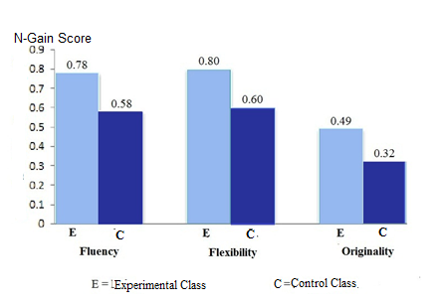
Figure 1. The Difference Diagram of each Aspect

