The Development of Science Comic in Human Digestive System Topic for Junior High School
Nelah Roswati^{1*}, Nuryani Y. Rustaman ², and Ikmanda Nugraha¹
¹International Program on Science Education, Faculty of Mathematics and Science Education, Universitas Pendidikan Indonesia
²Department of Biology Education, Faculty of Mathematics and Science Education, Universitas Pendidikan Indonesia
*Corresponding Author. ikmandanugraha@upi.edu

ABSTRACT
The engagement of science education has been covered by using teaching media, the popular media that usually used is printed media. One of popular printed media that actually most accessible and may be used in science education classroom as instructional tool is comic book. However, it is sometimes difficult to find the ideal and the appropriate comic books that can be used as the instructional tool of science education, because most of them are inappropriate for learning science and did not fit with the readers’ culture. The purpose of this study is to develop and evaluate the science comic to contribute science learning about human digestive system topic concepts. In this study a science comic book was created and implemented to 92 students of year eight from three different junior high schools and three science teachers as a subject implementation development. Students’ responses through the questionnaire and students-teachers implementation test sheets were evaluated through qualitative content analysis. The result shows, most of the students agreed that science comic book help them to learn learning through simplifying science concept and understanding the topic easier. Science comic book also help them to learning science more enjoy because the presence of humor and uniqueness aspect of the science comic book.
Keywords
Instructional Media, Science Comic Book, Human Digestive System Topic

1. Introduction
In many countries, the engagement of science education and communication has been emphasized using teaching media. Teaching media that is used usually in the form of printed media such as books, magazine, and newspaper (Falk, Storksdieck, & Dierking, 2007). The use of teaching media in science education is an important issue because science education mostly appears through the public media such as newspapers, magazine, radio and television that people learn mostly about what they know about science (Detjen, 2014). A recent survey from Media Studies Centre or Roper Centre found that 68% of the public get most of their science information in an environment from television, 59% from the newspaper, 32% from the magazine, and 30% from the radio. The result of the US government is even farther back at 24%, schools are 19% and local business also corporations are far down the list at 11% and 9% (Detjen, 2014).
Among the popular media, printed media has a strong capability to communicate science education because they are available to all various location such as public or private (Gilbert & Lin, 2013). Although the availability of printed teaching media is good and effective to use in science education, the content of teaching media itself should be covered the need to communicate the fascination, joy, and utility of science (Hosler & Boomer, 2011). The reality says different, most of the printed teaching media cannot bring these needs, one of the common example is a traditional science textbook. Among a variety printed media, comics are believed as a potential means of conveying scientific information that could cover fascination, joy and the utility of science because the contamination of humour as the specific feature of comics may attract many people’s attention, interest, and enjoyment (Tatalovic, 2009).
Moreover, the production of science comic nowadays is not always to be proper by its way. Most of science comic production focus on one aspect only without considering the sense of comic itself, and this condition is aggravated by the fact that science comic for science teacher is sometimes difficult to find (Ozdemir, 2016). Therefore, the present science comic that is ideal for science teaching should be developed along with this study.
This study focused to develop and evaluate a number of comic book that contribute learning about Human Digestive System topic. The topic is for 8th grade Junior High School students in the first semester. This topic chapter will be emphasized on the concept of the human digestive system process and organ's roles also added by the effort to maintain the health of human digestive system concept. To produce better science comic book, this development is focused on several aspects such as science content, sense of artwork that includes of humour and uniqueness, and the language aspect. The validation is conducted by the experts to check the suitability of science comic before science comic is implemented to the science teachers and student for the pilot study.
- Science Comic in Science Education
The difference between comic strip and comic book in presentation aspect support that science comic book is more available to deliver the science information because there is no limitation for both frames and words to explain the story. This statement supported by the fact that comic book and animated cartoon can be used as media communication of education, especially in science education. Many common comics have put the reference about the scientific facts and ideas. Besides, comics are a famous art form especially for the children and they provides a potential medium for science education and communication (Tatalovic, 2009). To make this study focus, the development of science comics has been improved based on three aspects (Lin S. F., Lin, Lee, & Yore, 2014) those aspects that have been considered consist of humour, contextualize learning, and visualize learning.
- Human Digestive System Study
Discipline-specific knowledge of Biology has been developed in the fields of developmental physiology and cognitive physiology. The investigation of children's knowledge about the concept in Biology especially in Human Digestive System Topic is formed have gathered momentum in pre-school education research in the last 30 years (AHİ, 2017). Through the amount of research, many researchers found that biological knowledge viewpoint by the students is always increasing. There is a paucity of research that biological knowledge is always changing over time and depending on the developmental process (Geerdts, Walle, & LoBue, 2015).
On the contrary, Istikomayanti and Mitasari (2017) found that there are overcoming misconceptions in the learning process conducted by three teacher neither certified nor uncertified. The result of students’ misconception test were mostly reach only level 3 or medium, thus the study of misconception of the digestive system material needs to get attention of the teacher and educational practitioner.
- Research Question
With those explanation above, it can be stated that comic book may be used as teaching media in science classroom, however how instructional comic book should be designed and develop with scientific methods is not answered well. The purpose of this study is to develop a science comic book about human digestive system and to get the review from the experts during the development. After the construction of comic book has developed, the teachers’ feedback through the comic also analysed together with the students’ questionnaire and implementation test sheets. The results will be used as feedback for developing the better science comic book.

2. Method
- Research Methodology
The research design used in this study is a design and development. This type of research aiming to develop an instructional finding and solution to achieve a goal related to education or learning. This Research design working based on the existing theory and evidence, testing individual component and get feedback in the development process (Institute of Education Sciences [IES], 2013).
This study had two main stages: development and evaluation of science comic book about human digestive system concept that started from identification of problem, formulating research objective, curriculum and content analysis, aspect measurement analysis, the construction of science comic which included the creative process of writing the first outline & storyboard and drawing the comic with expert reviews. The evaluation stage consist of the implementation and analysis of participants’ responses. The participants’ responses were investigated through qualitative content analysis.

- Material
This study has been passed several stage and review to develop the science comic book in human digestive system. The study begin from the curriculum analysis as the science content development. The standard curriculum used in this study following Indonesian 2013 curriculum and focused on the process, organs, and how to maintain the health of human digestive system.
After the science content analysis has been constructed, the next stage is the analysis of science comic aspects as the measurement of this study. In briefly, there are four aspects of science comic that this study looking for. The aspect are consist of artwork, science content, language and uniqueness. Those aspect would be used as the main aspects to help the reviewers and the students focus on giving feedback and suggestion though the science comic development.
The feedback and score from the participant were collected from the score they given. The way how participants give the score is by giving assessment gradient. Table 1 below shows the assessment gradient of each indicator measurement that given by the participants.
After the analysis of science content aspect been done, the creative process of science comic construction can be started. In general, the stage of creative process consist of: writing the first outline of the comic, making the panels and storyboard, drawing the comic, reviewing by expert, and revising the comic. The first outline of the story in this comic tell that there are two-twin sibling that lived with their grandfather who become a professor. They live happily with one robot named Payjo. Every science phenomena that happen in their daily life always be asked by two sibling twin and Professor will always explain it to their child. In this series of comic book they were talking and explain about human digestive system, so that the topic explanation that they are discuss is about human digestive system and its been added by some humor, culture, unique and drawing style to make a good sequence of comic.
After finishing drawing, some experts reviewed the comic by using the instrument rubric that consist of several indicators from the aspects (artwork, science content, languages, and uniqueness). In order to develop final revision of the science comic book for implementation test, comic book were revised according to the feedback and suggestion from the experts. Two example of comic pages developed are shown in Figure 1.
- Implementation Test
On the implementation test, participants are consist of three science teachers and three group in 92 total of students in grade eight which are chosen from three different junior high school in Bandung city area, Indonesia. After getting the permission for implementation, the researcher start to conduct the test in different time because the location of the school is far each other.
The implementation process is the same for three of the classroom. After the science comic book printed on papers were given to the students, the students will be guided to read all the comic and directed to fill the questionnaire and implementation rubric test. The questionnaire and implementation rubric about the comic of human digestive system are listed in the Table 2.
After answering the questionnaire, the students are directed to fill the implementation rubric test that consist of several aspects measurement. The gradient measurement can be seen on Table 1. The indicator of each aspect can be seen on the Table 3. In addition to this study, the researcher also added the data of observation in class and the students’ interview after implementation. The result data will be analyze on the result session.
- Data Analysis
In this In this research, there are several sources of data: judgment review from the experts, students and teacher implementation result, the written answer of students’ questionnaire, observation during the implementation and students’ interview. Because these data are in verbal form and patterns that may be qualitative feedback, they were analyzed through qualitative content analysis. All data that have been obtained such as the review from the expert judgments, teachers-students implementation result, and written answer to the questionnaire will be analyzed.
The participants such as experts, teachers, and students as the main data of this research were coded for some categories in order to draw a meaningful pattern and to obtain useful feedback for the development process of instructional science comic. The analysis of all data obtain will be presented in percentage form before it is shown in table bar form for comparison and discussion result. The other data such as researchers' observation and interviews which are supplementary data of the study, were used to ensure the pattern in data from the questionnaire in the implementation process. In other words, the objective was to establish the validity of the results by using three different sources of the data.
The descriptive statistic will be used as the analysis of data technique. In this study, quantitative analysis was avoided because numeric results would not provide in-depth and detailed feedback for the development process of instructional science comic.

3. Result and Discussion
- Experts’ Review to Science Comic Aspects
The result of experts’ review divided into four aspects result. Each results were review and scored by the experts. The first is about the artwork aspect, this aspect consist of ten indicator that related to the artwork things of the science comic. Experts review through artwork aspect shows the positive value because each expert (coded by E1, E2, E3, and E4) give the positive feedback for each item indicator. The items that have the higher average score agreement of 90% are Image clear, characters, and cartooning humor. The item that has the medium score agreement of 80% are visualization item, and the items that have the lower score agreement of 70% are setting place or background item.
The second one is the science content aspect. Experts review through science content items shows a positive value and feedback. The higher score agreement is 90% placed on concept appropriateness and visualizes learning item. The medium score agreement is 80% placed on the specific example, learning experience, and thinking triggering item. And the lower score agreement is 70% placed on up-to-date item aspect.
The third is about language aspect. Both English and Indonesian language from the expert feedback shows that the sense of humor aspect get the higher score of 100% agreement Indonesian language and 93% agreement in English. The lower score gained by grammatical structure which get 73% in English and 60% in Indonesian Language.
The last aspect is about uniqueness aspect. From five items, one item of culture aspect gets the lower score agreement which is 70%. This indicates that culture aspect in this comic is not quite enough to be added, so this aspect should be changed or revised to gain the more score. Besides the score, experts also give some comments and suggestion through this aspect.
- Teachers’ Feedback Through Science Comic Aspect
The result of teachers’ feedback also divided into four aspects. The first aspect is artwork of science comic. The higher score gained on cartooning humor, visualization, balloon dialogue, and setting place. The score agreement is 93%. This score indicates that those item has filled the expectation of the teacher through the comic artwork. The rest items gain lower score which is framing, image clear, story flow, perspective, characters, body movement, and text. The average score agreement gained was 87% from 100% ideal score. The second aspect is about science content. The higher score which is 100% gained by Learning experience item. The medium score gained by up-to-date and enjoyable learning item which is 87% score, and the lower score gained by thinking triggering item which is 80% score from 100% ideal score.
The third aspect is about Language aspect. The higher score gained by understanding word which is 93% score. The medium score gained by word to expression, word to image, and scientific content dialogue which is 80% score. And the lower score gained by the grammatical structure which is 73% score from the ideal score agreement of 100%. The fourth aspect is about uniqueness. The data shows all item has the same score which is 93% in all item of relatable, unique and new, enjoyable learning, sense of humor and culture. This score indicates the positive feedback from all science teachers
- Students Responses through Science comic
Students’ responses through the science comic divided into two different data. The first is about students’ implementation test. This test allowing student to give the score on each aspect on the Table 3. The implementation test divided into four aspect which are artwork, science content, language and uniqueness.
The first aspect of artwork shows that 59.7% of student reputed that the image and text of the comic is very good. Beside that there are 52.1% of students agree that the expression of and text of the character in the comic is related to the story. The second aspect of science content aspect shows that 52.1% of students agree that the science content on the comic is good to understood. Beside that, 43.4% of the students agree that the image is very good to explain the science concept more easily.
The third aspect is about language aspect. There are 52.1% of students agree that the legibility of story and character and image is very good. Beside that, there are 42.3% choose that the science term used in the comic is good. In the last aspect of uniqueness shows that 60.8% of the students choose that the science comic is very good which are very interesting and unique to read.
The second is about students’ questionnaire result. Students’ questionnaire result conducted to 92 students of year eight from different schools. The analysis answer has been scored based on the rubric of each question. The lower score gained by students BJ-F-54 and BJ-F-55 (Students code, BJ means classroom two, F means female gender, and 54 means the number of student) which is 50 score. The highest score gained by student PN-M-03 (PN means classroom one, male gender, number three) and student BD-M-85 (BD means classroom three, male gender, number 85) which is 92 score. The average score gained from 92 student is 75.9 score.
After the average score is already obtained, the comparison between how many students get the lower score and higher score from the average score can be obtained. The results can be seen on the Figure 2. Figure 2 shows from the total number of students which are 92 students, there are 40 students get the lower score from the average score and there are 52 students get the upper score from the average score. The result means, the science comic can help the students to gain the average score and ease them to learn about human digestive system.

- Finding from Students’ Observation and Interviews
The observation class divided into three classroom which are PN, BJ and BD classroom. Each classroom are treated the same, but the language media used is different. PN classroom given English science comic book and the rest classroom is Indonesian language comic. All classroom give the positive feedback and attitude, especially in classroom BJ. In this classroom, all student shows a conducive class environment different from the other.
Beside that, the interview also conducted in this study. The researcher just focus on the students who got a lower score (student BJ-F-55) in questionnaire test which is 50 score. The answer that she filled to the question actually was out of topic and totally different from the science concept given to the comic story. But, what makes the researcher put attention to her result is, she gives a very good score to the readability test, which means these students is reputed that she can comprehend the comic. Actually, when the researcher asks this student, she is randomly giving the score and try to appreciate the researcher hard work through the science comic made, when filling the questionnaire, she also cheated to her friend. This BJ-F-55 student said that she cannot focus to read the science comic because she dislikes reading books, magazine, comics and other reading materials. So that she cannot comprehend the science comic better.

4. Conclusion
Based on the research result, there are some conclusion that can be reached. Firstly, step of making the science comic should following several steps such as curriculum content analysis, material source analysis, aspects measure analysis and making the storyboard and first outline to the creative drawing process. The drawing process can be categorized as the important process because in this step, the application of all plans will be realized in the form of sequential art and narrative text.
Secondly, the experts’ review toward science comic shows that all aspects consisted on the comic which are of artwork, science content, language, and uniqueness aspect mostly gain a good score but it needs to be revised. The feedback that experts give also shows a positive value because most of them tried to give a supportive feedback for science comic development.
Thirdly, the review from science teacher to all aspect measurement of science comic is categorized as good score. Science teachers agree that this science comic could give the good learning outcomes and the new experience to the students for learning science. Science teacher mostly criticized the grammatical and content aspect of the comic. Science teachers suggest to revise some grammatical structure on the comic text and reduce some science concepts that are not suitable for 8th grade student.
Forth, most of the students agree that science comic could help them to comprehend the science content more easily because they can enjoy the story and the knowledge with the addition of humor in the comic. This data can be proved because there are more 50% of students get the higher score compared to the average score (75.9 score) gained in questionnaire session. Therefore, it was concluded that developing science comic which consist of some humorous figures and clear narrative content could bring some interest for the students to learning science.

Acknowledgment
The authors acknowledge Mrs. Nuryani Y. Rustaman and Mr. Ikmanda Nugraha who has given the best suggestion, support, and improving the quality of this research.

References
AHİ, B. (2017). Thinking about digestive system in early childhood: A comparative study about biologcal knowledge. Cogent Education, 4: 1278650.
Çimer, A. (2012). What makes Biology learning difficult and effective students' views. Educational Research and Reviews, Vol. 7(3), 61-71.
Detjen, J. (2014). The Media's Role in Science Education: The public in interested in news about science and the environment. Oxford University Press and American Institute of Biological Sciences in collaboration with JSTOR, S-58.
Eisner, W. (1985). Comics & Sequential Art. Tamarac: Poorhouse Press.
Falk, J. H., Storksdieck, M., & Dierking, L. (2007). Investigating public science interest and understanding: Evidence for the importance of free-choice learning. Public Understanding of Science, 16(4), 455-469.
Geerdts, M. S., Walle, G. A., & LoBue, V. (2015). Daily animal exposure and children's biological concepts. Journal of Experimental Child Psychology, 130, 132-146.
Gilbert, J., & Lin, H. (2013). How might adults learn about new science and technology? the case of nanoscience and nanotechnology. International Journal of Science Education, Part B, 3(3), 267-292.
Hosler, J., & Boomer, K. (2011). Are Comic Books an Effective way to engage nonmajor in learning and appreciating science? CBE-Life Sciences Education, 309.
Istikomayanti, Y., & Mitasari, Z. (2017). Students' misconception of igestive system materials in MTs eight grade of Malangcity and the role of teachers' pedagogic competency in MTs. Jurnal Pendidikan Biologi , 103-113.
Kemendikbud. (2017). Model Silabus Mata Pelajaran SMP/MTs IPA (Syllabus Model for Junior High School Subject Topic) . Jakarta: Kementrian Pendidikan dan Kebudayaan.
Lin, S. F., Lin, H. s., lee, l., & Yore, L. D. (2014). Are Science Comics a Good Medium for Science Communication? The Case for Public Learning of Nanotechnology. International Journal of Science Education, Part B, 1-19.
Lin, S., Lin, H. S., Lee, L., & Yore, L. D. (2014). Are Science Comics a Good Medium for Science Communication? The Case for Public Learning of Nanotechnology. International Journal of Science Education, Part B, 1-19.
Negrete, & Aquiles. (2013). Constructing a comic to communicate scientific information about sustainable development and natural resources in Mexico. Procedia - Social and Behavioral Sciences 103 ( 2013 ) 200 – 209 13th, 200-209.
Ozdemir, E. (2016). Humor in Elementary Science: Development and Evaluation of Comic Strip about Sound. International Electronic Journal of Elementary Education, 9(4), 837-850.
Tatalovic, M. (2009). Science Comic as tools for science education and communication: a brief, exploratory study. Journal of Science Comminication, 1-17.

Table Lists
Table 1 Assessment Gradient on the Rubric for Each Indicator Measurement
Assessment (√) Gradient Scale
Very Poor | Poor | Enough | Good | Very Good
1 | 2 | 4 | 5 | 6

Table 2 Students’ Questionnaire about Human Digestive System
No | Question | Aspect
1. | What is the story of the comic? Can you explain it using your own words? | General information about science comic
2. | Who are the characters of the comics? Can you call it one by one? | General information about science comic
3. | How is the process of digestion happen in the mouth? | Science content understanding
4. | During swallowing, the food that will be transferred to the esophagus from the mouth will be shaped like a food ball. What is it called? | Science content understanding
5. | Why does the condition of the stomach should be acid? | Science content understanding
6. | Why should small intestine be longer than the large intestine? | Science content understanding
7. | Please mention three accessory organs based on comics you have read! | Recalling knowledge
8. | What is the function of the appendix in the small intestine? | Recalling knowledge
9 | Why should we clean our hand after going back from the toilet? | Recalling knowledge
10. | Mention three good eating habits for human especially for children! | Recalling knowledge

Table 3 Table 3. Students’ Implementation Rubric
No | Aspect | Indicator
1. | Legibility | I can understand the story, characters, and image easily
2. | Science Content | The story of each organ can be easy to understand.
3. | Characters | The characters of the comic give the strong personality to explain the story
4. | Image and Text | I can see the image and text balloon in the comic is related to each other
5. | Learning outcomes | I think comic gives learning more easy to understand
6. | Science Terms | The science term that used in the comics is understandable for me.
7 | Image to content | The comic gives me an easy image to explain science concept more easily
8. | Ambiguous words | There are no difficulties for me to comprehend this comic (there are no ambiguous words)
9. | Expression character to the story | The expression and the text of the characters are related to the story
10. | Uniqueness | This comic is interesting and unique to read

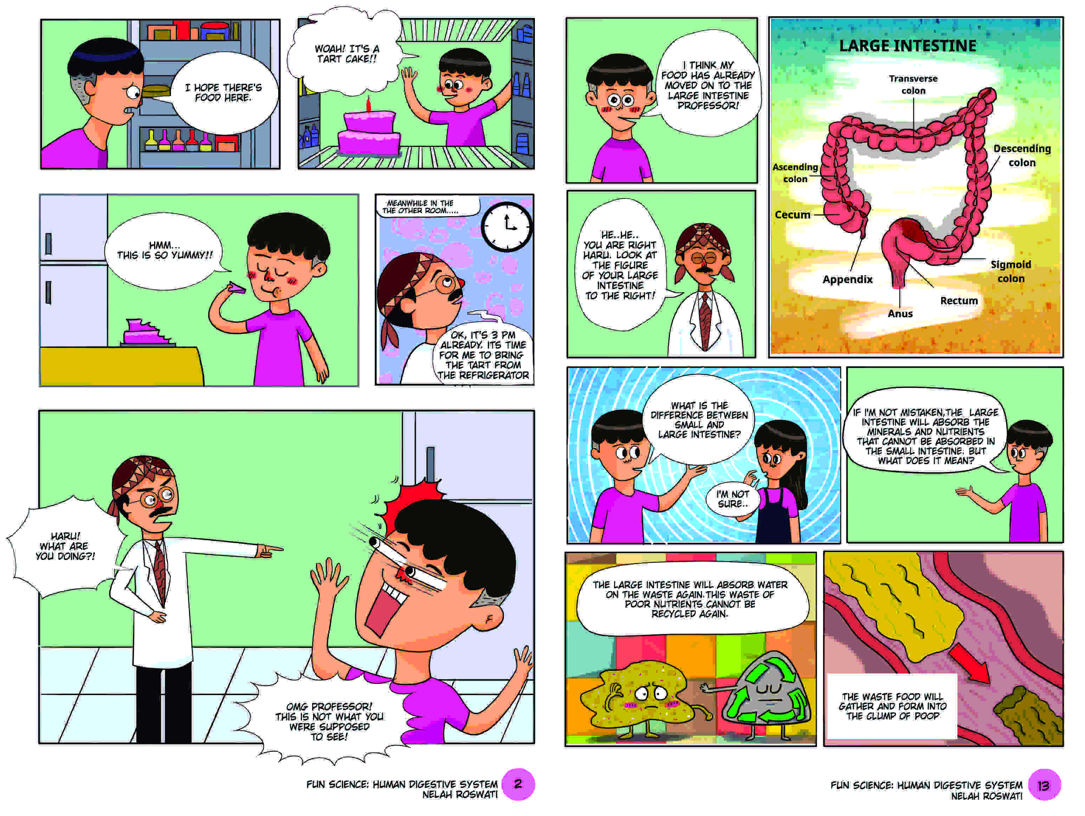
Figure Lists

Figure 1. The Example of Two Pages of Comic Book Developed in This Study
Figure 2. The Comparison of Students’ Average Score

Highlights
- Science comic is one of effective printed teaching media
- Humor can be illustrated by the narrative to transfer the information of science
- Science comic can covered the need to communicate the fascination, joy and utility of science

