Tabel List
Table 1 Black Box Testing Results
Input/Even | Process | Output/Next Stage | Test Results
"Periodic Table" button” | 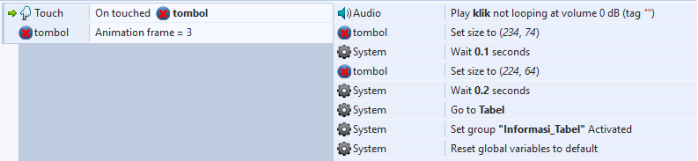 | Showing Periodic Table Menu | Valid
"List of Elements" button | 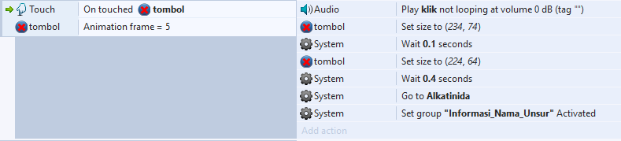 | Showing Element List Menu | Valid
"Chemical Experiments" button | 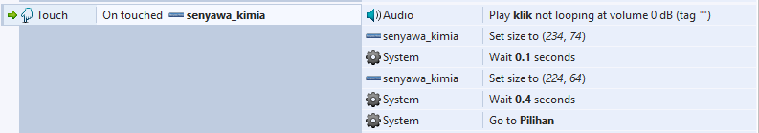 | Showing  Animation Options Menu  Appropriate | Valid
"Play" button | 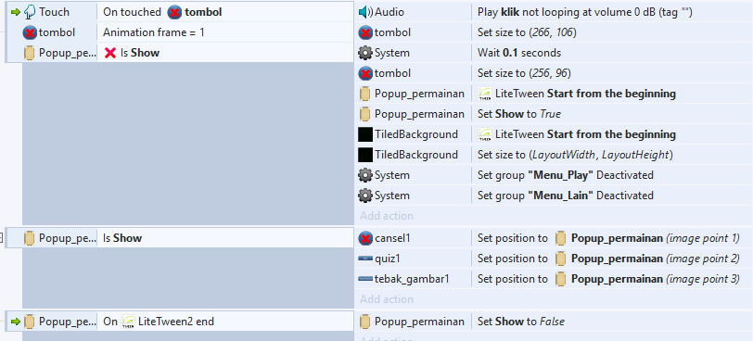 | Showing Game Options Menu | Valid
Input/Even | Process | Output/Next Stage | Test Results
“Informasi” Button | 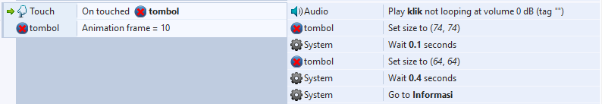 | Showing Information Menu | Valid
“Exit (X)”  Button | 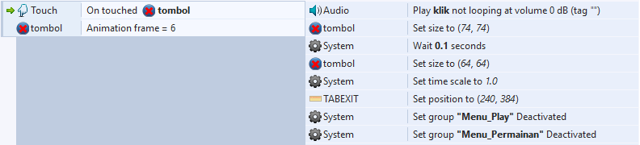 | Showing  Exit Confirmation Menu | Valid
“Quiz Game” Button | 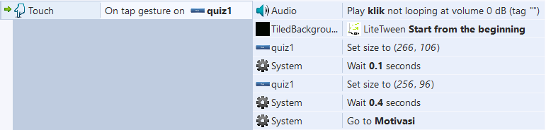 | Showing Motivation Menu | Valid
"Picture Guessing Game" button | 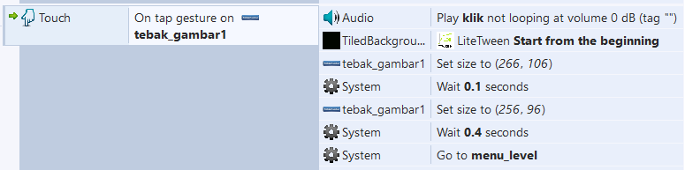 | Showing Level Menu | Valid
Input/Even | Process | Output/Next Stage | Test Results
“Back  (<<)” Button | 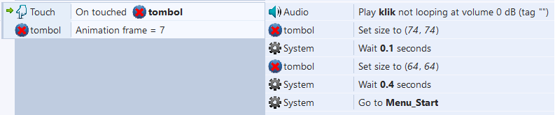 | Back to Previous Menu | Valid
Periodic Table Element Options" button |  | Showing the Periodic Table Explanation Menu | Valid
Element List Options button | 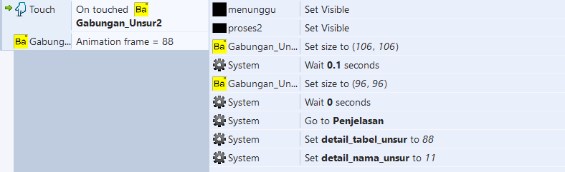 | Showing the Explanation Menu List of elements | Valid
Input/Even | Process | Output/Next Stage | Test Results
“Riset” Button | 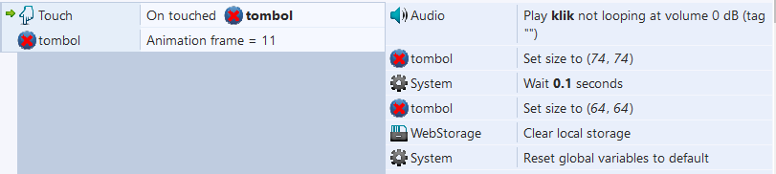 | Showing The Level of Re-Greed | Valid
“Level Option” Button | 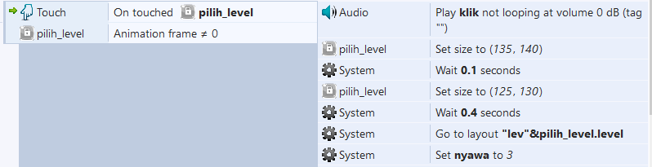 | Showing  Picture Guessing Game | Valid
“Solvent PH” Button | 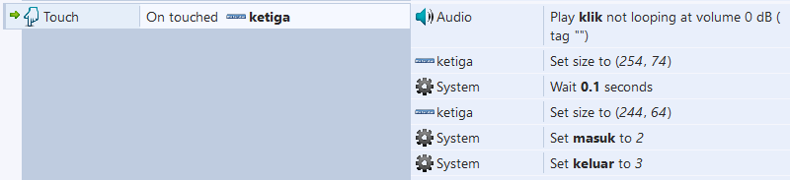 | Showing Ph Solution Animations | Valid
“Answer Quiz" button | 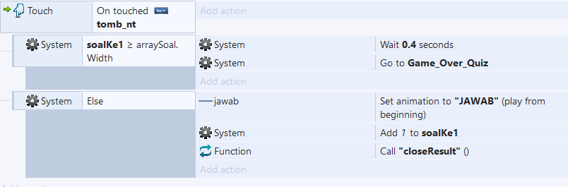 | Answering Questions, And Displaying True or False Information | Valid
Input/Even | Process | Output/Next Stage | Test Results
"Exit Quiz" button | 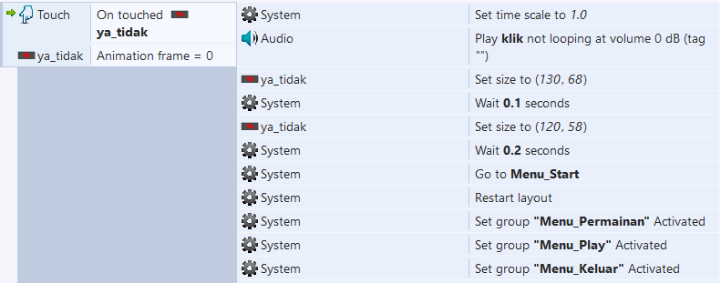 | LogOut of Qiuz, And Go Back To The Previous Menu | Valid

