DYNAMIC CAPABILITIES IN THE CREATIVE ARTS INDUSTRY

Ghia Ghaida Kanita (ghiaghaida@upi.edu)
Resa Respati (respati@upi.edu)
Universitas Pendidikan Indonesia (UPI)

ABSTRACT

Dynamic ability is a form of knowledge that can create values ​​for the company both with the results of innovation and transformation from input to output in order to produce sustainable competitive advantage. The purpose of this research is to know about what factors influence dynamic capabilities of a company or organization. In this study, more than that, what affects the dynamic capabilities in industries in Bandung. Creative industry is a collection of information related to information and information. Creative industry is an economic activity that produces added value from the art side. The creative arts industry is already boooming in Indonesia. Therefore, the author wants to learn about the dynamic capabilities that exist in the creative arts industry in Bandung. Things to look for are components such as environmental sensing capabilities, change capabilities and upgrades, technological flexibility capabilities, and organizational flexibility. Putri Pamayang Dance Studio is a dance studio in Bandung. This study uses a research-based design or Design Based Research (DBR). Based on the results of the study, the steps adopted by the Putri Pamayang Dance Studio are related to variation strategies, market testing strategies, development and development, backward integration, horizontal integration.

Keywords: Dynamic Capabilities, Sustainable Competitive, Environmental Sensing Capabilities, Change and Renewal Capabilities, Flexibility Technology Capabilities, and Organizational Flexibility.
INTRODUCTION
Researchers and practitioners agree that dynamic capabilities greatly affect sustainable competitive advantage. This is evident from a variety of studies that reveal the importance of dynamic capabilities within a company or organization to support competitive performance in a competitive market. The company or organization continues to conduct competition or competition globally in rapidly changing market conditions or called dynamic. Therefore, companies or organizations really need to improve dynamic capabilities that can provide adjustments to dynamic changes that occur.
Change is a maneuvering movement that occurs, causing a difference from the previous condition. Of course from time to time many changes have occurred, this is also due to the role of increasingly sophisticated or modern technology. This change will certainly have a different effect on the company or organization. In this case, a company that is able to adjust to the changes that occur will be able to dominate the market and be able to survive in the midst of tighter competition. But for companies or organizations that are unable or difficult to adapt to the rhythm of changes that occur quickly and dynamically will cause these companies or organizations unable to survive in the midst of existing market competition.
Therefore the writer wants to know and study about what factors affect the dynamic capabilities of a company or organization. In this study, more specifically, the writer wants to know about the factors that influence dynamic capabilities in the creative arts industry. Because according to Bekraf 2017 data, the creative arts industry has increased. That is also because the community's need for the creative arts industry is getting bigger.

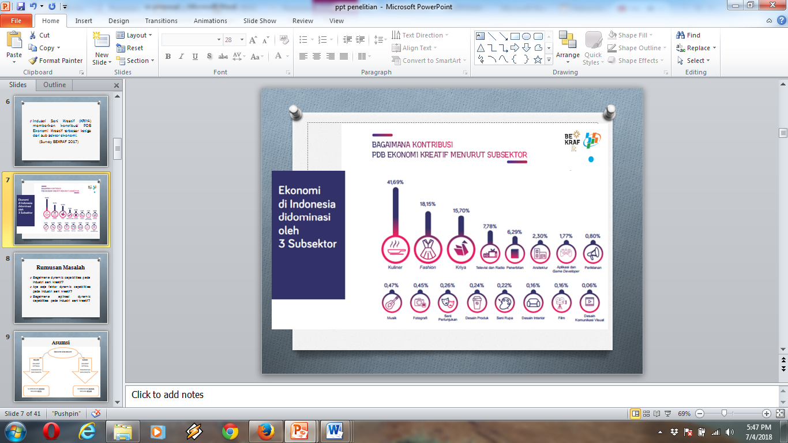
Figure 1. Contribution of the Creative Arts Industry According to Bekraf 2017

Creative arts industry is one of the industrial sectors that provide foreign exchange. However, the management and management of the creative arts industry has not been worked on by either the government or the private sector. Yet it is clear that this industry provides a large contribution if it is able to be managed properly. Based on the results of previous studies, the lack of facilities and infrastructure is an obstacle to the difficulty of the development of the creative arts industry.
From the conditions above, researchers assume that, with the dynamic capabilities in the creative arts industry will be able to encourage to be more productive and developing.
Based on the results of researchers' observations of the creative arts industry, researchers found that the creative arts industry was less than optimal, the lack of use of the media to market products in the creative arts industry. This happens because basically to be able to manage the creative arts industry management strategies needed in this case appropriate dynamic capabilities so as to optimize the performance that exists in the creative arts industry. So there are obstacles for the movers of the creative arts industry to manage and market their products. While the competition from other industries is getting bigger, so a strategy is needed to be able to reverse the situation, namely with dynamic capabilities.
The output of this research is a real breakthrough that can be applied from dynamic capabilities in the creative arts industry. So that it can encourage the progress and development of the creative arts industry even better. The output is expected to make a positive contribution and can be put to good use by many parties. In addition, this research will also produce articles containing information on research results and can be developed for further research.
The idea of ​​dynamic capabilities was first presented by Teece et al. (1997) "dynamic capabilities by which firm managers integrate, build, and reconfigure internal and external competencies to address rapidly changing environments become the source of sustained competitive advantage". Teece's view of dynamic capabilities is about how the ability of company or organizational managers in integrating, building and configuring corporate or organizational competencies both from internal sources and from external sources to be able to adapt to rapid environmental changes, thus making internal competencies and external as a source of sustainable competitive advantage. Furthermore, in 1997 further research was carried out to increase understanding of the relationship of dynamic capabilities to increase competitive advantage. Teece et al. (1997) "Dynamic capabilities are often characterized as unique and idiosyncratic processes that emerge from path-dependent histories of individual firms." Dynamic capabilities have unique and different characteristics that give rise to a separate history for the company. Because the company should have special characteristics that are able to distinguish these companies from similar companies. The uniqueness or uniqueness in a company is the main attraction.
According to Barney (1991) "dynamic capabilities are processes embedded in firms, assuming an organizational and empirical lens, rather than an economic and formal modeling one". So according to Barney that dynamic capabilities are processes that are embedded in the company, meaning that these values ​​are already in the company in the form of internal competence. According to Peteraf (1993) "the examine of dynamic capabilities, how those capabilities are influenced by market dynamism and their evolution over time." According to Peteraf that to measure dynamic capabilities is to measure the capabilities or capabilities that are influenced by dynamic market mechanisms and their evolution.
According to Eisenhardt and Martin (2000) in a journal entitled 'dynamic capabilities: what are they?' Said that "Dynamic capabilities are the firms' processes that use resources - specifically the processes to integrate, reconfigure, gain and release resources - to match and even create market change. Dynamic capabilities thus are the organizational and strategic routines by which the firm achieves new resource configurations as markets emerge, collide, split, evolve, and die. "Thus it can be said that dynamic capabilities are processes of companies or organizations that use specific resources to be matched with changes in the existing market with the aim to adjust to the dynamic changes that occur in the market. In addition dynamic capabilities are also a configuration of resources in accordance with the product life-cycle, namely emerge, collide, split, evolve, and die. Eisenhardt and Martin (2000) "Dynamic capabilities consist of specific strategic and organizational processes such as product development, alliancing, and strategic decisions making that create value for firms in dynamic markets by manipulating resources into new value-creating strategies." According to the views of Eisenhardt and Martin clearly that dynamic capabilities is a special strategy that is able to make strategic conclusions that create new value for companies in dynamic markets by manipulating or changing existing resources in order to be able to create new strategic values.
According to Grant (1996), and Pisano (1994) "dynamic capabilities are the antecedent organizational and strategic routine by which managers alter their resource base to acquire and shed resources, integrate them together, and recombine them-to generate new value-creating strategies. "Then dynamic capabilities are the whole organization or company and strategic routines in which managers are able to change the resources obtained and the resources provided and are able to pool these resources together and combine them well so as to create a new strategic value.
Henderson and Cockburn's (1994) views; Teece et al. (1997) "Dynamic capabilities are the drivers behind the creation, evolution, and recombination of other resources into new sources of competitive advantage." Dynamic capabilities are said to be the roots of the creation, evolution, and recombination of resources to later become sources new to get competitive advantage.
Kogut and Zander (1992) "Dynamic capabilities are organizational processes by which firms synthesize and acquire knowledge resources, and generate new applications from those resources." Dynamic capabilities are part of the process of organizations or companies where companies get knowledge resources and then resources these are integrated into new applications from available resources.
Clark (1994) "The concept of dynamic capabilities recognizes that especially companies operating in changing environments need to be able to develop dynamic view perspectives on the resources and competences in order to create competitive advantage is developed." So dynamic capabilities are seen from the effects of environmental change for companies that need to improve their perspective from a dynamic view of existing resources and competencies to create competitive advantage.
According to Grunbaum (2013) in a journal entitled 'dynamic capabilities-are they profitable?' Stated that "dynamic capabilities are the internal processes with the purpose of modifying the resources of a given organization." So dynamic capabilities according to Grunbaum are more focused on internal processes within the company or organization itself whose purpose is to modify the resources provided by the organization or company.
Hansen (1999) "Dynamic capabilities focus on reconfiguration of resources within firms, transfer processes including routines for replication and broking are used by managers to copy, transfer, and recombine resources, especially knowledge-based ones, within the firm." Dynamic capabilities are more focus on reconfiguring company resources, the process is carried out by company managers who copy, transfer and recombine resources, especially those based on knowledge.
According to Evers (2011) in a journal entitled 'International new ventures in low tech sectors: a dynamic capabilities perspective' it is said that "dynamic capabilities are actually developed and manifested in international new ventures." In this case the contribution of dynamic capabilities is more focused on the knowledge sector and technology that develops intensively over time. This provides new opportunities for INVs to further develop in the economic sector.

Helfat and Peteraf (2003) "Dynamic capabilities are the approaches to understanding business firm builds upon the basic assumptions of resource-based theory through its assertion that these unique firm capabilities develop over time." Dynamic capabilities are an approach to understanding company business based on theory a resource base that enables unique company capabilities to flourish.
According to Jiao (2013) in a journal entitled 'Environmental dynamism, innovation and dynamic capabilities: the case of China' said that "dynamic capabilities are the development of management capabilities and difficult to imitate the combination of organizational, functional, and technological skills to change existing operational mechanism in order to meet new customer needs and finally to improve performance. "Dynamic capabilities are a form of management capability that is difficult to be organizational, functional, and technology capable of changing operational mechanisms to find new customer needs and the ultimate goal is to improve performance.
According to Jiao (2010) in the journal 'An empirical study on the path to developing dynamic capabilities: from the perspective of entrepreneurial orientation and organizational learning' stated that "dynamic capabilities are regarded as a strategic premise to creating, maintaining and upgrading sustainable competitiveness." Dynamic capabilities are a strategic rationale for creating, maintaining and enhancing sustainable competieiveness.
Teece (2007) "dynamic capabilities are the entrepreneurial ability to adapt to rapidly changing environments." Entrepreneurial orientation is to have an innovative, proactive, and risk challenger character. So dynamic capabilities can be categorized into entrepreneurial capabilities that are able to adapt to dynamic market changes.
Griffith and Harvey (2000) "Dynamic capabilities are the capabilities of enterprises to integrate, develop and reconfigure internal and external competencies so as to address rapidly changing environments." So dynamic capabilities are the company's ability to be able to integrate, develop and configure internal and external competencies to be able to deal with changes that are fast.
According to Schlemmer (2008) in the journal 'The managing director and the development of dynamic capabilities' it is said that "dynamic capabilities are the framework that today is fast changing market force firms to respond quickly and to be innovative." a rapidly occurring market that companies must also respond quickly to and be more innovative.
In the journal 'Knowledge based dynamic capabilities and innovation in networked environments' explained that "Dynamic capabilities are knowledge based and consists of acquiring, generating and combing knowledge resources." Dynamic capabilities are one form of basic knowledge that consists of gathering, uniting and combining sources that knowledge power.
Teece et al. (1997) and Helfat et al. (2007) suggested that "dynamic capabilities include tangible, intangible, and human assets as well as capabilities that the organization owns, controls, or has access to". So dynamic capabilities are in the form of tangible, intangible resources and HR assets that are the same as organizational capabilities in ownership, control, and ownership of access.
Zollo and Winter (2002) "Dynamic capabilities as a learned and stable pattern of collective activities to modify their operational processes and improve their effectiveness." Dynamic capabilities as learning and patterns in collective activities are modified in operational processes and able to increase effectiveness.
In the journal 'Responsible downsizing strategy as a panacea to firm performance: the role of dynamic capabilities' states that "dynamic capabilities as a mediator and examines whether a firm's responsible downsizing strategy can assist in developing and improving firm's performance." Dynamic capabilities can indicate companies or organizations that apply downsizing can improve company performance.
Enkel's idea (2012) in the journal 'dynamic capabilities for new business creation: a cross-industry study' explains that "dynamic capabilities are the adaptation of a firm's resource base and the regenerative capabilities impact of a firm itself." Dynamic capabilities are adaptations of resources company and regenerative capabilities that have a separate impact on the company.
According to Nielsen (2006) in the journal 'Understanding dynamic capabilities through knowledge management' explained that "dynamic capabilities are seen as integrated sets of knowledge management activities that changes, renews and exploits the knowledge based resources of the firm." Dynamic capabilities are a form of integration of knowledge and management activities that are able to change, update and exploit a company's knowledge-based resources.
Grant (1996) "Dynamic capabilities are the firm's ability to perform repeatedly a productive task which relates either directly or indirectly to a firm's capacity for creating value through effecting the transformation of inputs into outputs." Dynamic capabilities are the ability of companies to produce both directly or indirectly that is able to create value because of the effect of changing inputs into outputs.
From the perspective, understanding and definition of dynamic capabilities above, it can be said that companies or organizations should be able to manage their dynamic capabilities to be able to survive and compete in a market that has rapid dynamic changes. Dynamic capabilities are a form of knowledge that is able to create value for companies both with the results of innovation and the transformation of inputs into outputs in order to obtain sustainable competitive advantage.
Top Management Team (TMT) has a role in building, uniting, combining, and configuring existing resources to be used optimally. TMT creative arts industry is able to empower the existing potential so as to create the value of competitive advantage. According to Prahalad and Hamel (1990) "companies should deepen their understanding of laws in industries and seize upon changing trends." So corporate activities (TMT) are adapting to environmental changes to be able to meet their environmental needs. Changes to the environment are concerned about the environment.
Collis (1994) "the capabilities to integrate resources are valuable" therefore every capability that brings together resources is valuable. According to Teece et al. (1997) "dynamic capabilities are not only capable of developing, configuring and integrating resources, but also integrating, innovating and updating operational processes." Certainly in companies need changes and updates, this is so consumers do not feel bored with the products offered. In the creative arts industry of course the content or content can be modified, bearing in mind that matters relating to art are flexible. Modifications can be done in the form of attractive packages as now done with images in advertisements, promotions through social media, promotions through newspapers and competent media.
According to Ianisti and Clark (1994) "it is critically important that existing technologies shall be rapidly improved to meet the needs of customers based on given products and services." Companies must be able to choose the right technology for the company or its organization. The ability to compete in the creative arts industry is also determined by technological advancements, companies with sophisticated technology whose products are adjusted will be able to increase competitiveness in market competition. The creative arts industry must be able to take advantage of good technological advancements in taking advantage of it. This will be able to deliver the creative arts industry to be able to compete with other existing industries. It is hoped that the creative arts industry will be able to gain competitive advantage in terms of utilizing renewable technology.
Organizational flexible capability refers to the structure of organizational attributes that are concerned with policy procedures for making decisions, configuring obligations, and information flow. According to Chandler (1962) "organizational structure should follow strategy" This means that strategy execution requires permission from different departments not to follow formal procedures with the aim of maintaining dynamic work flexibility. It was also agreed by Zollo and Winter (1999) "organizational structure should be flexible, so as not to petrify organizational routines."
METHOD
This study uses a research-based design or Design Based Research (DBR) and SWOT analysis. DBR aims to improve the practice of the creative arts industry in the field through analysis, design and development. The concept becomes a basis that becomes the reference in this study. SWOT analysis aims to find out strength, weakness, opportunity, and threat. These help researcher find the best strategy for the development.
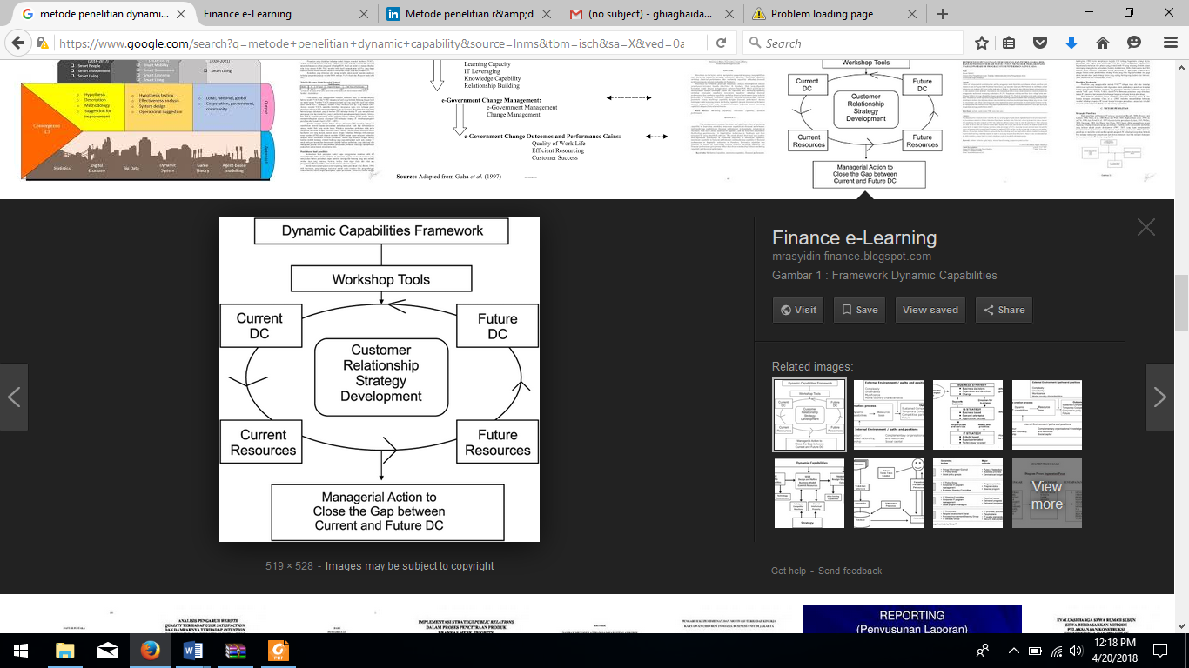
Figure 2. Research Method
This research will involve lecturers, students, arts workers in Bandung and Tasikmalaya. The research will be conducted at art galleries in Bandung.
The instruments used in this study include :
The validation sheet is used by researchers to retrieve data and identify problems faced by workers and parties involved in the creative arts industry. Validation sheets are the initial action of identifying problems faced by practitioners in the field.
Interview guidelines are used by researchers to make a list of questions for the information needed so that the questions asked will not go beyond the established limits. In addition, with this guideline, researchers can determine the focus, as well as the structure of the questions to be searched for data. In this study a free lead interview (Top Management Team) was conducted, in which the researcher dug up information according to the guidelines to the leaders in the arts, but also if there were questions needed from employees, it would be adjusted.
The observation rubric is used by researchers, when conducting direct observations in the field. This rubric is used to record whether the concept of dynamic capabilities can be applied optimally, as well as knowing the customer or connoisseurs of art to the changes that have been offered.
The questionnaire sheet is used by researchers, to explore data from art workers and connoisseurs of art on the implementation of dynamic capabilities that have been applied in the creative arts industry.

FINDINGS AND DISCUSSION

Putri Pamayang Dance Studio is a dance studio in Bandung. The age of this dance studio is approximately 15 years, this dance studio was established on August 7, 2003 in Bandung. This dance studio is a hereditary legacy, now this dance studio was taken over by the second generation. Over a period of 15 years, this dance studio has been able to expand into three branches in Bandung, branches of the Putri Pamayang Dance Studio are:
a) Taman Budaya, Dago Tea House
b) Studio Ega Robot, Ujung Berung
c) Cipatat District Hall, West Bandung Regency
Meanwhile, there are programs offered by Putri Pamayang Dance Studio, namely:
a) Quarterly Evaluation
b) Semester Evaluation
There are a number of Princess Pamayang Dance Studio classes consisting of:
a) Beginner with an indicator of achievement, namely Memorization
b) Intermediate with technical achievement indicators
c) Proficient with Overall achievement indicators (Wirahma, Wiraga, Wirasa)
d) Skillful with achievement indicators Able to Create Koreo
The object of research is the studio owner, studio trainer, and studio participants totaling 100 people. Studio trainers and studio participants are given a questionnaire that must be completed. After the questionnaire has been filled in, the next step is to identify the problems faced by the studio trainers and the studio participants, as well as being a reference for the weighting of the SWOT analysis for the studio owners, besides that the studio owner is also asked to fill in an interview questionnaire.
In this study the data were analyzed using the IFE (Internal Factor Analysis) and EFE (External Factor Analysis) methods which aim to find out the right strategy used by Putri Pamayang Dance Studio based on the results of the SWOT analysis. David stated that internal-external matrices position the various divisions of an organization in nine-cell views as illustrated in tables 1, 2 and 3 (David, 2010: 344).
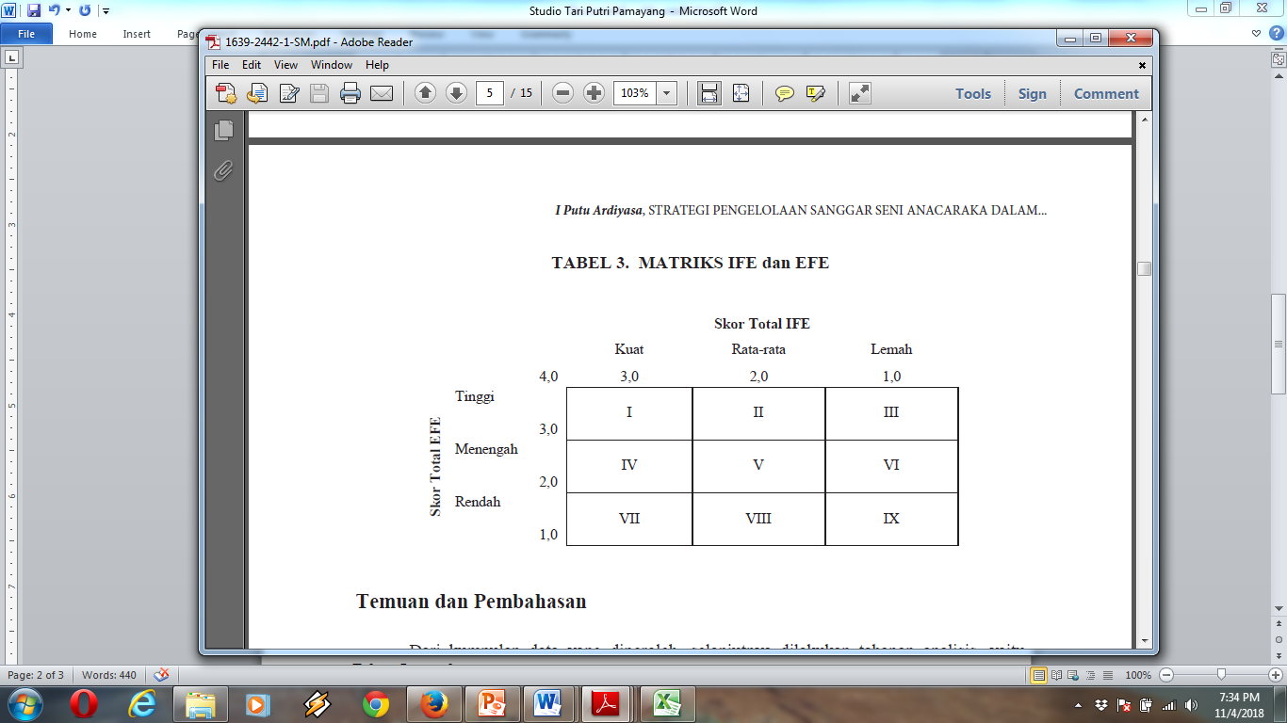
Figure 3. Internal Factor Evaluation (IFE) and External Factor Evaluation (EFE) Matrix
Based on the results of the data obtained, then the analysis stage is carried out, namely through a descriptive analysis (describing the main results of the study) and a two-stage analysis of the strategy formulation consisting of input stages by analyzing the external and internal environment (EFE and IFE), matching stages, namely IE and SWOT analysis. The following results are related to the management of Putri Pamayang Dance Studio.
Internal factors
Strength
1 Trainers are graduates of art colleges.
2 Packaging concept exercises can attract the attention of participants.
3 Has extensive facilities for training.
4 Get family and community support.
Weakness
1 Lack of trainer power.
2 Has not received full support from the government.
3 Not able to perform a stage increase.
4 Don't have broad network access.
5 Not yet maximized promotion on social media.
External Factors
Opportunity
1 The enthusiasm of the participants in participating in art activities was enormous.
2 The desire of parents who want to provide useful things for their children.
3 The availability of art space to present valuable art.
4 There are artistic talents that need to get a special space.
5 There is a government program that promotes art.
6 There are not too many such organizations.
Threat
1 Changes in social, cultural, demographic and economic environment.
2 Most likely new competitors will emerge.
3 Fear of losing supporters if not anticipated early on.
4 Entertainment (not art) in television and other media is increasingly rife.
5 Possible lack of collaboration.
6 Possible people who are talented but confused for art.
From the descriptive analysis above, SWOT analysis can then be carried out by giving weight to each factor by the key resource person at the organization, Nenden Amalia as owner and manager of Putri Pamayang Dance Studio.
In internal and external analysis, weight determination is carried out by submitting a questionnaire to the manager of the Putri Pamayang Dance Studio, namely Nenden Amalia as the owner and manager of this studio.
Weight indicates the level of importance of a factor on the success of an organization in its performance.
The determination of weights on each variable used a scale of 1,2,3.
Ratings for each scale can be explained as follows:
1 = if the horizontal indicator is less important than the vertical indicator
2 = if the horizontal indicator is as important as the vertical indicator
3 = if the horizontal indicator is more important than the vertical indicator
Table 1. Assessment of Internal Factor Weights (Strengths and Weaknesses)
Internal Factor | Nenden Amalia
A | 0,091
B | 0,122
C | 0,167
D | 0,091
E | 0,106
F | 0,076
G | 0,083
H | 0,167
I | 0,167
Total | 1,000

Information:
A Trainers are graduates of art colleges.
B Packaging concept exercises can attract the attention of participants.
C Has a large facility for practice.
D Get family and community support.
E Lack of trainer power.
F Has not received full support from the government.
G Has not been able to do a stage increase.
H Don't have broad network access.
I Not maximal promotion on social media.
Table 2. Assessment of the Weights of External Factors (Opportunities and Threats)
External Factor | Nenden Amalia
A | 0,141
B | 0,084
C | 0,161
D | 0,144
E | 0,110
F | 0,131
G | 0,174
H | 0,131
I | 0,094
J | 0,131
K | 0,076
L | 0,049
Total | 1,000
Information:
A The enthusiasm of the participants in participating in art activities was enormous.
B The desire of parents who want to provide useful things for their children.
C Art space is available to present valuable art.
D There are artistic talents that need to get special space.
E There is a government program that promotes art.
F There are not too many such organizations.
G Social, cultural, demographic and economic environmental changes.
H Most likely new competitors will emerge.
I Fear of losing supporters if not anticipated early on.
A Entertainment (not art) in television and other media is increasingly rife.
K Possible lack of collaboration.
L Chances are people who are talented but confused about art.

Table 3. Ranking of Company Advantages
No | Strength | Nenden Amalia
1 | The trainers are graduates of art colleges. | 2
2 | Packaging concept exercises can attract the attention of participants. | 3
3 | Having extensive facilities for training. | 4
4 | Get family and community support. | 3

Table 4. Rating of Company Weaknesses
No | Weakness | Nenden Amalia
1 | Lack of coach power. | 2
2 | Has not received full support from the government. | 3
3 | Have not been able to do a stage increase. | 3
4 | Don't have wide network access. | 1
5 | Not yet maximized promotion on social media. | 1

Table 5. Ranking of Company Opportunities
No | Opportunity (Peluang) | Nenden Amalia
1 | The enthusiasm of the participants in participating in art activities was enormous. | 3
2 | The desire of parents who want to provide useful things for their children. | 2,5
3 | The availability of art space to present valuable art. | 3,5
4 | There are artistic talents that need to get special space. | 4
5 | There is a government program that promotes art. | 2
6 | Similar organizations are still not too many. | 3
Table. 6 Rating of Company Threats
No | Threats (Ancaman) | Nenden Amalia
1 | Social, cultural, demographic and economic environmental changes. | 1
2 | Most likely new competitors will emerge. | 2
3 | Fear of losing supporters if not anticipated early on. | 3
4 | Entertainment (not art) in television and other media is increasingly rife. | 2
5 | Possible lack of collaboration. | 4
6 | Possible people who are talented but confused for art. | 4
Table 7. The Internal Factor Evaluation (IFE) Matrix
No | Internal Factor | Weight | Ratting | Weighted Score
Strength
1 | The trainers are graduates of art colleges. | 0,091 | 2 | 0,182
2 | Packaging concept exercises can attract the attention of participants. | 0,122 | 3 | 0,366
3 | Having extensive facilities for training. | 0,167 | 4 | 0,334
4 | Get family and community support. | 0,091 | 3 | 0,182
 |  |  |  | 1,074
Weakness
1 | Lack of coach power. | 0,106 | 2 | 0,212
2 | Has not received full support from the government. | 0,076 | 3 | 0,228
3 | Have not been able to do a stage increase. | 0,083 | 3 | 0,249
4 | Don't have wide network access. | 0,167 | 1 | 0,334
5 | Not yet maximized promotion on social media. | 0,167 | 1 | 0,334
 |  |  |  | 1,31
 | Total | 1,000 |  | 2,422

Table 8. The External Factor Evaluation (EFE) Matrix
No | Faktor Eksternal | Bobot | Ratting | Weighted Score
Opportunity
1 | The enthusiasm of the participants in participating in art activities was enormous. | 0,141 | 3 | 0,423
2 | The desire of parents who want to provide useful things for their children. | 0,084 | 2,5 | 0,210
3 | The availability of art space to present valuable art. | 0,161 | 3,5 | 0,563
4 | There are artistic talents that need to get special space. | 0,144 | 4 | 0,576
5 | There is a government program that promotes art. | 0,110 | 2 | 0,220
6 | Similar organizations are still not too many. | 0,131 | 3 | 0,393
 |  |  |  | 2,385
Threat
1 | Social, cultural, demographic and economic environmental changes. | 0,174 | 1 | 0,174
2 | Most likely new competitors will emerge. | 0,131 | 2 | 0,262
3 | Fear of losing supporters if not anticipated early on. | 0,094 | 3 | 0,282
4 | Entertainment (not art) in television and other media is increasingly rife. | 0,131 | 2 | 0,262
5 | Possible lack of collaboration. | 0,076 | 4 | 0,304
6 | Possible people who are talented but confused for art. | 0,049 | 4 | 0,196
 |  |  |  | 1,480
 | Total | 1,000 |  | 3,865

Table 9. Matrix of IFE and EFE Putri Pamayang Dance Studio
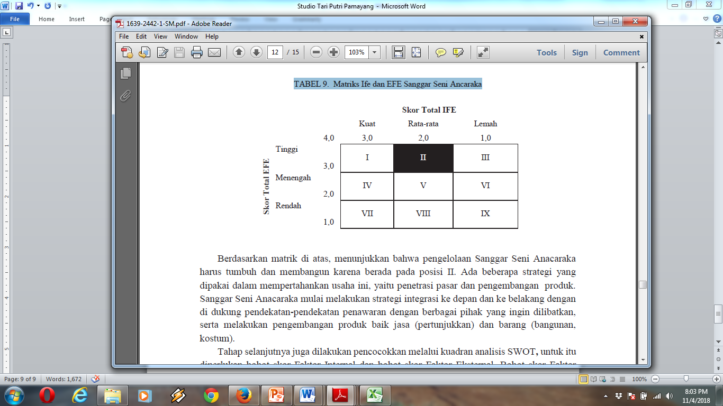 Based on the matrix above, shows that the management of Putri Pamayang Dance Studio must grow and develop because it is in position II. There are several strategies used in maintaining this business, namely market penetration and product development.
Putri Pamayang Dance Studio began to carry out forward and backward integration strategies with
supported bidding approaches with various parties who want to be involved, as well as developing products both services (shows) and goods (buildings, costumes). The next step is also to be matched through the SWOT analysis quadrant, for that we need the Internal Factor score weighting and the External Factor score weighting. The Internal Factor score weights are obtained from the Strength score weights minus Weaknesses, while the External Factor score weights are obtained from Opportunities minus Threats.
Internal Score Weight: Strengths - Weaknesses
1,074 – 1,310 = -0,236
External Score Weight: Opportunity – Threat
3,865 – 2,385 = 1,480

The results obtained from the reduction of indicators on external factors and internal factors can be obtained quadrant 0.555; 1,000

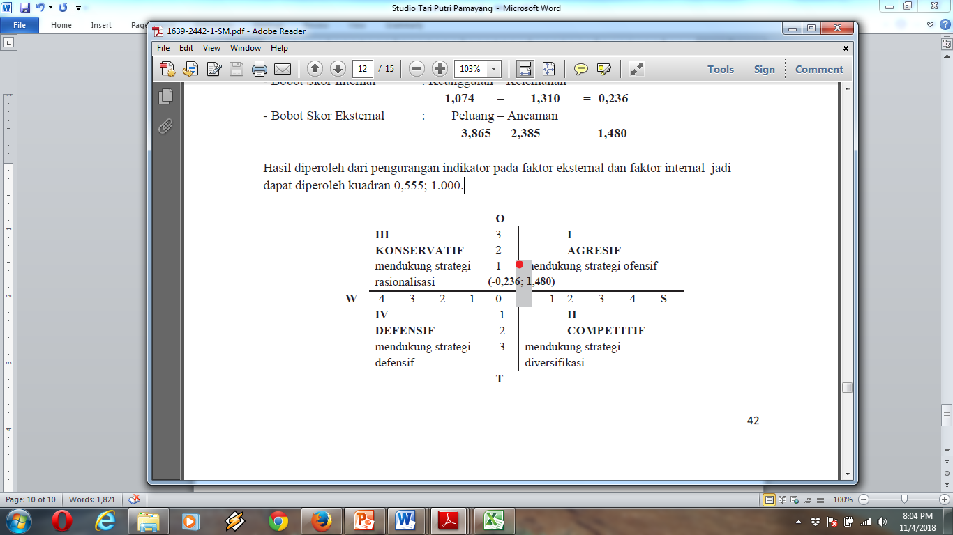Figure 4 . Quadrant

The SWOT Analysis Quadrant for the management of Putri Pamayang Dance Studio, shows the position in quadrant III, so it is necessary to choose a strategy in the form of using each strength to deal with all threats by penetrating market development, market development, product development and related diversification.

CONCLUSION
Putri Pamayang Dance Studio struggles to implement an interesting training strategy so that the studio participants are interested in continuing to follow the training process as well as many other potential participants who wish to join. An interesting training concept using Contemporary Jaipong songs and Sundanese traditional cloth makes the participants more active, creative and love the process that is followed. It seems that until now the studio participants have been enthusiastic in participating in the training process. The market segmentation of Putri Pamayang Dance Studio still offers products and services to anyone who wants to learn Sundanese dance, Jaipong.
Based on the results of the above analysis, the steps implemented by Putri Pamayang Dance Studio relate to variations in strategy, namely, market penetration strategies, must grow and develop, backward integration, horizontal integration.
REFERENCES
Cheng, P. (2013). Responsible downsizing strategy as a panacea to firm performance: the role of dynamic capabilities. Internaional journalof manpower , 1015.
Eisenhardt, K. M., & Martin, J. A. (2000). Dynamic Capabilities: What Are They? Strategic Management Journal , 1105-1121.
Enkel, E. (2012). Dynamic capabilities for new business creation: a cross industri study. Journal of management , 17.
Evers, N. (2011). International New Ventures in "Low Tech" Sectors: A Dynamic Capabilities Perspective. Strategic Management Journal , 502-528.
Grunbaum, N. N. (2013). Dynamic Capabilities-Are They Profitable? Strategic Management Journal , 182.
Jiao, H. (2011). Environmental dynamism, innovation, and dynamic capabilities: the case of China. Journal of Enterprising Communities People and Places in the Global Economy , 131-144.
Jiau, H. (2010). An empirical study on paths to develop dynamic capabilities: from the perspective of enterpreneurial orientation and organizational learning. Front. Bus. Res. China , 47.
Nielsen, A. P. (2006). Understanding dynamic capabilities through knowledge management. Journal of knowledge management , 59.
Schlemmer, F. (2008). The managing director and the development of dynamic capabilities. International journal of organizational analysis , 109-137.
Zheng, S. (2011). Knowledge based dynamic capabilities and innovation in networked environments. Journal of knowledge management , 1035.

