Appendix-A
Monomodal Texts
Text 1
Pancreas
The pancreas is a triangular organ located between the stomach and the first part of the small intestine. The pancreas plays many roles in the body. For example, the pancreas produces enzymes that break down into the small intestine and help break down starches, proteins, and fats. Enzymes are proteins that help biochemical reactions occur more easily and often much faster. The pancreas also secretes hormones. Hormones are small molecules that travel through the bloodstream and affect other parts of the body. Hormones have an effect on certain cells that recognize them and affect the way organs work. This hormone produced by the pancreas is called insulin. Insulin is produced in special pancreatic cells called Langerhans. Insulin is then introduced into the bloodstream and travels to the liver and muscle cells. Insulin helps these cells take up sugar and store it so it can be used for energy.
Diabetes and Insulin Use in the Body

Diabetes is a condition that affects millions of people. People with diabetes either have a pancreas that does not produce enough insulin or their body cells cannot use insulin properly. As a result, a person with diabetes has a high blood sugar level and even sugar is found in their urine. In fact, hundreds of years ago, people with diabetes were identified by their sweet-smelling urine.

People with diabetes often have diets that limit the amount of sugar they eat. Their body doesn't break down sugar. Unused sugar is excreted in the urine and cannot be used for energy. If left untreated, people with diabetes experience weight changes and feel weak and hungry. In addition, diabetics may urinate frequently and become thirsty as the kidneys try to excrete excess sugar in the body. The long-term effects of diabetes are serious. It can cause blindness, kidney failure, and heart disease.

There are two main types of diabetes. Type I diabetes usually begins in childhood or early adulthood. In type I diabetes, the pancreas produces little or no insulin. People with this condition must sometimes use a needle to inject insulin into their body to stay healthy. Type II diabetes usually develops during adulthood. In this situation, the pancreas does not produce enough insulin or the body cells do not respond normally to existing insulin. People with type II diabetes can control their symptoms through adequate nutrition, weight control, and exercise.

Text 2

How does the pancreas control blood sugar?

People have known diabetes for hundreds of years. A long time ago, diabetics were identified by their sweet-smelling urine caused by excess unused sugar in their bodies. This disease has affected millions of people whose cells are unable to get sugar from the blood and use it for energy. Diabetes can cause weight changes, fatigue, and constant hunger. Over time, diabetes can cause blindness, kidney failure, and heart disease.

In 1889, two scientists named Joseph von Mering and Oskar Minkowski believed that the pancreas, an organ close to the stomach and intestines, could help the body use sugar for energy. In their animal experiments, they detected high levels of sugar in the blood of an animal without a pancreas and a low amount of sugar in the blood of those with a pancreas.

After scientists learned that the pancreas helps the body use sugar molecules for energy, they wanted to know how this happened. Frederich Banting and Charles Best believed that the pancreas secretes a hormone, a small molecule that affects the function of other cells, into the blood to help cells take up and use sugar.

Banting and Best conducted an experiment to test their hypothesis. First, scientists removed the pancreas from a few dogs. As expected, the blood sugar levels of these dogs were much higher than normal 9%. Then, they took the fluid from the pancreas. This fluid contained small molecules believed to help cells take up blood sugar. Scientists injected this liquid into the veins of dogs with diabetes. They re-measured the dogs' blood sugar levels to see if the molecules in the liquid were affecting their blood sugar level, and they observed that their blood sugar was at a normal level.

Scientists have found that molecules injected from the pancreas help dogs control their blood sugar levels. This supported Banting and Best's hypothesis that the pancreas secretes hormones that help other cells get sugar from the blood that can be used for energy. Five years later, the hormone was isolated and called insulin. Insulin is now produced artificially, some diabetics inject themselves with insulin to control their blood sugar levels.

Text 3

The circulatory system is responsible for the distribution of heat in the body. This applies to both 'warm' and 'cold blooded' animals. The term warm-blooded is the name given to those who can keep their body temperature higher than those in their environment. Birds and mammals can be given as examples.

This is not always the case; some allow temperatures close to ambient temperature, such as those who hibernate. Some of these, for example mammals in the tropical savanna, keep their body temperatures below the scorching temperatures of the surrounding area to survive.

There are two characteristics that distinguish birds and mammals from the rest of the animal kingdom. First, they keep their body temperature within narrow limits regardless of the ambient temperature. For this reason, they are often described as homeothermic. Second, they are endothermic; The heat they retain body heat is produced in the body.
Text 4
The circulatory system distributes heat through the blood vessels in an animal's body. This system is responsible for heat transport for both warm-blooded and cold-blooded animals.

Examples of warm-blooded animals include birds and mammals, cold-blooded animals, reptiles, amphibians and fish. The term warm-blooded is a name given to birds and breasts because they can keep their body temperature higher than their surroundings and are generally able to do this.

This is not always the case because some warm-blooded animals - such as hibernating ones - allow their body temperature to be close to the temperature of the air around them when they hibernate.

Mammals living in the heat of the tropical savannah are another example of warm-blooded animals that do not always keep their body temperature higher than the surrounding temperature. These animals often have to keep their body temperature below the scorching heat of their environment.

However, there are two characteristics that distinguish warm-blooded animals from most of the rest of the animal kingdom:

1. Warm-blooded animals are homeothermic. In other words, unlike other animals, birds and mammals keep their body temperature within narrow limits regardless of the surrounding temperature.
2. Two warm-blooded animals are endothermic. Endothermic animals are different from cold-blooded animals whose body temperature is protected by heat from external sources. Therefore, although some cold-blooded animals, such as lizards that sunbathe in the sun, develop body temperatures as high as those of birds, these creatures retain their body temperature from the outside. Such animals are called ectothermic.

Text 5

Events During the Carbon Cycle Process

1. Emission: Carbon emission is the emission of carbon dioxide gas released as a result of the reaction of carbon-containing fuels with oxygen to the atmosphere.

2.Photosynthesis: The process of green plants capturing light energy and converting it into chemical energy is called photosynthesis.

3. Respiration: Living things need energy to maintain their metabolic activities. This energy is obtained by the chemical reaction of glucose with oxygen in the cells, resulting in carbon dioxide being released as water and energy. This event is called breathing.

4. Decomposition: The process of transforming dead organic structures into inorganic structures by decomposers is called decomposition.

5. Fossilization: The folding and mineralization of hard parts of living things with sediments as a result of decay that occurs after death is called fossilization.
Text 6

Events During the Carbon Cycle Process

1. Emission: Carbon emission (release) is the emission of carbon dioxide gas released as a result of the reaction (burning) of carbon-containing fuels (fossil fuels: oil, natural gas, coal, etc.) with oxygen to the atmosphere.

2.Photosynthesis: The roots of green plants take water and minerals from the soil, carbon dioxide from the atmosphere with their stems and leaves, and light energy from the sun. The process of producing food (glucose-sugar) and oxygen with this energy is called photosynthesis.

3. Respiration: Living things need energy to maintain their metabolic (vital) activities. For example, digestion and urinary system. This energy is obtained by the chemical reaction (burning) of glucose (sugar) with oxygen (O₂) in the cells, resulting in carbon dioxide (CO₂), water (H₂O) and energy (ATP). This event is called as respiration.

4. Decomposition: The process of transforming dead organic structures (consisting of C, H and O) into inorganic structures (minerals and vitamins) by decomposers (bacteria and fungi) is called decomposition.

5.Fosilization: The mineralization (the combination of minerals in the shell's structure and surrounding minerals such as calcium and iron) by covering the hard parts (skeleton) of the creature with sediments (sand and sea) after death is called fossilization.

Appendix B
Multimodal Texts

Decorational Relation
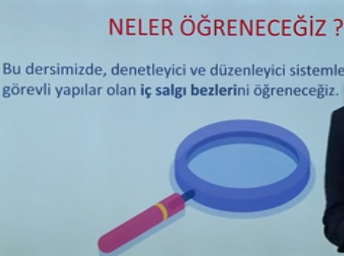 | What will we learn?  We will learn about the endocrine glands.

Exemplary Relation
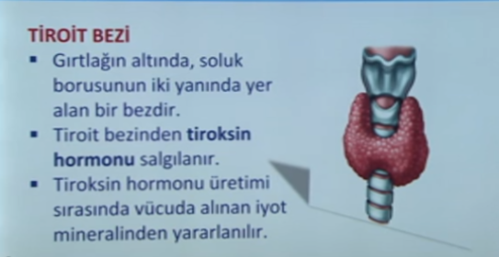 | Thyroid Gland  -It is a gland under the larynx on both sides of the windpipe.  -Thyroxine is secreted from the thyroid gland.  -During the production of thyroxine hormone, the iodine mineral taken into the body is used.

Representational Relation
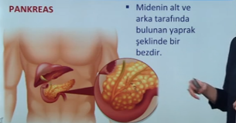 | Pancreas  is an organ located in the lower and back of the liver.

Expositional Relation
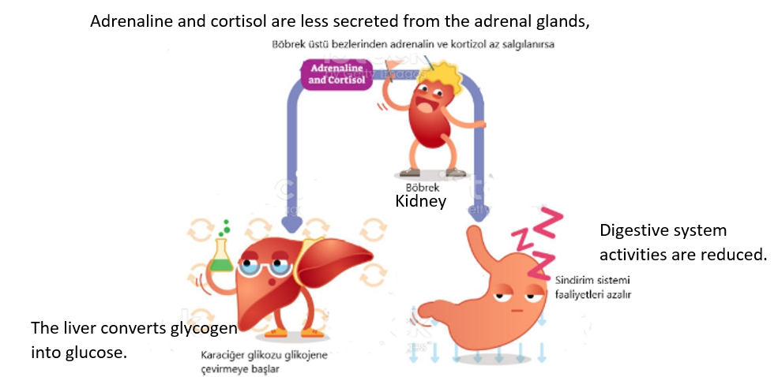

Comparative Relation
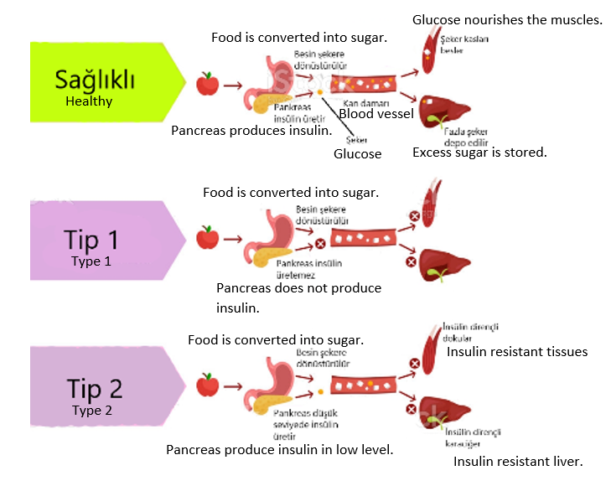

Augmentational Relation
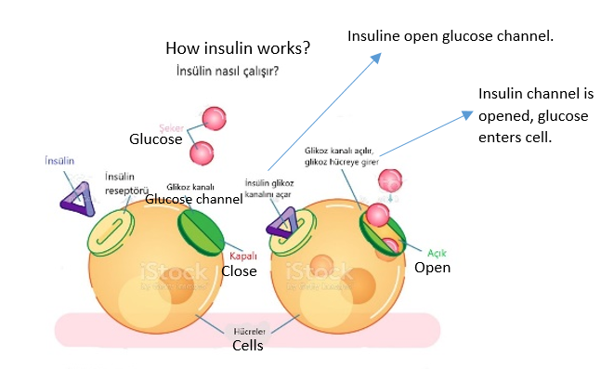
Organizational Relation
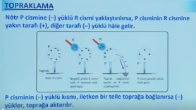 | Grounding  If the neutral P object is brought closer to the negatively charged R object, the side of P near R becomes positive and the far side negative.  If the negatively charged part of the P object is connected to the ground with a conductive wire, the negative charges are transferred to the ground.
Interpretational Relation
