JPJO 5 (2) (2020)

Jurnal Pendidikan Jasmani dan Olahraga

http://ejournal.upi.edu/index.php/penjas/index

Batting Performance On Softball
Agus Gumilar*¹, Jajat Darajat KN¹, Amung Ma’mun¹, Nuryadi¹, Mudjihartono¹, Dadan Mulyana², Burhan Hambali¹,

¹Department of Sports Education, Universitas Pendidikan Indonesia, Indonesia
² Sports Coaching Education Study Program, Universitas Pendidikan Indonesia, Indonesia
Info Artikel  ____________________  Article History :  Received July 2019  Revised August 2019  Accepted August 2019  Available online September 2019  _____________  Keywords:  Softball, batting, speed bat, time to impact, zeep swing analysis |  | Abstract  ______________________________________________________  The purpose of this research was to analyse the performance of batting skills on softball using an application of technology. The results of the assessment can help the coaching process by providing empirical data and become material for evaluation and recommendations for trainers and coaches in the next coaching process. The method used in this research was a descriptive analysis survey. The samples were 21 West Java female softball athletes who were doing training concentration. The measurement of the speed impact parameter obtained (79.94 ± 7.73) to achieve the 25.06% target achievement. The results of the parameter test against the target obtained p-value (0.0001) <0.05. This means that the percentage of the results on this parameter had not significantly met the target. The time to impact parameter obtained an average percentage of the results of (83.06 ± 8.47). The percentage of the target was 16.94%. The results of the Tukey statistical follow-up test showed that the time to impact parameter had not shown a significant achievement with p-value (0.0001) <0.05. The conclusion is that the batting performance of the West Java female softball athletes had not reached the stated target. Therefore, it is recommended to increase the training according to the portion and exercise items based on the predetermined parameters.
 Corresponding address : Jl. Dr Setiabudhi No 229, Bandung, Indonesia  *Corresponding email : gumilaragus27@upi.edu |  |  | ISSN 2580-071X (online)  ISSN 2085-6180 (print)

INTRODUCTION
Today, humans cannot be separated from the digital world, where increasingly sophisticated technology has changed the pattern of human life (Prensky, 2009). The impact of this technological development is the reduction of physical activity performed by humans, because every human need can be obtained by simply pressing a button on a cell phone. Therefore, the role of sports activities is needed to prevent people from sedentary diseases. Sports is a syllable that cannot be separated from our lives, this word tends to be inherent in the life of Indonesian society. A sports actor is any person or group of people who is directly involved in sports activities which include its management, sports coaches, and sports personnel (UU No 3 Tahun 2005, 2005). In the implementation of sports carried out by the community, there are many purposes of sports, including sports for achievement, sports for health, and sports for recreation or pleasure. When children and teens are involved in sports, it is believed that they will benefit from their experiences. Parents, coaches, and school administrators often assume that in addition to physical nervousness, children and young people will acquire important life skills (Gould & Voelker, 2010).
A hitting move, such as a tennis forehand, a ping pong hit, or a baseball bat, depends on predicting where the ball can be hit correctly and returned to the opponent (Kober et al., 2010). Baseball players manipulate the batt with both hands exerting force and moment on the handle grips of the batt to hit a ball thrown in various directions. Due to the kinetic reduction in a system consisting of the batt and the upper hand, it is essentially impossible to know how each hand exerts force and moment on the batt. This is known as the closed loop problem (Kazumichi Ae and Sekiya Koike, 2011). There is a reduction in the kinetic system when hitting, causing the energy released when hitting can not be investigated with certainty.
The analysis in hitting the ball was carried out for three category levels, namely the professional league, university league, and high school league. Average, slugging, and contact rates were calculated at the end of the pre-intervention, intervention, and intervention seasons (DeRenne & Morgan, 2013). This study analysed the time taken for the step / stride hitting at three different championship levels (Takamido et al., 2019). Research was related to the contribution of joint torque to strike speed in baseball games. This research measured all joint movements that work when a baseball player makes a swing. The results showed that the joint moments, the motion dependent term, and the gravity term gave the greatest contribution to the swing speed in baseball (Koike & Mimura, 2016). The speed of strokes in softball is applied in the field. This study used a video camera to see the speed of a player's stroke with various ball speeds. However, this study still used a video camera as an instrument to analyse the biomechanical motion of the stroke results (Smith et al., 2012) .
However, there are still not many local trainers who apply the data from the results of the biomechanical analysis in the softball hitting practice process, even though this is very important as material for evaluation and implementation of the next program. Negligence in evaluating and only focusing on game techniques and tactics, will result in players having weak strengths so that they can worsen their sports performance. (Nurul et al., 2019; Sugimoto et al., 2017). Mechanics is a branch of science from physics that studies the motion and changes in the shape of a material caused by mechanical disturbances called forces (Hendrayana et al., 2019). Mechanics is the oldest of all branches of physics. Biomechanics is defined as the application of mechanics to biological systems (Hendrayana et al., 2019; Hidayat, 1998). Biomechanics is a combination of the disciplines of applied mechanics and the sciences of biology and physiology. Biomechanics concerns the human body and almost all bodies of living things. In biomechanics, the principles of mechanics are used in the drafting, analysis, design, and development of equipment and systems in biology and medicine (Hidayat, 1998). The importance of the role of science, as well as the application of science and technology in the coaching process in the development of youth movement skills becomes one aspect that the writers concerned to conduct science-based research and the application of science and technology for the needs of learning development and to participate in coaching achievement sports in Indonesia. Therefore, the authors intended to research and analyse the muscle performance and movement skills of hitting of softball athletes.
Methods
The research method used in this research was descriptive research with a survey research approach. The purpose of descriptive research is to make descriptions systematically, factually, and accurately regarding the facts of the characteristics and relationships between the phenomena being investigated (Muhammad Nazir, 2004). Survey research is collecting information from several groups of people in order to describe some aspects or characteristics that can use questions in data collection, while information can be obtained from a sample of the population (Fraenkel JR, Wallen NE, 1993).
Participant
Participants in this study were West Java female softball athletes who were conducting training in order to face the national multi-event championship. Participants do an exercise program five times a week. The number of participants involved in this study were all athletes, involving 21 people. The sampling technique of this study was a saturated sampling method, where the entire population became the samples of the study. This was because the total number of athletes who were members of the training camp team were 21 people in total.
Instrument
The instrument used in this research was the Zeep Swing Analysis Sensor, a sensor developed to measure hitting skills. The sample hit the ball with the ball served by the pitcher 10 times. The speed and time to impact data were obtained in real time. ZEEP (Zone Based Energy Efficient Routing Protocol). The ZEEP protocol is designed for stationary and mobile nodes in the process of transmitting data (Vidyapeetham et al., 2013). The mechanism is when the batter batting, the sensor installed on the knob of the bat, the sensor is directly connected to the IOS device in which there is already a database of batter. The output generated from this sensor is data related to speedbat, impact, as well as a picture of swing in biomechanics of motion.
Data Analysis and Results
After the performance data from hitting skills were obtained, the next step was to carry out statistical tests to measure the achievement of the batting performance with the predetermined achievement targets. For this reason, the data was tested with a one-way statistical test and then strengthened by further post-hoc test (Tukey's method). Based on the one-way ANOVA test, the result obtained p-value (0.0001) <0.05, which means that there was a significant difference in the achievement of the results against the target. Thus, the two parameters had not reached the target perfectly. The mean and standard deviation of the percentage of the results of the measurement of the bat speed impact parameter obtained (79.94 ± 7.73), to achieve the target achievement of 25.06%. The results of the parameter test against the target obtained p-value (0.0001) <0 , 05. This means that the percentage of output achievement significance on this parameter had not met the target. It needs action and application of technical exercises tailored specifically.
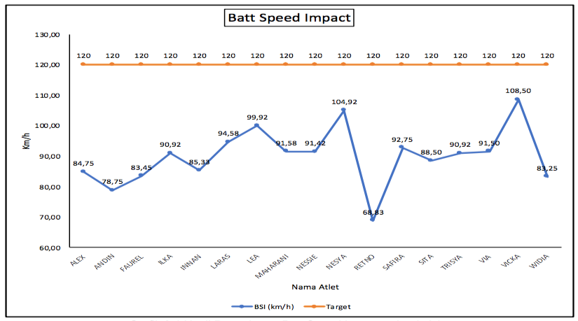
Figure 1: Bat speed impact measurement
The time to impact parameter obtained an average percentage of achievement of (83.06 ± 8.47). The percentage of the target was 16.94%. The results of Tukey's statistical follow-up test show that the time-to-impact parameters had not shown significant achievements. In other words, the achievement of the target was 16.94% that required rigorous training to achieve these targets. The p-value (0.0001) <0.05. The percentage result of each athlete is shown on Figure 2.
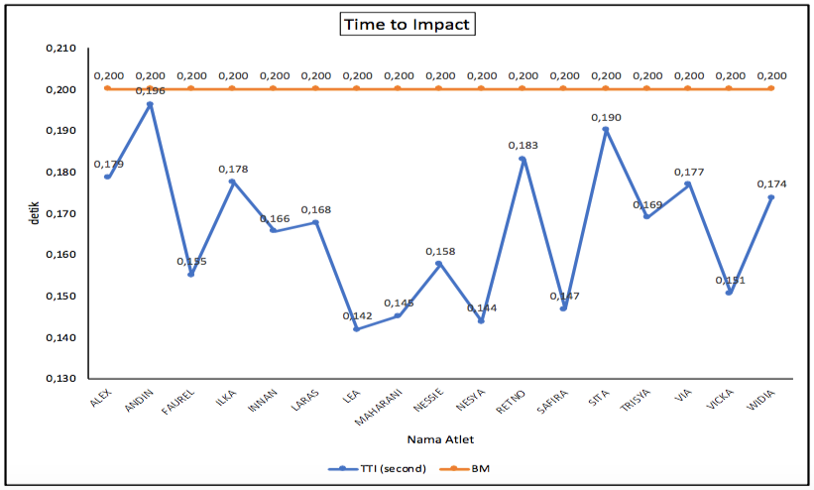Figure 2: Time to impact measurement
Discussions
Hitting is undoubtedly a difficult skill, as pitchers can reach speeds of ≥120 km / h and the ball can be released from as close as 12m from home plate (Flyger et al., 2006). There are many ways to improve hitting performance in softball games, such as the application of training using a heavy bat drill and reaction time as an exercise to increase bat speed (Zawrotny, 2005). Transfer weight, ground reaction force, centre of pressure, stride, flexion and extension, segment rotation, bat movement, batting event, etc., can affect the speed of the bat and the momentum when it will hit the ball (Ae et al., 2018; Welch et al., 1995). Parameters for bat position and rotation axes, force acting on the bat, torque acting on the bat, angular displacement and body segments, force exerted by each arm, and bat swing model are parameters for hitting motion to detect errors that occur when hitting (Cross, 2009).
In producing an increased stroke speed, of course, many aspects are needed, other studies conclude that the speed of the stroke is also influenced by the pattern of the exercise performed (Dabbs et al., 2010). Of course, the heating pattern must be chosen properly, experiments were carried out to increase the speed of the stroke by placing a load on the tip of the bat when the warm-up turned out to have a negative effect on increasing the speed of the stroke on players at the college level (Koenig et al., 2004). This is also supported by other research conducted on baseball players that giving a ballast at the end of the bat makes the swing pattern lower, resulting in a lower hitting speed (Kim & Hinrichs, 2003).
The motion of hitting a softball is a highly coordinated three-dimensional motion, as depicted in figure. 3 (Milanovich & Nesbit, 2014).
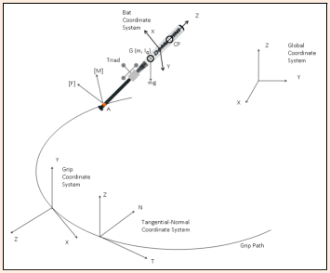
Figure 3 : Free body diagram bat (Milanovich & Nesbit, 2014)
Figure 1 shows a free-body diagram of this model. The local and global coordinate systems are defined as shown in figure 1. The local batt coordinate system (XYZ) is aligned with the three markers attached to the batt. The Z axis is aligned with the long axis of the batt, the Y axis is perpendicular to the plane formed by these markers, and the X axis completes the three markers of the right hand. The global coordinate system (XYZ) is fixed to the ground with the Z axis in the vertical position. Two other local coordinate systems were defined to facilitate kinematic and resolution of the kinetic components and their descriptions. The grip coordinate systems are attached to point A, and are parallel to the tangential, normal and bi-normal directions relative to the path of the grip points. A tangential-normal (swingpitch-roll) coordinate system is also attached to point A, and is parallel to the long axis of the batt, the relative normal direction to the swing plane (defined by the batt position), and the bi-normal coordinates in these two directions.
Understanding the mechanics of batting moves at various levels of competition can help players and coaches identify the key kinematics essential to being a successful batter. (Dowling & Fleisig, 2016). The results of the analysis of course become a reference for the coach to make an exercise program. The mechanics of motion can be seen through the three-dimensional softball batt model which was developed to study the hitting motion, the interaction between the subject (batter) and energy transfer, it turns out that the shift in body weight does not affect the speed of the ball, players are given the freedom to use whichever model feels most comfortable for them. (Jensen, 2016). To increase the speed bat, you can perform an interval-based hitting program designed to gradually return the athlete's performance to competition (Chang et al., 2016).
In addition, the experience of competing is one of the important things, while training with the stimulation of situations and conditions will actually affect more quickly the increase in overall batting performance (Gray & Beilock, 2011). Batters with high skill and experience have better hitting speed than beginner batter (Dowling & Fleisig, 2016). Through the analysis carried out by applying the zeep swing sensor analysis, it is hoped that the coaches of the West Java softball team can analyze and provide training programs that can increase the speed bat and time to impact of the West Java female softball players so that they can improve their best performance.
Conclusion
Based on the results of the analysis and discussion, the researchers can conclude that the performance of the bat speed was 25.06% and the time to impact was 16.94%. This shows that the batting performance of female softball athletes had not yet reached the target performance set, therefore need action and application of technical exercises tailored to the periodization of certain exercises. In this case, the results of this batting analysis will be a recommendation for the trainer to create an exercise program so that the batting performance can be improved.
Acknowledgement
The authors would like to thank all those who have helped writing this article, especially the promotors and lecturers of sports education in postgraduate school, Universitas Pendidikan Indonesia, who had helped and guided the process of writing this article. I hope this research can continue to analyse hitting skills from other parameters.`
References
Ae, K., Koike, S., Fujii, N., Ae, M., Kawamura, T., & Kanahori, T. (2018). A comparison of kinetics in the lower limbs between baseball tee and pitched ball batting. Human Movement Science, 61(October 2017), 126–134. https://doi.org/10.1016/j.humov.2018.07.010
Chang, E. S., Bishop, M. E., Baker, D., & West, R. V. (2016). Interval Throwing and Hitting Programs in Baseball: Biomechanics and Rehabilitation. American Journal of Orthopedics (Belle Mead, N.J.), 45(3), 157–162.
Cross, R. (2009). Mechanics of swinging a bat. American Journal of Physics, 77(1), 36–43. https://doi.org/10.1119/1.2983146
Dabbs, N. C., Brown, L. E., Coburn, J. W., Lynn, S. K., Biagini, M. S., & Tran, T. T. (2010). Effect of whole-body vibration warm-up on bat speed in women softball players. Journal of Strength and Conditioning Research, 24(9), 2296–2299. https://doi.org/10.1519/JSC.0b013e3181eccde5
DeRenne, C., & Morgan, C. F. (2013). Multimodal Modeling Increases Performance and Biomechanical Indicators in Intercollegiate Softball Players: A Longitudinal Study. Journal of Sport Behavior, 36(2).
Dowling, B., & Fleisig, G. S. (2016). Kinematic comparison of baseball batting off of a tee among various competition levels. 3141(June). https://doi.org/10.1080/14763141.2016.1159320
Flyger, N., Button, C., & Rishiraj, N. (2006). The science of softball. Sports Medicine, 36(9), 797–816.
Fraenkel JR, Wallen NE, H. H. (1993). How to design and evaluate research in education (Second edi).
Gould, D., & Voelker, D. K. (2010). Youth sport leadership development: Leveraging the sports captaincy experience. Journal of Sport Psychology in Action, 1(1), 1–14. https://doi.org/10.1080/21520704.2010.497695
Gray, R., & Beilock, S. L. (2011). Hitting is Contagious: Experience and Action Induction. Journal of Experimental Psychology: Applied, 17(1), 49–59. https://doi.org/10.1037/a0022846
Hendrayana, Y., Negara, J. D. K., & Gumilar, A. (2019). The Analysis of Muscle Performance on Softball Pitching Motion. 11(Icsshpe 2018), 401–403. https://doi.org/10.2991/icsshpe-18.2019.111
Hidayat, I. (1998). Biomekanika. IKIP Bandung. https://scholar.google.com/scholar?lookup=0&q=8.%09Hidayat,+Imam.Biomekanika.+Bandung:+IKIP+Bandung.+1998.&hl=en&as_sdt=0,5
Jensen, T. (2016). An Experimental Comparison of Hitting Mechanics in Softball. 0–68.
Kazumichi Ae and Sekiya Koike. (2011). KINETIC ANALYSIS OF EACH HAND IN BASEBALL BATTING MOTION. 11, 831–832.
Kim, Y., & Hinrichs, R. N. (2003). Does warming up with a weighted bat help or hurt bat speed in Baseball? ISB XXth Congress, 808.
Kober, J., Katharina, M., Kr, O., Lampert, C. H., Sch, B., & Peters, J. (2010). Movement Templates for Learning of Hitting and Batting. 853–858.
Koenig, K., Mitchell, N. D., Hannigan, T. E., & Clutter, J. K. (2004). The influence of moment of inertia on baseball/softball bat swing speed. Sports Engineering, 7(2), 105–117. https://doi.org/10.1007/bf02915922
Koike, S., & Mimura, K. (2016). Contributions of Joint Torques, Motion-dependent Term and Gravity to the Generation of Baseball Bat Head Speed. Procedia Engineering, 147, 191–196. https://doi.org/10.1016/j.proeng.2016.06.212
Milanovich, M., & Nesbit, S. M. (2014). A three-dimensional kinematic and kinetic study of the college-level female softball swing. Journal of Sports Science and Medicine, 13(1), 180–191.
Muhammad Nazir. (2004). Metode Penelitian. Ghalia Indonesia.
Nurul, R., Raja, J., Mea, K. K., Razman, R., Ismail, S. I., Shari, M., Idris, N. M., & Sciences, E. (2019). Effects of whole-body electromyostimulation on strength and batting velocity of female collegiate softball players. Movement Health & Exercise, 8(1), 175–184.
Prensky, M. (2009). H. sapiens digital: From digital immigrants and digital natives to digital wisdom. Innovate: Journal of Online Education, 5(3).
Smith, L., Burbank, S., Kensrud, J., & Martin, J. (2012). Field measurements of softball player swing speed. Procedia Engineering, 34(1), 538–543. https://doi.org/10.1016/j.proeng.2012.04.092
Sugimoto, D., Mattacola, C. G., Bush, H. M., Thomas, S. M., Barber Foss, K. D., Myer, G. D., & Hewett, T. E. (2017). Preventive neuromuscular training for young female athletes: Comparison of coach and athlete compliance rates. Journal of Athletic Training, 52(1), 58–64. https://doi.org/10.4085/1062-6050-51.12.20
Takamido, R., Yokoyama, K., & Yamamoto, Y. (2019). Task constraints and stepping movement of fast-pitch softball hitting. PLoS ONE, 14(2), 1–18. https://doi.org/10.1371/journal.pone.0212997
UU No 3 Tahun 2005. (2005). Undang-Undang Republik Indonesia Nomor 3 Tahun 2005 Tentang Sistem Keolahragaan Nasional Dengan. Presiden RI, 1, 1–53.
Vidyapeetham, A. V., Campus, B., Vidyapeetham, A. V., & Campus, B. (2013). ZEEP: Zone based Energy Efficient Routing Protocol for Mobile Sensor Networks. 990–996.
Welch, C. M., Banks, S. A., Cook, F. F., & Draovitch, P. (1995). Hitting a baseball: A biomechanical description. Journal of Orthopaedic and Sports Physical Therapy, 22(5), 193–201. https://doi.org/10.2519/jospt.1995.22.5.193
Zawrotny, S. C. (2005). Strength and conditioning for baseball and softball. Hitting & Pitching Academy, 1–22.

