The Feasibility of Hospitality Business Incestments in Banjar City
Angela Caroline¹, Ivan Mulyadi Yaprimadi²
¹Program Studi Ilmu Administrasi Bisnis, Universitas Katolik Parahyangan
²PT. Awani Bandung
angela.caroline21@gmail.com
ivanmulyadiyap@gmail.com

Abstract: The Feasibility of Hospitality Business Investments in Banjar City. This study aims to help investors assess the feasibility of business hotels in the Banjar City. To assess the business feasibility of the hotel was used several framework to analyze environmental factors consisting of: PEST Analysis, and Five Forces. Environmental analysis is reinforced by financial analysis made based on interviews with investors and employees of PT.X which is a developer company that want to build a business hotel in the Banjar City. Financial analysis is made using the NPV, IRR, and Payback Period approaches. The results of these calculations are used to estimate the feasibility of business hotels in the city of Banjar. However, this study is limited to the condition of hotel competition in Banjar City nowadays and limited to the business plan of PT. X.
Keywords : Hospitality Business, feasibility study, PEST analysis, Porter 5’Forces

INTRODUCTION
The city of Banjar is a developing city. As it is a strategic city seen from its position which is located in theinter-province of West Java and Central Java. As a township, this city provides public facilities for business and trading infrastructures. Overall, the business in Banjar City was dominated by trading, agriculture, and plantation business.
The increasing number of businesses in Banjar City leads to higher demand of accommodation in the city as well. If seen from the lodging sector, this city has several hotels which classified as ‘Melati Hotel', and home-based lodging. Based on data from "Bappeda Kota Banjar", there are 10 lodgings in Banjar City. The lodging in Banjar City is a like hotel like we mentioned above Melati class and most of them are dominated by resident's houses which formed become lodging. There are two Melati hotels' class that are fully furnished hotel and Banjar Indah Hotel. Generally, these hotels will accommodate tourists and business people who visit Banjar City.
‘ Two-star' hotel in Banjar City is equal with a low-budget hotel that is booming in the big cities. The budget hotel attracts the investors in hospitality areas because of the less cost investment if you compare with star hotel and high occupation when the hotel is already existing. Indonesia has so many regions that attract the investor to build a budget hotel such as sub-urban region, bis city, and small city; which is the purpose as a destination place or city that has excellent potential in business, economic, and trade area. Based on the number of guests, Hotel in Jakarta, West Java and Bali still become an attraction for the investors to open a hospitality business (Dicky Sumarsono, 2014).
Therefore, this research will be focusing on the industry of ‘two-star' hotel in West Java, that is in Banjar City. The purpose of this research is to know the environmental factors that affect the hotel industry in Banjar City and also helps the investor to see the opportunities and challenges of hospitality business in Banjar City.

Framework
The hotel business is a business that uses a building or specially constructed buildings which provides everyone to stay, eat, and experience services and other facilities with charges (Badan Pusat Statistik, 2015). To know the business hotel feasibility in Banjar City, are needed some analysis such as environmental analysis, marketing analysis, and so on. In this research, business feasibility analysis will be done with environmental analysis (external and internal), then investment capability from one of the developer company that is PT. X. The environmental factor is chosen because to develop a new business, the company should do an environmental analysis which can affect the business. In this research, the environmental analysis will be done by collecting complete documentation from any sources. While investments analysis will be done by interview with some people from PT. X and also collect its financial statements that needs to calculate business feasibility to get the number which indicates whether the hotel business is profitable or not.
Environmental analysis is divided into two parts, which are external and internal factor analysis. The external analysis will use PEST analysis (Politics, Economic, Social, and Technology) and Porter 5's Forces. PEST is a framework to analyze company's external factor that consists of politic, economic, social and technology. The use of PEST analysis for the company could anticipate the challenge and get opportunities to summarize the external environment in business operations (Peppard, 2002).
External factor analysis also use ‘Porter 5's Forces'. Porter 5's analysis is a framework to assist company to analyze factors that affect industry which can be useful to summarize external environment in business operations (QuickSTART Indonesia, 2016). The factors consist of threat of new entry, competition among the existing companies, threat of substitute, bargaining power of buyer, and the bargaining power of supplier.
After knowing the environmental factors that affect the hotel business in Banjar City, the researcher will do a business feasibility assessment. The business feasibility is a study that assesses the benefits that come from a business activity. This analysis includes business continuity, stability, profitability from business, sub-business, and project. These things will provide financial benefits and decrease risks of failure when starting a new business.
To see the business feasibility of ‘two-star' hotel in Banjar City, the researcher will focus on financial management where the business feasibility will be calculated based on some calculation tools such as other payback periods, IRR, and NPV. Payback Period (PP) method is an assessment technique on the investment payback period of a business project (Gitman, & Zuther, 2012). IRR is an interest rate that will be received (PV Future Proceeds) equal to the present amount of capital expenditure (Gitman, & Zuther, 2011). NPV (Net Present Value) is an analysis method that pays attention to the changes of the value of the money due to time factors; cash flow projection can be assessed now (the initial period of investment) by cutting the value by a reduction factor that is attributed to the cost of capital (interest percentages) (Gitman, & Zutter, 2012).
To support the calculation, the researcher will collect financial planning report on PT. X that will be projected for 10 years. The financial statements that necessary to calculate the business feasibility that are income statement, balance sheet and statement of cashflow.

Research Method
Kindly find the figure 1 for planning research below. This research will begin with analyzing the external company factor, then internal company factor that the discussing in this research will be limited to financial analysis that sourced from PT. X financial statement.
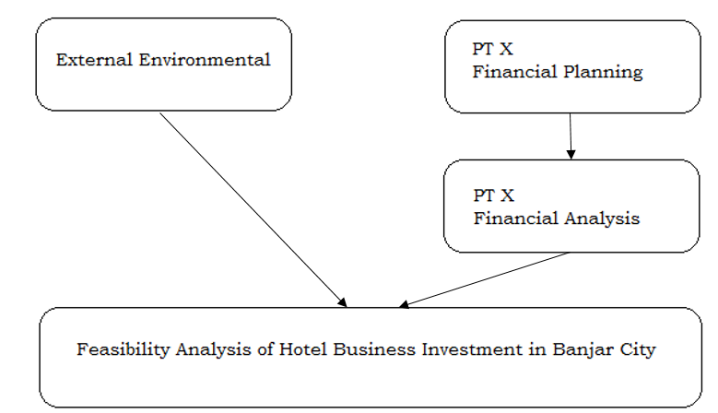
Figure 1. Planning Research (Source: Data Processing)

Operationalization of variables that shows in table 1 used to show the operation variables and the indicator (studied) in this research.

Table 1 Operationalization Variable of The Hospitality Business Investment Feasibility
in Banjar City
Variables | Sub-Variables | Dimensions | Indicators
feasibility analysis studies are activities to learn a business activity in depth or business to be run | External Environmental | PEST Analysis | Politic
 | External Environmental | PEST Analysis | Economy
 | External Environmental | PEST Analysis | Social
 | External Environmental | PEST Analysis | Technology
 | External Environmental | Porter 5’s Forces | Competition in The Industry
 | External Environmental | Porter 5’s Forces | New Joiner
 | External Environmental | Porter 5’s Forces | Substitution Product
 | External Environmental | Porter 5’s Forces | Supplier
 | External Environmental | Porter 5’s Forces | Consumer
 | Internal Environmental | Financial Analysis | Payback Period
 | Internal Environmental | Financial Analysis | NPV
 | Internal Environmental | Financial Analysis | IRR

Result and Explanation
Data analysis technique will be done with PEST analysis, Porter 5’s forces analysis and financial calculation analysis. To support the type of qualitative research that has been explained before, validity test and data validity are done by using triangulation technique. Triangulation data are validity and reability test for collecting data from a lot of sources and also to collect data in a different period (Sekaran & Bougie, 2013). The researcher also does a comparison (Yin. 2011), namely comparing the external data, which is hotel industry condition in Banjar City with feasibility investment based on the calculation that resulted from PT X investment planning.

PEST Analysis
PEST analysis is used to do a company external analysis. This analysis is used to find things that could affect the company from politic, economic, social, and technology aspects. The PEST analysis shows in the figure below
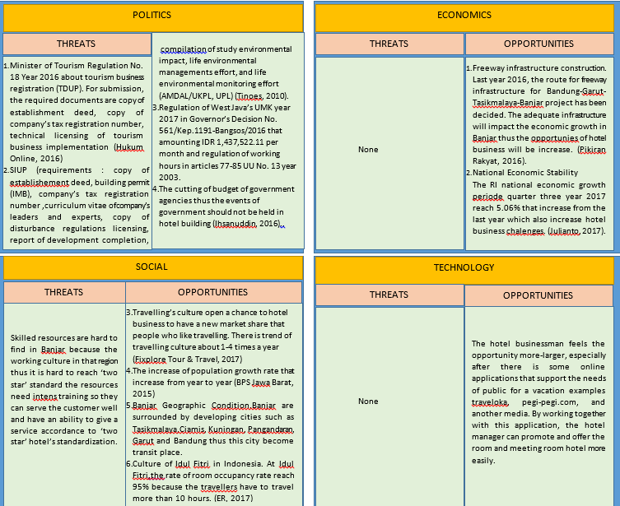
Figure 2. PEST Framework for Hospitality Industry in Banjar City

Industry Analysis (Porter 5’s Forces)
Porter 5's Forces industry analysis describes the condition and existing competitive situation. When entering an industry, it is necessary to know the opportunities and threats. There are five powers in Five Forces which is a threat of substitute, threat of new entry, a power of buyers, a power of suppliers, and competitive rivalry.
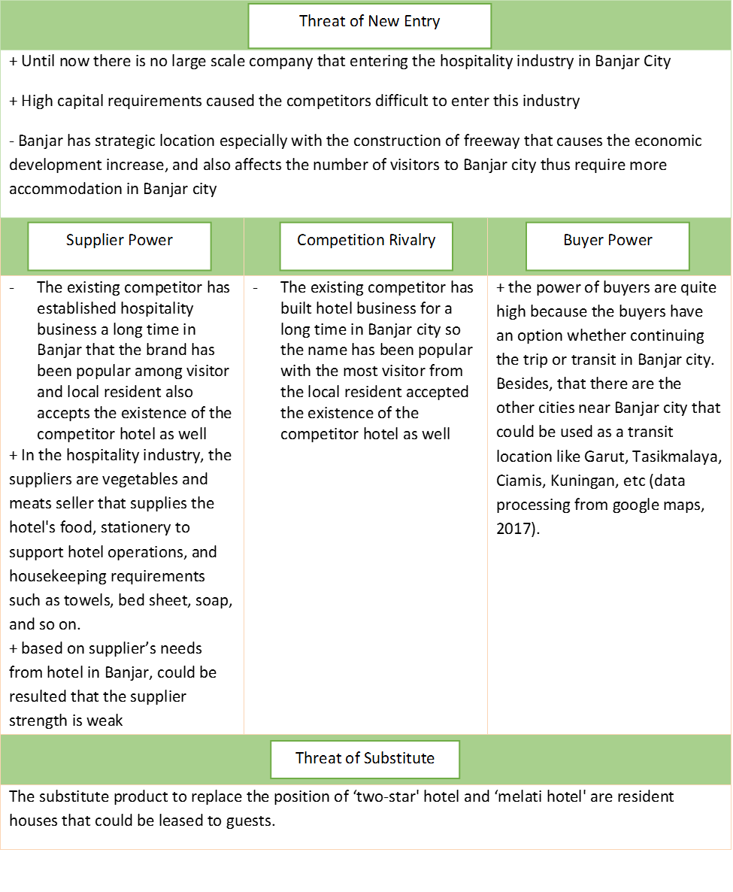
Figure 3. Hospitality Industry Analysis in Banjar City based on Porter’s Forces Framework

Financial Analysis
Financial Analysis in this research is based on the result of interview session with the owner and the employees of PT X which have been supported with some documentation from PT X. Several factors that support the financial analysis such as initial capital of PT X for developing the business hotel, sales planning of the hotel, expenses and costs that will be deployed based on data received from PT X, completed by projection data for 10 years ahead.
A financial aspect includes initial capital, operational cost, salary employees, and the prediction of income earning for the next ten years. The purpose of financial projection is to analyze the business ability to obtain a return on equity and to analyze the company's capability to generate profits. To see the company performance will be created the income statement for PT. X and also will be calculate the revenue estimation for 10 years.

Initial Capital
Initial capital that will be issued by PT X amounting IDR 10,640,200,000.00. The details of initial capital hotel show in the table 2 below.
Table 2 Initial Capital PT X to Build Hotel in Banjar City
No | Investment Name | Amount
1 | Land | 1,400,000,000.00
2 | Building and facilities | 6,255,000,000.00
3 | Capital interior of the buildings | 2,179,500,000.00
4 | Capital equipments | 255,000,000.00
5 | Initial licenses fee | 184,500,000.00
6 | Design Projection Costs, etc | 344,200,000.00
7 | Supplies Capital | 22,000,000.00
 | Total | 10,640,200,000.00

Sales Plan
PT X plan to rent two types of room that is rooms and meeting rooms. The hotel restaurant can't be considered as the additional source of income because the restaurant is only for the hotel's guests. Sales projection will be created for 10 years ahead. For each sales group will be created three financial scenarios that are pessimistic, the most possible (most-likely), and optimistic. The pessimistic scenario has occupancy of rooms and meeting room at around 30%, the most-likely has occupancy at 50% and optimistic at 70%.
The hotel standard room rate per night is IDR 350,000 while for the family room is IDR 600,000. The rate is for the first year, when the hotel started to operate, the increase in the room rate is 5% per years adjusted to the inflation rate and the target of the company. The standard rooms consist of 22 units while the family room is only 1 unit.
The rate of meeting room in the hotel is IDR 2,000,000 for 3 hour durations. The rate is the price in the first year when the hotel starting to operate. The capacity of the meeting room is for 50 peoples and also has pre-function room. The increase in the meeting rooms rate at 5% per years based on inflation and target of PT X. Meeting room of PT. X consist of 1 room. The sales prediction based on 3 scenarios shows in the table 3 below.
Table 3 Sales of Room and Meeting Room
 | Occupancy
 | 100% | 30% | 50% | 70%
Total revenue per year for meeting rooms | IDR 720,000,000.00 | IDR 216,000,000.00 | IDR 360,000,000.00 | IDR 504,000,000.00
Total revenue per years for room | IDR 3,024,000,000.00 | IDR 907,200,000.00 | IDR 1,512,000,000.00 | IDR 2,116,800,000.00
Total | IDR 3,744,000,000.00 | IDR 1,123,000,000.00 | IDR 1,872,000,000.00 | IDR 2,620,000,000.00

The value of net income based on income statement
Table 4 below shows the net profits that will be receiving by PT X based on sales planning, total operating costs, and also after tax deduction at 10%.
Table 4. Net Profit Values Based on Three Scenarios for 10 years
Year | Net Profit
Year | Pessimistic | Most-Likely | Optimistic
2018 | -Rp 247.401.000,00 | Rp 131.301.000,00 | Rp 465.021.000,00
2019 | Rp 99.705.600,00 | Rp 1.036.308.600,00 | Rp 2.168.769.600,00
2020 | Rp 403.687.260,00 | Rp 1.110.582.900,00 | Rp 3.944.456.460,00
2021 | Rp 707.083.641,00 | Rp 1.188.535.285,80 | Rp 5.793.143.301,00
2022 | Rp 1.007.076.767,85 | Rp 1.270.271.111,89 | Rp 7.715.691.410,85
2023 | Rp 1.346.328.895,52 | Rp 1.401.787.896,41 | Rp 9.758.626.270,67
2024 | Rp 1.675.233.633,51 | Rp 1.491.373.251,51 | Rp 11.876.397.877,41
2025 | Rp 1.989.561.837,71 | Rp 1.585.002.516,71 | Rp 14.069.036.293,81
2026 | Rp 2.284.501.729,38 | Rp 1.682.736.059,23 | Rp 16.336.201.908,29
2027 | Rp 2.554.592.645,61 | Rp 1.784.616.201,36 | Rp 18.677.129.833,46
Total Cashflow
After making the income statement (the net profit shown in table 4 above), the authors continue to make cash flow statement to help PT. X sees the business feasibility of hotels in Banjar City. The total cash flow from cash flow statement are shown in the table 5 below.
Table 5 Total Cashflow Based on Three Scenarios
Year | Net Profit
Year | Pessimistic | Most-Likely | Optimistic
2018 | Rp 21.549.000,00 | Rp 400.251.000,00 | Rp 733.971.000,00
2019 | Rp 368.655.600,00 | Rp 1.436.559.600,00 | Rp 2.437.719.600,00
2020 | Rp 672.637.260,00 | Rp 2.547.142.500,00 | Rp 4.213.406.460,00
2021 | Rp 976.033.641,00 | Rp 3.735.677.785,80 | Rp 6.062.093.301,00
2022 | Rp 1.276.026.767,85 | Rp 5.005.948.897,69 | Rp 7.984.641.410,85
2023 | Rp 1.615.278.895,52 | Rp 6.407.736.794,09 | Rp 10.027.576.270,67
2024 | Rp 1.944.183.633,51 | Rp 7.899.110.045,60 | Rp 12.145.347.877,41
2025 | Rp 2.258.511.837,71 | Rp 9.484.112.562,31 | Rp 14.337.986.293,81
2026 | Rp 2.553.451.729,38 | Rp 11.166.848.621,54 | Rp 16.605.151.908,29
2027 | Rp 2.823.542.645,61 | Rp 12.951.464.822,91 | Rp 18.946.079.833,46

Business Feasibility Analysis
Business feasibility analysis uses Payback Period method, Net Present value (NPV) and Internal Rate of Return (IRR). Every calculation use three scenarios that are pessimistic, most-likely, and optimistic. Based on the calculation the values are obtained as shown in table 6 below.
Table 6 Recapitulation Payback Period, NPV, IRR
 | Pessimistic | Most-Likely | Optimistic
Payback Period | 8 years 6 months | 4 years 6 months | 3 years 6 months
IRR | 4,42% | 30% | 42%
NPV | -Rp 1.559.618.841,00 | Rp 25.096.814.169,00 | Rp 44.098.603.342,00
Based on the analysis above, shown in table 6, the pessimistic scenario is not proper to use. Because of the values of NPV is negative (it means the negative cash flow is incompatible with the values of investment that has incurred) and IRR is lower than deposit rate (deposit rate is around 5%-7% nowadays).
Therefore, based on the value of business feasibility as calculated above (table 6) then PT X must lease at least 50% of the total amount of room that has been leased (50% occupancy). Return investment values (payback period) for 3-8 years is faster enough if compared with the average of investment return that is around 8-12 years. Most-Likely and Optimistic scenario is acceptable (the calculation shows a positive number) so that both scenarios are feasible to be run by PT. X if seen from the financial side,

Conclusion
- Based on PEST analysis of the hospitality industry in Banjar, it is concluded that politic factor can be a threat to the owner of business hotel in Banjar because of the number of administrative things that must be prepared when building a hotel. While the other factors can be an opportunity that can be used, such as build a hotel in Banjar.
- Based on Porter 5's Forces Framework, we can see that the competitor, the substitute, and customers become the factors that would be weaken and complicated the new businessmen in Banjar city. While new entry and suppliers factors have challenges and opportunities for the new hotel businessmen in Banjar City.
- The result calculation of hotel business feasibility from PT X is the hotel investments in Banjar proper to run with the total capital around IDR 10,640,000,000.- in about four years exclude payment dividend for the shareholders every year. But, this thing can be a consideration for hotel investors in developing cities. Because, the hotel in developing city also needs to be supported by maximizing the promotion (marketing) and adequate sales until the occupancy rate of the hotel can reach at least 50% so that the benefits can be felt by investors.

Daftar Pustaka
Badan Pusat Statistik. (2015). Badan Pusat Statistik. Retrieved 2017, from Konsep dan definisi statistik Kunjungan Wisatawan Mancanegara: https://www.bps.go.id/Subjek/view/id/16#subjekViewTab1
Bappeda Kota Banjar. (2016). Retrieved from bappeda.banjarkota.go.id: http://bappeda.banjarkota.go.id/hotel-dan-restoran/
Dicky Sumarsono, C. (2014). Dahsyatnya bisnis hotel di Indonesia. Jakarta: Kompas Gramedia.
ER. (2017, Juni 30). Lebaran, Tingkat Hunian Kamar Hotel di Jabar mencapai 95%. Retrieved Juli 2017, from apps.traveltexonline.com: http://apps.traveltextonline.com/2017/06/30/lebaran-tingkat-hunian-kamar-hotel-di-jabar-mencapai-95/
Fixplorer Tour & Travel. (2017, Mei 9). Tren Travelling Wisatawan Nusantara. Retrieved Juli 20, 2017, from kumparan: https://kumparan.com/fixplorer-tour-and-travel/tren-travelling-wisatawan-nusantara
Gitman,, L., & Zutter, C. (2012). Principles of managerial finance. Prentice Hall.
Hukum Online. (2016). Prosedur Pendaftaran Usaha Hotel. Retrieved Juli 2017, from hukumonline.com: sumber: http://m.hukumonline.com/klinik/detail/lt52c6d3586e80d/prosedur-pendaftaran-usaha-hotel
Ihsanuddin. (2016, Agustus 2). Jokowi : Yang Dipotong Anggaran Perjalanan Dinas dan Biaya Rapat. Retrieved Juli 2017, from Kompas: www.kompas.com
Julianto, P. A. (2017, November 6). Membaik, Pertumbuhan Ekonomi RI Kuartal III 2017 Capai 5,06 Persen. Retrieved from ekonomi.kompas.com: http://ekonomi.kompas.com/read/2017/11/06/122646926/membaik-pertumbuhan-ekonomi-ri-kuartal-iii-2017-capai-506-persen
Kasmir, Jakfar. (2012). Studi Kelayakan Bisnis. Edisi revisi. Jakarta: Kencana.
Kominfo. (2016). Sejarah Kota Banjar. Retrieved from banjarkota.go.id: www.banjarkota.go.id/sejarah/
Peppard, J. W. (2002). Strategic Planning for Information System 3rd Edition. Chichester: John Wiley & Sons Ltd.
Pikiran Rakyat. (2017). Tol Bandung - Banjar. Bandung: Pikiran Rakyat .
QuickSTART Indonesia. (2016). Five Forces Model. Retrieved from quickstart-indonesia.com: http://quickstart-indonesia.com/five-forces-model/
Sekaran, Uma. 2013. Research Methods for Business: a Skill-Building Approach, 6th Edition. New York: John Wiley & Sons, Inc.
Sumarwan, U. (2014). Metode Riset Bisnis dan Konsumen. Bogor: IPB Press.
Tinoess. (2010). alur pengurusan izin usaha hotel. Retrieved from tinoess.wordpress.com: www.google.co.id/amp/s/ tinoess.wordpress.com
Yin, R. K. (2011). Qualitative Research from Start to Finish. New York: The Guilford Press.

