JPIS (Jurnal Pendidikan Ilmu Sosial)

Journal homepage: [https://ejournal.upi.edu/index.php/jpis](https://ejournal.upi.edu/index.php/jpis%20x)

*JPIS : Jurnal Pendidikan Ilmu Sosial 33(2) (2024) 173-180*

Earthquake and Fire Disaster Evacuation Route Plan

at Siliwangi University

*Setio Galih Marlyono*, Dede Wahyu Firdaus*, Dita Agustian\**

*\**Universitas Siliwangi, Tasikmalaya, Indonesia

Correspondence: E-mail: setiogeo@unsil.ac.id

|  |  |  |
| --- | --- | --- |
| **A B S T R A C T** |  | **A R T I C L E I N F O** |
| The natural state of West Java province, especially Tasikmalaya City, which is vulnerable to earthquakes and fires, requires humans to do disaster mitigation in order to minimize the risk and impact of disasters. This includes Siliwangi University which is located in an area with a fairly high potential to be affected by earthquakes and the possibility of a fire disaster that is quite vulnerable. Geographical characteristics and university buildings need to be considered in designing an effective evacuation route. The purpose of this research is to increase the University's readiness and response to earthquake and fire disasters, as well as ensure maximum safety for all academic and administrative communities at Siliwangi University. The approach in this study uses quantitative descriptive. The results showed that the highest availability of disaster facilities and infrastructure of Siliwangi University (Per Building) was 80.95% (University Clinic) and the lowest was 2.38% (FIK RKU Bawah); the highest availability of disaster facilities and infrastructure of Siliwangi University (Per Facilities) was 29.79% (Light Fire Extinguishing/APAR) and the lowest was 2.13% (Disaster Management Post). In conclusion, there needs to be an increase in disaster mitigation preparations at Siliwangi University, Tasikmalaya City.  © 2020 Fakultas Pendidikan Ilmu Sosial |  | ***Article History:***  *Submitted/Receive; 03 feb 2024*  *First Revised; 05 Aprl 2024*  *Accepted; 21 June 2024*  *First Available online; 30 Dec 2024*  *Publication; 30 Dec 2024*  ____________________  ***Keyword:***  *Disaster mitigation, Earthquake, Fire Disaster.* |

**1. INTRODUCTION**

Indonesia's position is on the mountainous route (Ring of Fire), namely the Mediterranean Circum and the Pacific Circum. Indonesia also has the potential for disaster because it is located between young mountains and also between tectonic plates. According to Sugandi, 2010 in Husna's article (2012) disaster events in Indonesia can reach more than 1,000 times a year or up to 3 times a day. Natural disasters that have occurred have caused many victims, direct losses and damage to infrastructure. Indonesia is an area that is vulnerable to earthquakes and fires, therefore disaster preparation and mitigation is very important to reduce the risk and impact of earthquakes and fires.

Earthquakes are one of the natural disasters caused by plate movements that can occur suddenly without even prediction or notification that an earthquake will occur (Pasari et al., 2021). The city of Tasikmalaya has one of the worst tectonic earthquakes in history which occurred on September 2 2009 with an earthquake strength reaching 7.9 on the Richter Scale. This earthquake was felt throughout the island of Java and even Bali.

Fire is a disaster that is mostly caused by human error (human error) with the impact of property loss, stagnation or cessation of business, obstruction of the economy and government and even loss of life (Pribadi et al., 2021). According to the Decree of the Minister of Public Works No. 10/2000, the danger of fire is caused by the potential threat and the degree of exposure to sparks from the start of the fire until the spread of the fire, smoke and gas generated. To prevent losses due to fire, it is important to have fire prevention, namely all efforts to prevent and eradicate fires (Fitri et al., 2021).

Siliwangi University is located in Tasikmalaya City in West Java Province and is an area with a high potential for being affected by earthquakes and the possibility of fire disasters which are quite vulnerable. Geographical characteristics and university buildings need to be considered in designing effective evacuation routes.

University community awareness of the importance of disaster preparation and active participation from all academics, including students, staff and administrators, is the key to successful implementation of the evacuation plan (Al Kautsar & Mulyono, 2021). Risk mapping and needs assessment will be the basis for designing effective and targeted evacuation routes. This involves identifying vulnerable areas on campus and evaluating the evacuation capacity of each area (Ruswandi et al., 2021). The use of technology and supporting infrastructure, such as early warning systems and clear evacuation signs, will also be part of this research to improve response and evacuation efficiency in emergency situations.

This research aims to improve the university's preparedness and response to earthquake and fire disasters, as well as ensuring maximum safety for all academic and administrative members at Siliwangi University (Prayoga & Koestoer, 2021).

**2. LITERATURE REVIEW**

Indonesia is a country that is vulnerable to various natural disasters, including earthquakes and fires. Universities as educational institutions must have adequate preparedness to protect the entire academic community. Evacuation routes are a crucial part of a disaster mitigation plan that needs to be prepared systematically (Darmawan et al., 2023). Siliwangi University, which is located in a disaster-prone area, needs to develop an integrated evacuation route plan to reduce the impact caused by disasters, both earthquakes and fires.

**2.1. Earthquake Disaster Evacuation Route Plan**

Evacuation plans for earthquake disasters must consider several key factors, including building type, number of occupants, and potential damage to infrastructure. Research shows that well-designed evacuation routes can save many lives during an earthquake. For example, research emphasizes the importance of evacuation routes that are easily accessible, unobstructed, and clearly identified (Wahyuni et al., 2018). In addition, evacuation routes must be evaluated periodically to ensure that there are no structural changes that hinder the evacuation process (Samanta et al., 2020).

In Indonesia, research by Rahmawati et al. (2022) found that knowledge regarding earthquake evacuation routes in educational institutions needs to continue to be disseminated. They also emphasized the importance of disaster simulation as part of disaster mitigation planning in schools and campuses to minimize casualties (Rahmawati et al., 2012).

**2.2. Fire Disaster Evacuation Route Plan**

Fires in office buildings and campuses often cause casualties due to delays in evacuation. Humans tend to be slow to react to fires because of psychological effects such as denial and surprise (Marlyono, 2019). Therefore, fire evacuation routes must be designed to prioritize speed of access, minimize the distance to a safe place, and be equipped with easily identifiable signs. In the university context, outreach and regular training are important factors in ensuring preparedness (Arrasyid et al., 2024).

Local research in Indonesia by Sari & Lestari (2019) regarding campus fire preparedness shows that many educational institutions do not have adequate evacuation route signs, thereby increasing the risk during the evacuation process. They emphasize the importance of regular evaluation and updating of fire evacuation routes (Zhang et al., 2023).

**2.3. Use of Technology in Evacuation Routes**

Utilization of modern technology such as Geographic Information Systems (GIS) is also an important element in planning evacuation routes. This technology can help map evacuation routes more effectively, especially in densely populated areas such as campuses. GIS can be used to analyze vulnerable areas, design alternative evacuation routes, and accelerate the dissemination of information to the academic community (Cheng et al., 2019).

In Indonesia, research by Arrasyid et al. (2024) discussed the use of GIS to design disaster evacuation routes in educational institutions. They emphasize that GIS provides better visualization of evacuation routes and helps identify areas that need to be avoided during a disaster (Arrasyid et al., 2024).

Effective evacuation routes at Siliwangi University for earthquake and fire disasters must consider factors such as accessibility, clarity of signs, use of GIS technology, as well as active involvement of the academic community through regular outreach and training. Careful planning based on scientific research will increase campus preparedness in facing potential disasters.

**3. METHOD**

The research method used by the researcher is using a quantitative descriptive method, which in this method means that the researcher collects, narrates, processes and writes down the information obtained in detail and thoroughly based on symptoms and situations that occur in the field which are measurable, calculated and analyzed using numbers. which is macro in nature and has the aim of confirming previously existing theories so that their truth can be tested. The descriptive method is a method used to study and analyze various data, symptoms and events that exist and occur on earth (Rahmawati & Isya, 2022). Researchers use tools and materials to collect and process data obtained from the field.

**4. RESULTS AND DISCUSION**

**Description of Geographical Conditions of the Research Area**

The location of this research is at Siliwangi University which is one of the State Universities in Tasikmalaya City in West Java Province. Siliwangi University is astronomically located between 7º10' - 7º 26'32" South Latitude and between 108º 08'32" - 108º 24'02" East Longitude. Siliwangi University is the largest state university in East Priangan. Siliwangi University itself has a new campus area in the Mugarsari Village area, Tamansari District, Tasikmalaya City.

**Evacuation Routes and Infrastructure Requirements in Siliwangi University Campus 1 Buildings with IDEP 2007 Standards**

The 2007 IDEP standardization regulates evacuation routes and infrastructure requirements in buildings, including at Campus 1 of Siliwangi University. Evacuation routes are routes designed to ensure individual safety in emergency situations, such as fire or earthquake. In campus buildings, implementation of the IDEP 2007 standard ensures that each building is equipped with clear and structured evacuation routes, which must meet several infrastructure needs, including:

1. Signboards and Emergency Signs: Each evacuation route is equipped with signboards and emergency signs made of fire-resistant and easily visible materials.
2. Minimum Width of Evacuation Paths: According to the 2007 IDEP standard, evacuation routes must have sufficient width to allow rapid and safe evacuation for all building occupants, including people with disabilities.
3. Fire Resistant Materials: All materials used for the construction of evacuation routes must be fire resistant to minimize the risk of fire spreading in emergency situations.
4. Evacuation Doors: Each floor must be equipped with an evacuation door that is easily accessible and can be opened from the inside without the need for keys or special equipment.
5. Emergency Lighting: Emergency lighting systems should be installed along evacuation routes to ensure adequate visibility during evacuation in low light conditions.
6. Regular Maintenance and Testing: It is important to carry out regular maintenance and testing of all evacuation route infrastructure to ensure that they are always in good condition and ready to be used in an emergency.

Implementation of the IDEP 2007 standard not only maintains compliance with existing safety regulations, but also guarantees optimal protection for the entire campus academic community in facing emergency situations that may occur.

Based on field results, there are several buildings that already have evacuation route instructions and infrastructure requirements in buildings that comply with IDEP 2007 standards, but the majority of buildings do not meet IDEP 2007 standards regarding evacuation routes and infrastructure requirements in buildings. Therefore, there is a need for an analysis regarding evacuation routes and infrastructure needs in buildings on Campus 1 of Siliwangi University, as follows:

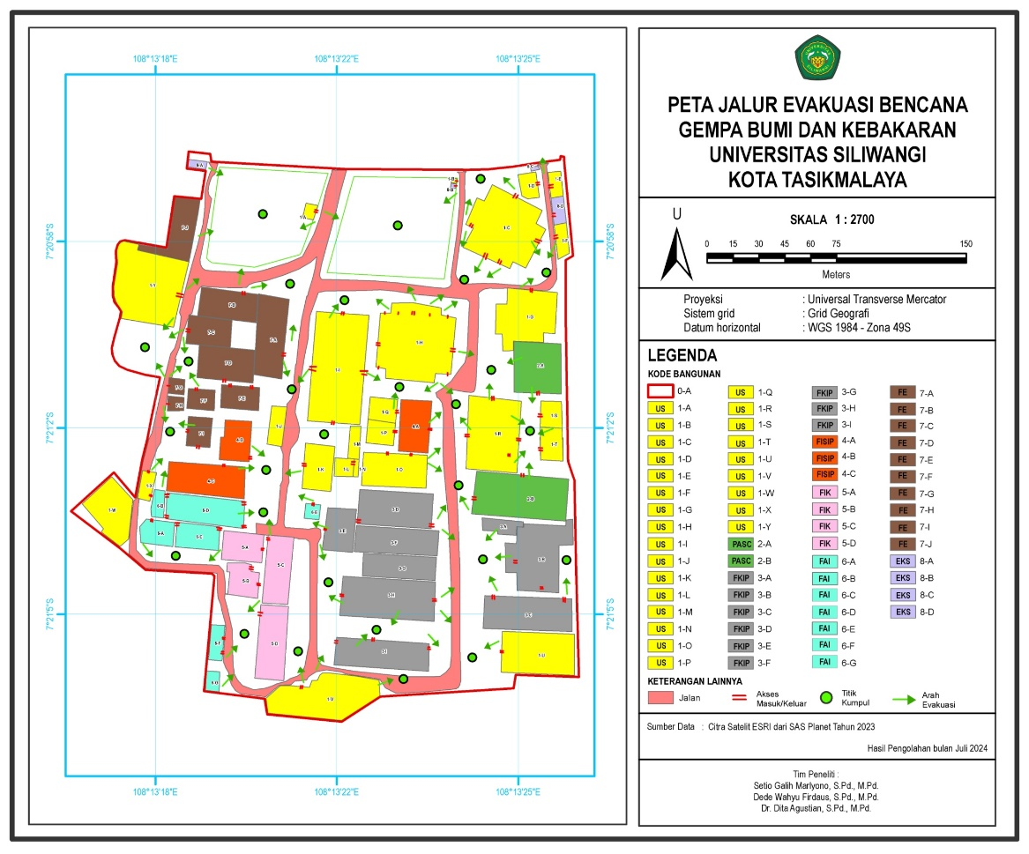*Source: Author's Data Processing Results, 2024.*

**Figure 1. Map of Evacuation Routes for Earthquake and Fire Disasters**

**Earthquake disaster evacuation route plan at Siliwangi University**

Referring to the results of field observations, most of the Siliwangi University Campus 1 facilities do not meet disaster safe standards. For example, there are several buildings that are not used according to their function. One of them is the FKIP (Faculty of Teacher Training and Education) parking building, which has four floors, but only the 2nd and 3rd floors are used for parking. Meanwhile, the 1st and 4th floors are used as student organization secretariats. There is also a parking area which is used as a gathering point place or zone.

Earthquakes can occur at any time without prediction, therefore, to minimize the risk of earthquake disasters, it is necessary to re-assess the use of buildings and gathering point areas. If the building used does not comply with the function and standards, it can have a negative impact, namely a high number of fatalities and material and non-material losses.

Therefore, it is necessary to create safe and secure evacuation routes in accordance with disaster and emergency procedures. If it is in accordance with disaster procedures, various risks can be minimized properly.

**Fire Disaster Evacuation Route Plan at Siliwangi University**

This evacuation route plan was created with the aim of increasing preparedness and minimizing the risk of casualties as well as material and non-material losses. This evacuation route was also created as a form of implementation of disaster mitigation.

Referring to the results of field observations, most of the Siliwangi University Campus 1 facilities do not meet disaster safe standards. For example, APAR (light fire extinguisher) is not available in all buildings, only in certain buildings. This also applies to other fire disaster facilities, namely hydrants, and smoke detectors which are available in only a few buildings. Fire disasters can actually occur at any time and anywhere, including in educational institutions. Siliwangi University is a place where many people can gather and do activities, it should be able to provide a feeling of security and comfort. Therefore, it is necessary to evaluate campus facilities regarding fire disasters.

The Earthquake and Fire Disaster Evacuation Route Plan at Siliwangi University is a strategic effort to ensure the safety of all campus occupants during emergencies. This plan is designed by considering various aspects, such as determining optimal evacuation routes, placing safe assembly points, and providing supporting infrastructure for evacuation. Determining an effective evacuation route is crucial to minimizing injuries or casualties during the evacuation process. In this context, the Dijkstra Algorithm can be applied to determine the shortest and fastest evacuation route to designated assembly points. The implementation of this method has proven effective in designing evacuation route maps at various educational institutions (Rahmawati et al., 2021).

In addition to route determination, the placement of assembly points is another crucial component of the evacuation plan. Assembly points should be located in safe and easily accessible areas for all campus occupants. Choosing the right location will facilitate coordination and headcount during evacuation, ensuring that everyone can be safely evacuated (Putra & Santoso, 2020).

Providing supporting facilities and infrastructure, such as evacuation signs, strategically placed evacuation maps, and regular training and evacuation drills, is also an integral part of this plan. These steps aim to enhance preparedness and understanding among all academic community members regarding the evacuation procedures that must be followed during disasters (Nugroho, 2019). The implementation of a comprehensive evacuation route plan at Siliwangi University is expected to minimize the negative impact of earthquakes and fires, ensuring the safety of all campus occupants.

**5. CONCLUSION**

Based on the research results and analysis, several things can be concluded as follows:

**Earthquake disaster evacuation route plan at Siliwangi University**

Based on the results and discussion explained above, it is concluded that there are 29 area points for the nearest gathering point zone on Campus 1 of Siliwangi University. Apart from that, several repairs (renovations) need to be carried out on several buildings to minimize the risk of collapse from an earthquake.

**Fire disaster evacuation route plan at Siliwangi University**

Based on the results and discussion explained above, it is concluded that there are 29 area points for the nearest gathering point zone on Campus 1 of Siliwangi University. Several adjustments are needed to fire facilities (smoke detectors, hydrants and fire extinguishers), so that they can minimize casualties caused by fire disasters.

**6. REFERENCES**

Al Kautsar, P. H., & Mulyono, N. B. (2021). Ecosystem-based disaster risk reduction concept for forest and land fire disaster. *International Journal of Emergency Services*, *10*(3), 289-314.

Arrasyid, R., Ruhimat, M., Setiawan, I., Ihsan, H. M., Darmawan, W., Mulyana, A., ... & Darmawanto, R. A. (2024). Design, Development, and Evaluation of a Mobile Learning Application for Geography Education. *Journal of Advanced Research in Applied Sciences and Engineering Technology*, *38*(1), 109-134.

Cheng, Y., et al. (2019). "Application of GIS in Disaster Management and Evacuation Planning." International Journal of Geographical Information Science, 33(5), 793-815.

Darmawan, R. A., Salira, A. B., Kurniawati, Y., Logayah, D. S., & Arrasyid, R.(2023). Enhancing Digital Literacy in Social Studies through Augmented Reality Media. *Jurnal Pendidikan Ilmu Sosial*, *33*(1), 69-76.

Fitriany, A. A., Flatau, P. J., Khoirunurrofik, K., & Riama, N. F. (2021). Assessment on the use of meteorological and social media information for forest fire detection and prediction in Riau, Indonesia. *Sustainability*, *13*(20), 11188.

Isya, H. R. M., Wibowo, W. A., & Arrasyid, R. (2021). Analysis of the sunami Disaster risk study in the Pelabuhanratu bay tourism area. *Jurnal Pendidikan Ilmu Sosial*, *30*(2), 135-144.

Marlyono, Setio Galih. (2019). "Students’ Tsunami Preparedness Level Comparison in Pangandaran, Indonesia." *Jurnal Pendidikan Ilmu Sosial* 28, no. 2 164-171.

Pasari, S., Simanjuntak, A. V., Mehta, A., Neha, & Sharma, Y. (2021). The current state of earthquake potential on Java Island, Indonesia. *Pure and Applied Geophysics*, *178*, 2789-2806.

Prayoga, M. B. R., & Koestoer, R. H. (2021). Improving forest fire mitigation in Indonesia: A lesson from Canada. *Jurnal Wilayah Dan Lingkungan*, *9*(3), 293-305.

Pribadi, K. S., Abduh, M., Wirahadikusumah, R. D., Hanifa, N. R., Irsyam, M., Kusumaningrum, P., & Puri, E. (2021). Learning from past earthquake disasters: The need for knowledge management system to enhance infrastructure resilience in Indonesia. *International Journal of Disaster Risk Reduction*, *64*, 102424.

Rahmawati, F., & Isya, H. R. M. (2022). Determining The Location of The Earthquake Shelter Evacuation In School. *Jurnal Pendidikan Ilmu Sosial*, *31*(2), 149-158.

Ruswandi, D., Maarif, S., & Wijaya, A. F. (2021). Strategic Analysis of Collaborative Governance for Disaster Management on Forest and Land Fires in Indonesia. *International Journal of Criminology and Sociology*, *10*, 1707-1716.

Samanta, S., et al. (2020). "Design and Optimization of Earthquake Evacuation Routes Using GIS." Journal of Geospatial Engineering, 17(1), 45-59.

Sari, M. A., & Lestari, E. (2019). "Kesiapsiagaan Kampus dalam Menghadapi Bencana Kebakaran." Jurnal Kesehatan Masyarakat, 14(3), 67-75.

Shafrullah, F., Sedarmayanti, S. I., Akbar, B., Effendy, K., Lukman, S., Kurniawati, L., ... & Asral, K. (2022). Risk Management for Fire Disaster Prevention in DKI Jakarta Province. *Journal of Positive Psychology and Wellbeing*, *6*(2), 739-752.

Wahyuni, L., Rohmat, D., & Setiawan, I. (2018). Hazard analysis of earthquake in the main campus of Universitas Pendidikan Indonesia. *J. Pendidik. Ilmu Sos*, *27*(2), 116.

Zhang, Y., Zhang, X., & Huang, X. (2023). Design a safe firefighting time (SFT) for major fire disaster emergency response. *International Journal of Disaster Risk Reduction*, *88*, 103606.

Nugroho, A. (2019). Evakuasi dan kesiapsiagaan tanggap darurat. Slideshare. Retrieved from https://www.slideshare.net/slideshow/evakuasi-dan-kesiapsiagaan-tanggap-daruratpptx/252397171

Putra, D., & Santoso, R. (2020). Analisis peta jalur evakuasi dan penentuan titik kumpul di gedung UNTIDAR Kampus Tuguran. Jurnal UNTIDAR. Retrieved from https://jurnal.untidar.ac.id/index.php/jris/article/download/3520/1745

Rahmawati, L., Pratama, H., & Wijaya, M. (2021). Perancangan peta jalur evakuasi dengan metode Dijkstra (Studi kasus Universitas Dirgantara Marsekal Suryadarma). Jurnal Universitas Suryadarma. Retrieved from https://journal.universitassuryadarma.ac.id/index.php/jtin/article/download/203/181